7th Grade Homework #7
Due Date: Nov. 17, 2013
1.
Suppose the time is now time 2 o’clock on a twelve-hour
clock. If the clock runs continuously, what time will it show
1000 hours from now?
2.
A car leaves a town travelling at 40 mph. Tow hours later, a second car leaves the same town, on the same road, travelling at 60 mph. In how many hours will the second car be passing the first car?
3.
If two fair dice are tossed, what is the probability that
the difference of the number of dots on the top faces
will be 4?
4.
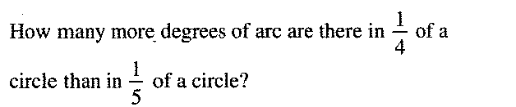
5.
Sara has a bag of nickels, dimes and quarters
worth $2.50. She has twice as many dimes as
nickels, and two less quarters than dimes.
How many coins does she have?
6.
If the length of UZ is 30% of the length of UY and the area
Of ΔXYZ is 210, what is the area of ΔUXZ ?
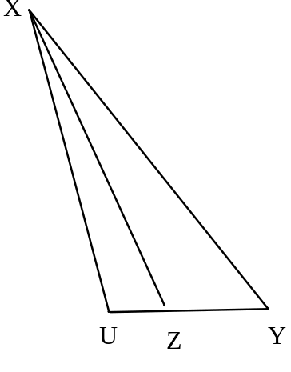

7.
