7th Grade Homework #8
Due Date: Nov. 24, 2013
1.
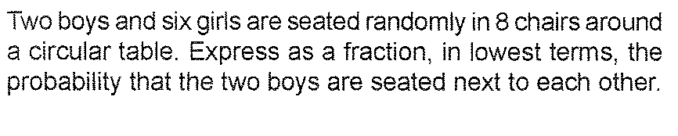
2.
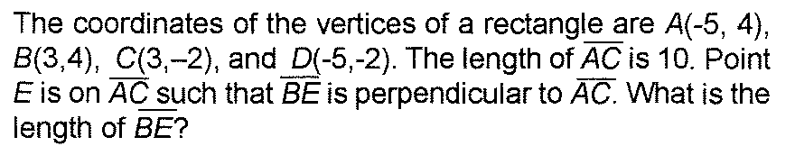
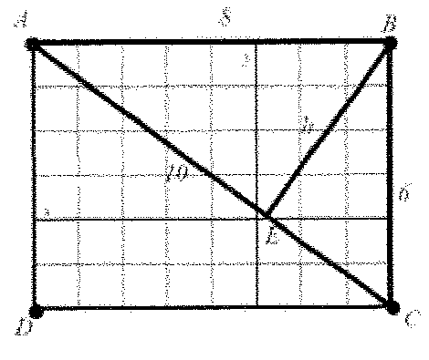

3.
