8th Grade Homework #2
Due Date: Sept. 29, 2013
1.
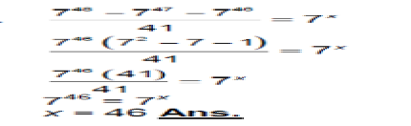Find x.
2.
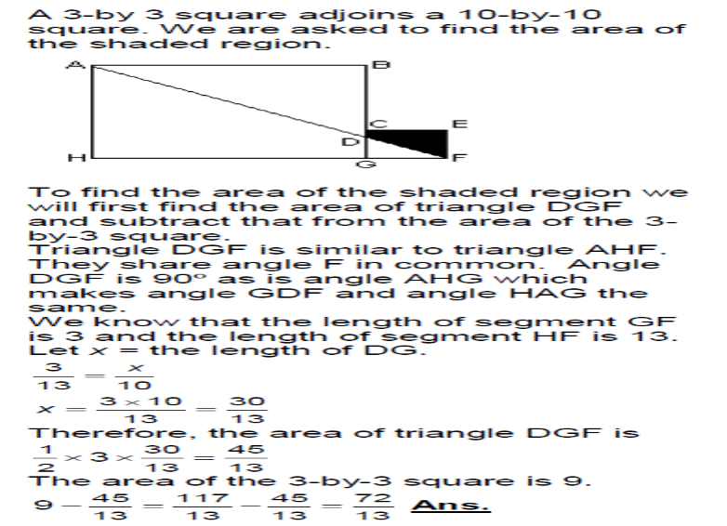
3.
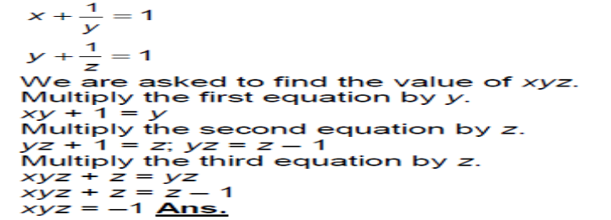
4.
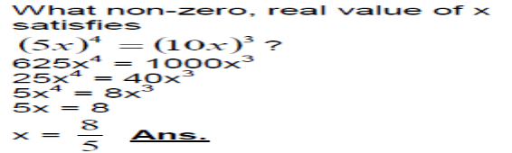 Find x.
5.
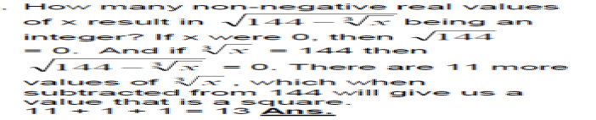
Integer.

