8th Grade Homework #4
Due Date: Oct. 13, 2013
1.
2.
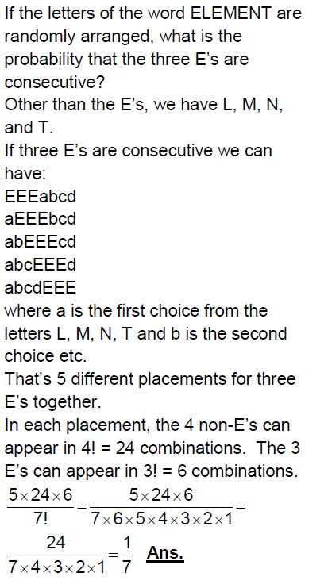
3.
A committee is to be chosen from 10 girls. If Ann, Betty and
Carol are among the group of 10 girls, what is the probability
that all three of them will be on the committee?
4.

5.
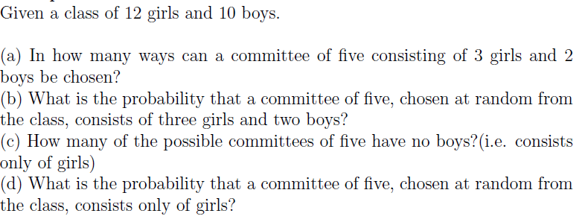
6.
Find n.

