8th Grade Homework #5
Due Date: Oct. 27, 2013
1.
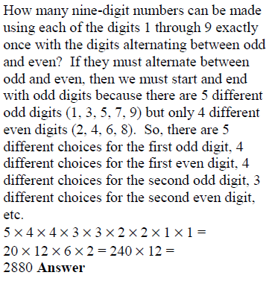
odd and even.
2.
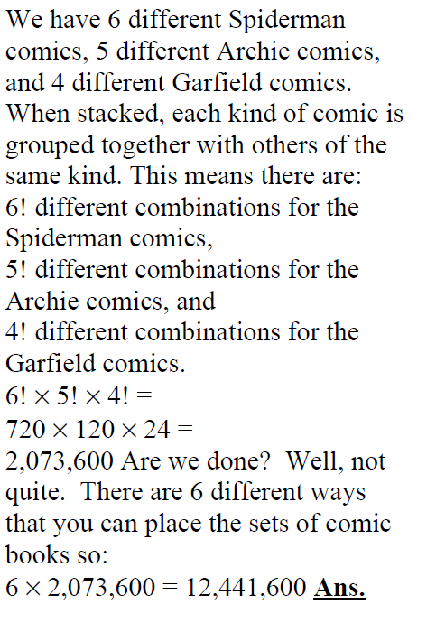
same kind. How many different ways to place
the sets of comic books?
3.
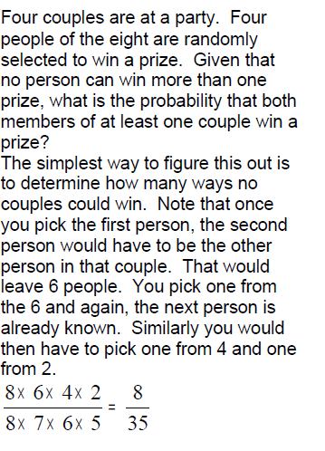
4.
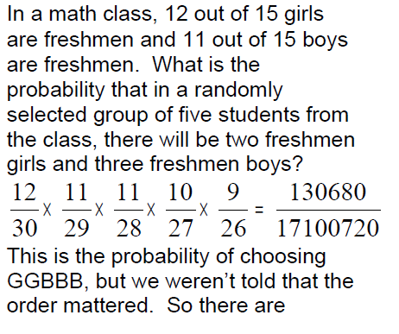
5. From a standard 52-card deck, how many 7-card hands have exactly 5 spades and 2 hearts?
6. A subcommittee consists of 3 girls and 3 boys.
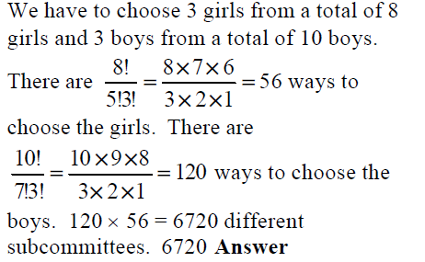
How many different subcommittees can be formed?
7.
