8th Grade Homework #6
Due Date: Nov. 03, 2013
1.
What is the first time after 1 PM at which the minute hand and the hour hand of a clock point in the exact opposite directions?
2.
What is the first time after 7 PM at which the minute hand and the hour hand of a clock point in the exact same directions?
3.
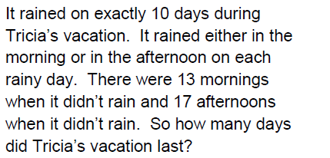

4.
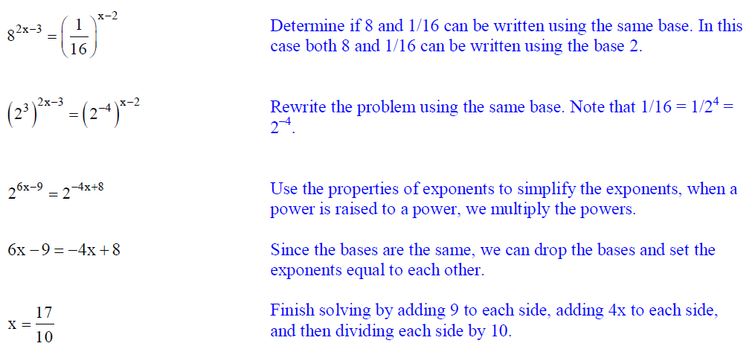
5.
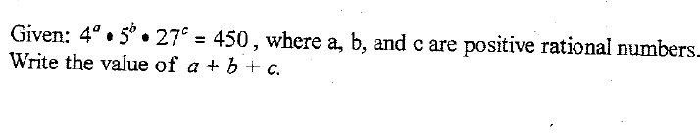
6.
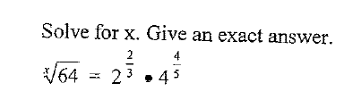
7.
