8th Grade Homework #7
Due Date: Nov. 17, 2013

- Factor the following:

x² – 20x + 75

x² + x - 56

ab² + 2ab - 15a

xy² – 5xy + 6x

x² – 5xy + 6y²

2a³ + 8a² – 64a

x² – 5xy + 6y²

x⁴ – 12x³ + 35x²

2x⁴ – 26x³ - 96x²

2.
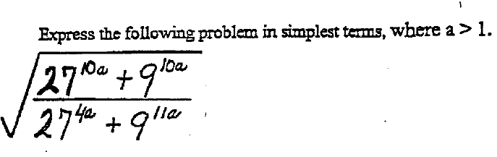
3.
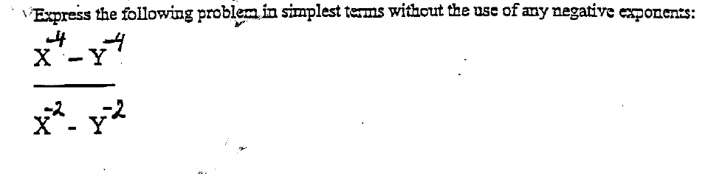
4.
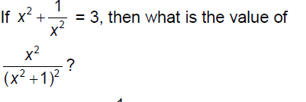
5.
