8th Grade Homework #7
Due Date: Nov. 24, 2013

- Factor the following:
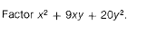
2.
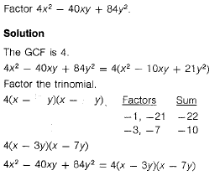
3.
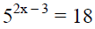

4.
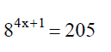

5.
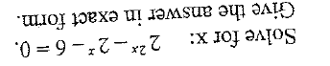
6.
