8th Grade Homework #9
Due Date: December 15, 2013

- Factor the following:
- a²(b – 7) + (7 – b)
- 4(x – 5) – x²(x – 5)
- X⁴ – x²y²
- 18a³ + 24a² + 8a
- 4a² – 12ab + 9b²
- 27a²b – 18ab + 3b

2. Simplify

(1) (x² – 4)/(x² – 2x – 8)
(2) (10 + 3x – x²)/(x² – 4x – 5)
(3) (9 – x²)/(x² + x – 12)
(4) (x2 + 4x – 12)/(x2 – 3x + 2)

3.
2^{x} + 9^{Y} = 371
2^{x+4} – 9^{Y} = 1805
4.
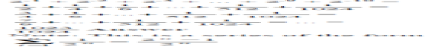
5.
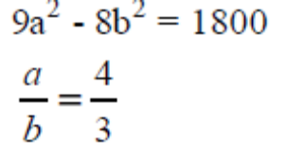
Find the value of ab.
6.
Alexandria had the letters R,O, O, V, G, N and O. How many different ways to make a 7-letter arrangement?
7.
8.
9.
