花 非 花
唐词: 白居易 (772-846) / 作曲: 黄自 (1904-1938)
huā fēi huā , wù fēi wù , yè bàn lái , tiān míng qù
花 非 花, 雾 非 雾, 夜 半 来， 天 明 去。
lái rú chūn mèng bù duō shí , qù sì zhāo yún wú mì chù
来 如 春 梦 不 多 时， 去 似 朝 云 无 觅 处。

Hua Fei Hua (Flower In The Mist)
Poem: Bo Ju Yi (772-846, Tang Dynasty Poet)
Composer: Huang Zi (1904-1938)
Call it flower - 'tis not a flower; Call it foggy mist - 'tis none such either.
It comes in the dead of the night. And takes flight the moment dawn alights;
It stays no longer than a dream in spring, Departs like the fleeting early morning clouds -
And is seen no more.

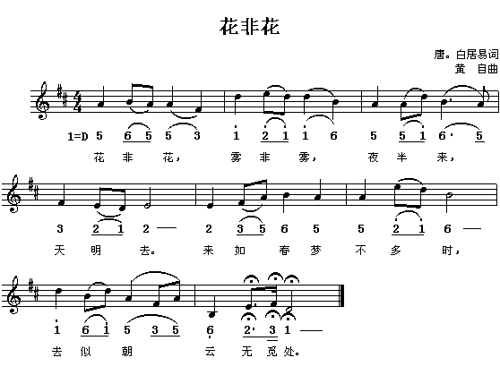

花非花 — 王作欣 Cindy Wang D.M.A. http://www.youtube.com/watch?v=Dqfl0qhCQz8

