茉莉花
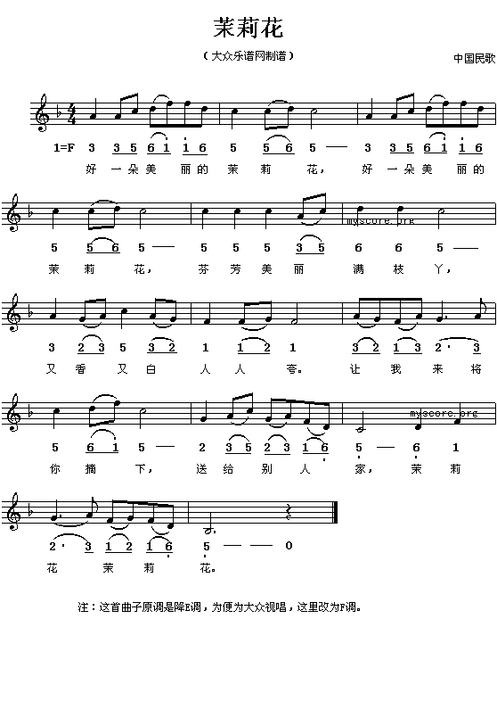
Jasmine Flower (茉莉花)
hǎo yī duǒ měi lì dè mò lì huā, hǎo yī duǒ měi lì dè mò lì huā
好 一 朵 美 丽 的 茉 莉 花, 好 一 朵 美 丽 的 茉 莉 花

fēn fāng měi lì mǎn zhī yá, yòu xiāng yòu bái rén rén kuā
芬 芳 美 丽 满 枝 桠 又 香 又 白 人 人 夸

ràng wǒ lái jiāng nǐ zhāi xià , sòng gěi bié rén jiā , mò lì huā yā mò lì huā
让 我 来 将 你 摘 下, 送 给 别 人 家, 茉 莉 花 呀 茉 莉 花

(Literally;)

A good beautiful jasmine flower
A good beautiful jasmine flower
Sweet-smelling, beautiful, stems full of buds
Fragrant and white, everyone praises
Let me pluck you down
Give to someone
Jasmine flower, oh jasmine flower

(Figuratively;)

Flower of jasmine, oh so fair!
Flower of jasmine, oh so fair!
Budding and blooming here and there,
Pure and fragrant all declare.
Let me take you with tender care,
Your sweetness for all to share.
Jasmine fair, oh jasmine fair.

(on Youtube, there are many version of this song, here is one:

http://www.youtube.com/watch?v=ndxh8LuKLC0 )

