Model no 1

Parameters :

* Input Shape(64,64,3)
* Epoch = 100
* Batch size = 64

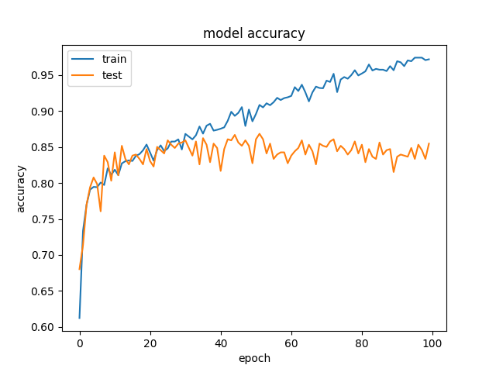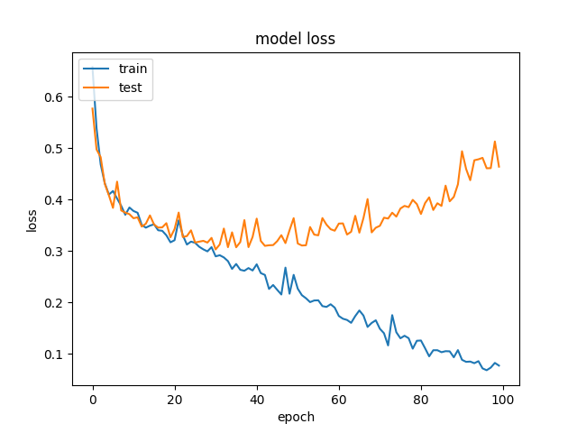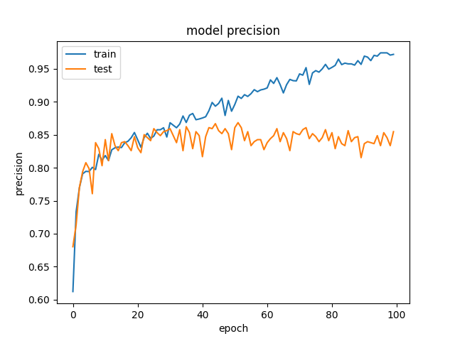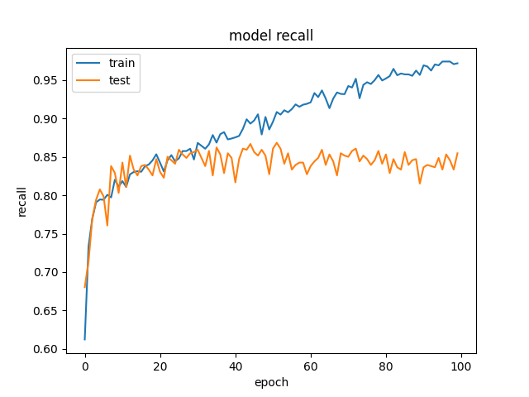

Model no 2

Parameters :

* Input Shape(64,64,3)
* Epoch = 100
* Batch size = 64

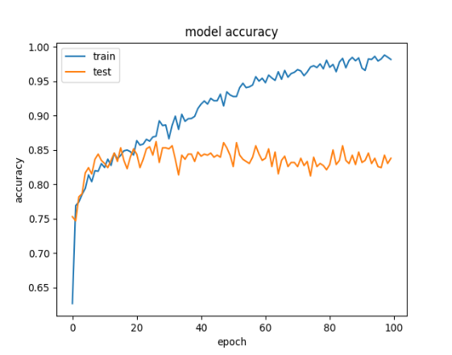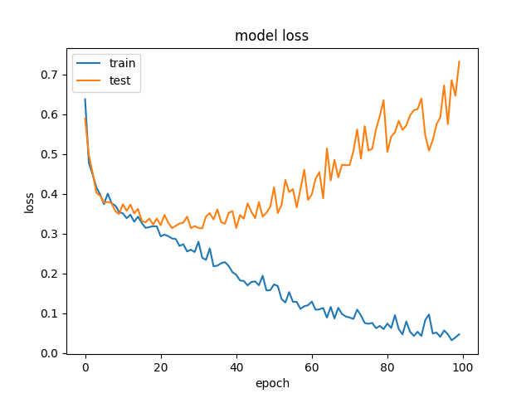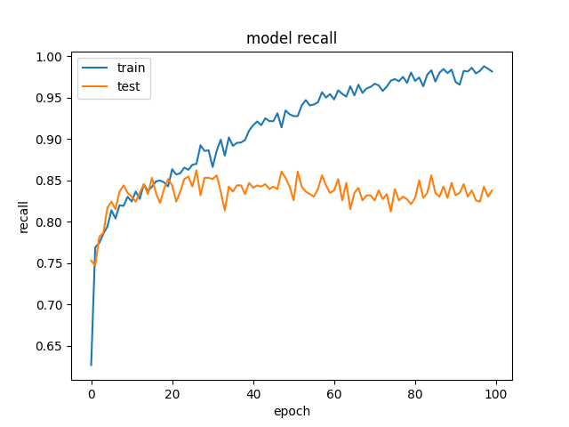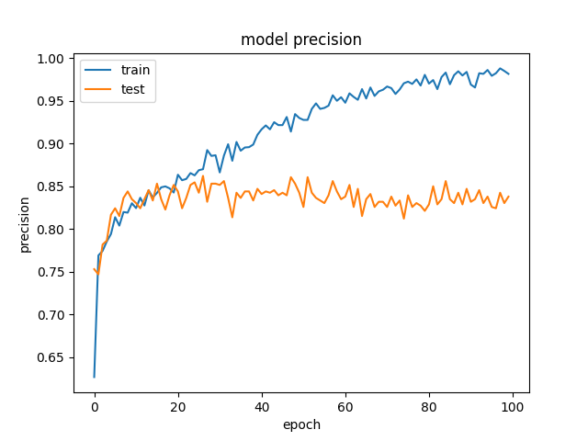

Model no 3

Parameters :

* Input Shape(64,64,3)
* Epoch = 100
* Batch size = 32
* Input filters = 64

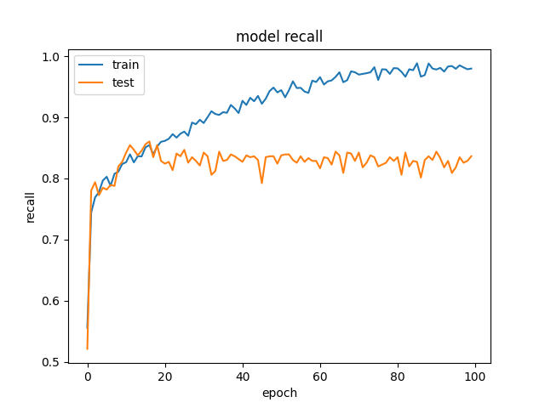2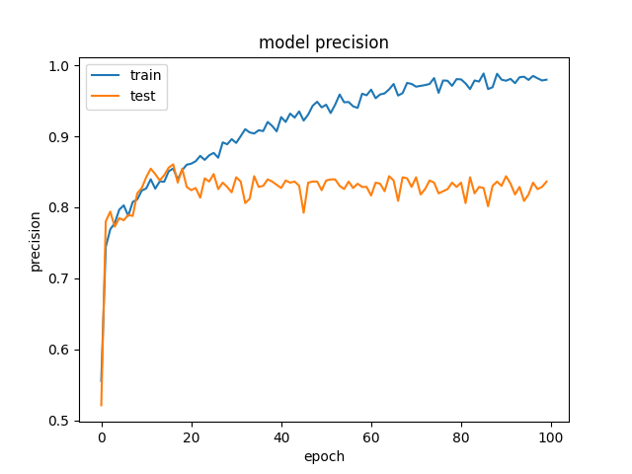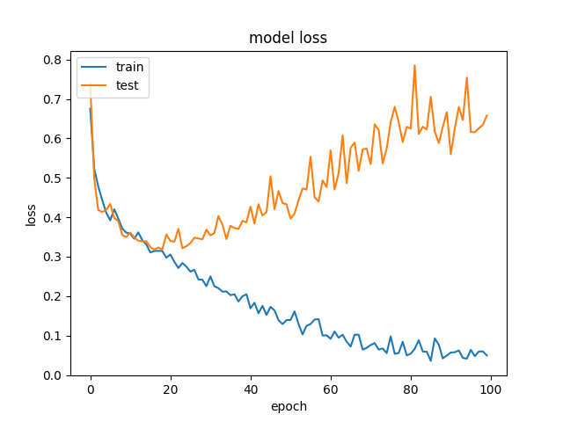2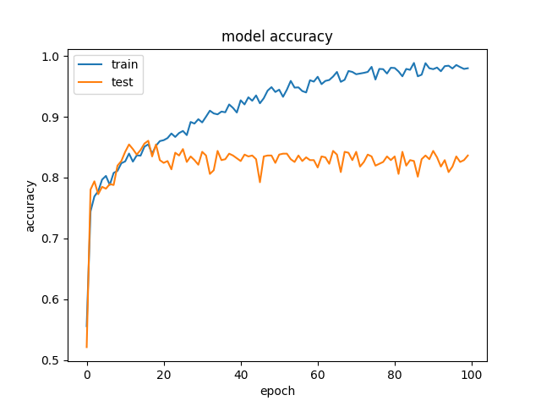

Model no 4

Another conv is add

Parameters :

* Input Shape(64,64,3)
* Epoch = 100
* Batch size = 32
* Input filters = 124

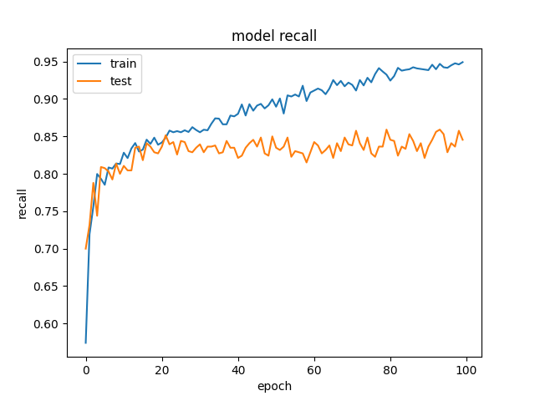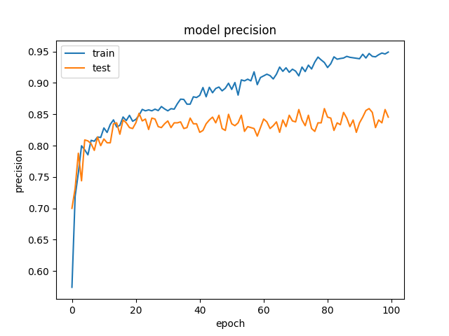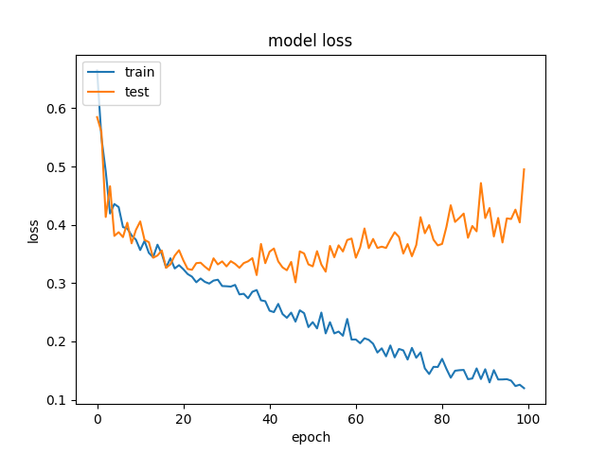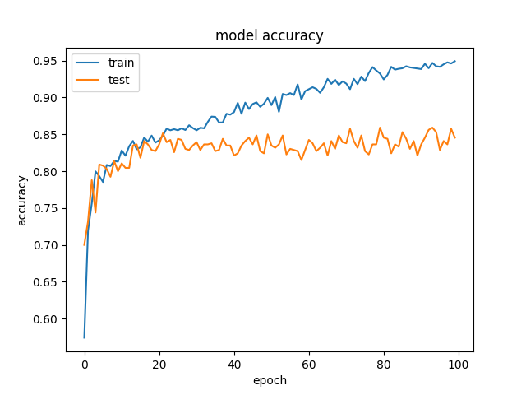

Model no 5

Parameters :

• Input Shape(64,64,3)

• Epoch = 100

• Batch size = 64

• Input filters = 124

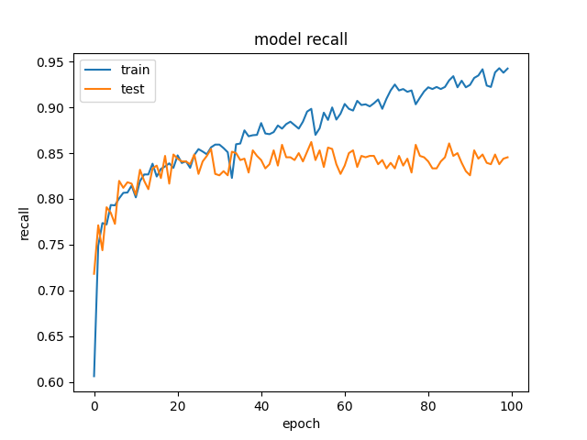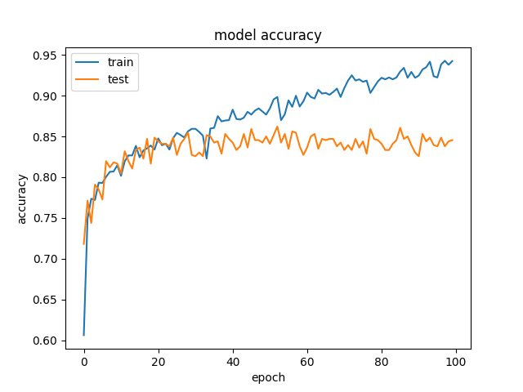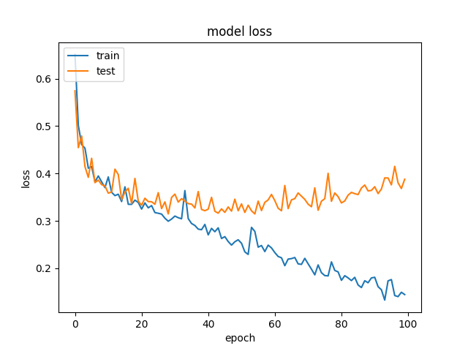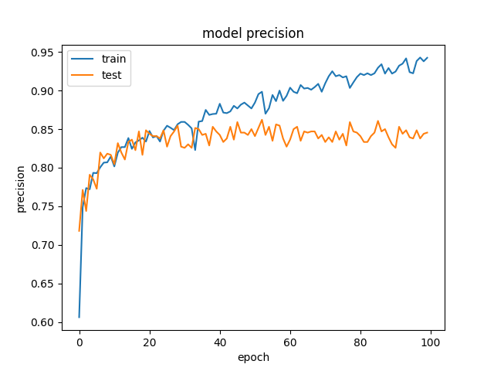

Model no 6

Parameters :

* Input Shape(64,64,3)
* Epoch = 100
* Batch size = 124
* 3 conv layers

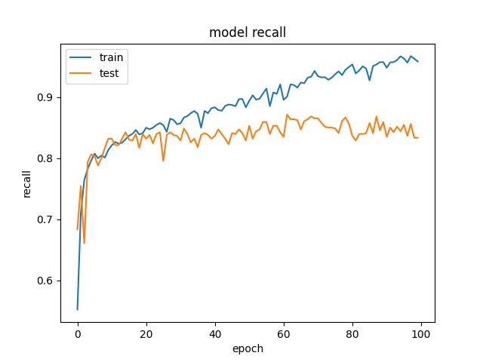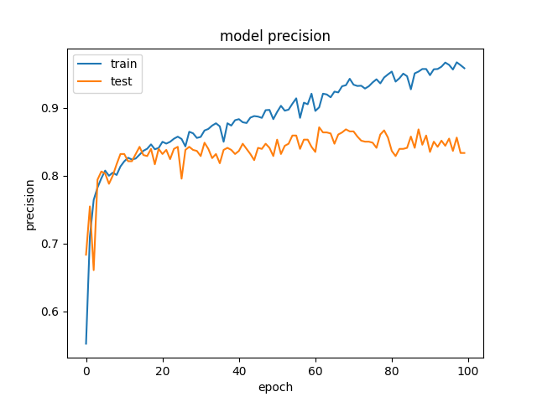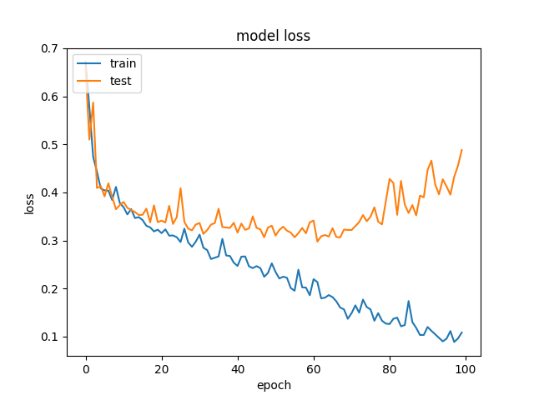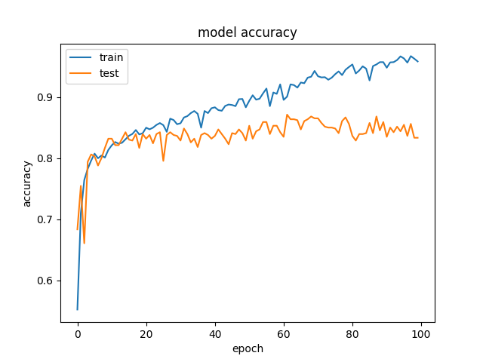

Model no 7

Parameters :

* Input Shape(64,64,3)
* Epoch = 100
* Batch size = 124
* 4 conv layers

Model no 8

Parameters :

* Input Shape(64,64,3)
* Epoch = 100
* Batch size = 124
* 5 conv layers

Model no 9

Parameters :

* Input Shape(64,64,3)
* Epoch = 100
* Batch size = 124
* 5 conv layers (filters = 224)

Model no 6

Parameters :

• Input Shape(64,64,3)

• Epoch = 100

• Batch size = 64

Model no 6

Parameters :

• Input Shape(64,64,3)

• Epoch = 100

• Batch size = 64

Model no 6

Parameters :

• Input Shape(64,64,3)

• Epoch = 100

• Batch size = 64

Model no 6

Parameters :

• Input Shape(64,64,3)

• Epoch = 100

• Batch size = 64

Model no 6

Parameters :

• Input Shape(64,64,3)

• Epoch = 100

• Batch size = 64

Model no 6

Parameters :

• Input Shape(64,64,3)

• Epoch = 100

• Batch size = 64

Model no 6

Parameters :

• Input Shape(64,64,3)

• Epoch = 100

• Batch size = 64

Model no 6

Parameters :

• Input Shape(64,64,3)

• Epoch = 100

• Batch size = 64

Model no 6

Parameters :

• Input Shape(64,64,3)

• Epoch = 100

• Batch size = 64

Model no 6

Parameters :

• Input Shape(64,64,3)

• Epoch = 100

• Batch size = 64

Model no 6

Parameters :

• Input Shape(64,64,3)

• Epoch = 100

• Batch size = 64

Model no 6

Parameters :

• Input Shape(64,64,3)

• Epoch = 100

• Batch size = 64

Model no 6

Parameters :

• Input Shape(64,64,3)

• Epoch = 100

• Batch size = 64