Boby parts of elephant

This is a ear.

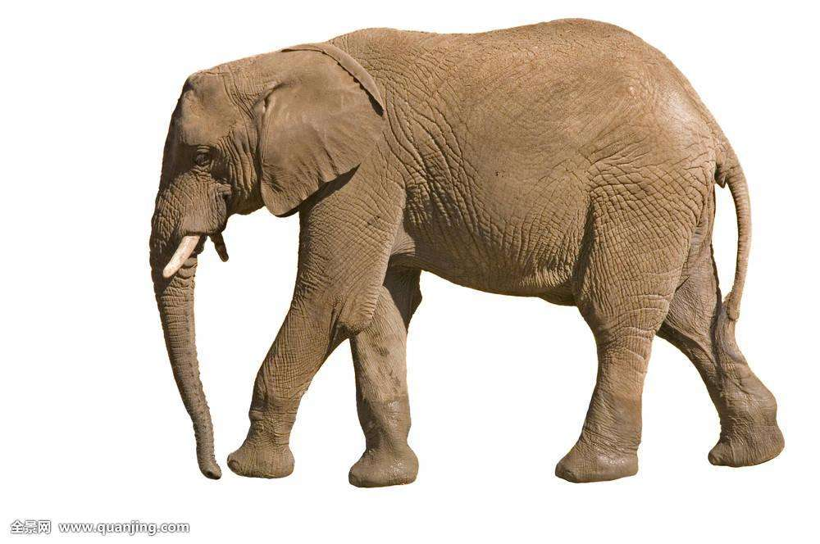

This is a tail

These are legs.

This is a trunk.