美国和中国

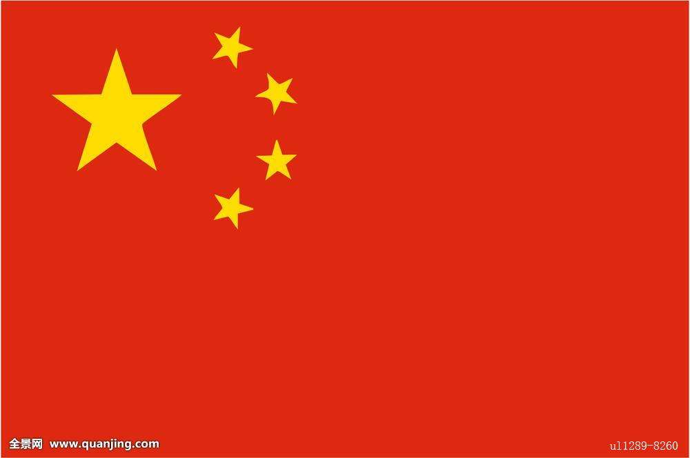

**China** **America**

|  |  |  |  |  |
| --- | --- | --- | --- | --- |
| Different Things | Name in China | | Name in America | |
| Language | Chinese | 你好！ | English | Hello! |
| Food | In north    Noodles | In south    Rice | Bread | |
| Celebrations | Chinese New Year | | Christmas | |

之间的差异

