Example RMarkdown Document

Anonymous

2024-06-03

# Introduction

This is a combined example RMarkdown document that incorporates elements from various examples.

## Code Chunks

I can execute R code chunks like this:

# Create a vector of numbers  
x <- 1:10  
  
# Print the vector  
print(x)

## [1] 1 2 3 4 5 6 7 8 9 10

# Create a plot  
plot(x, x^2, type = "l", col = "blue", main = "Example Plot", xlab = "X", ylab = "X^2")

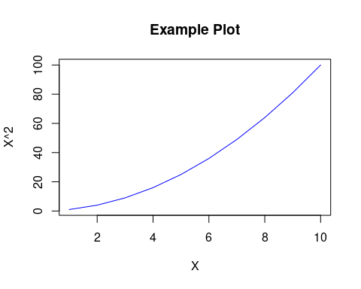

# Create a simple data frame  
df <- data.frame(  
 Name = c("Alice", "Bob", "Charlie"),  
 Age = c(30, 25, 35)  
)  
  
# Print the data frame  
print(df)

## Name Age  
## 1 Alice 30  
## 2 Bob 25  
## 3 Charlie 35