Sample Quarto Document

## R Code Chunk

# R code chunk  
# Generate some random data  
set.seed(123)  
x <- rnorm(100)  
y <- rnorm(100)  
  
# Scatter plot  
plot(x, y, main = "Scatter Plot", xlab = "X", ylab = "Y")

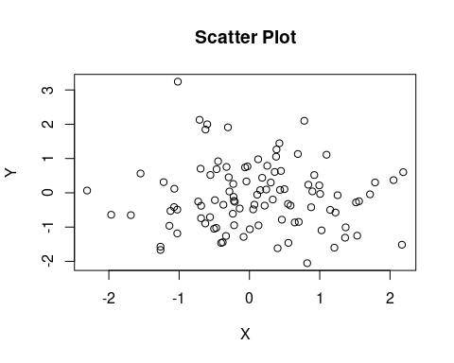

## Python Code Chunk

# Python code chunk  
import numpy as np  
import matplotlib.pyplot as plt  
  
# Generate some random data  
np.random.seed(123)  
x = np.random.randn(100)  
y = np.random.randn(100)  
  
# Scatter plot  
plt.scatter(x, y)  
plt.title("Scatter Plot")  
plt.xlabel("X")  
plt.ylabel("Y")  
plt.show()

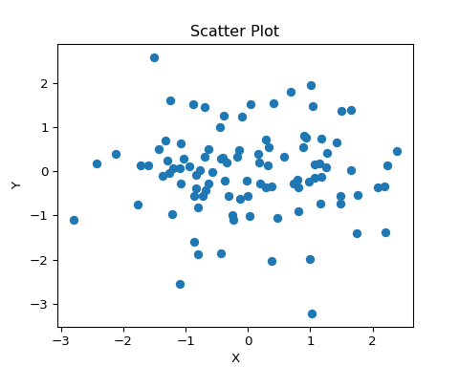

This document contains both R and Python code chunks demonstrating basic data generation and plotting.