Short 10-1 Add figures, icons, fonts, and custom colors to a page
In this exercise, you’ll use some of the skills presented in chapter 10 to update a page. When you’re done, the page should look like the one shown below. Estimated time: 10 to 20 minutes.
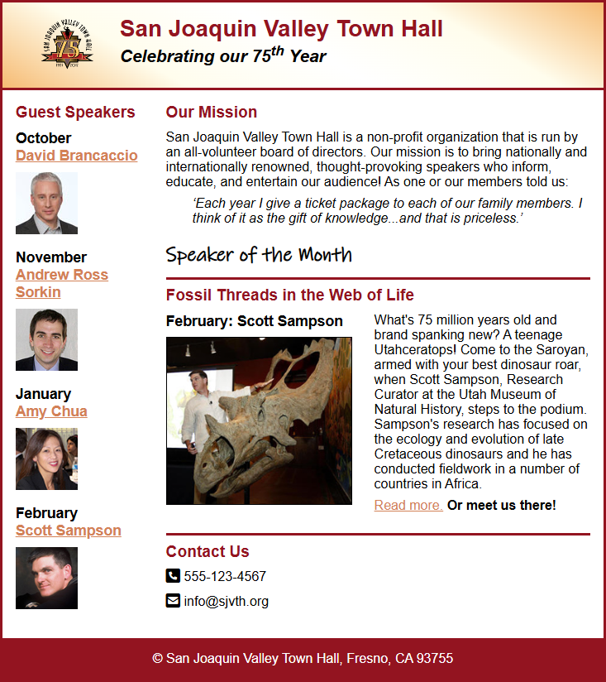
- Open the HTML and CSS files that follow and display the page in a browser:

short_exercises\ch10\index.html
short_exercises\ch10\styles\main.css
- Modify the HTML so it uses a figure to display the article image with a caption above it.
- Modify the CSS so the text flows around the figure properly and the figure is displayed to the left of the text.
- Add Font Awesome icons to the list items in the Contact Us section.
- Make the color of the links in the main content a mix of the accent color (65%) and the primary color (35%).
- Use the Ink Free Regular font that’s in the fonts subfolder for the <h1> element. If you don’t like that font, use a font from your computer. Or, use a font that’s available from Google Fonts.

