S CUBE FOUNDATION
Website Requirements

SECTION 1 — HEADER
- Logo: S Cube Foundation Tagline below logo: "Serving with Purpose. Transforming Lives."

- Navigation menu:

Navigation Menu: Home | About Us | Our Work | Get Involved | Contact Us

Reference - Akshaya Patra-NGO in India Supporting Food & Education of Children

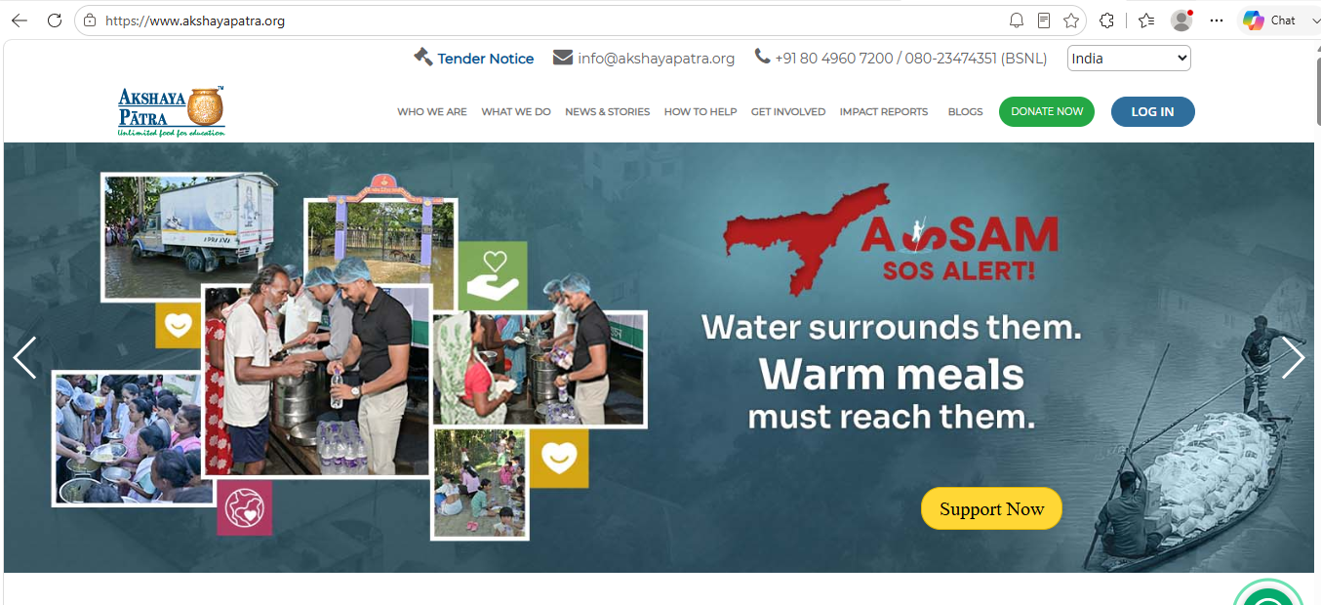

SECTION 2 — HERO BANNER

Large image/video slider

Headline:
Building Healthier Communities Through Sustainable Action

Subheading:
Healthcare • Environment • Education • Community Development

Buttons:
- Learn More
- Contact Us

Section 3 - WHO WE ARE

About S Cube Foundation
Short introduction

Building Healthier Communities Through Sustainable Action
S Cube Foundation is a community-focused non-profit organization based in Dharwad, Karnataka, dedicated to improving lives through preventive healthcare, environmental conservation, education, and sustainable community development. We believe that meaningful change begins with understanding local needs, empowering communities, and creating practical solutions that deliver lasting impact.
Through health camps, environmental initiatives, awareness programmes, school engagement, employee wellness campaigns, and village development projects, we strive to build healthier, cleaner, and more resilient communities.

Who we are
S Cube Foundation is committed to creating positive social impact by working closely with local communities, educational institutions, healthcare professionals, government bodies, corporate partners, and volunteers. Our initiatives focus on prevention, awareness, and sustainable development rather than one-time interventions.
We believe that every individual deserves access to better health, a cleaner environment, quality awareness, and opportunities to thrive. By combining professional expertise with community participation, we aim to develop practical solutions that continue to benefit people long after each programme is completed.

Our Mission
To improve the quality of life in communities by promoting preventive healthcare, environmental responsibility, education, and community participation through sustainable, inclusive, and impactful initiatives that empower people to lead healthier and more fulfilling lives.

Our Vision
To build healthier, cleaner, and more self-reliant communities where every individual has access to opportunities for better health, environmental sustainability, education, and social wellbeing, creating a lasting positive impact for future generations.

Together, we can create healthier communities and a more sustainable future.
Learn More About Our Journey → Read More (About Us Page)
S Cube Foundation was established with a simple belief—that lasting change is created through consistent community engagement rather than isolated interventions. We work with individuals, schools, villages, workplaces, healthcare professionals, government institutions, and corporate organizations to design initiatives that address real community needs.
Our work spans preventive healthcare, employee wellness, environmental conservation, educational awareness, village development, and community empowerment. Every programme is planned with a focus on sustainability, measurable outcomes, and community ownership.
One of our long-term flagship initiatives, Gramodaya, reflects this commitment by working alongside villages to develop sustainable solutions in healthcare, environmental conservation, education, women and youth empowerment, and overall community development.
As we continue to grow, our goal is to become a trusted partner for communities, institutions, and organizations seeking to create meaningful and lasting social impact through collaboration, innovation, and service.

Reference - Akshaya Patra-NGO in India Supporting Food & Education of Children
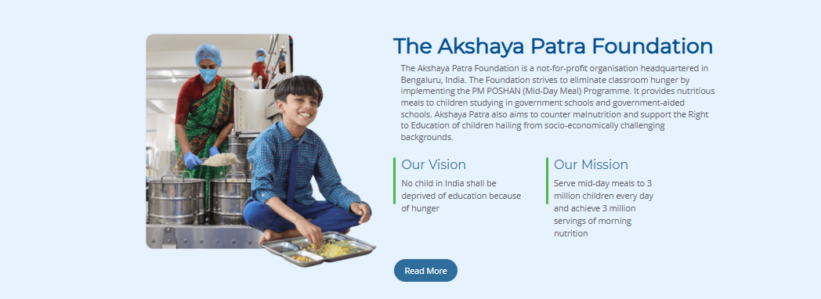

Our Focus Areas
Cards with icons

each card clickable. When a visitor clicks Healthcare, they should be taken to a dedicated page showcasing:
- Medical camps
- Employee health & wellness programmes
- Health awareness campaigns
- Preventive screening initiatives
Similarly, Environment can showcase:
- Cleanliness drives
- Tree plantation activities
- Plastic reduction campaigns
- School environmental programmes

Creating Sustainable Impact Across Communities
Our initiatives are designed to address the key challenges affecting individuals and communities through practical, sustainable, and people-centred solutions.

🩺 Healthcare
Promoting preventive healthcare through medical camps, health screenings, awareness programmes, employee wellness initiatives, and improved access to quality healthcare services.

🌿 Environment
Building cleaner and greener communities through tree plantation drives, cleanliness campaigns, waste management awareness, plastic reduction initiatives, and environmental conservation.

📚 Education
Empowering children and communities through educational support, health awareness programmes, life skills education, school engagement activities, and capacity-building initiatives.

👩 Women Empowerment
Supporting women through health awareness, skill development, financial literacy, leadership opportunities, and programmes that promote dignity, independence, and equal participation.

🌟 Youth Development
Inspiring young people to become responsible leaders through volunteering, community engagement, leadership development, career guidance, environmental action, and social responsibility programmes.

❤️ Elderly Care
Enhancing the wellbeing of senior citizens through health check-ups, awareness programmes, social engagement activities, and initiatives that promote healthy and dignified ageing.

🏘️ Community Development
Working alongside communities to identify local needs and implement sustainable initiatives that improve health, sanitation, education, environmental awareness, and overall quality of life through collaborative action.

Reference - Leading NGO for Education, Health & Empowerment | Smile Foundation
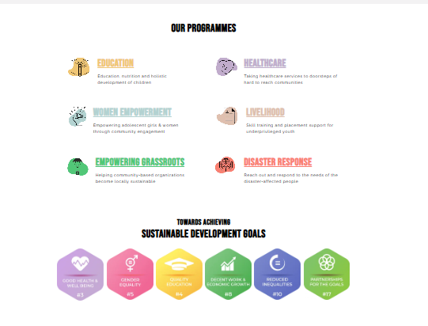

Section 4: Our Impact

Making a Difference, One Initiative at a Time
Every health camp, awareness programme, and community initiative brings us closer to building healthier and stronger communities. Our impact continues to grow through the support of healthcare professionals, volunteers, institutions, and community members.

👨‍⚕️ 300+
Lives Screened

🌳 100+
Trees Planted

🏥 5+
Health & Community Camps

🏫 2+
Schools Engaged
250+ Students Reached

🤝 10+
Community Partnerships
👥 50+
Volunteers & Supporters

Reference - Akshaya Patra-NGO in India Supporting Food & Education of Children

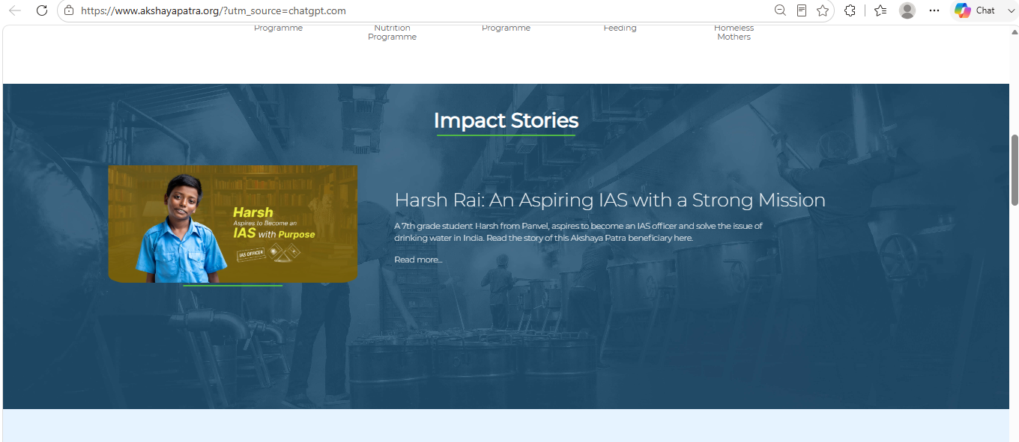

SECTION 5- Featured Initiatives

• Latest Activities - Each card should include:
- Photo
- Title
- Short description
- Read More

Show the latest 3–6 activities with photos, such as:
- World Environment Day Tree Plantation
- School Green Club Initiative
- Community Health Screening Camp
- Employee Wellness Camp
- Cleanliness Drive

SECTION 6 Partners & Collaborators
Include logos or names of organizations you've worked with, such as:
- S Cube Clinic & Diagnostics
- Schools
- Gram Panchayats
- BPCL (once collaboration is confirmed)
- Other hospitals or organizations

Our Partners & Collaborators
We believe meaningful change is achieved through collaboration. We are grateful to the organizations, institutions, healthcare professionals, volunteers, and community leaders who support our mission.

Section 7 : Get Involved
Be a Part of the Change
Whether you're an individual, school, company, healthcare professional, or volunteer, your support can help create healthier and more sustainable communities.
Buttons:
- Volunteer With Us
- Partner With Us
- Organize a Health Camp
- Contact Us

Partner With S Cube Foundation

Section 8 Contact & Footer

Reference
Both Smile Foundation and Akshaya Patra.
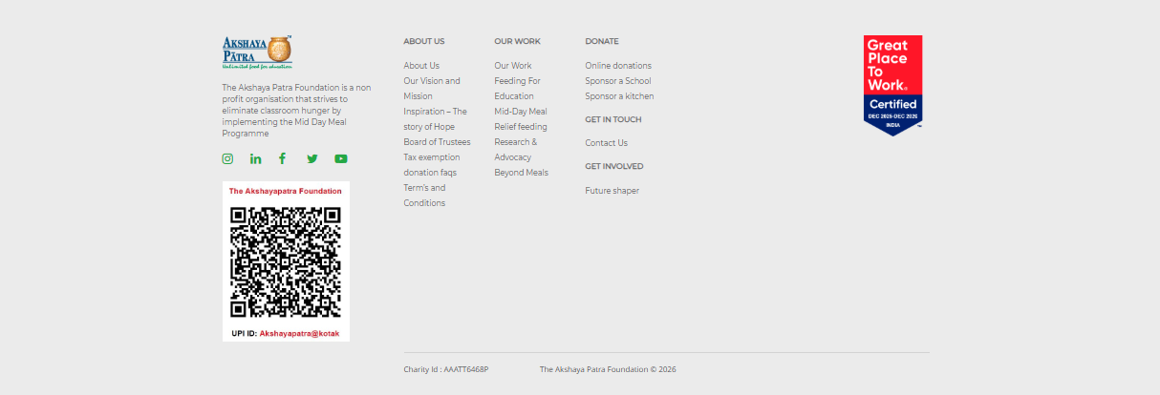
Include
Address
Phone
Email
Google Map
Social Icons
Quick Links

"Make it look like a professional organization rather than a charity."
The design should feel like a blend of:
- Corporate professionalism (clean, trustworthy, organized)
- Healthcare (blue, white, reassuring)
- Community impact (warm imagery, real people)
- Government collaboration (credible and structured)

