Dual-Laser PDH Driver
Two-channel CW 1550 nm DFB laser + TEC driver for differential ring-resonator thermometry • Project summary, rev 3 (RF derivative lock)

What the instrument does
The driver locks two independent DFB lasers, one to each of a pair of 1550 nm ring resonators that sit on a single silicon die separated by a thermal barrier. Each laser is held on its ring’s transmission slope by a closed feedback loop. The measured quantity is the optical beat between the two locked lasers, which is a direct, ratiometric readout of the local temperature difference across the barrier:
Δν = ν_B − ν_A = S·(T_B − T_A), with S = dν/dT ≈ 2 GHz/K
Because the result is a material-defined ratio, the scale factor and all slow common-mode drifts cancel, so absolute accuracy and long-term reproducibility are not required. The figure of merit is within-window stability over ~60 s, projected at the single-to-low-tens of nanokelvin level. Each laser channel comprises a precision current source with low-side Kelvin current sensing, a thermo-electric cooler loop with thermistor and current sensing, and a 1–3 MHz analog derivative lock (RF current modulation → wideband transimpedance amplifier → synchronous demodulator → analog PI servo). An embedded microcontroller supervises acquisition, calibration, and telemetry.
Optical interfacing. Each laser delivers light over an FC/APC (angled) single-mode fiber connector, chosen to suppress back-reflection into the DFB source; the beat photodetector terminates in an FC/PC fiber connector. The photodetector converts ring output power to current as I_pd = ℛ·P_opt (responsivity ℛ ≈ 1 A/W), and its handling limit caps the usable power out of the microrings: P_opt ≤ P_max ≈ 18 mW (detector damage threshold). This sets the optical-power budget for the ring outputs feeding the beat path.
Measurement setup
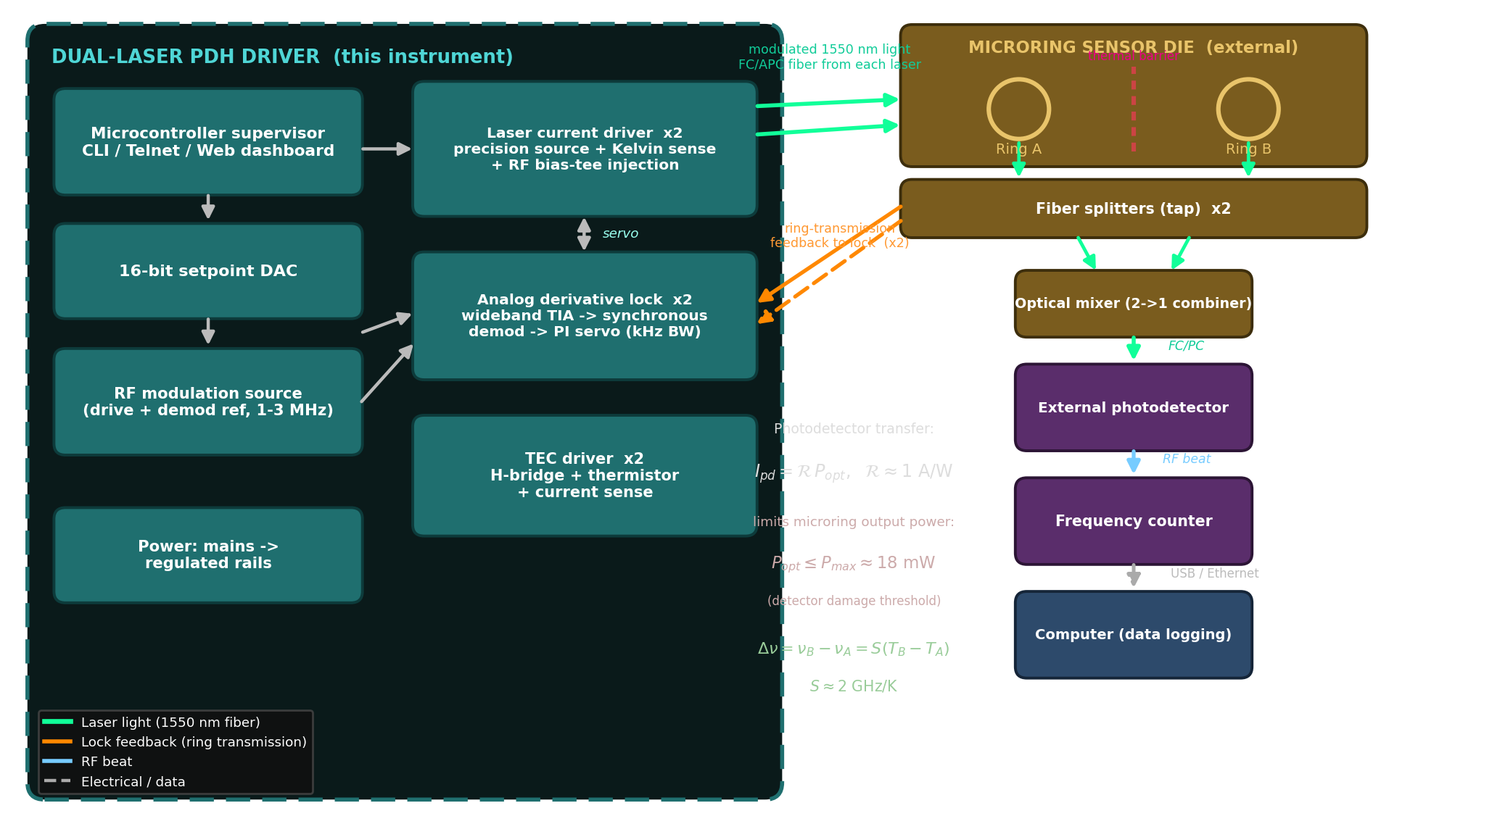
Each laser is current-locked to its microring via the ring-transmission feedback path. A fiber splitter and an optical mixer sit inline with the microring outputs: the splitters tap each ring output for the lock feedback, and the through arms are combined in the 2→1 mixer onto the external photodetector. The resulting RF beat is read by a frequency counter whose output goes to an external computer for logging — not back into the instrument. The two channels run at slightly different modulation frequencies so modulation crosstalk stays out of the differential beat.
Estimated build cost
Item | Detail | Qty | Est. cost (USD)
Board electronics (DigiKey-orderable) | Op-amps, DACs, DDS, TIAs, mixers, regulators, passives | 1 set | $552
DFB laser modules | 1550 nm CW butterfly laser, FC/APC fiber output | 2 | $3,600
Fiber photodiodes | InGaAs fiber photodiode, FC/PC connector | 2 | $240
Bare parts subtotal |  |  | $4,392
PCBs | Fabrication + assembly allowance |  | $1,000
Mechanical fixture / enclosure | Optical mounting + chassis allowance |  | $1,000
ESTIMATED TOTAL |  |  | $6,392
Small-quantity estimates from the KiCad-derived BOM (15 hierarchical sheets). The two DFB laser modules dominate cost; board electronics are a small fraction of the total.

Control software & operator interface

The instrument is driven by embedded microcontroller firmware that acts as a supervisor over the analog lock hardware. Per channel it programs the modulation and phase-reference oscillators, sweeps the DC setpoint to acquire the cavity (a coarse TEC/temperature scan finds the mode, a fine laser-current scan walks onto the peak), auto-calibrates the demodulation phase, hands the loop to the analog PI servo, and continuously monitors the post-mix error signal and lock quality. A built-in simulation (demo) mode reproduces the full acquire-and-lock behaviour with no hardware attached. The same control surface is exposed three ways:
USB-serial / Telnet CLI — text command console (also embedded in the web page and the front panel). HTTP dashboard — live browser UI on port 80. On-board TFT — small read-only status display.
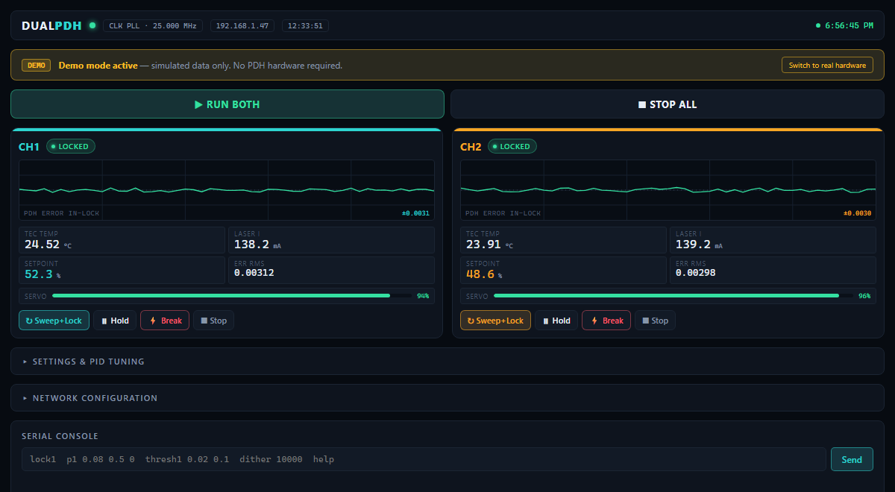 | 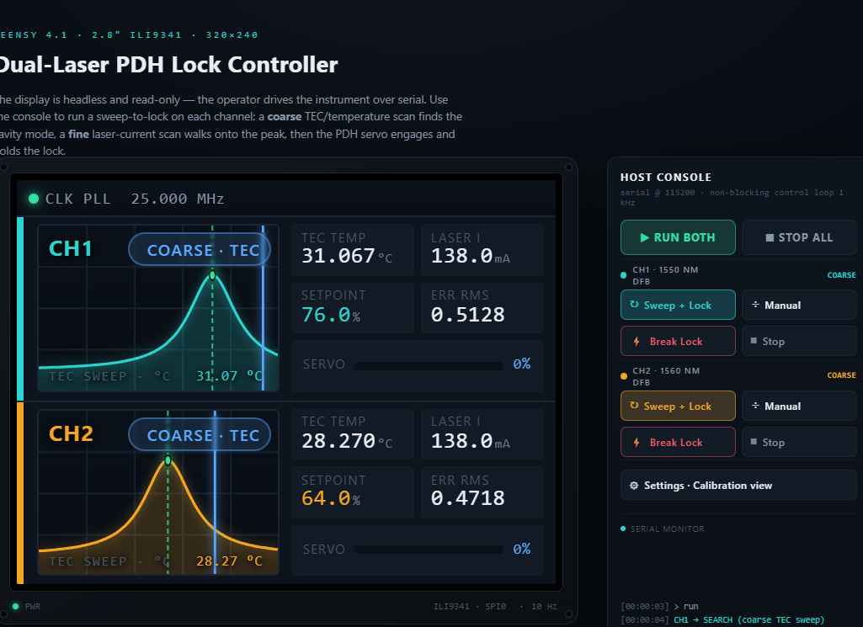
Web dashboard: per-channel error trace, TEC temperature, laser current, setpoint, servo health, lock state, and an embedded serial console. | On-board TFT: coarse/fine scan view and live lock status for both channels.
Basic interface functions
Command | Function
lock1 / lock2 | Start the sweep-and-lock acquisition sequence on a channel
stop1 / stop2 | Return a channel to idle (outputs to safe midscale)
hold1 / hold2 | Freeze the servo and outputs at their current values
break1 / break2 | Deliberately break the lock and re-enter the relock search
omega1 / omega2 <Hz> | Set the RF modulation frequency per channel (100 kHz - 3.5 MHz)
phase1 / phase2 <deg> | Set the demodulation reference phase
cal1 / cal2 | Auto-calibrate the demod phase for maximum error-signal slope
thresh1 / thresh2 <l> <a> | Set capture / loss thresholds for lock detection
s / status | Print full telemetry (state, error RMS, temp, currents, gains)
d | Raw ADC dump of all monitor channels
demo on / demo off | Toggle hardware-simulation vs. real-hardware mode (saved to EEPROM)
netset / netinfo / netreset | Configure and apply DHCP/static IP, gateway, and mDNS hostname
Graphical controls on the web dashboard and front panel map onto the same commands: Run Both / Stop All, and per-channel Sweep+Lock, Hold, Break, and Stop, plus collapsible panels for PID/threshold tuning and network configuration. Lock state is colour-coded (search → acquire → locked / relock) on every interface.
Generated 2026-06-05 from the laser_driver_v3 KiCad project, BOM, and controller firmware. Costs are small-quantity estimates for budgeting only.

Uncertainty budget (this design)
Differential ring-resonator thermometer • ratiometric, within-60 s window • RF analog-derivative lock

The measurement is a ratio defined by the die material (Δν = S·ΔT, S ≈ 2 GHz/K), acquired over a ~60 s window. Because it is ratiometric, the scale factor and every slow common-mode term cancel, so the figure of merit is within-window stability — the Allan deviation at τ ≈ 60 s, expressed as an equivalent differential temperature. The budget below is for this design only: the 1–3 MHz analog-derivative (RF) lock. All entries are 1σ per channel; terms flagged cancels drop out of the ratio and do not enter the result.
Within-window budget at τ = 60 s — RF analog-derivative lock
Contributor | In the ratio | σν @ 60 s | Equiv. ΔT
Detection / discrimination noise | kept | 2.6 Hz | 1.3 nK
Residual laser FM (above loop BW) | kept | 6.0 Hz | 3.0 nK
RIN → lock-point pulling (in-band) | kept | 5.0 Hz | 2.5 nK
In-band RAM (flicker) | kept | 20.0 Hz | 10.0 nK
Carrier-modulation smear | kept | ~0 | ~0
Timebase short-term | kept | 0.01 Hz | ~0
RAM slow drift | cancels | (387 Hz) | (194 nK)
Thermal common-mode leakage | cancels | (232 Hz) | (116 nK)
Strain / mount creep | cancels | (155 Hz) | (77 nK)
Combined (ratiometric) @ 60 s | — | 21.6 Hz | 10.8 nK
Kept terms add in quadrature to the combined result; the cancelled terms (shown in parentheses) are large but are common-mode and removed by the ratio. In-band RAM dominates the surviving budget. If the residual amplitude modulation is slower than the 60 s window it too cancels and the floor drops to ~4 nK; with ~20 Hz of in-band flicker RAM the floor is ~11 nK. Measuring the RAM spectrum early is the key open item that fixes where in this 4–11 nK band the instrument lands.
Beat-frequency Allan deviation
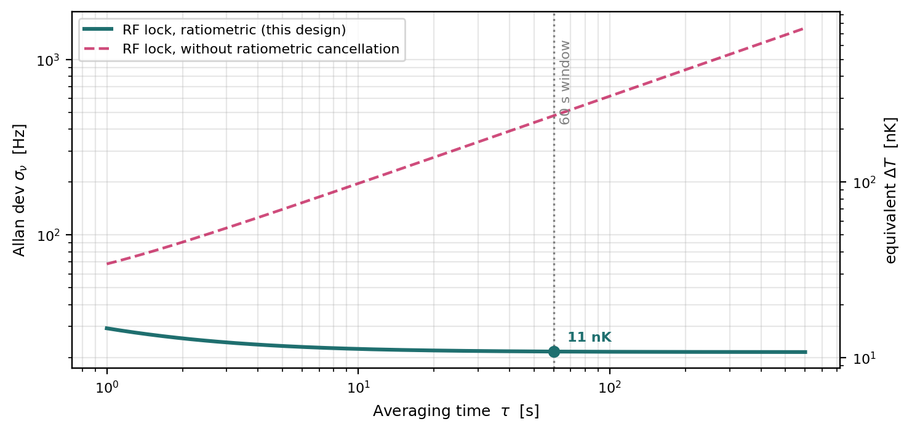
Solid: this design (RF lock) with ratiometric cancellation — the curve stays flat across the 60 s window at the low-nanokelvin floor. Dashed: the same lock without ratiometric cancellation, where slow common-mode terms re-enter as a random-walk upturn (hundreds of nK by 60 s). The ratiometric, same-die measurement is what makes the low-nK figure reachable without an absolute frequency reference.
Operative result: with ratiometric cancellation the within-window spec is ~4–11 nK at τ ≈ 60 s, set by in-band RAM. Reproduced from the project differential-thermometer uncertainty budget (1σ, S ≈ 2 GHz/K).

