** UC Schedule**

Developed by:

Arthur Johnson and Matthew Scurry

**What does this app do?**

The UC Schedule Android app will import your current class schedule and put it into the calendar on your phone.

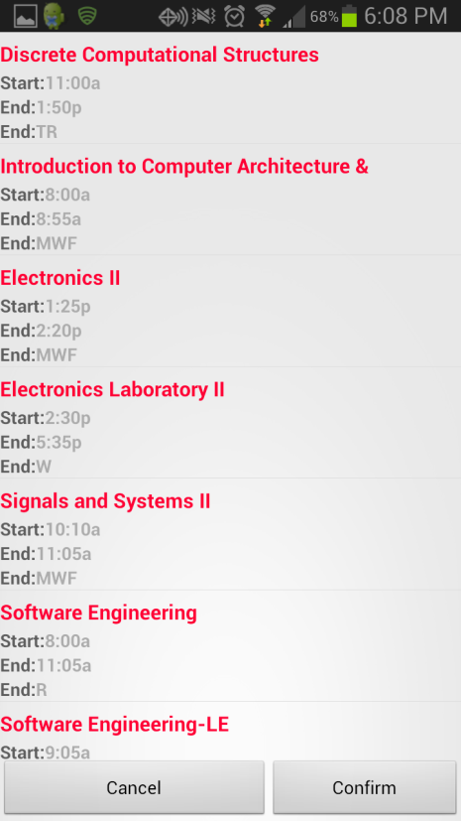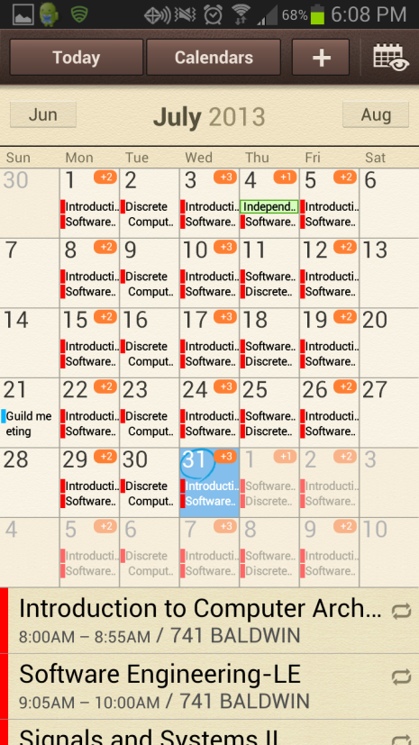

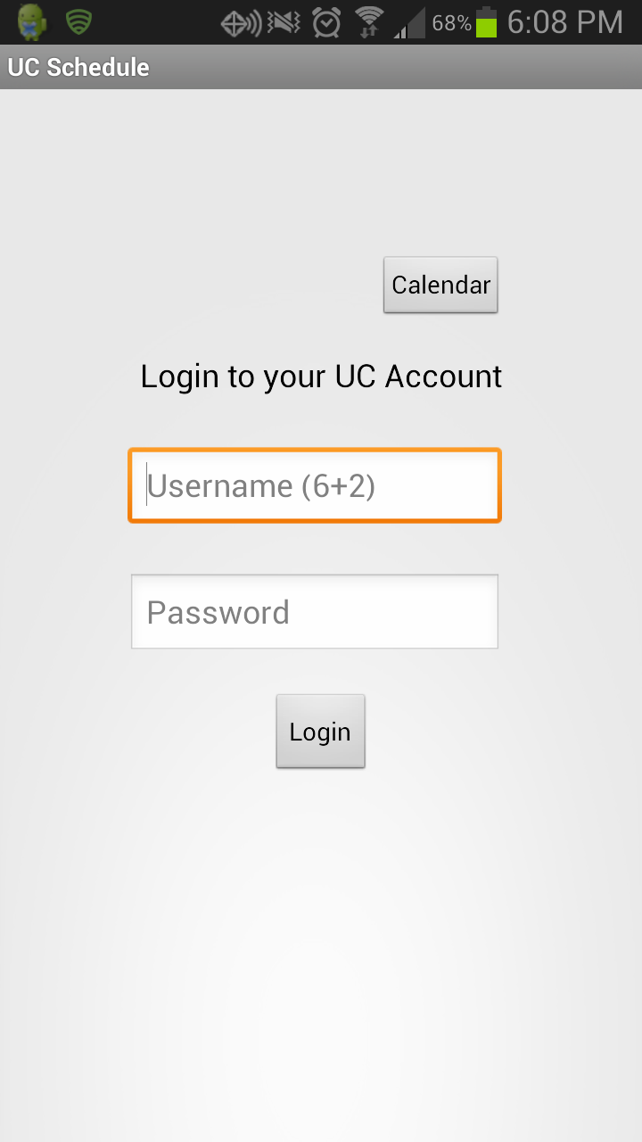

Adding classes to your calendar manually can be very time consuming. With our app, you can add your classes to your calendar with just a few clicks.