**UC Schedule**

**Specifications Document**

**Ver. 1.1**

**Application Name:**

System Metaphor: Calendar

Authors: Matthew Scurry, Arthur Johnson

**Use Case Diagram:**

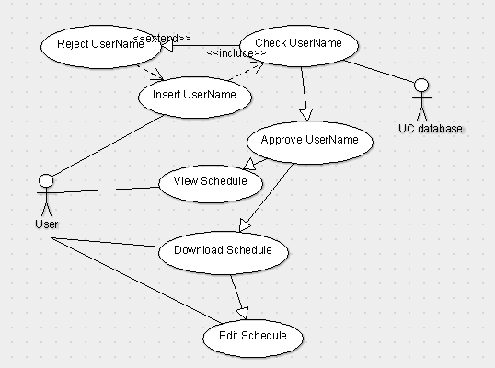

**User Stories:**

Pre-alpha Release 0.1:

* The user will need to login to the UC database with their credentials in order to access their schedule.