1、概述

2、系统概念数据模型：ER模型

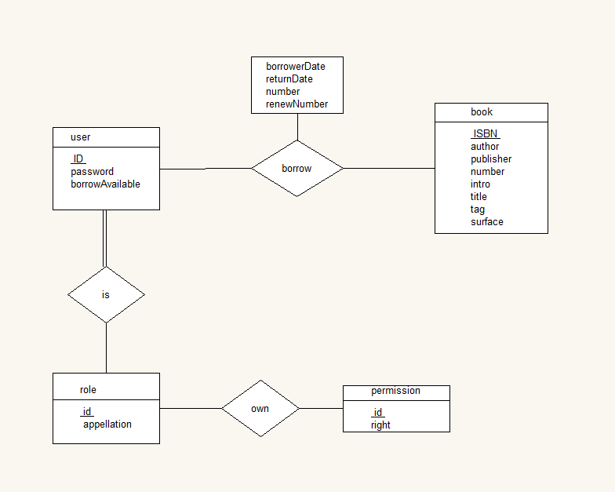

3、系统逻辑数据模型：（可以不写）

4、系统物理数据模型：数据库表

book

|  |  |  |  |  |  |  |  |
| --- | --- | --- | --- | --- | --- | --- | --- |
| ISBN | author | publisher | number | intro | title | tag | surface |
|  |  |  |  |  |  |  |  |

user

|  |  |  |  |
| --- | --- | --- | --- |
| ID | password | borrowAvaiable | role_id |
|  |  |  |  |

role

|  |  |
| --- | --- |
| id | appellation |
|  |  |

own

|  |  |
| --- | --- |
| role_id | permission_id |
|  |  |

permission

|  |  |
| --- | --- |
| id | right |
|  |  |

borrow

|  |  |  |  |  |  |
| --- | --- | --- | --- | --- | --- |
| ID | ISBN | borrowDate | returnDate | number | renewNumber |
|  |  |  |  |  |  |

系统数据字典：

|  |  |  |  |  |  |
| --- | --- | --- | --- | --- | --- |
| 数据名称 | 数据业务描述 | 业务数据类型 | 所属表格 | 对应的字段 | 字段类型 |
|  |  |  |  |  |  |
|  |  |  |  |  |  |

备注：前3列来自需求，后3列来自设计