South China University of Technology
《Introduction to Pattern Recognition》Experiment Report
Experiment Title： Neural Network Implementation
Name： 陈浩鑫 Student ID： 201530311042
Class： 15计科一班 Group： null
Collaborator：
Teacher： S. Wu
Description
【Objective and Requirement】
Objective： Employ the Back-Propagation (BP) algorithm to update a neural network, and apply the trained network to a classification task (XOR problem).

Requirement：Implement the BP algorithm, evaluate the trained network, and investigate the effectiveness of the model parameters on the classification result.

【Environment】
Operating System：Windows 10, C++
Content
【Procedure】
- Problem
1.Complete the function of forward-propagation and back-propagation in code
2.Change the value of hyperparameters—learning_rate (0.01, 0.1, 1, 10) and HN(num. of hidden units, 1,2,3,5,10) respectively, analysis the influence
3.(Optional) modify the code by replacing the active function with relu function(𝑓(𝑥)=max⁡(0,𝑥)))

- Method description
Fully connected network represents a neural network with all neurons between neighbour layers connected to each others
Input Layer(colored in blue): accept and send input data (usually with identical output as input), here we have a 2-dim vector as input layer:
Hidden Layer(colored in orange)
Output Layer(colored in red)
Loss Function(represented as 𝐽(∙), 𝑦 is the output from network)
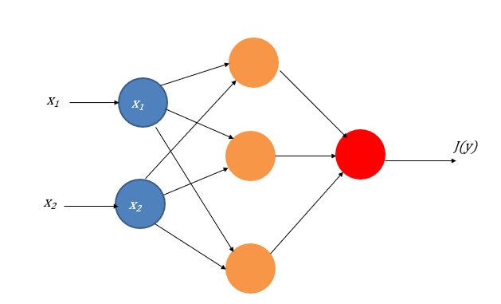
IN : input_layer
HN:hidden_layer
ON:output_layer

forward-propagation

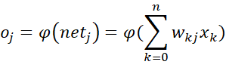
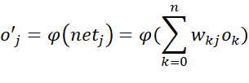
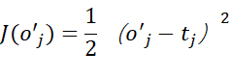
active function: Sigmoid Function

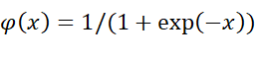
Relu function
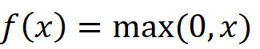

back-propagation:
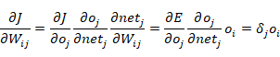

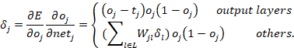

- Experimental results
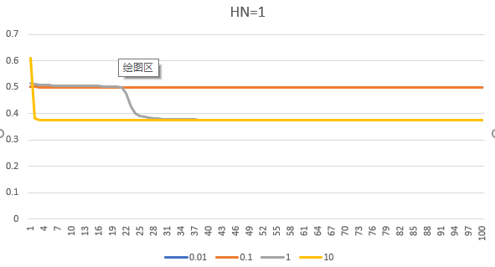
The nn(hidden unit = 1) could not fit the XOR problem well.
The bigger learning rate that nn have, The loss function conver faster .
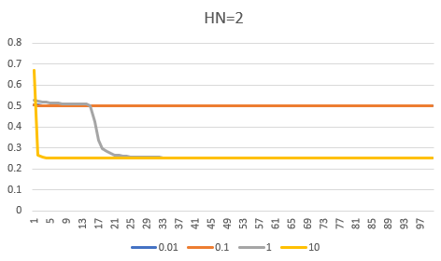
The nn(hidden units = 2) could not fit the XOR problem well.
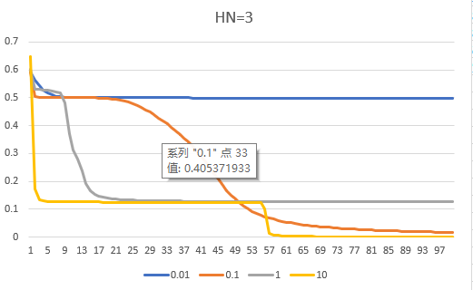
The nn(hidden units = 3) could fix the XOR problem well.
The learning rate in 1 have a jump to a better result after 5700 epochs.
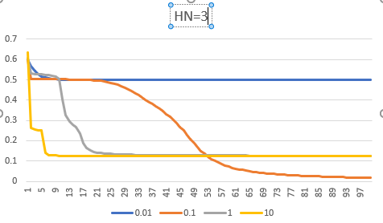
Bigger Learning rate may no optimal loss fuction well.
The final result of 0.1 learning rate better than 1!

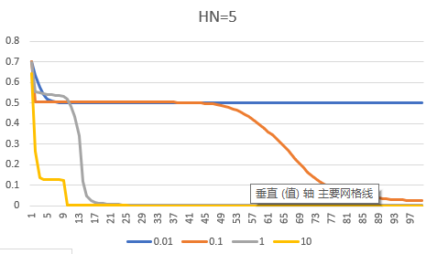
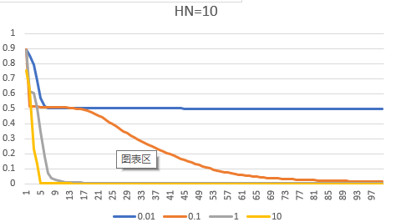
The result of 10 hidden units is the best in this experiment
HN = 1(the best we get)
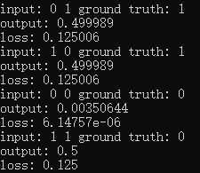
Loss = 0.125
HN = 2(the best we get)
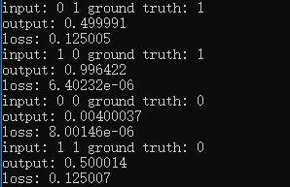
Loss = 0.125
HN = 3 learning rate = 0.1
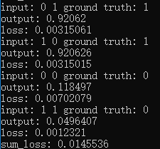
Loss = 0.0145
HN = 5,learning rate = 1
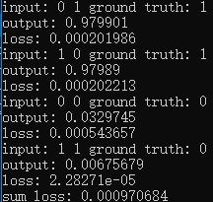
Loss = 0.0009
HN = 10 learning rate = 10
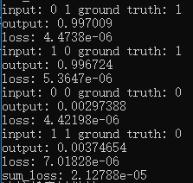
Loss = 2.12e-5
Relu:HN = 5 learning-rate = 0.1
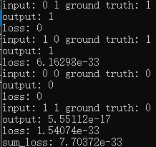
Loss = 7.7e-33
The loss of relu is petty good.
Active function | Hidden unit | Learn rate(best) | Loss
sigmoid | 1 | 10 | 1.25e-1
sigmoid | 2 | 10 | 1.25e-1
sigmoid | 3 | 0.1 | 1.45e-2
sigmoid | 5 | 1 | 9.7e-4
sigmoid | 10 | 10 | 2.12e-5
relu | 5 | 0.1 | 7.7e-33

- Codes of ‘forward-pass’ & BP
- int forward_propagation()
- {
- for (int i = 0; i < HN; i++) {
- double temp_sum = 0.0;
- for (int j = 0; j < IN; j++) {
- temp_sum += input[j] * weight_ih[j][i];
- }

- output_ho[i] = 1/(1 + exp( -1 * temp_sum));
- }
- for (int i = 0; i < ON; i++) {
- double temp_sum = 0.0;
- for (int j = 0; j < HN; j++) {
- temp_sum += output_ho[j] * weight_ho[j][i];
- }

- output[i] = 1 / (1 + exp(-1 * temp_sum));
- }
- return 0;
- }

- int backward_propagation()
- {
- //-----layer2
- double sigema2[ON];
- for (int j = 0; j < ON; j++) {
- sigema2[j] = (output[j] - t[j])*output[j] * (1 - output[j]);
- }
- for (int i = 0; i < HN; i++) {
- for (int j = 0; j < ON; j++) {
- delta_ho[i][j] = sigema2[j] * output_ho[i];
- }
- }
- //-----layer1
- double sigema1[HN];
- for (int j = 0; j < HN; j++) {
- sigema1[j] = 0.0;
- for (int i = 0; i < ON; i++) {
- sigema1[j] += weight_ho[j][i] * sigema2[i] * output_ho[j] * (1 - output_ho[j]);
- }
- }
- for (int i = 0; i < IN; i++) {
- for (int j = 0; j < HN; j++) {
- delta_ih[i][j] = sigema1[j] * input[i];
- }
- }

- return 0;
- }

Relu
- double relu(double i) {
- if (i > 0)return i;
- else return 0;
- }

- int forward_propagation()
- {
- for (int i = 0; i < HN; i++) {
- double temp_sum = 0.0;
- for (int j = 0; j < IN; j++) {
- temp_sum += input[j] * weight_ih[j][i];
- }
- output_ho[i] = relu(temp_sum);
- //output_ho[i] = 1 / (1 + exp(-1 * temp_sum));
- }
- for (int i = 0; i < ON; i++) {
- double temp_sum = 0.0;
- for (int j = 0; j < HN; j++) {
- temp_sum += output_ho[j] * weight_ho[j][i];
- }
- output[i] = relu(temp_sum);
- //output[i] = 1 / (1 + exp(-1 * temp_sum));
- }
- return 0;
- }
relu
- double relu_back(double i) {
- if (i > 0)return 1;
- else return 0;
- }
- int backward_propagation()
- {
- //-----layer2
- double sigema2[ON];
- for (int j = 0; j < ON; j++) {
- sigema2[j] = (output[j] - t[j])*relu_back( output[j]);
- }
- for (int i = 0; i < HN; i++) {
- for (int j = 0; j < ON; j++) {
- delta_ho[i][j] = sigema2[j] * output_ho[i];
- }
- }
- //-----layer1
- double sigema1[HN];
- for (int j = 0; j < HN; j++) {
- sigema1[j] = 0.0;
- for (int i = 0; i < ON; i++) {
- sigema1[j] += weight_ho[j][i] * sigema2[i] * relu_back(output_ho[j]);
- }
- }
- for (int i = 0; i < IN; i++) {
- for (int j = 0; j < HN; j++) {
- delta_ih[i][j] = sigema1[j] * input[i];
- }
- }
- return 0;
- }

Conclusion
As the experimental results show, if the number of hidden layer units of a neural network is too small, it will leads to the inability to fit a function.
The more units of hidden layer in the neural network, the better the results will be.
For different numbers of neural networks, the optimal learning rate is different.
The greater the learning rate is, the faster the loss function converges and the less convergent to optimal result.

Relu Function is better than sigmoid in this experiment.

Teacher’s Comments and Score
Comment：

Score： Signature：
Date：

