South China University of Technology
《Introduction to Pattern Recognition》Experiment Report
Experiment Title： K-Means Implementation
Name： 陈浩鑫 Student ID： 201530311042
Class： 15计科一班 Group：
Collaborator：
Teacher： S. Wu
Description
【Objective and Requirement】
Objective： Implement K-means Clustering Algorithm

Requirement：Implement the functions of finding nearest cluster centers, grouping data points and computing their centroids respectively, evaluate the algorithm, and investigate the effectiveness of the model parameters K.

【Environment】
Operating System：Windows 10, C++
Content
【Procedure】
- Problem
The Cluster problem:
Algorithm need to partition the input data set which is without labels into k partitions.

- Method description
Given a set of observations (x1, x2, …, xn), where each observation is a d-dimensional real vector, k-means clustering aims to partition the n observations into k (<=n) sets S = {S1, S2, …, Sk} so as to minimize the within-cluster sum of squares (WCSS) (i.e. variance). Formally, the objective is to find:
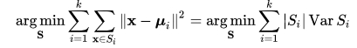
where μi is the mean of points in Si. This is equivalent to minimizing the pairwise squared deviations of points in the same cluster:
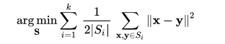
The Equivalence can be deduced from identity
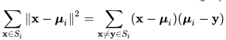
Because the total variance is constant, this is also equivalent to maximizing the squared deviations between points in different clusters (between-cluster sum of squares, BCSS)

- Experimental results

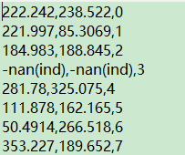
Num = 100, k = 8
The value of cluster 3 is nan, which means it doesn’t have data point.
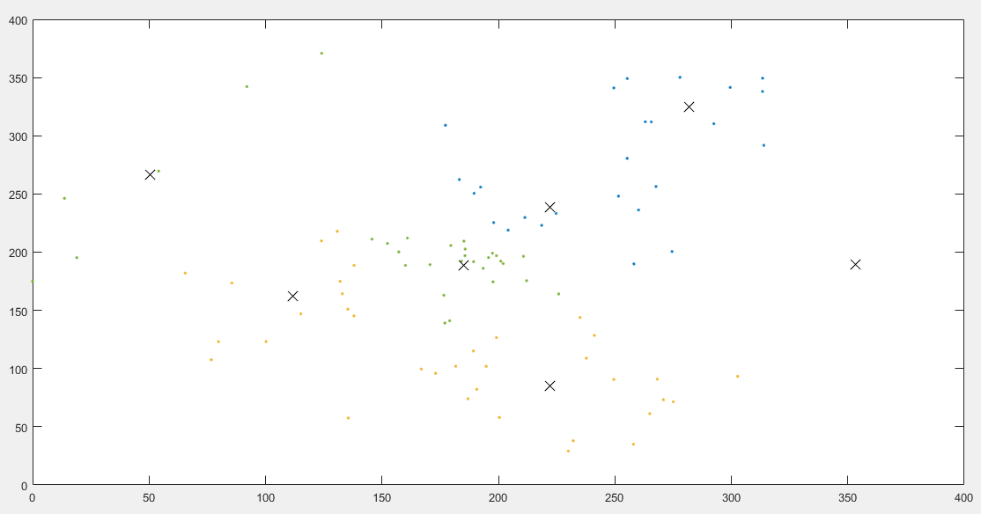
the num of data points is small, so that k-means couldn’t partition to some special partitions.

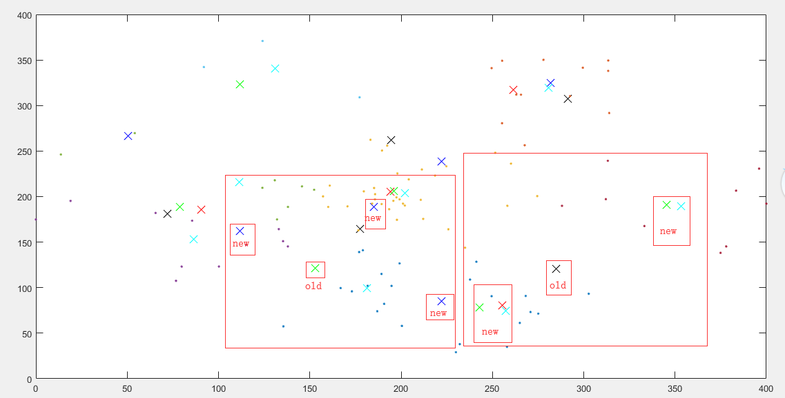
Num:100 k = 5,6,7,8
As the num of partitions increase, the old cluster center tend to split to 2 new cluster center but no create new center.

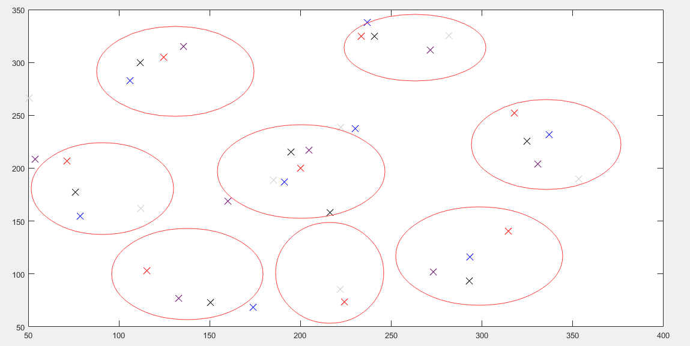
Cluster = 8 num of data:100,1000,10000,100000
No matter the num of data are so different, the cluster centers are close to each other.

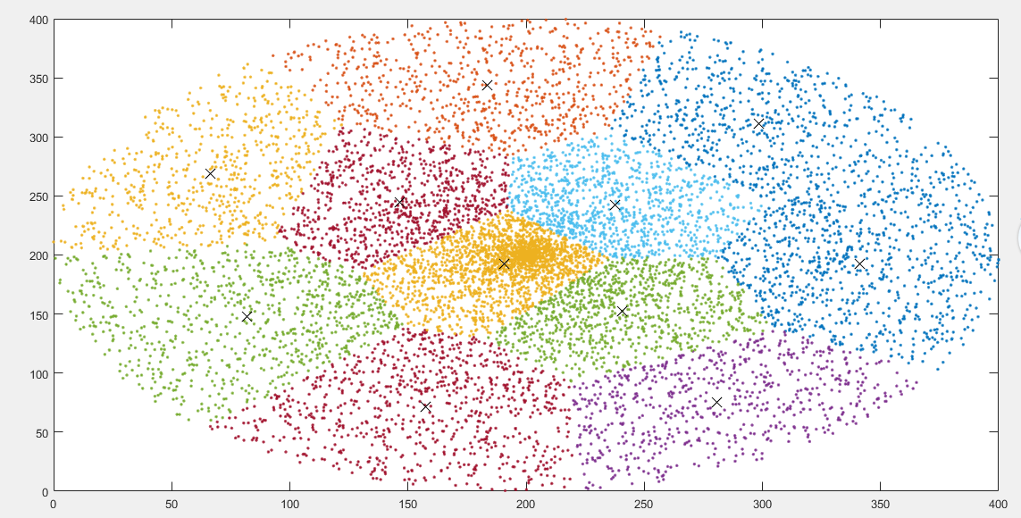
num. of data points = 10000，k = 11

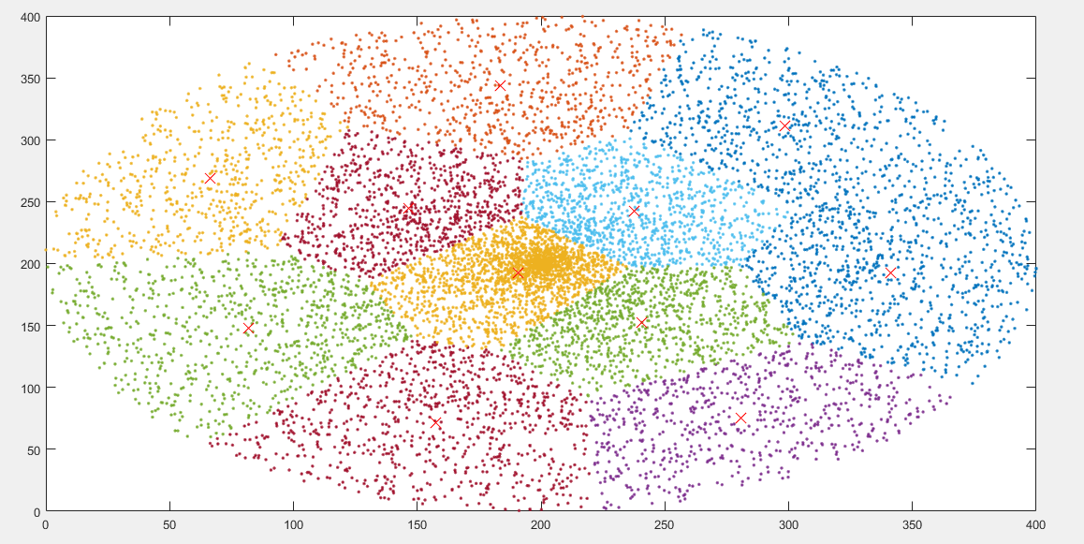
σ= 1
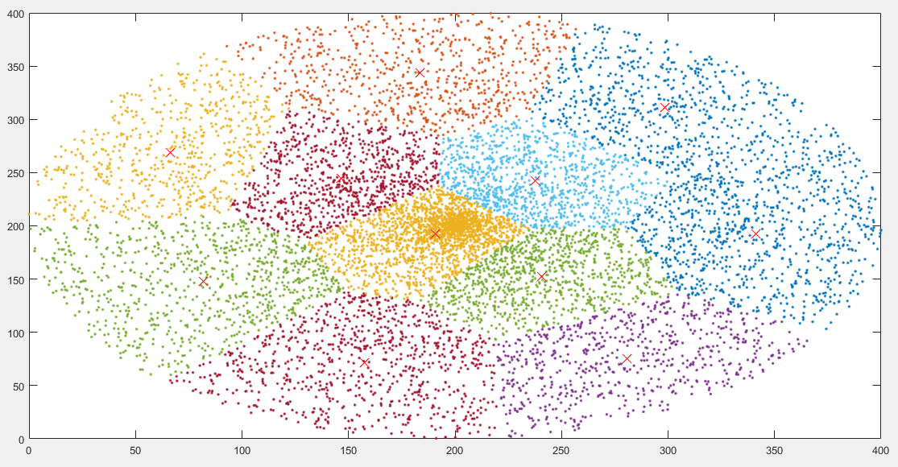
σ = 0.1
When σ is a constant, the function 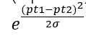doesn’t change the result. This distance is same as L2 distance in essence.
The data points of each cluster have similar distribution.
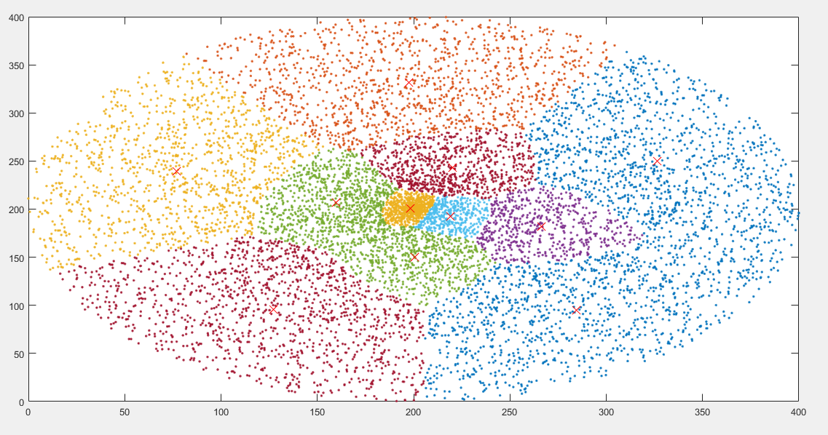
𝛔 is the variance of each cluster
Difference with σ is a constant, the cluster points in the center are more closed to each other and the outside cluster have more separated data points.

The best K:
If the data have potential clusters but not uniform generate.
Set potential cluster = 3: 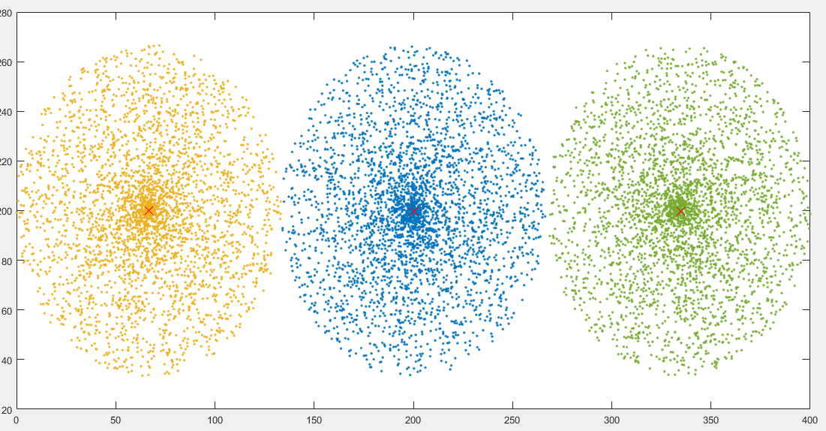
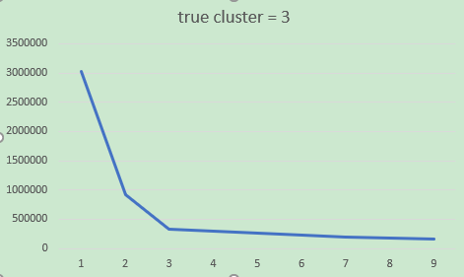
abscissa axis is the num of clusters we set, vertical axis is the sum of distance between cluster points with cluster centers.
The K = 3 is the inflection point that sum of distance decline rapidly.
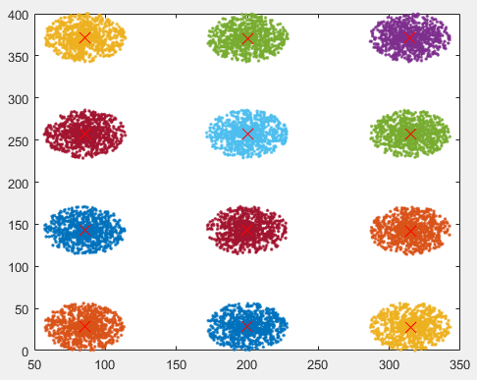
potential cluster = 12
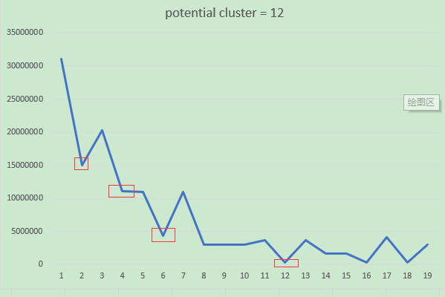
Because the data cluster centers are symmetry, there are serval inflection points.

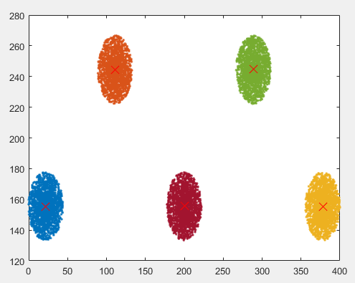
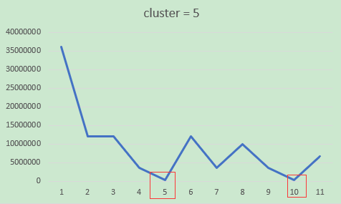
When the cluster center are not too symmetry, the sum of distance could help us to find the best K clusters!

- Codes
- inline int nearest(point pt, point cent, int n_cluster) //find nearest cluster center of point pt
- {
- int i, min_i;
- point c;
- double d, min_d;

- //TODO: find the nearest cluster center of point pt, return its index: min_i
- min_d = HUGE_VAL;
- min_i = pt->group;
- for_n{
- d = dist2(c,pt);
- if (d < min_d) {
- min_i = i;
- min_d = d;
- }
- }
- return min_i;
- }
- point KMeans(point pts, int len, int n_cluster)
- {
- int i, j, min_i;
- int changed;

- point cent = (point_t*)malloc(sizeof(point_t) * n_cluster), p, c; //cent is an array of centroids, c is an iterator on cent

- // assign init grouping randomly
- for_len p->group = j % n_cluster;

- do {
- //TODO: calculate centroids of each group
- for_n{
- double sum_x,sum_y,sum_have;
- sum_x = sum_y = sum_have = 0;
- for_len{
- if (p->group == i) {
- sum_x += p->x;
- sum_y += p->y;
- sum_have += 1;
- }
- }
- c->x = sum_x / sum_have;
- c->y = sum_y / sum_have;
- }
- changed = 0;
- // TODO: find closest centroid of each point & update its group
- for_len{
- min_i = nearest(p,cent,n_cluster);
- if (min_i != p->group) {
- changed ++;
- p->group = min_i;
- }
- }
- // you should update 'changed' when you assign a new centroid to a point
- } while (changed > (len >> 10)); // stop when groups of points have changed enough time

- for_n{ c->group = i; }

- return cent;
- }

Conclusion
Kmeans is a partitional clustering algorithm, which also is non-supervision machine learning.
We use Kmeans to partition given data into k clusters.
The function: , which σ is the variance of cluster, will make center cluster more aggregate closely.

The way to find the best K clusters of k-means is to calculate the sum of distance, the inflection point may be the best K.

Teacher’s Comments and Score
Comment：

Score： Signature：
Date：

