Intro to DevOps
LO4/LO5/LO6
Stjepan Cutvaric – Group A
LO4 1. Deploy a deployment named static-site-deployment with two replicas using the
nginx:alpine container image.
Command:
kubectl create deployment static-site-deployment --image=docker.io/library/nginx:alpine –replicas=2
Proof:
[student@vm69-61 ~]$ kubectl create deployment static-site-deployment --image=docker.io/library/nginx:alpine --replicas=2
deployment.apps/static-site-deployment created
[student@vm69-61 ~]$ kubectl get deployment
NAME READY UP-TO-DATE AVAILABLE AGE
static-site-deployment 2/2 2 2 14s

LO4 2. Create a ConfigMap named site-content holding a key index.html whose value is a small HTML page containing your name, surname and exam group. Mount that key into the deployment at /usr/share/nginx/html/index.html using subPath. Verify the file inside a pod with kubectl exec.
Command:
kubectl create configmap site-content --from literal=index.html=StjepanCutvaricGroupA
nano config.yaml

Contents:
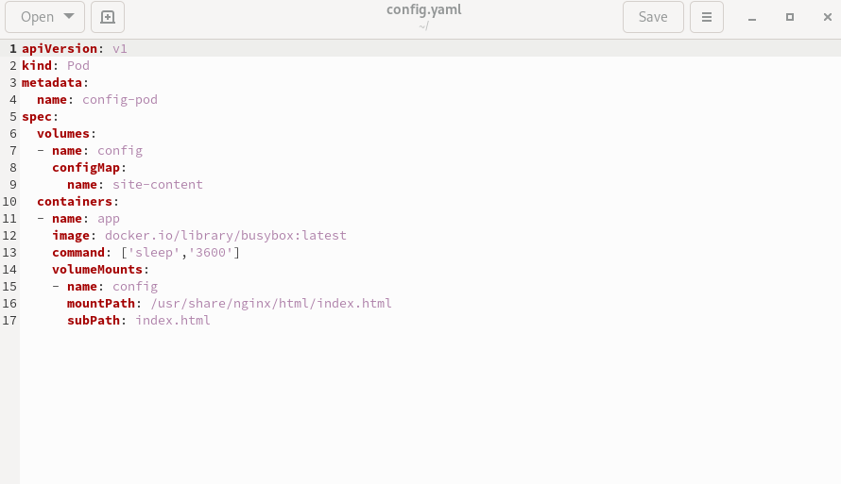
Run: kubectl exec config-pod -- ls /usr/share/nginx/html/index.html
Proof:
[student@vm69-61 ~]$ kubectl exec config-pod -- ls /usr/share/nginx/html/index.html
/usr/share/nginx/html/index.html

[LO4_D / 4 points] Update the deployment's image to nginx:stable-alpine. Follow the rolling update with kubectl rollout status. Show the rollout history with kubectl rollout history, then roll back to the previous revision. Prove with kubectl describe deployment (or -o yaml) that the running image afterwards is again
nginx:alpine.
Commands:
kubectl set image deployment/static-site-deployment nginx=docker.io/library/nginx:stable-alpine
kubectl rollout status deployment/static-site-deployment
kubectl rollout history deployment/static-site-deployment
kubectl rollout undo deployment/static-site-deployment
kubectl describe deployment
Proof:
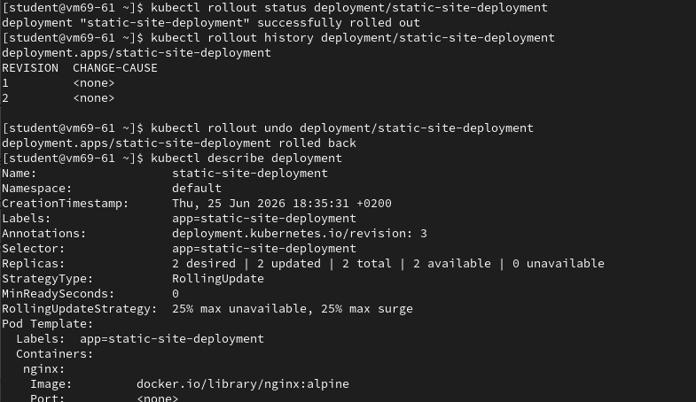
After rollout undo we cans ee that the image is back to nginx:alpine
Lo5_ 1. Explain what is wrong with the following podman command. Identify the mistake, fix it and explain what was wrong.
podman run --name mycontainer -d --port 8080:80 httpdx
Error: unknown flag: --port
Fix: podman run --name mycontainer -d -p 8080:80 httpdx
Explanation: --Port is not a known flag for podman run, to connect the port use -p to map HOST:CONTAINER.
2. [LO5_M / 4 points] Explain what is wrong with the following Dockerfile. Identify the mistake, fix it and explain what was wrong.
ORIGINAL:
# Use the official Ubuntu base image
FRM ubuntu:latest
# Set an environment variable
ENV student="your_value_here"
# Install Nginx RUN yum update && \ yum install -y nginx && \ rm -rf /var/lib/apt/lists/*
# Define the running port
EXPOSE 80
# Start Nginx and keep it from running in background
CMD ["nginx", "-g", "daemon off;"]
FIXED:
FROM ubuntu:latest
# Set an environment variable
ENV student="your_value_here"
# Install Nginx
RUN yum update && \ yum install -y nginx && \ rm -rf /var/lib/apt/lists/*
# Define the running port
EXPOSE 80
# Start Nginx and keep it from running in background
CMD ["nginx", "-g", "daemon off;"]
Explanation:Typo in from, Run in the comment line so it would not actually run, the rest is okay (keep in mind currently value of student is "your_value_here" with “”)
3. [LO5_D / 4 points] Explain what is wrong with the following kubernetes manifest. Identify the mistake, fix it
and explain what was wrong. You can also get the file from:
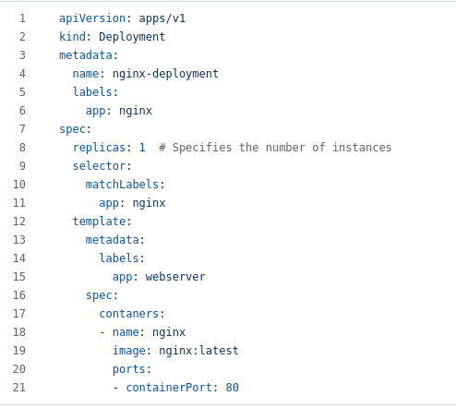

Correct:
apiVersion: apps/v1
kind: Deployment
metadata:
name: nginx-deployment
labels:
app: nginx
spec:
replicas: 1 # Specifies the number of instances
selector:
matchLabels:
app: nginx
template:
metadata:
labels:
app: nginx #has to be the same name as selector
spec:
nodeSelector:
disktype: ssd # node must have this label
containers: #typo in container
- name: nginx
image: nginx:latest
ports:
- containerPort: 80

Learning outcome 6 – 12 points / 30 min
1. [LO6_M / 4 points] Critically evaluate Kubernetes and Docker Swarm with respect to their scheduling capabilities, fault tolerance, and ease of deployment. Which orchestration system would you recommend for a startup with limited DevOps expertise and why?
Kubernetes is the industry standard with better ecosystem, more tools, more engineers who know it. It has better autoscaling, health checks, rolling updates. Managed cloud offerings reduce ops burden. On the other hand, docker swarm has a less learning curve than kubernetes, and is easier to deploy, but a higher cost. Therefore, for a startup with a limited expertise I would suggest Swarm until they hit the rate limits than potentially overtime with their growing expertise I would consider moving to Kubernetes.

2. [LO6_M / 4 points] A healthcare organization must deploy containerized applications in a hybrid cloud environment with strict compliance requirements. Evaluate the suitability of OpenShift and Kubernetes for this use case. Consider compliance, vendor lock-in, and operational complexity in your response.
OpenShift best satisfies the compliance and support requirement through its secure defaults and Red Hat backing, but it does so at the cost of licence fees and platform coupling. Kubernetes, especially managed (EKS/GKE/AKS), satisfies the lock-in concern through portability and no single-vendor dependency, but leaves the company to assemble compliance tooling, support contracts, and hardening itself. There is no platform that fully satisfies both constraints at once; the correct recommendation depends on which constraint the company weighs more heavily, and a strong answer states that trade-off explicitly rather than silently picking one side. Long story short, OpenShift (safer, more expensive, less complex) Kubernetes (more flexible, steeper learning curve, cheaper)
3. [LO6_D / 4 points] You have been tasked with selecting a container orchestration platform for a global e-commerce company expecting rapid scaling and microservice growth. Why would you choose Kubernetes over Podman on multiple servers.
In this case recommendation would definitely be Kubernetes, with Horizontal Pod Audoscaler (HPA) + CDN. HPA scales pods when traffic spikes. Cluster Autoscaler adds nodes when pods can’t be scheduled, multi-region deployments for global latency. CDN (CloudFront, Fastly) for static content which reduces backend load. Spot/preemtible nodes for cost savings during scaling. Self-healing + rolling updates for resilience under traffic churn. LoadBalancer/Ingress distributing incoming traffic.

