Punto 1:

SELECT query_1.NombreTabla AS NombreTabla,

NVL(query_2.NumColumnas, 0) AS NumColumnas,

NVL(query_3.NumColsPK, 0) AS NumColsPK,

NVL(query_4.NumColsNotNull, 0) AS NumColsNotNull,

NVL(query_5.NumColsFKs, 0) AS NumColsFKs

FROM (

/** Returns all table names**/

SELECT a_t.TABLE_NAME AS NombreTabla

FROM ALL_TABLES a_t

WHERE a_t.OWNER = 'PARRANDEROS'

GROUP BY a_t.TABLE_NAME

) query_1

LEFT OUTER JOIN (

/** Returns table names with their column numbers **/

SELECT a_t_c.TABLE_NAME AS NombreTabla,

COUNT(a_t_c.COLUMN_NAME) AS NumColumnas

FROM ALL_TAB_COLUMNS a_t_c

WHERE a_t_c.OWNER = 'PARRANDEROS'

GROUP BY a_t_c.TABLE_NAME

) query_2

ON query_1.NombreTabla=query_2.NombreTabla

LEFT OUTER JOIN (

/** Returns table names with their PK column numbers **/

SELECT a_c.TABLE_NAME AS NombreTabla,

COUNT(a_c.CONSTRAINT_NAME) AS NumColsPK

FROM ALL_CONSTRAINTS a_c

WHERE a_c.OWNER = 'PARRANDEROS'

AND a_c.CONSTRAINT_NAME LIKE 'PK%'

GROUP BY a_c.TABLE_NAME

) query_3

ON query_2.NombreTabla=query_3.NombreTabla

LEFT OUTER JOIN (

/** Returns table names with not null requirement **/

SELECT a_t_c.TABLE_NAME AS NombreTabla,

COUNT(a_t_c.COLUMN_NAME) AS NumColsNotNull

FROM ALL_TAB_COLUMNS a_t_c

WHERE a_t_c.OWNER = 'PARRANDEROS'

AND a_t_c.NULLABLE = 'N'

GROUP BY a_t_c.TABLE_NAME

) query_4

ON query_3.NombreTabla=query_4.NombreTabla

LEFT OUTER JOIN (

/** Returns table names with their FK column numbers **/

SELECT a_c.TABLE_NAME AS NombreTabla,

COUNT(a_c.CONSTRAINT_NAME) AS NumColsFKs

FROM ALL_CONSTRAINTS a_c

WHERE a_c.OWNER = 'PARRANDEROS'

AND a_c.CONSTRAINT_NAME LIKE 'FK%'

GROUP BY a_c.TABLE_NAME

) query_5

ON query_4.NombreTabla=query_5.NombreTabla

ORDER BY NombreTabla DESC;

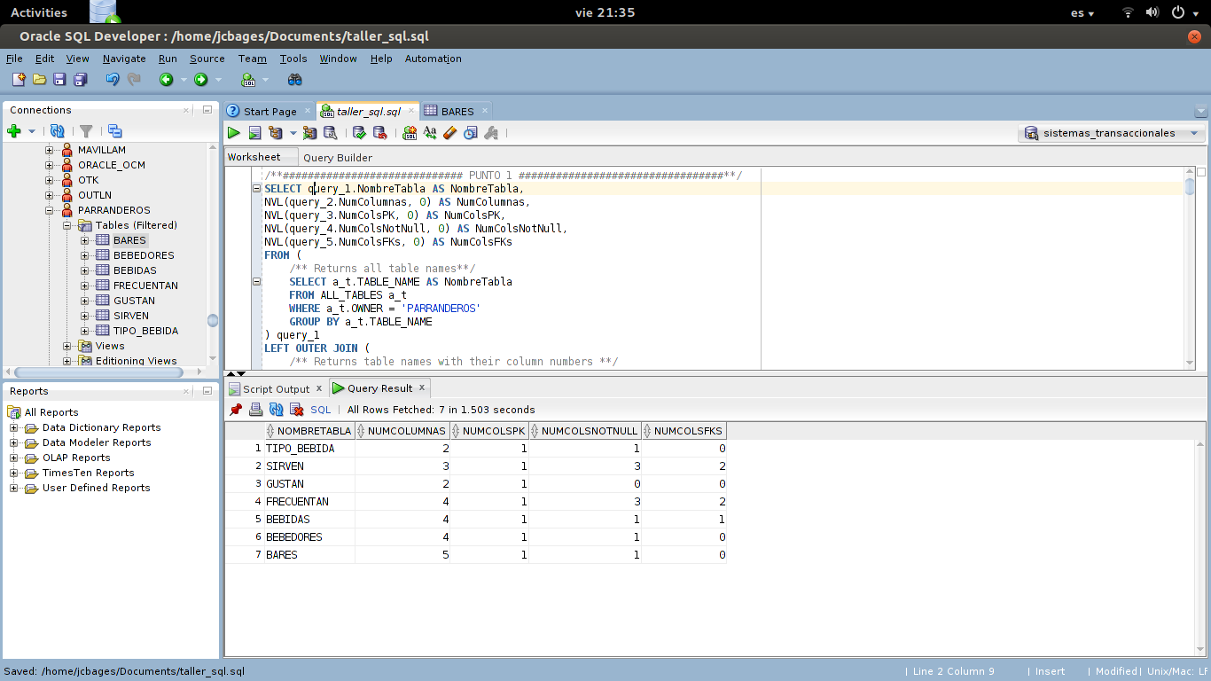

Punto 2:

SELECT query_1.NombreTabla AS NombreTabla,

query_2.TipoDataCol AS TipoDatoCol,

NVL(query_3.NumRestriccionesColsTipoDato, 0) AS NumRestriccionesColsTipoDato,

NVL(query_4.NumColsConEseTipoDeDato, 0) AS NumColsConEseTipoDeDato

FROM (

/** Returns all table names**/

SELECT a_t.TABLE_NAME AS NombreTabla

FROM ALL_TABLES a_t

WHERE a_t.OWNER = 'PARRANDEROS'

GROUP BY a_t.TABLE_NAME

) query_1

LEFT OUTER JOIN (

/** Returns all table names with their data types **/

SELECT DISTINCT a_t_c.TABLE_NAME AS NombreTabla,

a_t_c.DATA_TYPE AS TipoDataCol

FROM ALL_TAB_COLUMNS a_t_c

WHERE a_t_c.OWNER = 'PARRANDEROS'

) query_2

ON query_1.NombreTabla = query_2.NombreTabla

LEFT OUTER JOIN (

/** Returns all table names with their data types and their restriction **/

SELECT a_c_c.TABLE_NAME AS NombreTabla,

a_t_c.DATA_TYPE AS TipoDataCol,

COUNT(a_c_c.CONSTRAINT_NAME) AS NumRestriccionesColsTipoDato

FROM ALL_CONS_COLUMNS a_c_c,

ALL_TAB_COLUMNS a_t_c

WHERE a_c_c.OWNER = 'PARRANDEROS'

AND a_c_c.OWNER = a_t_c.OWNER

AND a_c_c.TABLE_NAME = a_t_c.TABLE_NAME

AND a_c_c.COLUMN_NAME = a_t_c.COLUMN_NAME

GROUP BY a_c_c.TABLE_NAME, a_t_c.DATA_TYPE

) query_3

ON query_2.NombreTabla = query_3.NombreTabla

AND query_2.TipoDataCol = query_3.TipoDataCol

LEFT OUTER JOIN (

/** Returns all table names with their data types and their column nums **/

SELECT a_t_c.TABLE_NAME AS NombreTabla,

a_t_c.DATA_TYPE AS TipoDataCol,

COUNT(a_t_c.DATA_TYPE) AS NumColsConEseTipoDeDato

FROM ALL_TAB_COLUMNS a_t_c

WHERE a_t_c.OWNER = 'PARRANDEROS'

GROUP BY a_t_c.TABLE_NAME, a_t_c.DATA_TYPE

) query_4

ON query_3.NombreTabla = query_4.NombreTabla

AND query_3.TipoDataCol = query_4.TipoDataCol

ORDER BY NombreTabla ASC, TipoDatoCol ASC;

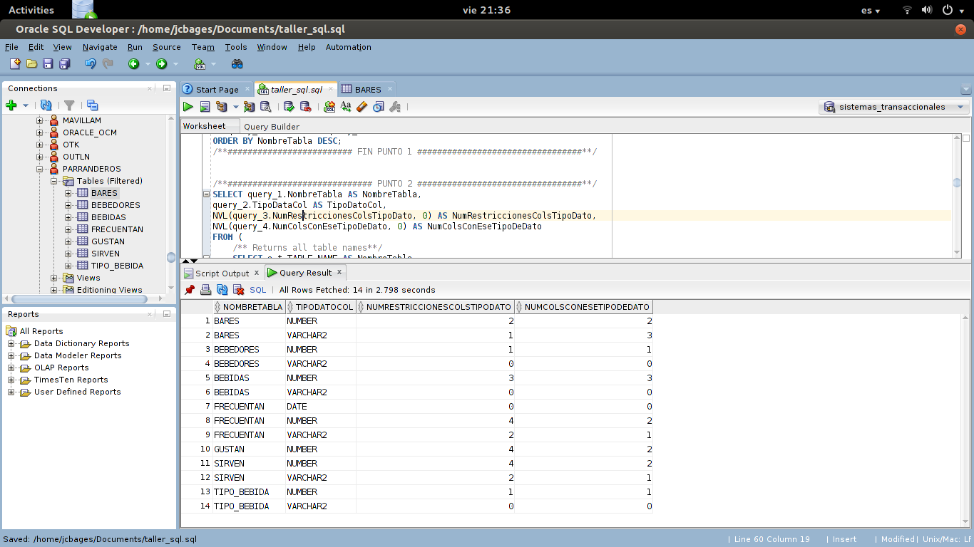

Punto 3:

Punto 4:

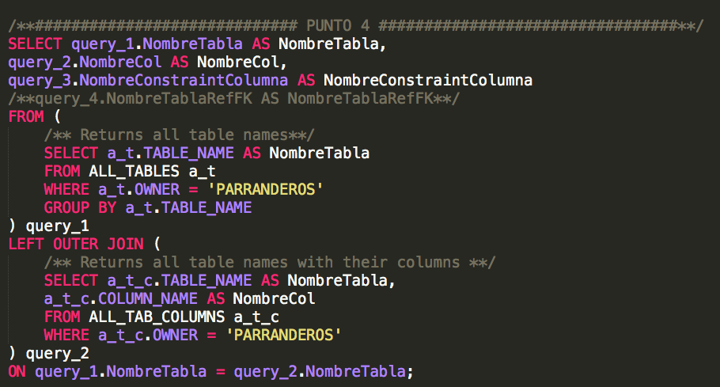

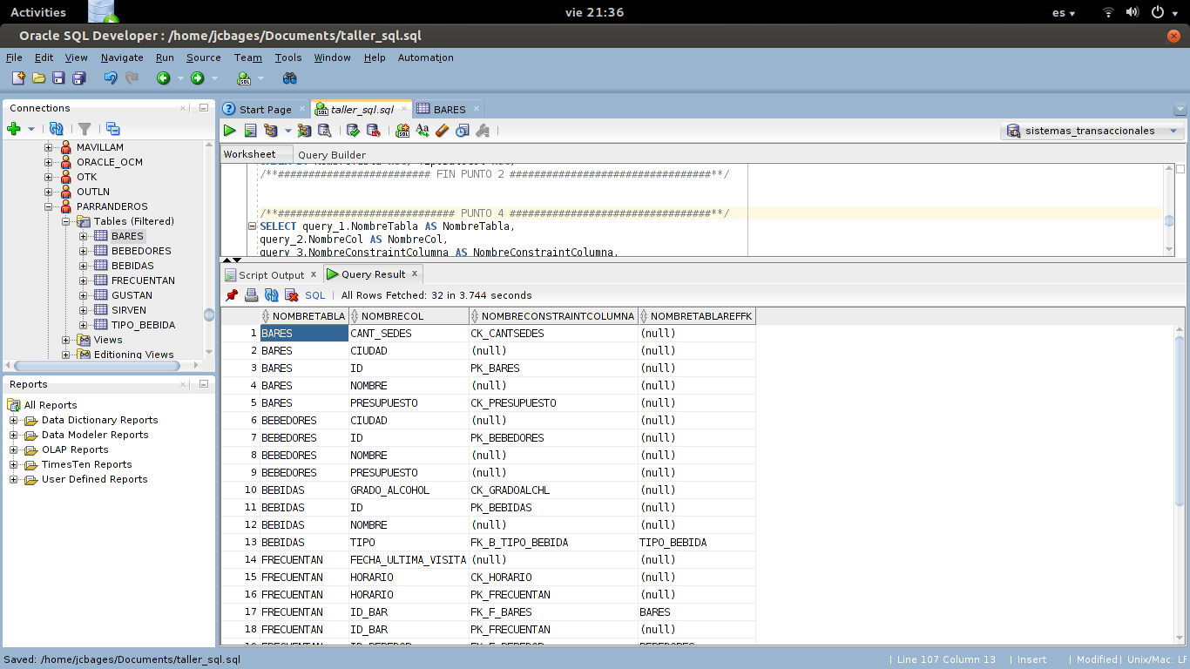

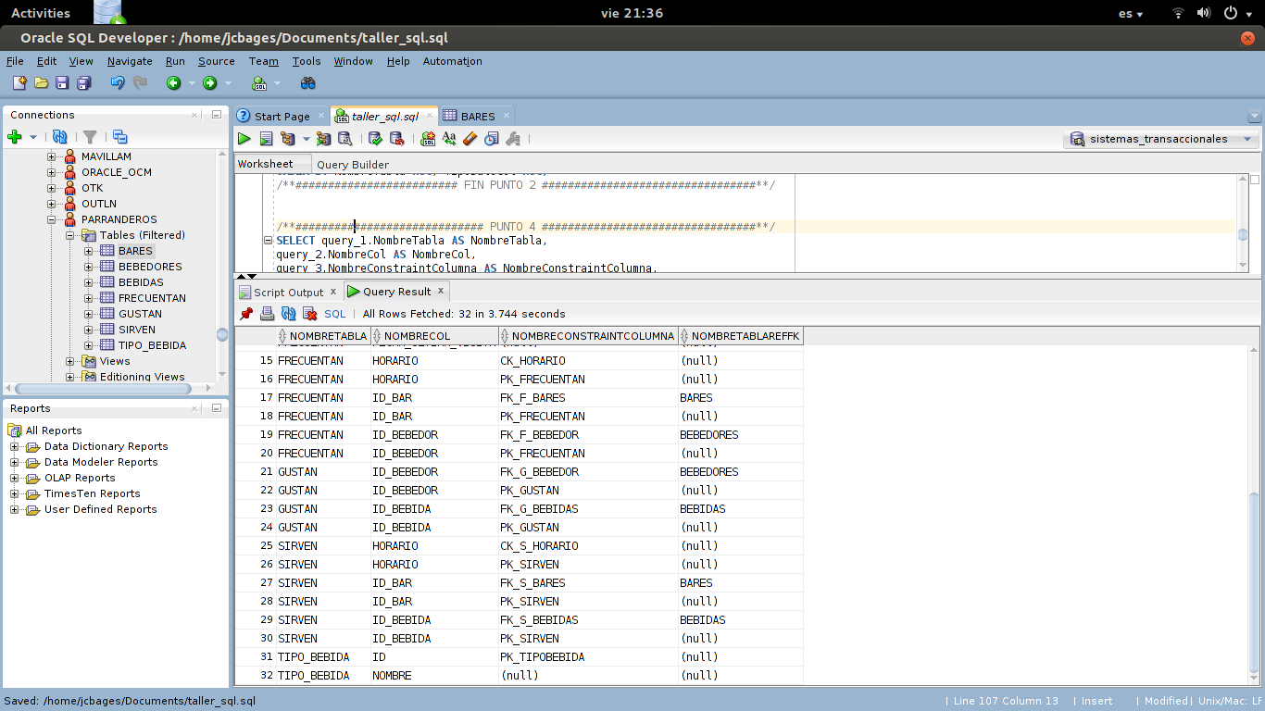

Punto 5:

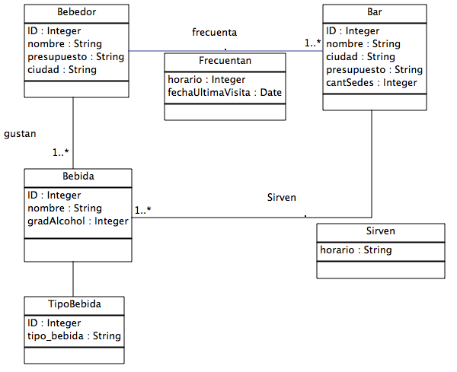

Punto 6:

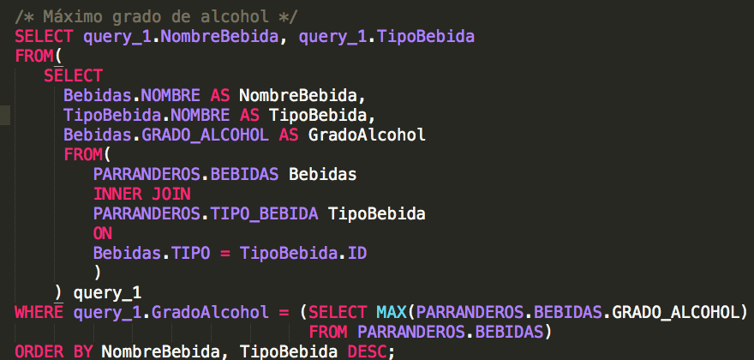

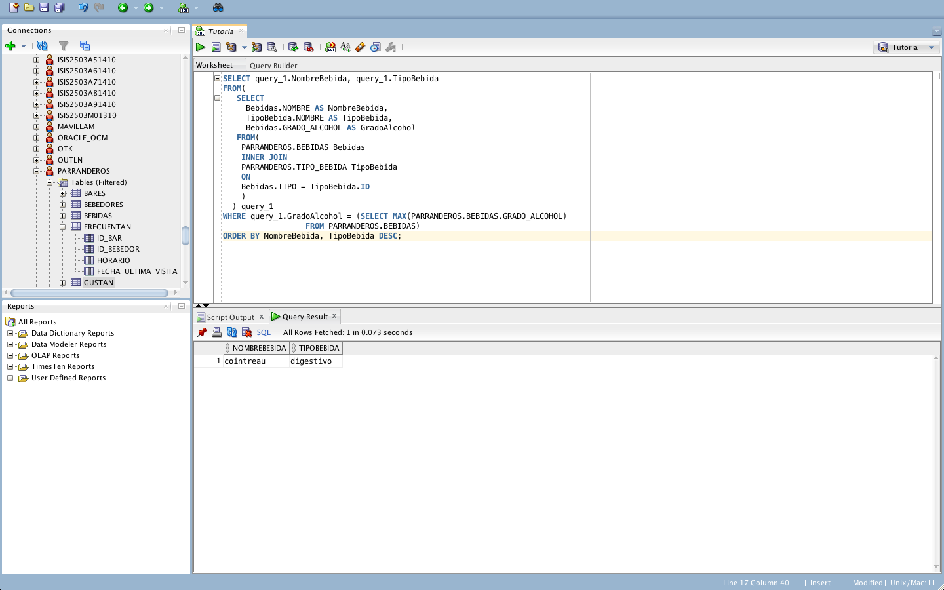

Punto 7:

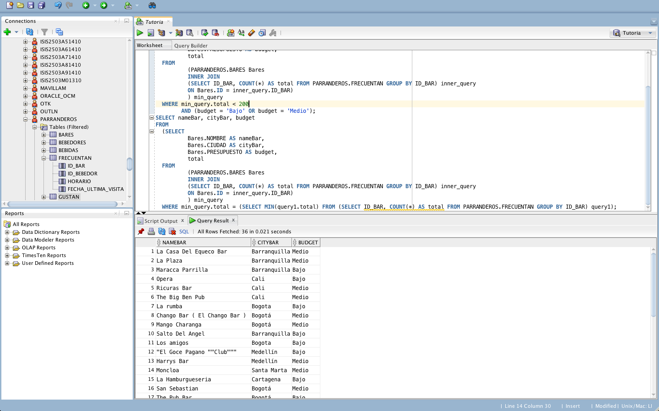

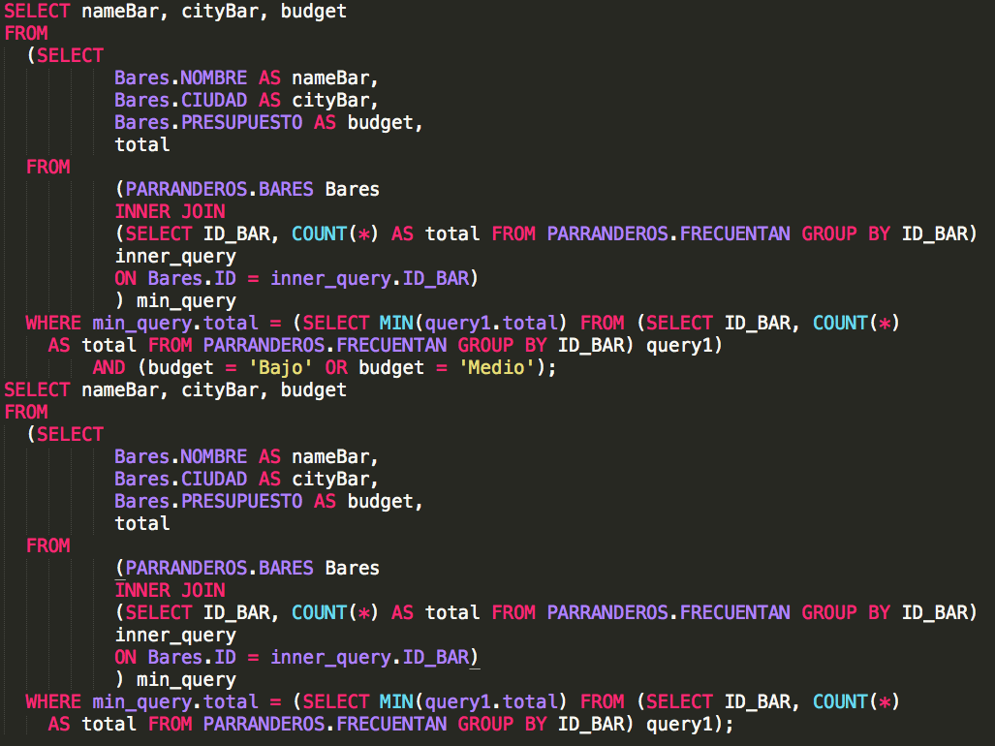

Punto 8:

/**############################# PUNTO 8 #################################**/

SELECT bebedores.NOMBRE,

bar.NOMBRE,

freq.FECHA_ULTIMA_VISITA

FROM PARRANDEROS.BEBEDORES bebedores,

PARRANDEROS.BARES bar,

PARRANDEROS.FRECUENTAN freq

WHERE bebedores.ID = freq.ID_BEBEDOR

AND freq.ID_BAR = bar.ID

AND bebedores.PRESUPUESTO >= bar.PRESUPUESTO

AND bar.CANT_SEDES >= 2

ORDER BY freq.FECHA_ULTIMA_VISITA ASC, bebedores.NOMBRE;

/**######################### FIN PUNTO 8 #################################**/

punto_8_1.png

punto_8_2.png

punto_8_3.png

Punto 9:

/**############################# PUNTO 9 #################################**/

select todo.nombre from

  (select todo.nombre, count(todo.id_bebida) as num from

    (select * from

        (select id as id_bar, nombre from parranderos.bares where presupuesto = 'Alto')

      natural join

        (select id_bar, id_bebida from parranderos.sirven where horario='diurno')

      natural join

        (select id as id_bebida, tipo from parranderos.bebidas)

      natural join

        (select id as tipo from parranderos.tipo_bebida where nombre='aperitivo')

    ) todo

  group by todo.nombre

  order by num, todo.nombre) todo

where todo.num between 3 and 7;

/**######################### FIN PUNTO 9 #################################**/​

Punto 10:

Tabla cada tupla selecciona los bebedores de una ciudad