Readme of RT Rendering Lab1:

1. How to use the program:

a. Open the index.html  
b. In the bottom of the webpage, select the csv file you would like to show.  
c. Now you can select the options under “Global Options”  
 - Background color: the color of the background  
 - Horizontal lines number: additional lines in graph, which can help you know the value of each bar  
 - Line color: the color of lines in this graph  
 - Bar color: the color of the bars in graph

d. Note that any change in these options except for background color requires you to click draw button again in order to show the change you made.

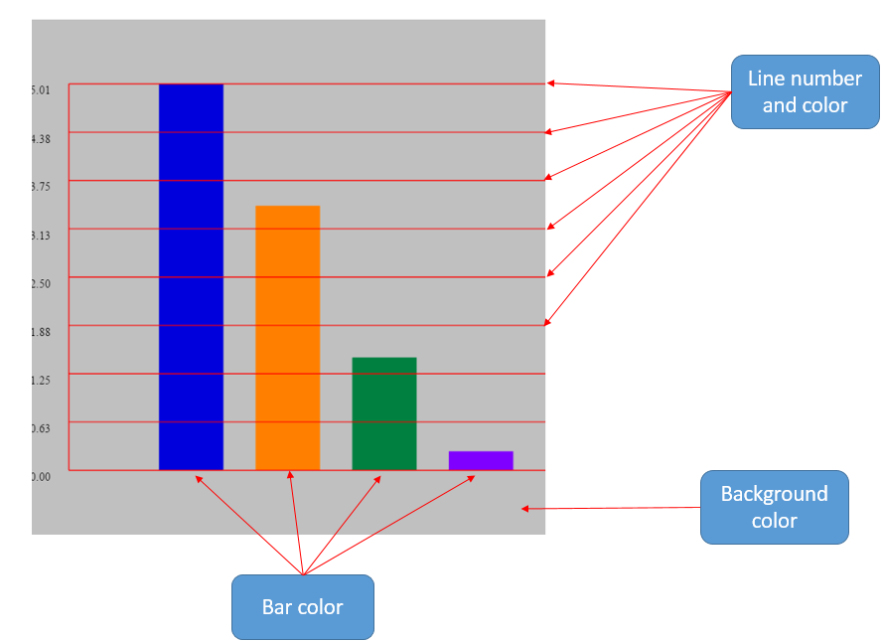

2. For the requirement A. you can click only one checkbox under “For Drawing Selected Species and Get Their Averages”, and click “Draw a group”

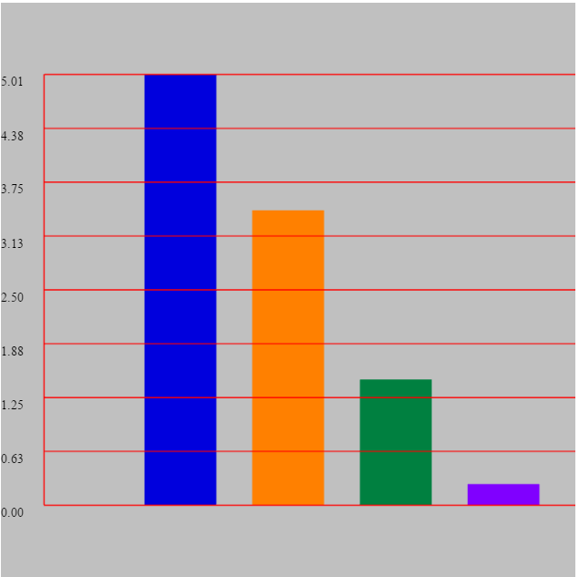

This can be a little bit confusing, but I just provide a more general solution for this requirement. This means you can choose any subset of these three species and get their averages. Of course you can get the averages from only one species of them.

3. For the requirement C. you can just click “Draw all”

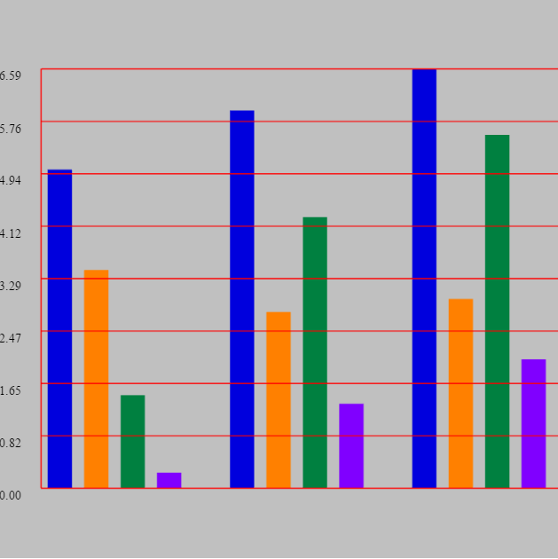

4. States which bonus tasks you attempted:

I believe that the above options I listed are additional features. Also, I let the digits show on left side of the graph.

Moreover, I provide simple animation effect when you click on one of the draw buttons. The bars will extend to the target length.

5. Lists which browser/OS you developed your code on (just in case)

I recommend using Chrome, because I cannot change background color in Firefox.