Readme of RT Rendering Lab3:

1. How to use the program:

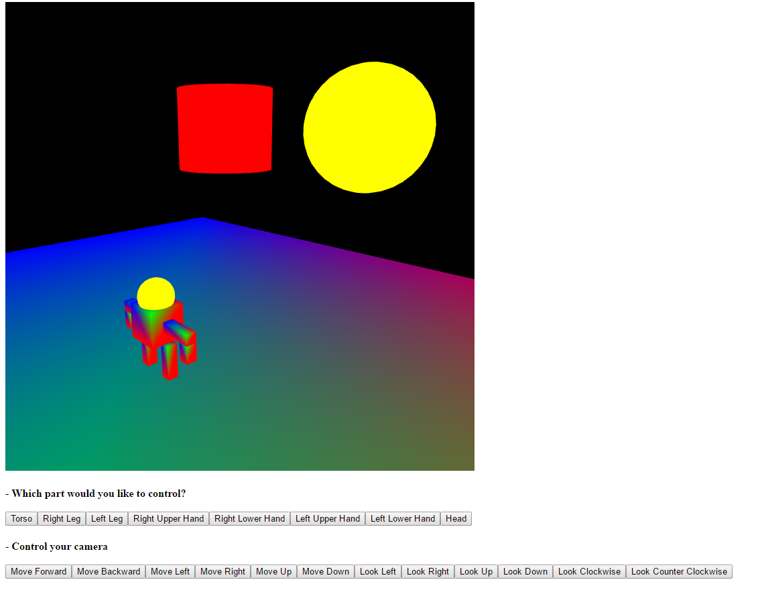

a. First click each button on the bottom of webpage to choose which part you would like to move.

b. To move a part, you can press:  
 F/ B: forward, backward  
 L/ R: left, right  
 Or conventional WSAD keys  
 Space/ C: upward, downward

c. To rotate a part, you can press:  
 Q/ E: around local Y axis

d. You can also move the camera around to see in different position  
 By pressing HTML button on webpage  
 U/ J: forward, backward  
 H/ K: left, right

e. You can rotate the camera around to see in different angle  
 By pressing HTML button on webpage  
 Up/ Down Arrow: local X axis  
 Left/ Right Arrow: global Y axis

f. You can rotate the entire scene  
 By holding left mouse button and moving the mouse

g. You can scale the scene  
 By holding right mouse button and moving the mouse

2. Lists which browser/OS you developed your code on (just in case)

Chrome/ Win10