Readme of RT Rendering Lab3:

1. How to use the program:

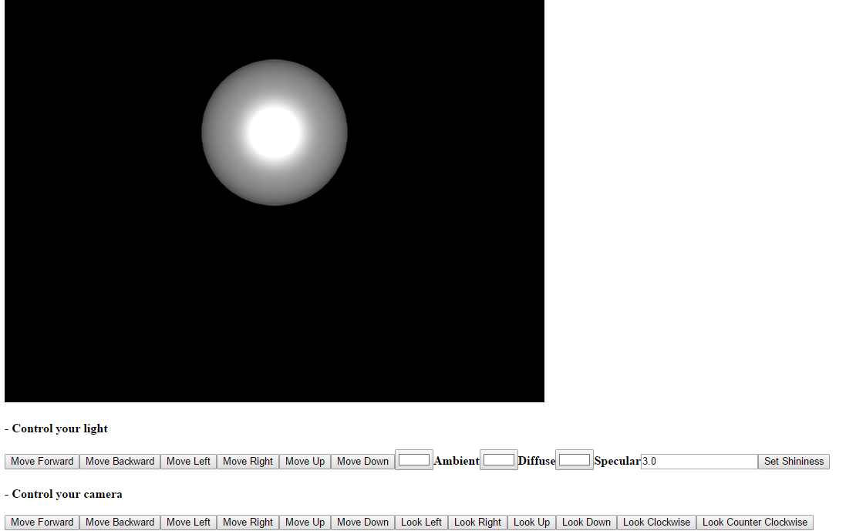

a. Move the light by clicking the buttons under the title “Control your light”

b. To move the light, you can press:  
 F/ B: forward, backward  
 L/ R: left, right  
 Or conventional WSAD keys  
 Space/ C: upward, downward

c. You can control the each light component by setting the color input under the title “Control your light”

d. You can control the shininess by type in the value and press “Set Shininess” button under the title “Control your light”

e. You can also move the camera around to see in different position  
 By pressing by clicking the buttons under the title “Control your camera”   
 U/ J: forward, backward  
 H/ K: left, right

f. You can rotate the camera around to see in different angle  
 By pressing by clicking the buttons under the title “Control your camera”   
 Up/ Down Arrow: local X axis  
 Left/ Right Arrow: global Y axis

2. Lists which browser/OS you developed your code on (just in case)

Chrome/ Win10