Sage FlashPoint
Multi-Node Lightning Localization & Wildfire Ignition Watch on the Sage Testbed
Technical Report — Sage Summer Camp 2026 Hackathon (University of Illinois Chicago, July 2026)
Samuel Watson · University of Hawaiʻi at Mānoa · Sage user scwatson

1. Executive summary
Sage FlashPoint turns the Sage testbed's existing cameras, microphones, and weather stations into a lightning-detection, strike-localization, and wildfire ignition-watch system — with no new hardware required at any node. During one hackathon week, the project (a) mined two real fire cases out of the fleet's own archives, (b) demonstrated that audio-only lightning detection false-alarms confidently (17 confident detections, all 17 falsified by two independent satellites), (c) rebuilt detection around that lesson — detections nominate, cross-checks confirm — and recovered 22 genuine thunder arrivals that rain noise had buried, (d) localized strikes to 96 m in an integration test using nothing but camera flashes and microphone delays, (e) built a storm-mode controller that armed 145 minutes before the first local flash when replayed against the real ignition storm, and (f) closed the loop with human-reviewed ignition-risk alerts in Slack. Every numeric claim in this report traces to code and data in the public repository, and the mathematics presented here is quoted from the code that actually runs.

2. Background and motivation

2.1 The platform
Sage is an NSF-funded (National Science Foundation) cyberinfrastructure of AI-capable sensor nodes deployed across the continental United States, Alaska, Hawaiʻi, and Puerto Rico — 294 registered nodes at the time of writing. Each Wild Sage node carries fixed and steerable (pan-tilt-zoom, PTZ) cameras, a microphone, a full weather station, LoRaWAN radio, and an on-node GPU running containerized machine-learning workloads at the edge (the Waggle software stack). Nodes report telemetry, detections, and media samples to the Beehive cloud, which exposes open data APIs.

2.2 The problem: lightning holdover fires
A significant fraction of natural-cause wildfires are started by lightning, and many are holdover fires: the strike ignites duff or a snag that smolders for hours to days before flaring into a detectable fire. The strike time and location are therefore the earliest possible warning — yet no system on the fleet connects a strike observation to a follow-up watch. FlashPoint's motivating discovery made this concrete: the Kitten Fire (Grand Teton, Wyoming, discovered July 3, 2025) ignited six kilometers from Sage node W06C, which recorded audio, imagery, and weather straight through both suspect storms — while its steerable camera pointed at a cabin wall the entire time.
In plain terms: A holdover fire is like a cigarette dropped in a couch: nothing visible happens for a long time, then the couch is on fire. If you know exactly when and where the cigarette dropped, you know where to keep checking. FlashPoint's whole purpose is to compute that “where to keep checking” from sensors the nodes already have — and then actually check.

3. System design

3.1 The governing principle: nominate, never confirm
The project's first result was negative and became its architecture. An audio-only detector (v0) flagged 17 thunder events across the Kitten storm nights, all with high confidence. Cross-validation against both GOES-18 and GOES-19 Geostationary Lightning Mappers (GLM), with a ±90-second window, found zero flashes within 50 km of any of the 17. Single-modality detection false-alarms confidently. Consequently, no single sensor is ever allowed to confirm a strike: standalone detections are nominations, and confirmation requires an independent anchor (a satellite flash, a camera flash) or cross-node agreement.
In plain terms: One microphone alone will swear it heard thunder and be wrong — rain drumming on the enclosure can imitate thunder well enough to fool human ears too. So the system is built like a newsroom: any one source can propose a story, but it only runs after a second, independent source corroborates it.

3.2 Flow of state
The target operating concept places an orchestrator agent at the Beehive level — where Sage already connects every node — supervising five node states: (1) quiet watch under normal snapshot schedules; (2) always-on capture when forecasts suggest lightning near a group of nodes; (3) strike located, when detections from enough nodes cross-check; (4) smoke watch, in which a horizon-view PTZ camera revisits the strike sector through the multi-day holdover window; and (5) notify responders, a human-reviewed alert carrying before/after imagery and the weather leading up to the strike. Each transition fires only when its condition is met, and every action is logged.
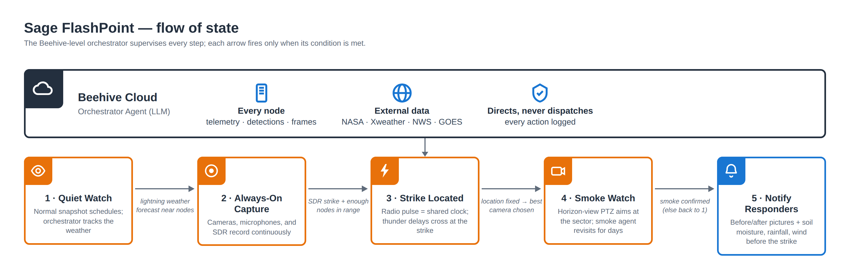
Figure 1 — Flow of state. The Beehive-level orchestrator supervises five node states; arrows fire only when their conditions are met.

3.3 The storm-mode controller (implemented and replay-tested)
The node-side piece that exists today is a deterministic state machine (controller/stormmode.py) with tiers IDLE → OUTLOOK → APPROACH → STORM → AFTERMATH. Free National Weather Service outlooks pre-arm it (OUTLOOK); storm evidence — radar cells within 100 km, three or more regional strikes, or a 2 hPa/3 h pressure fall paired with gusts above 10 m/s — arms continuous ring-buffer capture (APPROACH); the first local flash or thunder enters STORM; and a non-empty strike log exits into a 72-hour AFTERMATH holdover watch with 20-minute PTZ revisits. Guardrails are first-class: a daily continuous-capture budget (10 h), a hard cap per storm (6 h), 30-minute exit hysteresis, auto-revert timeouts at every tier, and an audit record for every transition, action, and guardrail firing. The transition engine is a pure function of (state, inputs, config, time) — no I/O and no clocks — so it is fully testable and replayable: 19/19 tests pass, and on a replay of the real Kitten storm feeds it armed 145 minutes before the first local flash.
In plain terms: The controller is deliberately boring: a flowchart with numeric thresholds, budgets, and an audit trail — not an AI making judgment calls. The intelligence (the proposed orchestrator agent) sits above it and can only move nodes between well-defined states. That split keeps node behavior predictable and every decision explainable after the fact.

4. Case studies from real archives

4.1 Kitten Fire — Grand Teton, Wyoming (flagship)
WFIGS (the interagency wildfire incident ledger) records the Kitten Fire as natural-cause, discovered midday July 3, 2025, six kilometers from node W06C. The node's archive for July 1–4 holds 779 audio clips, 2,739 PTZ frames, and 51,701 weather records; 518 clips covering the storm window were classified. The retrospective arc: (1) the 17 audio-only candidates were falsified as described above; (2) a GLM scan around the fire point found the real ignition storm — 219 flashes within 25 km on the night of July 2, the closest 3.1 km from the fire point, about three hours before discovery; (3) re-listening in narrow windows anchored on those satellite flash times recovered 22 genuine flash-to-bang arrivals from clips that rain noise had blinded — including one 30-second clip containing three separate strikes, each rumble arriving at its predicted delay; (4) PTZ forensics showed the steerable camera aimed at a cabin wall throughout. A second natural-cause fire (Signal Flat, 7.7 acres, 12 km) hit the same node's neighborhood on July 26.
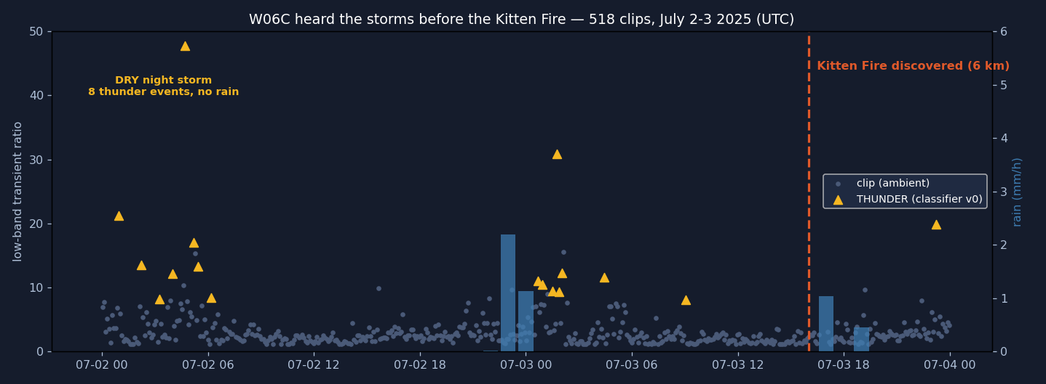
Figure 2 — Kitten Fire acoustic timeline: a dry night storm (0.0 mm rain), a second storm the next evening, then the discovery line.

4.2 The Selma bust — southwest Oregon
On July 8, 2025, WFIGS logged 14 natural-cause fires in a single day, 14–34 km from node W067. The node's own rain gauge recorded 0.06 mm across five days under a 37 °C spike — and its only movement, a 0.05 mm trace, lands exactly on the fire line: the ignition storm itself, passing essentially dry. This case validates the risk side of the system using weather data alone (the node had no audio sampler running).

4.3 Halemaʻumaʻu plume — Hawaiʻi Volcanoes National Park
On October 5, 2025, node W097's fixed fire-watch camera flagged the persistent volcanic gas plume with its production smoke detector — the same day the node's steerable PTZ camera studied canopy. Together with the cabin wall, this is the recurring lesson: camera capability was never the gap; watch tasking is.
In plain terms: Three different fires, one moral. The fleet's cameras and microphones already see and hear what matters — but nothing tells them where to look or when to listen. FlashPoint is that missing tasking layer.

5. Data sources
Source | What it provided
Sage node archives | W06C: 779 audio clips, 2,739 PTZ frames, 51.7k weather records (Jul 1–4, 2025); W067: 216 images, 25.9k weather records; 518 clips hand-classified.
Sage APIs + MCP server | Public query API for telemetry; the Sage Grande MCP server's authenticated proxy carried every archive file download; its job tools are the planned path for live storm-mode control.
NOAA GOES GLM (AWS Open Data) | Dual-satellite falsification (GOES-18 + GOES-19); the 219-flash ignition storm; Jetstream2 bulk scan of 7.05M granules → 353 fires near nodes → 448 ranked candidates.
NASA Earthdata | POWER dryness (GWETTOP) at both fire sites; SMAP L3 soil-moisture retrievals via Earthdata Login — moisture inputs the fleet cannot measure itself (no soil sensor publishes anywhere on the fleet).
NIFC WFIGS | Fire records with agency-determined cause: Kitten, Signal Flat, and the 14-fire Selma day. News (Buckrail) used as corroboration only.
Live weather feeds | NWS forecasts plus Vaisala Xweather lightning / storm-cell / threat endpoints, live-verified — the controller's arming inputs.

6. Methods — the mathematics, quoted from the code that runs
Every formula below was verified against the repository at the time of writing. File references are given per subsection; the two central implementations are fusion/engine.py (candidate pairing, consistency, gating) and dashboard/fp/geo.py (projection, trilateration, uncertainty).

6.1 Flash detection — the camera as a photometer (plugin-flash/detectors/flash.py)
The fixed wide-angle sky camera is used as a photometer, not a telescope: lightning illuminates the whole sky, so a flash registers as a scene-wide jump in mean frame luminance above a rolling baseline, whether or not the lightning channel is in frame. No aiming is involved. Because the sky is lit only while the flash burns (~0.2–1 s), a detected flash timestamps the strike to about ±0.5 s regardless of frame cadence, which propagates to only ~±170 m of range error. Sparse snapshot cadences instead cost catch probability, so events from sparse sequences carry a sparse_cadence flag meaning “absence of events proves nothing.” The brightest angular sector around the fisheye center additionally yields a coarse flash bearing.
In plain terms: Think of the camera as a light meter pointed at the sky. When lightning fires anywhere overhead, the whole image gets brighter for a fraction of a second. We do not need to see the bolt — just the brightening — and the moment of brightening is our stopwatch's start button.

6.2 Thunder detection — noise-adaptive whitened onset (plugin-flash/detectors/thunder.py)
The v0 failure taught that absolute low-band energy is the wrong axis in a storm: steady rain both masks real thunder and imitates it. The rebuilt detector (1) estimates a per-frequency stationary noise floor from the clip itself (the 20th percentile over STFT frames), so rain and wind noise are absorbed into the floor whatever their level; (2) measures whitened excess — decibels above that adaptive floor within the 15–200 Hz thunder band — with hysteresis (an event opens at +6 dB and closes at +3 dB); (3) gates events on thunder morphology: rumble-scale duration (≥0.7 s standalone, ≥0.4 s anchored), a fast leading edge with a slower decay, and a requirement that at least 12% of energy sits in the 60–200 Hz clap band (pure sub-60 Hz excess is wind buffeting); and (4) uses the node's anemometer as the primary wind veto (above 8 m/s, spectral gates tighten). In anchored mode, attention is restricted to the physical arrival window after each known lightning time, and an implied range must agree with the anchor's within 5 km.
In plain terms: Instead of asking “is it loud down low?” — which rain also is — the detector first learns what this particular clip's steady background sounds like at every pitch, then looks only for sounds that punch above that background in the way thunder does: a sudden arrival, a long rumbling tail, and energy spread across the right pitches. And when we already know a flash happened at time T, we only listen in the little window where its thunder could physically arrive.

6.3 Flash-to-bang ranging (plugin-flash/detectors/physics.py; fusion/engine.py)
c = 343 + 0.6 × (T − 20 °C) [m/s]
speed of sound, linearized around 20 °C, using the node's own thermometer
rᵢ = (t_thunder,ᵢ − t_flash) × c
per-node range from the flash-to-bang delay
Light arrives effectively instantly, so the flash is a free, absolute time-zero at every node — no cross-node clock synchronization is required. The engine groups flashes across nodes within 1.5 s into one strike (light is simultaneous fleet-wide at these scales) and pairs thunder events that trail their flash by 0.9–90 s, i.e., ranges of roughly 0.3–30 km.
In plain terms: This is the campfire trick — count seconds between the flash and the boom, divide by three to get kilometers — done precisely: about 343 meters per second, corrected for temperature, with each node counting from the same universal starting gun (the flash itself).

6.4 Trilateration — weighted least squares (dashboard/fp/geo.py)
Node coordinates are projected to local east/north meters via a flat-earth approximation valid at sub-50 km scales: x = (lon − lon₀) · 111,320 · cos(lat₀), y = (lat − lat₀) · 110,540. Each node's range defines a circle; the strike estimate is the point that best satisfies all circles at once:
p̂ = argmin_p Σᵢ [ ( ‖p − aᵢ‖ − rᵢ ) / σᵢ ]²
aᵢ = node position, rᵢ = its range, σᵢ = its range uncertainty (default 200 m)
The minimization is solved by Gauss–Newton iteration: at each step the residuals (distance-minus-range, weighted by 1/σ) are linearized through the Jacobian J whose rows are the unit vectors from each node toward the current estimate, and the step is the least-squares solution of Jw·Δp = −res (up to 60 iterations, converged when the step falls below 1 cm). Because the cost surface can have multiple minima, the solver is multistarted from every circle-pair intersection plus the centroid, and near-duplicate solutions (within 50 m) are merged; the lowest-cost survivor wins.
In plain terms: Draw a circle around each node with radius “how far the thunder said the strike was.” The strike is where the circles cross. Real measurements are noisy, so the circles never cross perfectly — the algorithm finds the point that comes closest to touching all of them, weighting trustworthy measurements more, and it starts the search from every place two circles cross so it cannot get stuck on the wrong side.

6.5 Consistency selection and honesty gates (fusion/engine.py; geo.py)
Each node may contribute several candidate ranges (real thunder plus rain artifacts). The engine sweeps up to 4,096 combinations of one candidate per node and keeps the combination with the lowest joint trilateration residual — random rain artifacts do not agree across nodes; real thunder does. Every accepted solution then passes through geometry gates before it may be called a fix:
GDOP = √( Σ 1/λᵢ ) = √tr( (JᵀJ)⁻¹ ), gate: GDOP ≤ 30
λᵢ = eigenvalues of JᵀJ, the unit-vector geometry matrix at the solution
GDOP (geometric dilution of precision) measures how much the node geometry amplifies range error into position error. A rank-deficient geometry (e.g., collinear nodes) is detected explicitly by a near-zero eigenvalue and reported as degenerate — the code deliberately avoids the pseudo-inverse, which would hide the defect behind a small, false GDOP. The 1-σ uncertainty ellipse comes from the weighted covariance (Jwᵀ Jw)⁻¹, scaled by the residual variance per degree of freedom; its eigenvalues give the semi-axes and its eigenvectors the orientation. Two-node solutions are intrinsically bimodal (two mirror intersections) and are labeled ambiguous, as is any solution whose runner-up cost ties the winner within 5%. The output vocabulary is deliberately three-valued: fix, ambiguous, or range-only — the system never silently over-claims.
In plain terms: Two checks keep the system honest. First: does one consistent story explain what several nodes heard? Second: even if it does, is the geometry good enough to pin the point down? Nodes in a straight line, for example, cannot tell you which side of the line the strike was on — and rather than guess, the system says “ambiguous” out loud.

6.6 Learning layer — classifier probe v0 (plugin-flash/detectors/probe_v0.py)
The first neural result uses frozen YAMNet audio embeddings (concatenated mean and max over frames, 2,048 dimensions) with a standardized, class-balanced logistic regression, evaluated by stratified 5-fold cross-validation on 13 positive and 27 control-negative clips: AUC 0.952, versus 0.699 for the DSP clip score on identical labels. At an operating point allowing zero false alarms on 0.225 hours of control audio, the probe recalls 9/13 thunder clips (15/22 arrivals) versus 1/13 for the DSP baseline. Reviewer clicks in the Slack loop (Confirm / False positive / Keep watching) accumulate as the next labeled training set.
In plain terms: A large Google-trained audio model turns each clip into a long list of numbers describing what it sounds like; a simple statistical separator then learns which number patterns mean thunder. Even with only 40 labeled clips it beats the hand-tuned signal-processing score decisively — and every reviewer click on an alert quietly grows the training set for the next version.

6.7 Ignition-risk score (risk/score.py)
risk = 35·dry(rain) + 30·dryness + 20·fuel + 15·thunder_conf
rain from the node gauge (strike time ± 30 min); dryness from NASA POWER GWETTOP; fuel from land-cover class; confidence from the detection chain
The weights are deliberately transparent, and every factor carries its source on the alert card. Back-test: the two real ignition storms score 87 (Kitten) and 84 (Selma); a wet-storm control scores 41; a no-strike day emits no card at all.
In plain terms: No black box here: four understandable ingredients — did rain accompany the strike, how dry is the ground, what fuel is nearby, how confident was the detection — each with a fixed number of points. Anyone reading an alert can see exactly why it scored what it scored.

7. Validation and results
Validation is layered: unit and integration tests on the laptop; the full suite re-run on camp node H03E (ARM64), where the edge plugin was built and actually run, publishing candidates to the Sage cloud API; the smoke-watch skillset exercised through the real sage-agent gateway on that node (test-mode PTZ, live Gemma 4 captions, YOLO11 detection boxes); and a bulk retrospective scaled out on ACCESS Jetstream2. One safety finding from that ladder: the NVIDIA NIM cloud endpoint silently drops attached images, and its text model hallucinated a building fire when offered pixels — the cloud escalation rung is therefore configuration-restricted to text-only triage. All alerting is human-reviewed in Slack; nothing is ever auto-dispatched.
Result | Value
Audio-only candidates surviving dual-satellite falsification | 0 of 17 (GOES-18 + GOES-19, ±90 s, 50 km radius)
Real ignition storm located (GLM scan) | 219 flashes ≤ 25 km; closest 3.1 km from the fire point, ~3 h before discovery
Anchored re-listening recovery | 22 flash-to-bang arrivals; rebuilt detector recall 20/22; median range error 0.7 km
Localization integration test | 96 m fix — no satellite, no clock synchronization
Replayed multi-node storm (real Argonne geometry) | 5/5 strikes fixed, errors 70–273 m
Storm-mode controller | 19/19 tests; armed 145 min before first local flash on the real-storm replay
Classifier probe v0 (5-fold CV) | AUC 0.952 vs 0.699 DSP baseline; at zero false alarms: 9/13 clips vs 1/13
Risk score back-test | Kitten 87, Selma 84, wet control 41, no-strike day 0
Jetstream2 fleet-history catalog | 7.05M GLM granules read; 353 fires near nodes; 448 ranked candidates (Kitten ranks #4)
Thunder-only TDOA feasibility (Monte Carlo, real coordinates) | median error 135 / 216 / 331 m at onset σ = 50 / 100 / 200 ms

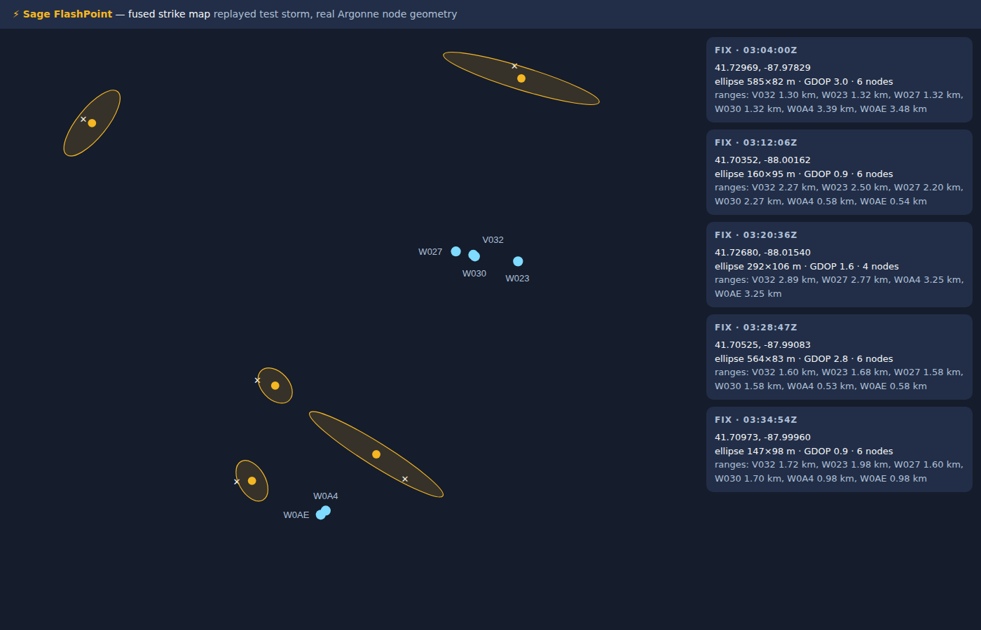
Figure 3 — Fused strike map from a replayed storm over the real Argonne node geometry: five strikes, all clean fixes, each with its uncertainty ellipse.

8. Findings returned to Sage
- Instrumentation gap — no soil, leaf, or fuel-moisture sensor publishes anywhere on the fleet (verified by a three-day sweep) — moisture inputs must come from NASA products until an on-node probe lands.
- The manifest is not the archive — 97 nodes list microphones in the manifest, but only 64 have ever recorded; W021 (Colorado) records 172k clips with no microphone listed.
- Microphone seasonality — the fleet's #2 and #3 most fire-exposed recording nodes (V040/V041, Oregon) ran their microphones only in autumn–winter, capturing 0 of their 35 storm days.
- Camera siting caps the smoke leg — W06C sits low in forest; smoke confirmation needs ridge-top “sentinel” placement or cueing partner camera networks (ALERTWildfire, HPWREN). Tasking and siting are separate failures with separate remedies.
- Liveness is task-level — a node can look healthy while a task is silently down — W096's image sampler was quiet for 24+ hours while weather and audio kept flowing.

9. Limitations
- One real storm (Kitten) validates the audio chain end-to-end; fusion and flash detection are validated in replay and integration tests — real multi-node captures require storm mode running live on the fleet.
- Available ground truth (satellite pixels, 8–14 km) is coarser than the sub-kilometer claims; a Vaisala NLDN research-data request was submitted July 24 and is not yet approved.
- Read access to key fire-country node archives (W067 imagery, W084/W06F, W019) was requested but not granted — additional storm and fire cases went unexamined.
- Live PTZ control is untested: the sanctioned sandbox camera (node W0A4) was reachable through an SSH tunnel, but control permissions were not granted, so re-aim runs in test mode only.
- No smoke model runs at the edge yet: SmokeyNet (the official Sage smoke plugin's model) is adopted and planned; current detection boxes come from YOLO11, and Gemma 4 provides captions.
- One hackathon week of scope: v0.1 risk weights, dry-run job control, and a replay harness standing in for live scheduling permissions.

10. Future directions
- NLDN ground truth — evaluation-grade ground truth for the sub-kilometer claims (request pending).
- Neural classifier — grow probe v0 with reviewer-click labels; distill toward an edge-deployable classifier.
- Smoke leg — SmokeyNet on watch cadence with horizon-band cropping and 3–5 minute dwells per strike sector.
- Radio-frequency time-zero — an SDR (software-defined radio) sferic pulse as the per-node time-zero — daytime parity with the night-strong camera flash; no SDR is deployed on the fleet today.
- Hawaiʻi variant — the same controller re-armed on wind triggers becomes the Hawaiʻi deployment on HCDP (Hawaiʻi Climate Data Portal) mesonet feeds.
- Agent and actuation — instantiate the Beehive-level orchestrator agent the skillset was shaped for (waggle-sensor/sage-agent), and obtain camera-control credentials on the W0A4 sandbox for real re-aim.

11. Reproducibility and artifacts
Everything — code, data, the actual thunder recordings, figures, the presentation deck, and this report — lives in github.com/scwatson4/sage-summer-camp-2026 under flashpoint/. The edge plugin is published on the Sage app portal at portal.sagecontinuum.org/apps/app/scwatson/flashpoint-thunder. Key entry points: detectors/ (flash, thunder, probe v0), fusion/ (engine, strike maps), controller/ (storm mode, replay), risk/ (score, Slack cards), catalog/ (Jetstream2 scan outputs), plugin-flash/, plugin-stormmode/, plugin-smoke-watch/ (ECR edge-app packaging), and project.md (the full writeup with case-file media).

12. References
- Sage / Waggle — sagecontinuum.org: the testbed, node hardware, data APIs, and the audio-sampler, ptz-yolo, and smoke-detector plugins whose archives made the retrospectives possible.
- NIFC WFIGS Incident Locations — data-nifc.opendata.arcgis.com: the interagency wildfire incident ledger (IRWIN-fed); all fire-cause labels are agency determinations.
- NOAA GOES-18/19 Geostationary Lightning Mapper — AWS Open Data registry (registry.opendata.aws/noaa-goes).
- NASA POWER (power.larc.nasa.gov) and NASA SMAP L3 (nsidc.org/data/spl3smp_e) via Earthdata Login.
- National Weather Service API — api.weather.gov.
- Vaisala Xweather — xweather.com (lightning, storm cells, threats endpoints).
- Sage Grande MCP server — mcp.sagecontinuum.org (authenticated storage proxy; query and job tools).
- ACCESS Jetstream2 (Indiana University) — cloud platform for the GLM bulk catalog scan.
- sage-smoke-detection — github.com/sagecontinuum/sage-smoke-detection: official SmokeyNet plugin (HPWREN/FIgLib-trained).
- sage-agent — github.com/waggle-sensor/sage-agent: the agentic gateway the smoke-watch skills target.
- Sage Autonomous Camera Control (Dematties et al.) and the Sage SDR lightning project — sagecontinuum.org/science.
- YAMNet (Google Research, TF-Hub) · Ultralytics YOLO11 · Gemma 4 via Ollama · GLM-4.x via NVIDIA NIM.
- Buckrail, July 3, 2025 — news corroboration of the Bridger-Teton lightning week (4,000+ strikes, 8 starts).

Acknowledgments. Samuel Watson (University of Hawaiʻi at Mānoa / Hawaiʻi Climate Data Portal), with Claude (Anthropic) as pair-programmer throughout. Thanks to the Sage Summer Camp 2026 organizers for node access grants, and to the Sage team for keeping five years of fleet archives queryable enough that a week-long hackathon could mine them. This work was supported in part by the National Science Foundation under Awards No. 2331263 and 2436842.

