1. Get the authentication token (if necessary)

<https://help.github.com/articles/creating-a-personal-access-token-for-the-command-line/>

1. Download a local version of the repository in an appropriate folder location:

git clone <https://github.com/scworland-usgs/wateruse-waterbudget.git>

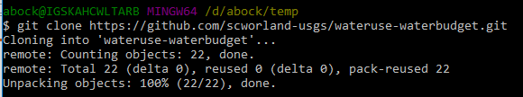

1. Check the status of files in the repo; if there are changes are new files they will be highlighted wit the git status command

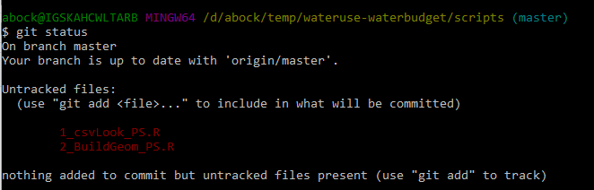

1. Add and commit files, add comments with the “commit” command

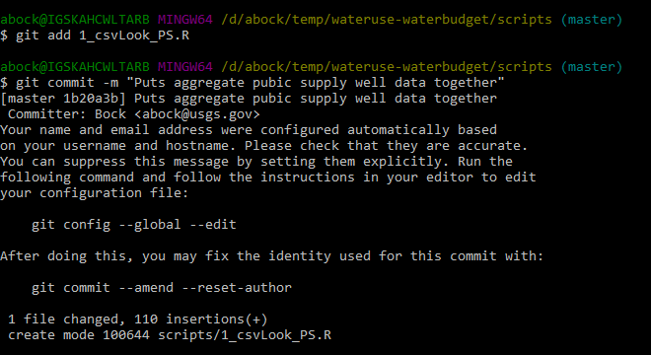

1. Push changes to repo (will be prompted with a username/password the first time in a session)

