浙大城市学院实验报告
课程名称 物联网技术与应用 实验项目 实验12 Node-RED数据可视化
专业班级 计算2002 学号 32001019 姓名 司晨旭
指导老师（签名 ） 蔡建平 日期 2022/12/5 实验成绩
请分别提交实验代码文件和实验报告
一、实验目的：
学习Node-RED相关内容，掌握Node-RED MQTT客户端的设计以及Dashboard数据可视化，学习微信小程序E-Charts组件使用。
二、实验内容：
1.完成基于Node-RED的MQTT客户端的设计，实现发布和订阅。
2.完成数据可视化设计，力求界面美观。

三、实验步骤：
1. 基于Node-RED实现MQTT消息的发布和订阅；
图形代码和JSON代码：

图形代码截图：
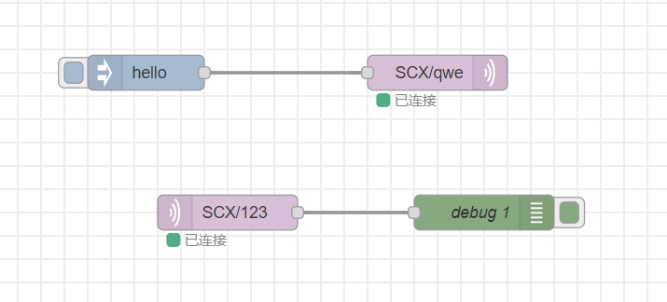

JSON代码：
[
{
"id": "99d2c329fdce6ad6",
"type": "tab",
"label": "流程 1",
"disabled": false,
"info": "",
"env": []
},
{
"id": "8414cbe0e5c76352",
"type": "mqtt in",
"z": "99d2c329fdce6ad6",
"name": "",
"topic": "SCX/123",
"qos": "2",
"datatype": "auto-detect",
"broker": "38aecd9549d4f08f",
"nl": false,
"rap": true,
"rh": 0,
"inputs": 0,
"x": 200,
"y": 260,
"wires": [
[
"52b9e091aad5a5c3"
]
]
},
{
"id": "978ac3e24110d828",
"type": "mqtt out",
"z": "99d2c329fdce6ad6",
"name": "",
"topic": "SCX/qwe",
"qos": "",
"retain": "",
"respTopic": "",
"contentType": "",
"userProps": "",
"correl": "",
"expiry": "",
"broker": "38aecd9549d4f08f",
"x": 380,
"y": 140,
"wires": []
},
{
"id": "340d3ce675c4411c",
"type": "inject",
"z": "99d2c329fdce6ad6",
"name": "",
"props": [
{
"p": "payload"
},
{
"p": "topic",
"vt": "str"
}
],
"repeat": "",
"crontab": "",
"once": false,
"onceDelay": 0.1,
"topic": "",
"payload": "hello",
"payloadType": "str",
"x": 130,
"y": 140,
"wires": [
[
"978ac3e24110d828"
]
]
},
{
"id": "52b9e091aad5a5c3",
"type": "debug",
"z": "99d2c329fdce6ad6",
"name": "debug 1",
"active": true,
"tosidebar": true,
"console": false,
"tostatus": false,
"complete": "false",
"statusVal": "",
"statusType": "auto",
"x": 420,
"y": 260,
"wires": []
},
{
"id": "38aecd9549d4f08f",
"type": "mqtt-broker",
"name": "SCX",
"broker": "121.5.180.148",
"port": "1883",
"clientid": "",
"autoConnect": true,
"usetls": false,
"protocolVersion": "4",
"keepalive": "60",
"cleansession": true,
"birthTopic": "",
"birthQos": "0",
"birthPayload": "",
"birthMsg": {},
"closeTopic": "",
"closeQos": "0",
"closePayload": "",
"closeMsg": {},
"willTopic": "",
"willQos": "0",
"willPayload": "",
"willMsg": {},
"userProps": "",
"sessionExpiry": ""
}
]

2. 在Node-RED上实现对ESP8266发布的温湿度数据的解析与显示，要求包括Chart控件和gauge控件；（topic格式： espCJP）
图形代码：
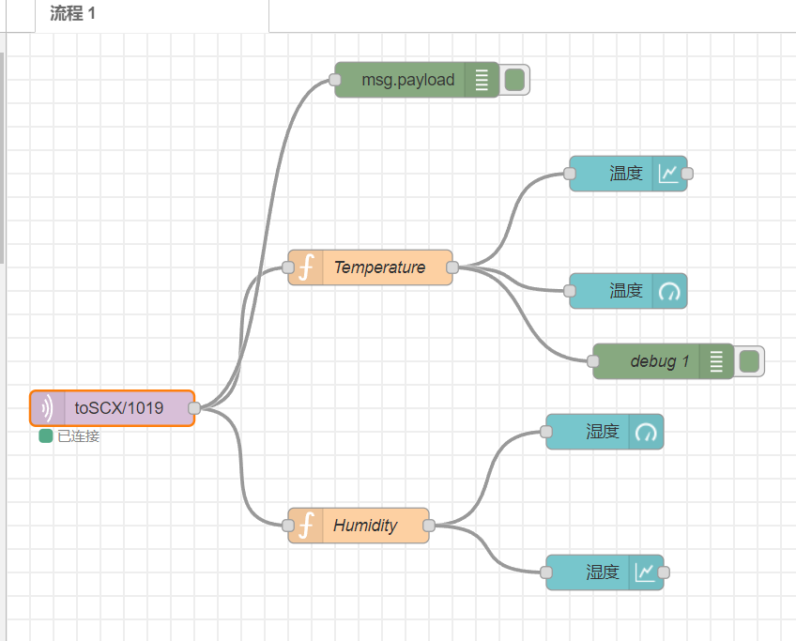

JSON代码：
[
{
"id": "8414cbe0e5c76352",
"type": "mqtt in",
"z": "99d2c329fdce6ad6",
"name": "",
"topic": "espSCX",
"qos": "2",
"datatype": "utf8",
"broker": "38aecd9549d4f08f",
"nl": false,
"rap": true,
"rh": 0,
"inputs": 0,
"x": 80,
"y": 420,
"wires": [
[
"b9ec948bd782b951",
"1ad01a4b8e6cfbe9",
"2286d3599a7d687f"
]
]
},
{
"id": "38aecd9549d4f08f",
"type": "mqtt-broker",
"name": "SCX",
"broker": "121.5.180.148",
"port": "1883",
"clientid": "",
"autoConnect": true,
"usetls": false,
"protocolVersion": "4",
"keepalive": "60",
"cleansession": true,
"birthTopic": "",
"birthQos": "0",
"birthPayload": "",
"birthMsg": {},
"closeTopic": "",
"closeQos": "0",
"closePayload": "",
"closeMsg": {},
"willTopic": "",
"willQos": "0",
"willPayload": "",
"willMsg": {},
"userProps": "",
"sessionExpiry": ""
}
]

运行效果：
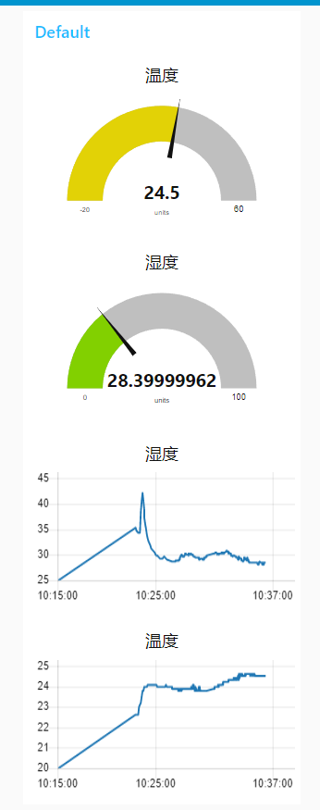

3. 在Node-RED上实现按钮控制ESP8266 RGB灯的显示控制和ESP8266 OLED屏的显示内容发送；（topic格式： nodeCJP）

图形代码：
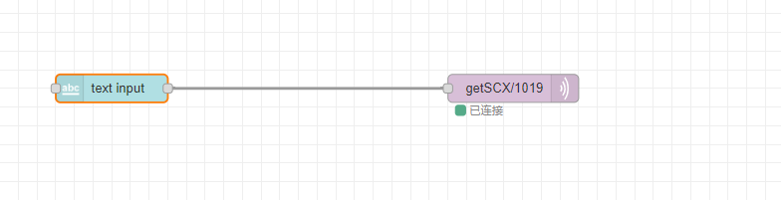

JSON代码：
[
{
"id": "2854d35f2d87a9e7",
"type": "ui_text_input",
"z": "99d2c329fdce6ad6",
"name": "",
"label": "",
"tooltip": "",
"group": "8fcf820d5cd4fba7",
"order": 4,
"width": 0,
"height": 0,
"passthru": true,
"mode": "text",
"delay": 300,
"topic": "topic",
"sendOnBlur": true,
"className": "",
"topicType": "msg",
"x": 300,
"y": 820,
"wires": [
[
"a9fc4b1715f33a2e"
]
]
},
{
"id": "a9fc4b1715f33a2e",
"type": "mqtt out",
"z": "99d2c329fdce6ad6",
"name": "",
"topic": "getSCX/1019",
"qos": "",
"retain": "",
"respTopic": "",
"contentType": "",
"userProps": "",
"correl": "",
"expiry": "",
"broker": "38aecd9549d4f08f",
"x": 730,
"y": 820,
"wires": []
},
{
"id": "8fcf820d5cd4fba7",
"type": "ui_group",
"name": "Default",
"tab": "cc80e38ec41658a8",
"order": 1,
"disp": true,
"width": "6",
"collapse": false,
"className": ""
},
{
"id": "38aecd9549d4f08f",
"type": "mqtt-broker",
"name": "SCX",
"broker": "121.5.180.148",
"port": "1883",
"clientid": "",
"autoConnect": true,
"usetls": false,
"protocolVersion": "4",
"keepalive": "60",
"cleansession": true,
"birthTopic": "",
"birthQos": "0",
"birthPayload": "",
"birthMsg": {},
"closeTopic": "",
"closeQos": "0",
"closePayload": "",
"closeMsg": {},
"willTopic": "",
"willQos": "0",
"willPayload": "",
"willMsg": {},
"userProps": "",
"sessionExpiry": ""
},
{
"id": "cc80e38ec41658a8",
"type": "ui_tab",
"name": "Home",
"icon": "dashboard",
"disabled": false,
"hidden": false
}
]

运行效果：
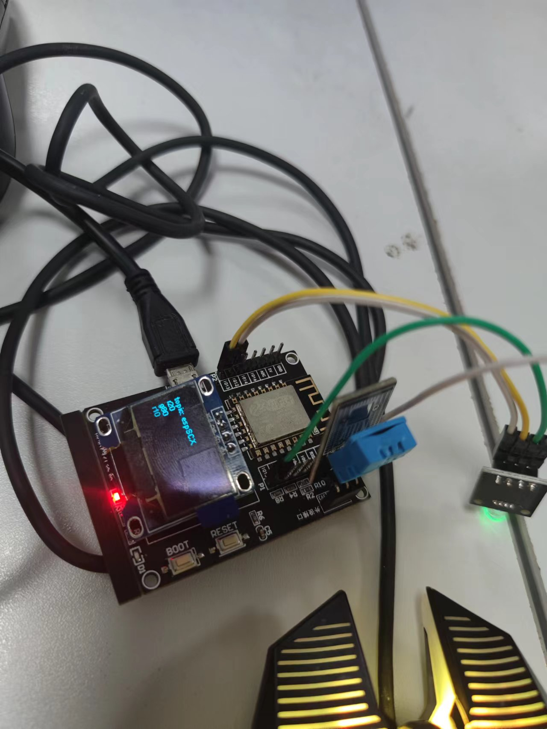

- （本次选做）微信小程序温湿度数据可视化
详细代码在作业十一中，上周已经完成
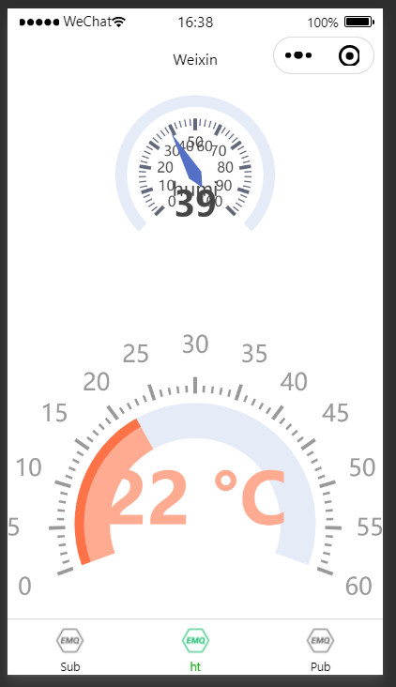

// pages/humitemp/humitemp.js
import * as echarts from '../../ec-canvas/echarts';

const app = getApp();
var mqtt = require('../../utils/mqtt.js');

function initChartHumi(canvas, width, height, dpr) {

const chart = echarts.init(canvas, null, {
width: width,
height: height,
devicePixelRatio: dpr
});
canvas.setChart(chart);
var humi = parseInt(app.globalData.humi);
var temp = parseInt(app.globalData.temp);
var option = {
tooltip: {
formatter: '{a} <br/>{b} : {c}%'
},
series: [
{
name: 'Pressure',
type: 'gauge',
detail: {
formatter: '{value}'
},
data: [
{
value: parseInt(app.globalData.humi),
name: 'humi'
}
]
}
]
};

setInterval(function() {
option.series[0].data[0].value = parseInt(app.globalData.humi);
chart.setOption(option, true);
}, 2000)

chart.setOption(option,true);
return chart;
}

function initChartTemp(canvas, width, height, dpr) {

const chart = echarts.init(canvas, null, {
width: width,
height: height,
devicePixelRatio: dpr
});
canvas.setChart(chart);
var humi = parseInt(app.globalData.humi);
var temp = parseInt(app.globalData.temp);
var option = {
series: [
{
type: 'gauge',
center: ['50%', '60%'],
startAngle: 200,
endAngle: -20,
min: 0,
max: 60,
splitNumber: 12,
itemStyle: {
color: '#FFAB91'
},
progress: {
show: true,
width: 30
},
pointer: {
show: false
},
axisLine: {
lineStyle: {
width: 30
}
},
axisTick: {
distance: -45,
splitNumber: 5,
lineStyle: {
width: 2,
color: '#999'
}
},
splitLine: {
distance: -52,
length: 14,
lineStyle: {
width: 3,
color: '#999'
}
},
axisLabel: {
distance: -20,
color: '#999',
fontSize: 20
},
anchor: {
show: false
},
title: {
show: false
},
detail: {
valueAnimation: true,
width: '60%',
lineHeight: 40,
borderRadius: 8,
offsetCenter: [0, '-15%'],
fontSize: 60,
fontWeight: 'bolder',
formatter: '{value} °C',
color: 'auto'
},
data: [
{
value: parseInt(app.globalData.temp)
}
]
},
{
type: 'gauge',
center: ['50%', '60%'],
startAngle: 200,
endAngle: -20,
min: 0,
max: 60,
itemStyle: {
color: '#FD7347'
},
progress: {
show: true,
width: 8
},
pointer: {
show: false
},
axisLine: {
show: false
},
axisTick: {
show: false
},
splitLine: {
show: false
},
axisLabel: {
show: false
},
detail: {
show: false
},
data: [
{
value: parseInt(app.globalData.temp)
}
]
}
]
};
setInterval(function () {

chart.setOption({
series: [
{
data: [
{
value: parseInt(app.globalData.temp)
}
]
},
{
data: [
{
value: parseInt(app.globalData.temp)
}
]
}
]
});
}, 2000);

chart.setOption(option,true);
return chart;
}

Page({
data: {

ec: {
onInit: initChartHumi
},
ec1:{
onInit: initChartTemp
}
}
})

- 本次实验心得与体会
node-red 不会多文本框读入

