实验五 JavaFX UI控件和多媒体

学号： 32001019 姓名： 司晨旭 班级： 计算2002
【实验目的和要求】
- 常见JavaFX UI控件。
- 数据库控件和UI数据集成。
- 实现增删改查功能。
【实验内容】
- 利用JavaFX编写一个数据库模块，实现学生信息的增删改查功能，修改的时候需要把原先录入的数据设置到界面上，查询的时候根据学号全匹配的形式查询，数据库采用MySQL数据库。

主要的信息包括如下：
学号：字符串
姓名：字符串
性别：（男、女）单选框
电话：：字符串
家庭地址：：字符串
兴趣爱好：（旅游、美食、体育、音乐、阅读、其他）多选框
生源地区（华东、华南、华北、华中、西北、西南、东北）
熟悉的开发语言（Java、Python、C、C++、JavaScript），可以多选，列表从数据库中读取。

代码：（截图和源代码）

Interface.java
package com.five;

import java.sql.Connection;
import java.sql.ResultSet;
import java.sql.Struct;
import java.util.ArrayList;

import javafx.application.Application;
import javafx.geometry.Insets;
import javafx.geometry.Pos;
import javafx.scene.Scene;
import javafx.scene.control.Button;
import javafx.scene.control.CheckBox;
import javafx.scene.control.ChoiceBox;
import javafx.scene.control.Label;
import javafx.scene.control.RadioButton;
import javafx.scene.control.TextField;
import javafx.scene.control.ToggleGroup;
import javafx.scene.layout.FlowPane;
import javafx.scene.layout.GridPane;
import javafx.scene.layout.HBox;
import javafx.scene.layout.Priority;
import javafx.scene.layout.VBox;
import javafx.stage.Stage;

public class Interface extends Application{

TextField idField;
TextField nameField;
TextField phoneField;
TextField homeField;
CheckBox c1 ;
CheckBox c2 ;
CheckBox c3 ;
CheckBox c4 ;
CheckBox c5 ;
CheckBox c6 ;
CheckBox l1 ;
CheckBox l2 ;
CheckBox l3 ;
CheckBox l4 ;
CheckBox l5 ;
ChoiceBox fromBox;
RadioButton manButton;
RadioButton womanRadioButton;
@Override
public void start(Stage primamStage) throws Exception {
// TODO Auto-generated method stub
// FlowPane pane = new FlowPane();
// pane.setPadding(new Insets(11, 12, 13, 14));
// pane.setHgap(5);
// pane.setVgap(5);
GridPane pane = new GridPane();

pane.setAlignment(Pos.CENTER);
pane.setPadding(new Insets(11.5, 12.5, 13.5, 14.5));
pane.setHgap(5.5);
pane.setVgap(5.5);
Label idLabel = new Label("id:");
idField = new TextField();
Label nameLabel = new Label("name:");
nameField = new TextField();

ToggleGroup sexGroup = new ToggleGroup();
manButton = new RadioButton("man");
womanRadioButton = new RadioButton("woman");
manButton.setToggleGroup(sexGroup);
womanRadioButton.setToggleGroup(sexGroup);

Label homeLabel = new Label("home:");
homeField = new TextField();

Label phoneLabel = new Label("phone:");
phoneField = new TextField();
Label hobbyLabel = new Label("hobby:");
//多选框 CheckBox

c1 = new CheckBox("旅游");
c2 = new CheckBox("美食");
c3 = new CheckBox("体育");
c4 = new CheckBox("音乐");
c5 = new CheckBox("阅读");
c6 = new CheckBox("其他");

HBox hobbyBox = new HBox(c1,c2,c3,c4,c5,c6);

Label languageLabel = new Label("language:");
l1 = new CheckBox("Java");
l2 = new CheckBox("Python");
l3 = new CheckBox("C");
l4 = new CheckBox("C++");
l5 = new CheckBox("JavaScript");
HBox languageBox = new HBox(l1,l2,l3,l4,l5);

Label fromLabel = new Label("From:");
fromBox = new ChoiceBox();
fromBox.getItems().addAll("华北","华中","华南","华东","华西","西北","西南","东北","东南");

Button selectButton = new Button("select");
selectButton.setOnAction(e -> fillable());

Button saveButton = new Button("save");
saveButton.setOnAction(e->saveStudent());

Button updateButton = new Button("update");
updateButton.setOnAction(e->updateAble());

Button deleteButton = new Button("delete");
deleteButton.setOnAction(e->deleteStudent());
Button addButton = new Button("add");
addButton.setOnAction(e->addStudent());

// pane.add(idLabel, 0, 0);
// pane.add(idField, 1, 0);
// pane.add(selectButton, 2, 0);
// pane.add(nameLabel, 0, 1);
// pane.add(nameField, 1, 1);
// pane.add(saveButton, 2, 1);
// pane.add(manButton, 0, 2);
// pane.add(womanRadioButton, 1, 2);
// pane.add(updateButton, 2, 2);
// pane.add(phoneLabel, 0, 3);
// pane.add(phoneField, 1, 3);
// pane.add(deleteButton, 2, 3);
// pane.add(hobbyLabel, 0, 4);
// pane.add(hobbyBox, 1, 4);
// pane.add(addButton, 2,4);
// pane.add(fromLabel, 0, 5);
// pane.add(fromBox, 1, 5);
// pane.add(languageLabel, 0, 6);
// pane.add(languageBox, 1, 6);

pane.add(idLabel, 0, 0);
pane.add(idField, 1, 0);

pane.add(nameLabel, 0, 1);
pane.add(nameField, 1, 1);

pane.add(manButton, 0, 2);
pane.add(womanRadioButton, 1, 2);

pane.add(homeLabel, 0, 3);
pane.add(homeField, 1, 3);

pane.add(phoneLabel, 0, 4);
pane.add(phoneField, 1, 4);

pane.add(hobbyLabel, 0, 5);
pane.add(hobbyBox, 1, 5);

pane.add(fromLabel, 0, 6);
pane.add(fromBox, 1, 6);
pane.add(languageLabel, 0, 7);
pane.add(languageBox, 1, 7);

pane.add(selectButton, 2, 0);
pane.add(saveButton, 2, 1);
pane.add(updateButton, 2, 2);
pane.add(deleteButton, 2, 3);
pane.add(addButton, 2,4);
// FlowPane pane1 = new FlowPane();
// GridPane pane1 = new GridPane();
// pane1.setAlignment(Pos.CENTER);
// Label addressLabel = new Label("From:");
// ToggleGroup addressGroup = new ToggleGroup();
// RadioButton dongRadioButton = new RadioButton("华东");
// dongRadioButton.setToggleGroup(addressGroup);
// RadioButton nanRadioButton = new RadioButton("华南");
// nanRadioButton.setToggleGroup(addressGroup);
// RadioButton beiRadioButton = new RadioButton("华北");
// beiRadioButton.setToggleGroup(addressGroup);
// RadioButton zhongRadioButton = new RadioButton("华中");
// zhongRadioButton.setToggleGroup(addressGroup);
// RadioButton xiRadioButton = new RadioButton("华西");
// xiRadioButton.setToggleGroup(addressGroup);
// RadioButton xibeiRadioButton = new RadioButton("西北");
// xibeiRadioButton.setToggleGroup(addressGroup);
// RadioButton xinanRadioButton = new RadioButton("西南");
// xinanRadioButton.setToggleGroup(addressGroup);
// RadioButton dongbeiRadioButton = new RadioButton("东北");
// dongbeiRadioButton.setToggleGroup(addressGroup);
// RadioButton dongnanRadioButton = new RadioButton("东南");
// dongnanRadioButton.setToggleGroup(addressGroup);
// pane1.add(addressLabel, 0, 0);
// pane1.add(dongRadioButton, 1, 0);
// pane1.add(nanRadioButton, 2, 0);
// pane1.add(beiRadioButton,3,0);
// pane1.add(zhongRadioButton, 4, 0);
// pane1.add(xiRadioButton, 5, 0);
// pane1.add(xibeiRadioButton, 6, 0);
// pane1.add(xinanRadioButton, 7, 0);
// pane1.add(dongbeiRadioButton, 8, 0);
// pane1.add(dongnanRadioButton, 9, 0);

// VBox root = new VBox(pane,pane1);
nameField.setEditable(false);
manButton.setDisable(true);
womanRadioButton.setDisable(true);
homeField.setEditable(false);
phoneField.setEditable(false);
c1.setDisable(true);
c2.setDisable(true);
c3.setDisable(true);
c4.setDisable(true);
c5.setDisable(true);
c6.setDisable(true);
fromBox.setDisable(true);
l1.setDisable(true);
l2.setDisable(true);
l3.setDisable(true);
l4.setDisable(true);
l5.setDisable(true);

Scene scene = new Scene(pane,450,450);
primamStage.setTitle("Interface");
primamStage.setScene(scene);
primamStage.show();

}

private void addStudent() {
// TODO Auto-generated method stub
if(nameField.isEditable()==false) {
return ;
}

String idString = idField.getText();
int id = Integer.parseInt(idString);
String nameString = nameField.getText();
StringBuffer sb = new StringBuffer();
if(manButton.isSelected()==true) {
sb.append("男");
}
else {
sb.append("女");
}
String sexString = sb.toString();
String homeString = homeField.getText();
String phoneString = phoneField.getText();
String fromString = fromBox.getValue().toString();
Student stu = new Student(id,nameString,sexString,homeString,phoneString,fromString);
ArrayList hobbyList = new ArrayList();
if(c1.isSelected()==true) {
hobbyList.add("旅游");
}
if(c2.isSelected()==true) {
hobbyList.add("美食");
}
if(c3.isSelected()==true) {
hobbyList.add("体育");
}
if(c4.isSelected()==true) {
hobbyList.add("音乐");
}
if(c5.isSelected()==true) {
hobbyList.add("阅读");
}
if(c6.isSelected()==true) {
hobbyList.add("其他");
}
ArrayList languageList = new ArrayList();
if(l1.isSelected()==true) {
languageList.add("Java");
}
if(l2.isSelected()==true) {
languageList.add("Python");
}
if(l3.isSelected()==true) {
languageList.add("C");
}
if(l4.isSelected()==true) {
languageList.add("C++");
}
if(l5.isSelected()==true) {
languageList.add("JavaScript");
}
Connection conn = null;
try {
conn = DBUtil.getConnection();
InterfaceDao interfaceDao = new InterfaceDao();
interfaceDao.addStudent(conn, stu);
interfaceDao.addHobby(conn, id, hobbyList);
interfaceDao.addLanguage(conn, id, languageList);
System.out.println("添加学生成功");
} catch (Exception e) {
// TODO: handle exception
e.printStackTrace();
}finally {
DBUtil.release(conn);
}

}

private void deleteStudent() {
// TODO Auto-generated method stub
if(nameField.isEditable()==false) {
return ;
}
String idString = idField.getText();
int id = Integer.parseInt(idString);

Connection conn = null;
try {
conn=DBUtil.getConnection();
InterfaceDao interfaceDao = new InterfaceDao();
interfaceDao.deleteStudent(conn, id);
interfaceDao.deleteHobby(conn, id);
interfaceDao.deleteLanguage(conn, id);
clearInterface();
System.out.println("删除成功");
} catch (Exception e) {
// TODO: handle exception
e.printStackTrace();
}finally {
DBUtil.release(conn);
}
}

private void saveStudent() {
// TODO Auto-generated method stub
if(nameField.isEditable()==false) {
return ;
}
// System.out.println("Yes");
String idString = idField.getText();
int id = Integer.parseInt(idString);
String nameString = nameField.getText();
StringBuffer sb = new StringBuffer();
if(manButton.isSelected()==true) {
sb.append("男");
}
else {
sb.append("女");
}
String sexString = sb.toString();
String homeString = homeField.getText();
String phoneString = phoneField.getText();
String fromString = fromBox.getValue().toString();
Student stu = new Student(id,nameString,sexString,homeString,phoneString,fromString);
ArrayList hobbyList = new ArrayList();
if(c1.isSelected()==true) {
hobbyList.add("旅游");
}
if(c2.isSelected()==true) {
hobbyList.add("美食");
}
if(c3.isSelected()==true) {
hobbyList.add("体育");
}
if(c4.isSelected()==true) {
hobbyList.add("音乐");
}
if(c5.isSelected()==true) {
hobbyList.add("阅读");
}
if(c6.isSelected()==true) {
hobbyList.add("其他");
}
ArrayList languageList = new ArrayList();
if(l1.isSelected()==true) {
languageList.add("Java");
}
if(l2.isSelected()==true) {
languageList.add("Python");
}
if(l3.isSelected()==true) {
languageList.add("C");
}
if(l4.isSelected()==true) {
languageList.add("C++");
}
if(l5.isSelected()==true) {
languageList.add("JavaScript");
}
Connection conn = null;
try {
conn = DBUtil.getConnection();
InterfaceDao interfaceDao = new InterfaceDao();
interfaceDao.saveStu(conn, stu);
interfaceDao.addHobby(conn, id, hobbyList);
interfaceDao.addLanguage(conn, id, languageList);
System.out.println("保存学生成功");
} catch (Exception e) {
// TODO: handle exception
e.printStackTrace();
}
finally {
DBUtil.release(conn);
}

}

private void updateAble() {
// TODO Auto-generated method stub
nameField.setEditable(true);
manButton.setDisable(false);
womanRadioButton.setDisable(false);
homeField.setEditable(true);
phoneField.setEditable(true);
c1.setDisable(false);
c2.setDisable(false);
c3.setDisable(false);
c4.setDisable(false);
c5.setDisable(false);
c6.setDisable(false);
fromBox.setDisable(false);
l1.setDisable(false);
l2.setDisable(false);
l3.setDisable(false);
l4.setDisable(false);
l5.setDisable(false);
System.out.println("可以更改");
}

private void fillable() {
// TODO Auto-generated method stub
Connection conn = null;
try {
conn = DBUtil.getConnection();
InterfaceDao interfaceDao = new InterfaceDao();
String idString = idField.getText();
int id = Integer.parseInt(idString);
ResultSet res = interfaceDao.selectStudent(conn, id);
if(res.next()) {
nameField.setText(res.getString(2));
String sexString = res.getString(3);
if(sexString.equals("男")) {
manButton.setSelected(true);
}
else {
womanRadioButton.setSelected(true);
}
phoneField.setText(res.getString(4));
homeField.setText(res.getString(5));
fromBox.setValue(res.getString(6));

}
//hobby 的多选框设计
ResultSet res1 = interfaceDao.selectHobby(conn, id);
ArrayList anslist1 = new ArrayList();
while(res1.next()) {
anslist1.add(res1.getString(3));
}
if(anslist1.contains("旅游")) {
c1.setSelected(true);
}
if(anslist1.contains("美食")) {
c2.setSelected(true);
}
if(anslist1.contains("体育")) {
c3.setSelected(true);
}
if(anslist1.contains("音乐")) {
c4.setSelected(true);
}
if(anslist1.contains("阅读")) {
c5.setSelected(true);
}
if(anslist1.contains("其他")) {
c6.setSelected(true);
}

//language 的多选框设计
ResultSet res2 = interfaceDao.selectLanguage(conn, id);
ArrayList anslist2 = new ArrayList();
while(res2.next()) {
anslist2.add(res2.getString(3));
}
if(anslist2.contains("Java")) {
l1.setSelected(true);
}
if(anslist2.contains("Python")) {
l2.setSelected(true);
}
if (anslist2.contains("C")) {
l3.setSelected(true);
}
if(anslist2.contains("C++")) {
l4.setSelected(true);
}
if (anslist2.contains("JavaScript")) {
l5.setSelected(true);
}

} catch (Exception e) {
// TODO: handle exception
e.printStackTrace();
}finally {
DBUtil.release(conn);
}

}

public void clearInterface() {
idField.setText("");
nameField.setText("");
manButton.setSelected(false);
womanRadioButton.setSelected(false);
homeField.setText("");
phoneField.setText("");
c1.setSelected(false);
c2.setSelected(false);
c3.setSelected(false);
c4.setSelected(false);
c5.setSelected(false);
c6.setSelected(false);
l1.setSelected(false);
l2.setSelected(false);
l3.setSelected(false);
l4.setSelected(false);
l5.setSelected(false);
fromBox.setValue(null);
}

public static void main(String[] args) {
Application.launch(args);
}

}

InterfaceDao.java
package com.five;

import java.sql.Connection;
import java.sql.PreparedStatement;
import java.sql.ResultSet;
import java.util.ArrayList;

public class InterfaceDao {
//学生表的修改部分
public ResultSet selectStudent (Connection conn,int id)throws Exception{
String sql = "select * from student where id = ?";
PreparedStatement pst = conn.prepareStatement(sql);
pst.setInt(1, id);

return pst.executeQuery();
}

public ResultSet selectHobby(Connection conn,int id)throws Exception{
String sql = "select * from hobby where sid = ?";
PreparedStatement pst = conn.prepareStatement(sql);
pst.setInt(1, id);
return pst.executeQuery();
}

public ResultSet selectLanguage(Connection conn,int id)throws Exception{
String sql = "select * from language where sid = ?";
PreparedStatement pst = conn.prepareStatement(sql);
pst.setInt(1, id);
return pst.executeQuery();
}
public int saveStu(Connection conn,Student stu)throws Exception{
String sql = "update student set name = ?, sex = ? , phone = ? , home = ? ,sfrom = ? where id = ?";
PreparedStatement pst = conn.prepareStatement(sql);
pst.setString(1, stu.getName());
pst.setString(2, stu.getSex());
pst.setString(3, stu.getPhone());
pst.setString(4, stu.getHome());
pst.setString(5, stu.getFrom());
pst.setInt(6, stu.getId());
return pst.executeUpdate();
}
public int addStudent(Connection conn,Student stu)throws Exception{
String sql = "insert into student(id,name,sex,phone,home,sfrom) values(?,?,?,?,?,?) ";
PreparedStatement pst1 = conn.prepareStatement(sql);
pst1.setInt(1, stu.getId());
pst1.setString(2, stu.getName());
pst1.setString(3, stu.getSex());
pst1.setString(4, stu.getPhone());
pst1.setString(5, stu.getHome());
pst1.setString(6, stu.getFrom());

return pst1.executeUpdate();
}

public int deleteStudent(Connection conn,int id)throws Exception{
String sql = "delete from student where id = ?";
PreparedStatement pst1 = conn.prepareStatement(sql);
pst1.setInt(1, id);
return pst1.executeUpdate();
}

//兴趣表的修改
public int addHobby(Connection conn,int id,ArrayList list)throws Exception{
String sql1 = "delete from hobby where sid = ?";
PreparedStatement pst1 = conn.prepareStatement(sql1);
pst1.setInt(1, id);
pst1.executeUpdate();
String sql2 = "insert into hobby(sid,name) values(?,?)";
PreparedStatement pst2 = conn.prepareStatement(sql2);
pst2.setInt(1, id);
int count = 0;
for(int i = 0;i<list.size();i++) {
pst2.setString(2, list.get(i).toString());
count+=pst2.executeUpdate();
}

return count;
}

public int deleteHobby(Connection conn,int id)throws Exception{
String sql1 = "delete from hobby where sid = ?";
PreparedStatement pst1 = conn.prepareStatement(sql1);
pst1.setInt(1, id);
return pst1.executeUpdate();
}

//语言表的修改
public int addLanguage(Connection conn,int id,ArrayList list) throws Exception{
String sql1 = "delete from language where sid = ?";
PreparedStatement pst1=conn.prepareStatement(sql1);
pst1.setInt(1, id);
pst1.executeUpdate();
String sql2 = "insert into language(sid,name) values(?,?)";
PreparedStatement pst2 = conn.prepareStatement(sql2);
pst2.setInt(1, id);
int count = 0;
for(int i = 0;i<list.size();i++) {
pst2.setString(2, list.get(i).toString());
count+=pst2.executeUpdate();
}

return count;
}

public int deleteLanguage(Connection conn,int id)throws Exception{
String sql1 = "delete from language where sid = ?";
PreparedStatement pst1=conn.prepareStatement(sql1);
pst1.setInt(1, id);
return pst1.executeUpdate();
}

}

Student.java
package com.five;

public class Student {
private int id;
private String name;
private String sex;
private String phone;
private String home;
private String sfrom;
public Student() {
super();
// TODO Auto-generated constructor stub
}

public Student(String name, String sex, String phone, String home, String sfrom) {
super();
this.name = name;
this.sex = sex;
this.phone = phone;
this.home = home;
this.sfrom = sfrom;
}

public Student(int id, String name, String sex, String phone, String home, String sfrom) {
super();
this.id = id;
this.name = name;
this.sex = sex;
this.phone = phone;
this.home = home;
this.sfrom = sfrom;
}
public int getId() {
return id;
}
public void setId(int id) {
this.id = id;
}
public String getName() {
return name;
}
public void setName(String name) {
this.name = name;
}
public String getSex() {
return sex;
}
public void setSex(String sex) {
this.sex = sex;
}
public String getPhone() {
return phone;
}
public void setPhone(String phone) {
this.phone = phone;
}
public String getHome() {
return home;
}
public void setHome(String home) {
this.home = home;
}
public String getFrom() {
return sfrom;
}
public void setFrom(String sfrom) {
this.sfrom = sfrom;
}

}

Hobby.java
package com.five;

public class Hobby {
private int hid;
private int sid;
private String name;
public Hobby() {
super();
// TODO Auto-generated constructor stub
}
public int getHid() {
return hid;
}
public void setHid(int hid) {
this.hid = hid;
}
public int getSid() {
return sid;
}
public void setSid(int sid) {
this.sid = sid;
}
public String getName() {
return name;
}
public void setName(String name) {
this.name = name;
}

}

DBUtil.java
package com.five;

import java.sql.Connection;
import java.sql.DriverManager;
import java.sql.ResultSet;
import java.sql.SQLException;
import java.sql.Statement;

public class DBUtil {

private static final String driverClassName;
private static final String url;
private static final String username;
private static final String password;
static {
driverClassName = "com.mysql.cj.jdbc.Driver";
url = "jdbc:mysql://localhost:3306/db_test_scx?useUnicode=true&characterEncoding=UTF-8";
username = "root";
password = "123456";
}
/**
* ע�������ķ���
*/
public static void loadDriver() {
try {
Class.forName(driverClassName);
} catch (ClassNotFoundException e) {
// TODO Auto-generated catch block
e.printStackTrace();
}
}
/**
* ������ӵķ���
*/
public static Connection getConnection(){
//������һ��ע��
Connection conn = null;
try {
loadDriver();
conn = DriverManager.getConnection(url, username, password);
} catch (SQLException e) {
// TODO Auto-generated catch block
e.printStackTrace();
}
return conn;
}

public static void release(Connection conn) {

if(conn!=null) {
try {
conn.close();
} catch (SQLException e) {
// TODO Auto-generated catch block
e.printStackTrace();
}
conn = null;
}
}

public static void release(Statement stmt,Connection conn) {
if(stmt!=null) {
try {
stmt.close();
} catch (SQLException e) {
// TODO Auto-generated catch block
e.printStackTrace();
}
stmt = null;
}

if(conn!=null) {
try {
conn.close();
} catch (SQLException e) {
// TODO Auto-generated catch block
e.printStackTrace();
}
conn = null;
}
}

public static void release(ResultSet rs,Statement stmt,Connection conn) {
if(rs!=null) {
try {
rs.close();
} catch (SQLException e) {
// TODO Auto-generated catch block
e.printStackTrace();
}
rs = null;//�������ջ��ƣ���������
}

if(stmt!=null) {
try {
stmt.close();
} catch (SQLException e) {
// TODO Auto-generated catch block
e.printStackTrace();
}
stmt = null;
}

if(conn!=null) {
try {
conn.close();
} catch (SQLException e) {
// TODO Auto-generated catch block
e.printStackTrace();
}
conn = null;
}
}
}

没有按下update键的界面

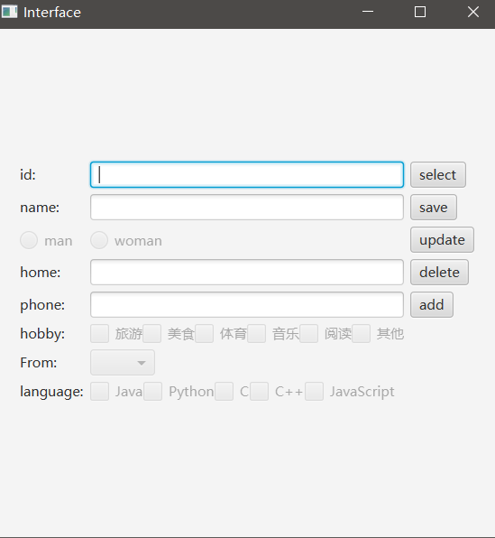

按下update后可以编辑

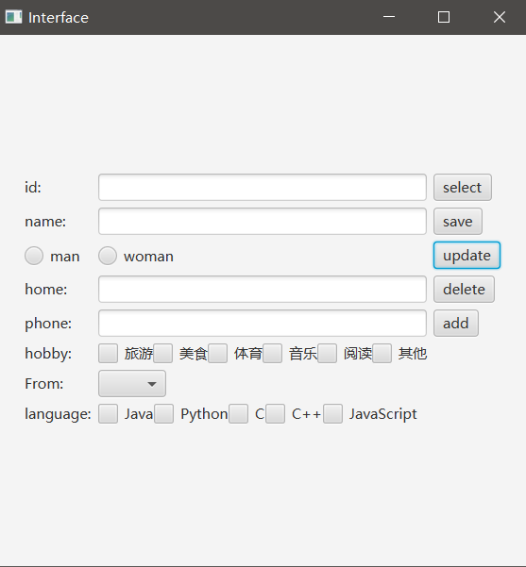

查询1001

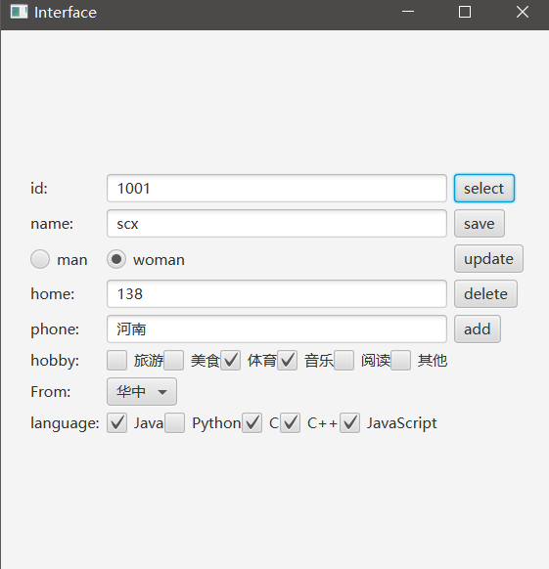

添加学生

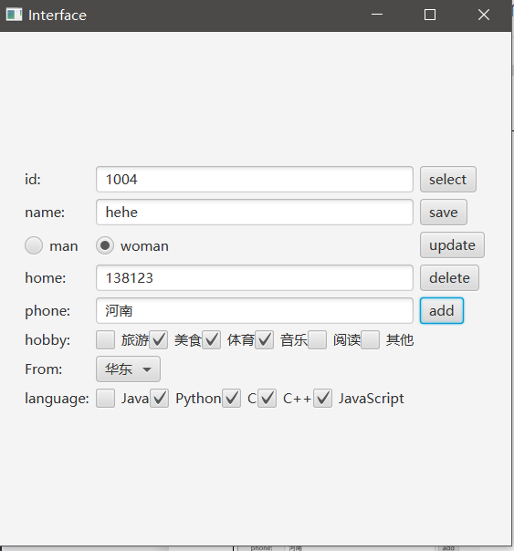

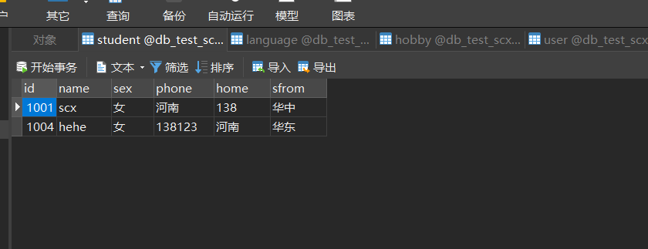

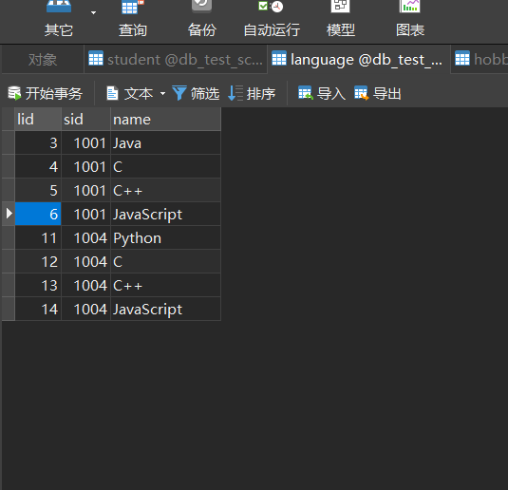

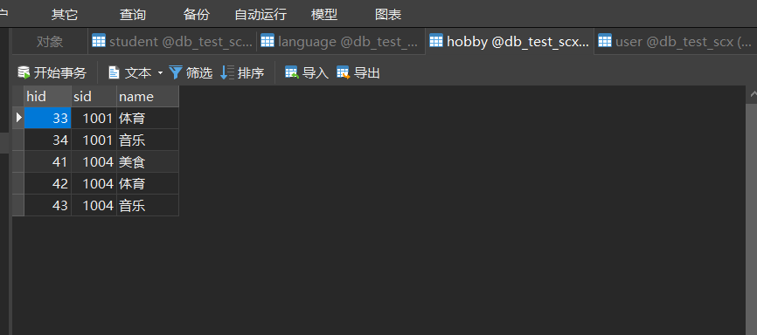

按下delete之后

