实验十 实现一个红五的发牌程序

学号： 32001019 姓名： 司晨旭 班级： 计算2002
【实验目的和要求】
- 理解多线程技术；
- 了解红五游戏的规则。
- 了解敏捷开发过程
【实验内容】

实现一个红五的发牌程序，给四位玩家排序时候采用多线程的方式进行，排序结束再统一输出每一位玩家排好序的结果。

1）游戏由两副牌构成

2）4个玩家

3）系统能随机洗牌后模拟真实情况分别向4个玩家发牌，并剩下8张底牌

4）程序能符合人性的方式输出四个玩家手上的牌和底牌（按照人类合理的理牌顺序输出）*合理的理牌顺序是分花色，分大小归类排序，每次都按照打2，并且黑心是主牌进行整理主牌大小顺序：

1、黑色：红心5，大王，小王，黑桃3，梅花3，黑桃2，梅花2，红色2，方色2， A,K,Q,J,10,9,8,7,6, 5,4

2、红色副牌：A,K,Q,J,10,9,8,7,6, 4,3

3、梅花色副牌：A,K,Q,J,10,9,8,7,6,5,4

4、方色副牌：A,K,Q,J,10,9,8,7,6,5, 4,3

输出结果截图：
每行的第一个字符串为 花色（即红心，梅花，黑桃，方片）
第二个字符串为 牌的数值 第三个整型数据为 权重（满足红5规则）

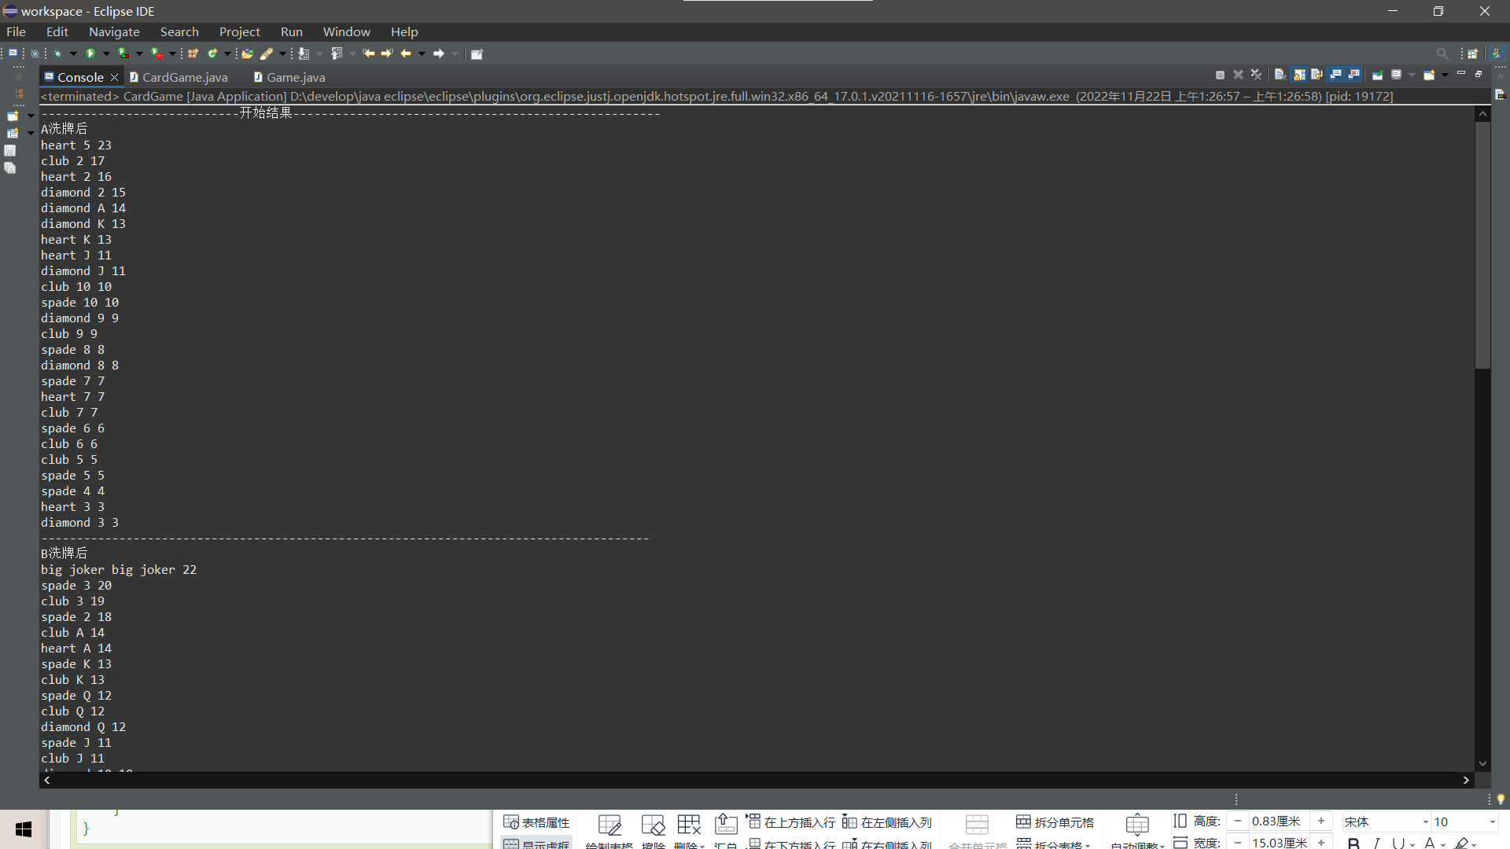

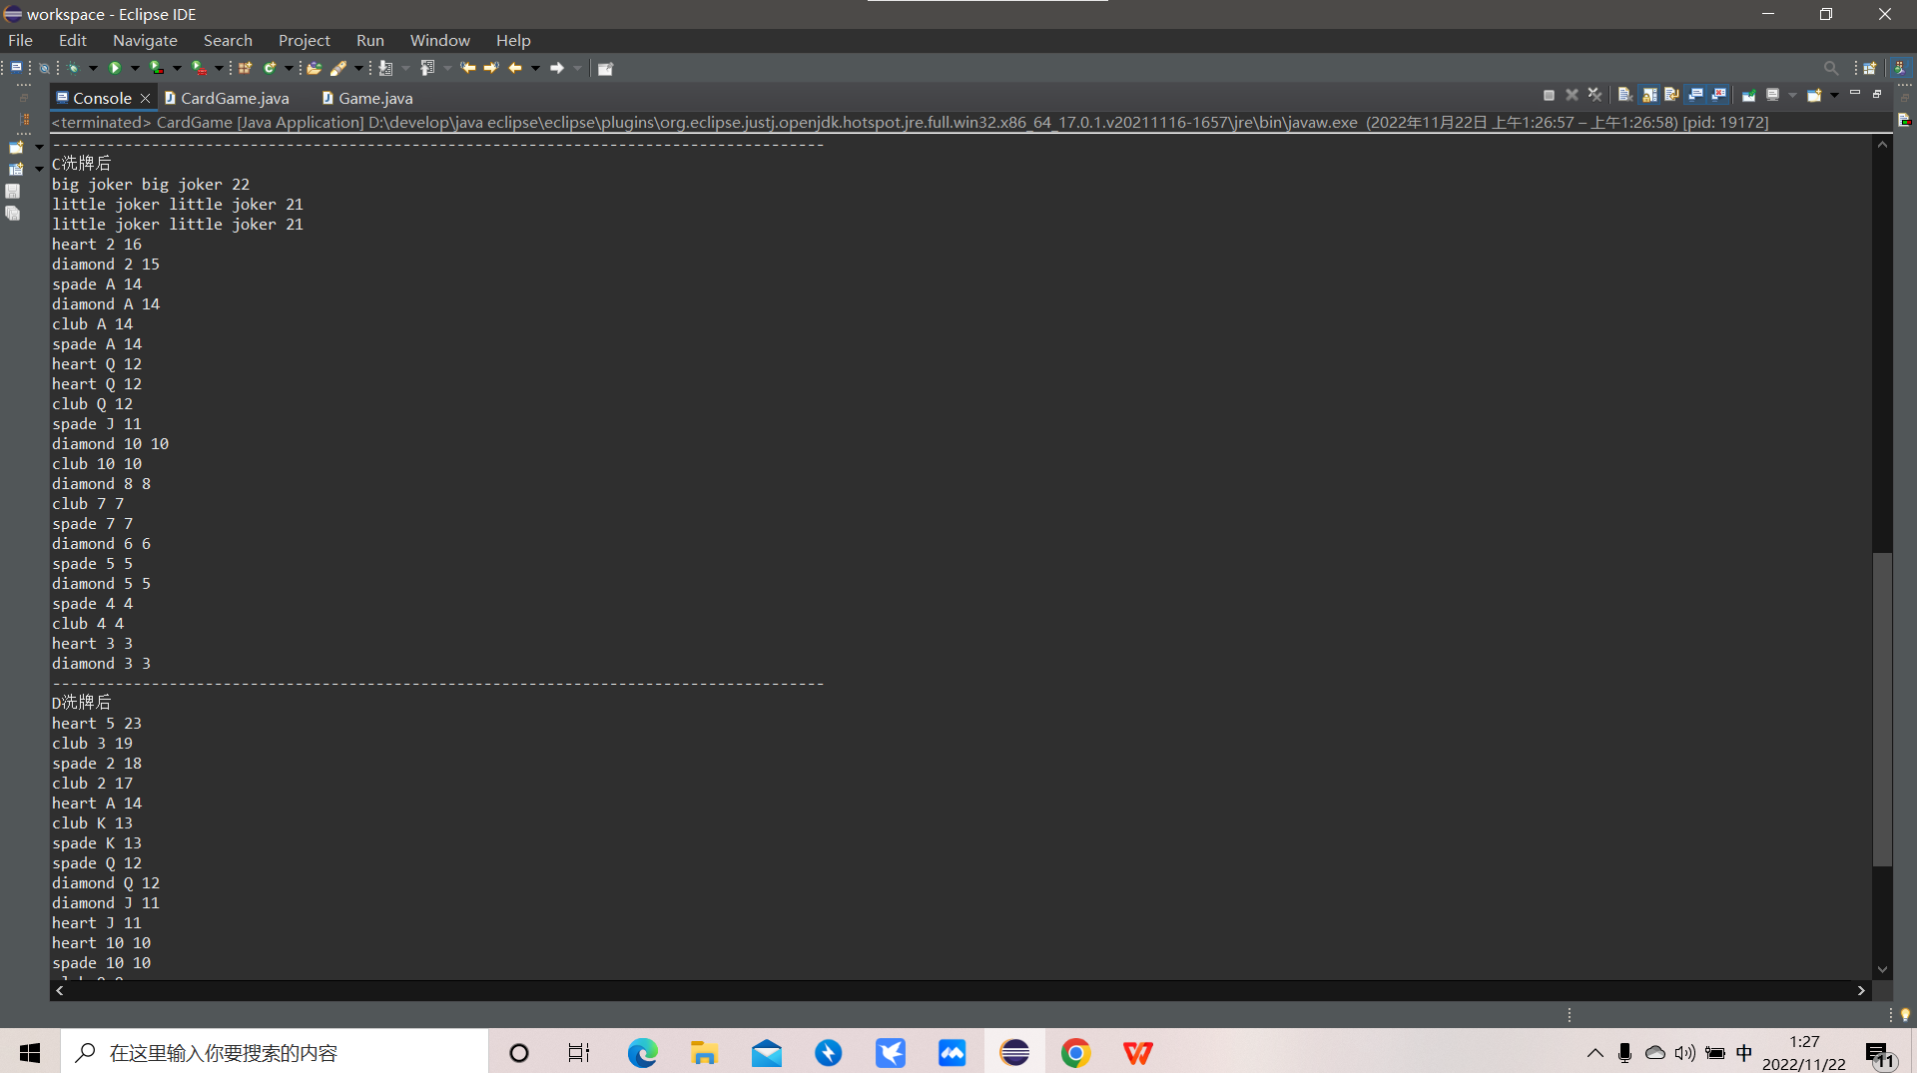

实现代码：
Card.java 存放卡片信息
package com.ten;

public class Card {

private String cardType;
private String cardValue;
private int quanzhong;

public Card() {
super();
}

public Card(String cardType, String cardValue, int quanzhong) {
super();
this.cardType = cardType;
this.cardValue = cardValue;
this.quanzhong = quanzhong;
}

public String getCardType() {
return cardType;
}
public void setCardType(String cardType) {
this.cardType = cardType;
}
public String getCardValue() {
return cardValue;
}
public void setCardValue(String cardValue) {
this.cardValue = cardValue;
}
public int getQuanzhong() {
return quanzhong;
}
public void setQuanzhong(int quanzhong) {
this.quanzhong = quanzhong;
}

}

Game.java 排序线程
package com.ten;

public class Game implements Runnable{

private Card[] cards;

public Game() {
super();
}

public Game(Card[] cards) {
super();
this.cards = cards;
}

@Override
public void run() {
// TODO Auto-generated method stub
for(int i=1;i<cards.length;i++) {
boolean flag =true;
for(int j=0;j<cards.length-i;j++) {
if(cards[j].getQuanzhong()<cards[j+1].getQuanzhong()) {
Card tempCard = cards[j];
cards[j]= cards[j+1];
cards[j+1]=tempCard;
flag =false;
}
}
if(flag) {
break;
}
}
}

}

CardGame.java 整体主函数，洗牌，发牌，排序
package com.ten;

public class CardGame {

public static void main(String[] args) {
// TODO Auto-generated method stub

/**
* 初始化部分
*/

Card[][] cards = new Card[2][54];

for(int i=0;i<2;i++) {
int index = 0;
Card[] tempCard=initCard("heart");//红心
for(int j=1;j<=13;j++) {
cards[i][index]=tempCard[j];
index++;
}
Card[] tempCard1=initCard("diamond");//方片
for(int j=1;j<=13;j++) {
cards[i][index]=tempCard1[j];
index++;
}
Card[] tempCard2=initCard("spade");//黑桃
for(int j=1;j<=13;j++) {
cards[i][index]=tempCard2[j];
index++;
}
Card[] tempCard3=initCard("club");//club 梅花
for(int j=1;j<=13;j++) {
cards[i][index]=tempCard3[j];
index++;
}
Card bigJoker = new Card("big joker","big joker",22);
cards[i][index]=bigJoker;
index++;
Card littleJoker = new Card("little joker","little joker",21);
cards[i][index]=littleJoker;
index++;
}
for(int i=0;i<2;i++) {
for(int j=0;j<54;j++) {
//System.out.println(cards[i][j].getCardType()+" "+cards[i][j].getCardValue()+" "+cards[i][j].getQuanzhong());
int index = (int) (Math.random()*54);
Card temp =cards[i][j];
cards[i][j] = cards[i][index];
cards[i][index]=temp;
}
}
for(int j=0;j<54;j++) {
for(int i=0;i<2;i++) {
//System.out.println(cards[i][j].getCardType()+" "+cards[i][j].getCardValue()+" "+cards[i][j].getQuanzhong());
int index = (int) (Math.random()*54);
Card temp =cards[i][j];
cards[i][j] = cards[i][index];
cards[i][index]=temp;
}
}

// for(int i=0;i<2;i++) {
// for(int j=0;j<54;j++) {
// System.out.println(cards[i][j].getCardType()+" "+cards[i][j].getCardValue()+" "+cards[i][j].getQuanzhong());
//
// }
// }

Card[] cardsAll = new Card[108];

int index = 0;
//写一个整体的数组存放
for(int i=0;i<2;i++) {
for(int j=0;j<54;j++) {
cardsAll[index]=cards[i][j];
index++;
}
}

// for(int i=0;i<108;i++) {
// System.out.println(cardsAll[i].getCardType()+" "+cardsAll[i].getCardValue()+" "+cardsAll[i].getQuanzhong());
// }
// System.out.println("--------------------------------------------------------------------------------------");
// Game game1 = new Game(cards);
//
// new Thread(game1).start();

// 四个数组存放四个人的结果
Card[] cardsA = new Card[25];
Card[] cardsB = new Card[25];
Card[] cardsC = new Card[25];
Card[] cardsD = new Card[25];
index = 0;
for(int i=0;i<25;i++) {
cardsA[i]=cardsAll[index];
// System.out.println(cardsA[i].getCardType()+" "+cardsA[i].getCardValue()+" "+cardsA[i].getQuanzhong());
index++;
}
// System.out.println("--------------------------------------------------------------------------------------");
for(int i=0;i<25;i++) {
cardsB[i]=cardsAll[index];
// System.out.println(cardsB[i].getCardType()+" "+cardsB[i].getCardValue()+" "+cardsB[i].getQuanzhong());
index++;
}
// System.out.println("--------------------------------------------------------------------------------------");
for(int i=0;i<25;i++) {
cardsC[i]=cardsAll[index];
// System.out.println(cardsC[i].getCardType()+" "+cardsC[i].getCardValue()+" "+cardsC[i].getQuanzhong());
index++;
}
// System.out.println("--------------------------------------------------------------------------------------");
for(int i=0;i<25;i++) {
cardsD[i]=cardsAll[index];
// System.out.println(cardsD[i].getCardType()+" "+cardsD[i].getCardValue()+" "+cardsD[i].getQuanzhong());
index++;
}
// System.out.println("--------------------------------------------------------------------------------------");

Game game1 = new Game(cardsA);
Game game2 = new Game(cardsB);
Game game3 = new Game(cardsC);
Game game4 = new Game(cardsD);

new Thread(game1).start();
new Thread(game2).start();
new Thread(game3).start();
new Thread(game4).start();
System.out.println("----------------------------开始结果----------------------------------------------------");
System.out.println("A洗牌后");
for(int i=0;i<25;i++) {

System.out.println(cardsA[i].getCardType()+" "+cardsA[i].getCardValue()+" "+cardsA[i].getQuanzhong());

}
System.out.println("--------------------------------------------------------------------------------------");
System.out.println("B洗牌后");
for(int i=0;i<25;i++) {

System.out.println(cardsB[i].getCardType()+" "+cardsB[i].getCardValue()+" "+cardsB[i].getQuanzhong());

}
System.out.println("--------------------------------------------------------------------------------------");
System.out.println("C洗牌后");
for(int i=0;i<25;i++) {

System.out.println(cardsC[i].getCardType()+" "+cardsC[i].getCardValue()+" "+cardsC[i].getQuanzhong());

}
System.out.println("--------------------------------------------------------------------------------------");
System.out.println("D洗牌后");
for(int i=0;i<25;i++) {

System.out.println(cardsD[i].getCardType()+" "+cardsD[i].getCardValue()+" "+cardsD[i].getQuanzhong());

}

}

public static Card[] initCard(String type) {

Card[] tempCards = new Card[14];
for(int i=1;i<=13;i++) {
Card temp = new Card();
temp.setCardType(type);
temp.setCardValue(""+i);
temp.setQuanzhong(i);
tempCards[i]=temp;
}

tempCards[1].setCardValue("A");
tempCards[13].setCardValue("K");
tempCards[12].setCardValue("Q");
tempCards[11].setCardValue("J");

tempCards[1].setQuanzhong(14);

if(type.equals("heart")) {
tempCards[5].setQuanzhong(23);
tempCards[2].setQuanzhong(16);
}
if(type.equals("diamond")) {
tempCards[2].setQuanzhong(15);
}
if(type.equals("spade")) {
tempCards[3].setQuanzhong(20);
tempCards[2].setQuanzhong(18);
}
if(type.equals("club")) {
tempCards[3].setQuanzhong(19);
tempCards[2].setQuanzhong(17);
}

return tempCards;

}
}

