实验2

一、相关知识点
1、JDBC基本概念
2、JDBC简单查询、连接查询、嵌套查询、集函数查询等

二、实验目的：
理解Statement对象、ResultSet对象。

三、实验内容：
1、在booklib工程的BookManager类中增加如下函数（要求采用Statement完成相关查询），并在main函数中进行测试，在实验报告中将代码补上:
public int getBookCount(String pubid) throws BaseException{
//要求返回该出版社的图书数量
int num = 0;
Connection conn = null;
Statement stmt = null;
ResultSet rs = null;
try {
conn = DBUtil.getConnection();
stmt =conn.createStatement();
String sql = "select * from BeanBook where pubid = '"+pubid+"'";
rs =stmt.executeQuery(sql);
while(rs.next()) {
num++;

}

}catch(Exception e) {
e.printStackTrace();
}finally {
DBUtil.release(rs, stmt, conn);//这段代码自己改了下DBUtil
}
return num;

}

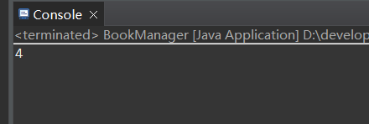

public int getPublisherCount() throws BaseException{

//要求返回图书表中出现过的出版社数量
int num = 0;
Connection conn = null;
Statement stmt = null;
ResultSet rs = null;
try {
conn = DBUtil.getConnection();
stmt =conn.createStatement();
String sql = "select * from beanpublisher where pubid in (select pubid from beanbook)";
rs =stmt.executeQuery(sql);
while(rs.next()) {
num++;
}

}catch(Exception e) {
e.printStackTrace();
}finally {

DBUtil.release(rs, stmt, conn);

}
return num;
}

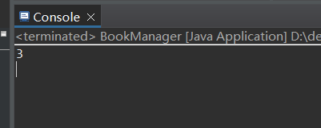

public int getNoneBookPublisherCount()throws BaseException{
//要求返回没有图书的出版社数量
int num = 0;
Connection conn = null;
Statement stmt = null;
ResultSet rs = null;
try {
conn = DBUtil.getConnection();
stmt =conn.createStatement();
String sql = "select * from beanpublisher where pubid not in (select pubid from beanbook)";
rs =stmt.executeQuery(sql);
while(rs.next()) {
num++;
}

}catch(Exception e) {
e.printStackTrace();
}finally {
DBUtil.release(rs, stmt, conn);
}
return num;
}

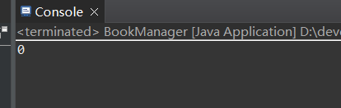

public double getBookAvgPrice()throws BaseException{
//要求返回图书的评价价格
double avg = 0;
Connection conn = null;
Statement stmt = null;
ResultSet rs = null;
int count = 0;
double sum = 0;
try {
conn = DBUtil.getConnection();
stmt =conn.createStatement();
String sql = "select * from beanbook";
rs =stmt.executeQuery(sql);
while(rs.next()) {
count++;
sum+=rs.getDouble("price");
}
}catch(Exception e) {
e.printStackTrace();
}
finally {
DBUtil.release(rs, stmt, conn);
}
avg = sum/count;
return avg;
}

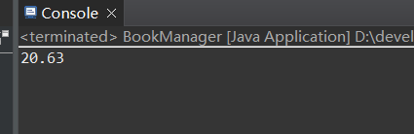

测试的主函数给出来
public static void main(String[] args) throws BaseException {
// BookManager w = new BookManager();
// int cnt = w.getBookCount("1");//1为出版社为scx，在系统中导入了两个出版社为scx
// System.out.println(cnt);

// BookManager w = new BookManager();//scx 和azy均在
// int cnt = w.getPublisherCount();
// System.out.println(cnt);

// BookManager w = new BookManager();
// int cnt = w.getNoneBookPublisherCount();//jo 不在
// System.out.println(cnt);

// BookManager w = new BookManager();
// double ans = w.getBookAvgPrice();
// System.out.println(ans);
}

- 在booklib工程的BookLendManager类中增加如下函数，并在main函数中进行测试，在实验报告中将代码补上:
public String loadBookLendOperator(String barcode)throws BaseException{
//参数为图书条码，返回这本图书最近一次被借出时的操作员姓名，要求采用连接查询实现。难点：如何识别出最近一次？假设不允许用mysql的limit关键字，也不能用嵌套查询，应该如何完成？

}
public String loadBookLendOperator(String barcode)throws BaseException{
Connection conn = null;
Statement stmt = null;
ResultSet rs = null;
try {
conn = DBUtil.getConnection();
stmt = conn.createStatement();
String sql = "select b.username from beanbooklendrecord as a ,beansystemuser as b where a.lendOperUserid = b.userid and a.bookBarcode = '"+barcode +"' order by lendDate desc";
rs = stmt.executeQuery(sql);
if(rs.next()) {
return rs.getString("username");
}
} catch (Exception e) {
// TODO: handle exception
e.printStackTrace();
}
finally {
DBUtil.release(rs, stmt, conn);
}
return null;
}

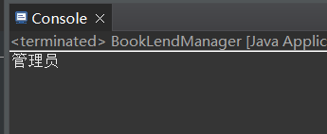

public static void main(String[] args) throws BaseException {
BookLendManager w = new BookLendManager();
String s = w.loadBookLendOperator("123");
System.out.println(s);
}

- 完成题2中的功能，要求采用嵌套查询实现。
public String loadBookLendOperator(String barcode)throws BaseException{
Connection conn = null;
Statement stmt = null;
ResultSet rs = null;
try {
conn = DBUtil.getConnection();
stmt = conn.createStatement();
// String sql = "select b.username from beanbooklendrecord as a ,beansystemuser as b where a.lendOperUserid = b.userid and a.bookBarcode = '"+barcode +"' order by lendDate desc";
String sql = "select username from beansystemuser where userid in "+"(select lendOperUserid from beanbooklendrecord where bookBarcode = '"+barcode+"' order by lendDate desc) ";
rs = stmt.executeQuery(sql);
if(rs.next()) {
return rs.getString("username");
}
} catch (Exception e) {
// TODO: handle exception
e.printStackTrace();
}
finally {
DBUtil.release(rs, stmt, conn);
}
return null;
}
public static void main(String[] args) throws BaseException {
BookLendManager w = new BookLendManager();
String s = w.loadBookLendOperator("123");
System.out.println(s);

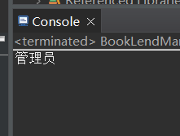

- 在booklib工程的BookLendManager类中增加如下函数，并在main函数中进行测试，在实验报告中将代码补上:
public void showAllLendRecord(){
通过System.out.println方法，输出所有借阅记录的明细数据，要求结果中包括读者姓名、图书名称、所属出版社名称、借阅操作员姓名、归还操作员姓名、借阅时间、归还时间等
注意：需要注意未归还图书的情况
}
public void showAllLendRecord() {
Connection conn = null;
Statement stmt = null;
ResultSet rs = null;
try {
conn = DBUtil.getConnection();
stmt = conn.createStatement();

String sql = "select beanreader.readerName,beanbook.bookname,beanpublisher.publisherName,a1.username,a2.username,lendDate,returnDate"
+ " from beanbooklendrecord as m"
+" left join beanreader on m.readerid = beanreader.readerid"
+" left join beanbook on m.bookBarcode = beanbook.barcode"
+" left join beanpublisher on beanbook.pubid = beanpublisher.pubid"
+" left join beansystemuser as a1 on a1.userid = m.lendOperUserid"
+" left join beansystemuser as a2 on m.returnOperUserid = a2.userid";
rs = stmt.executeQuery(sql);
while(rs.next()) {
System.out.print(rs.getString(1)+" ");
System.out.print(rs.getString(2)+" ");
System.out.print(rs.getString(3)+" ");
System.out.print(rs.getString(4)+" ");
System.out.print(rs.getString(5)+" ");
System.out.print(rs.getString(6)+" ");
System.out.print(rs.getString(7));
System.out.println();
}

} catch (Exception e) {
// TODO: handle exception
e.printStackTrace();
}
finally {
DBUtil.release(rs, stmt, conn);
}
}
public static void main(String[] args) throws BaseException {
// BookLendManager w = new BookLendManager();
// String s = w.loadBookLendOperator("123");
// System.out.println(s);
BookLendManager w = new BookLendManager();
w.showAllLendRecord();
}

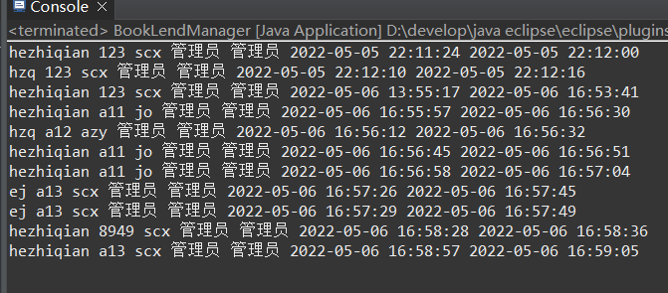

5、在booklib工程的BookManager类中增加如下函数，并在main函数中进行测试，在实验报告中将代码补上:
public void showTop5Books(){
//通过System.out.println方法，输出借阅次数最多的5本图书及其借阅次数
Connection conn = null;
Statement stmt = null;
ResultSet rs = null;
try {
conn = DBUtil.getConnection();
stmt = conn.createStatement();

String sql = "select distinct a.bookname,count(b.bookBarcode) from beanbook as a,beanbooklendrecord as b"
+ " where a.barcode = b.bookBarcode"
+ " group by b.bookBarcode"
+ " order by count(b.bookBarcode) desc limit 5";
rs = stmt.executeQuery(sql);
while(rs.next()) {
System.out.print(rs.getString(1)+" ");
System.out.println(rs.getString(2));
}
} catch (Exception e) {
// TODO: handle exception
e.printStackTrace();
}
finally {
DBUtil.release(rs, stmt, conn);
}
}

public static void main(String[] args) throws BaseException {
// BookManager w = new BookManager();
// int cnt = w.getBookCount("1");//1为出版社为scx，在系统中导入了两个出版社为scx
// System.out.println(cnt);

// BookManager w = new BookManager();//scx 和azy均在
// int cnt = w.getPublisherCount();
// System.out.println(cnt);

// BookManager w = new BookManager();
// int cnt = w.getNoneBookPublisherCount();//jo 不在
// System.out.println(cnt);

// BookManager w = new BookManager();
// double ans = w.getBookAvgPrice();
// System.out.println(ans);
BookManager w = new BookManager();
w.showTop5Books();
}

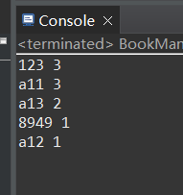

public void showTop5Publisher(){
//通过System.out.println方法，输出被借阅图书次数最多的5个出版名称及其总借阅次数和被借阅过的图书次数
Connection conn = null;
Statement stmt = null;
ResultSet rs = null;
try {
conn = DBUtil.getConnection();
stmt = conn.createStatement();

String sql="select c.publishername,count(b.id),count(distinct b.bookbarcode)"
+ " from beanbook a,beanbooklendrecord b,beanpublisher c " +
" where a.barcode=b.bookbarcode and a.pubid=c.pubid " +
" group by c.pubid " +
" order by count(b.id) desc " +
" limit 5";

rs = stmt.executeQuery(sql);
while(rs.next()) {
System.out.print(rs.getString(1)+" ");
System.out.print(rs.getString(2)+" ");
System.out.println(rs.getString(3)+" ");
}
} catch (Exception e) {
// TODO: handle exception
e.printStackTrace();
}
finally {
DBUtil.release(rs, stmt, conn);
}
}

public static void main(String[] args) throws BaseException {
// BookManager w = new BookManager();
// int cnt = w.getBookCount("1");//1为出版社为scx，在系统中导入了两个出版社为scx
// System.out.println(cnt);

// BookManager w = new BookManager();//scx 和azy均在
// int cnt = w.getPublisherCount();
// System.out.println(cnt);

// BookManager w = new BookManager();
// int cnt = w.getNoneBookPublisherCount();//jo 不在
// System.out.println(cnt);

// BookManager w = new BookManager();
// double ans = w.getBookAvgPrice();
// System.out.println(ans);
BookManager w = new BookManager();
//w.showTop5Books();
w.showTop5Publisher();
}

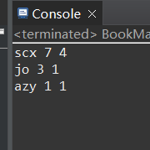

6、在BookLendManager中增加函数public void printDateLendRecord(String date)DbException，并在main函数中调用测试;要求通过该函数输出指定日期的所有借阅记录，，输出格式如下：
readerId=***,bookBarcode=****,lendDate=2020-05-01 15:17:01,returnDate=未归还
readerId=***,bookBarcode=****,lendDate=2020-05-01 15:17:01,returnDate=2020-05-12 12:00:00
说明：每个借阅记录1行输出，如果returnDate为空，则输出：“未归还”
注：时间的输出格式请使用java.text.SimpleDateFormat类实现
请提供函数代码及运行结果截图：
public void printDateLendRecord(String date) throws DbException{
Connection conn =null;
Statement stmt = null;
ResultSet rs =null;
try {
conn =DBUtil.getConnection();
String dateStart,dateEnd;
dateStart=date.trim()+" 00:00:00";
dateEnd=date.trim()+" 23:59:59";
stmt = conn.createStatement();
String sql = "select * from beanbooklendrecord where "
+ "lendDate between '"+dateStart+"' and '"
+ dateEnd +"' " ;
rs = stmt.executeQuery(sql);
while(rs.next()) {
java.text.SimpleDateFormat sdf = new java.text.SimpleDateFormat("yyyy-MM-dd");
String slendDate = sdf.format(rs.getDate("lendDate"));
Time lendDateTime= rs.getTime("lendDate");
Time returnDateTime=null;

String returnDate;
try {
returnDateTime= rs.getTime("returnDate");

returnDate = sdf.format(rs.getDate("returnDate"));

}catch (Exception e) {
returnDate = "未归还";

}
System.out.println(
"readerid="+rs.getString("readerid")
+", bookbarcode="+rs.getString("bookbarcode")
+", lendDate="+slendDate+" "+lendDateTime
+", returnDate="+returnDate+" "+(returnDateTime != null?returnDateTime:"")
);

}
} catch (Exception e) {
// TODO: handle exception
e.printStackTrace();
}
finally {
DBUtil.release(rs, stmt, conn);
}
}

public static void main(String[] args) throws BaseException {
// BookLendManager w = new BookLendManager();
// String s = w.loadBookLendOperator("123");
// System.out.println(s);
// BookLendManager w = new BookLendManager();
// w.showAllLendRecord();
BookLendManager bookLendManager = new BookLendManager();
bookLendManager.printDateLendRecord("2022-5-6");

}

