实验5 JDBC进阶（2）

一、相关知识点
1、JDBC基本概念
2、视图、索引
3、java集合框架

二、实验目的：
理解视图和索引的概念，并通过视图设计简化程序设计，通过索引设计优化查询性能；
理解java集合框架

三、实验内容：
- 设计读者视图view_reader，并修改readerManager类中相关代码。
第一步：建立读者视图，要求视图中包含读者类别名称；
第二步：改造ReaderManager类，将其中的连接查询用视图代替。
第三步：运行图书管理系统，进行各个功能的测试（读者类别管理、读者管理）
【实验结果与分析】
写出视图创建代码。
use booklib;

create view view_reader as
select readerId,readerName,beanreader.readerTypeId,readerTypeName,
beanreadertype.lendBookLimitted,createDate,creatorUserId,removeDate,removerUserId,stopDate,stopUserId
from beanreader,beanreadertype
where beanreader.readerTypeId=beanreadertype.readerTypeId

给出改造后ReaderManager类的各个方法的代码。

public PageDate loadAllReader(int page, int pagesize) throws DbException {
PageDate dp = new PageDate();

Connection conn = null;
try {
conn = DBUtil.getConnection();
java.sql.Statement st = conn.createStatement();
String sql = "select count(*) from beanreader";
java.sql.ResultSet rs = st.executeQuery(sql);
if (rs.next()) {
dp.setTotalRecordCount(rs.getInt(1));
dp.setPageCount(dp.getTotalRecordCount() / pagesize);

if (dp.getTotalRecordCount() % pagesize > 0)
dp.setPageCount(dp.getPageCount() + 1);
} else {
dp.setTotalRecordCount(0);
dp.setPageCount(0);
}

dp.setPageIndex(page);
dp.setPagesize(pagesize);
rs.close();

int start = (page - 1) * pagesize;
if (start >= dp.getTotalRecordCount()) {
return dp;
}
// sql = "select readerid,readerName,r.readerTypeId,r.lendBookLimitted,createDate,creatorUserId,stopDate,stopUserId,rt.readerTypeName"
// + " from BeanReader r,BeanReaderType rt where r.readerTypeId=rt.readerTypeId";
sql = "select readerid,readerName,r.readerTypeId,r.lendBookLimitted,createDate,creatorUserId,stopDate,stopUserId,rt.readerTypeName"
+ " from view_reader ";

sql += " limit " + start + "," + pagesize;
java.sql.PreparedStatement pst = conn.prepareStatement(sql);

rs = pst.executeQuery();
while (rs.next()) {

BeanReader r = new BeanReader();
r.setReaderid(rs.getString(1));
r.setReaderName(rs.getString(2));
r.setReaderTypeId(rs.getInt(3));
r.setLendBookLimitted(rs.getInt(4));
r.setCreateDate(rs.getDate(5));
r.setCreatorUserId(rs.getString(6));
r.setStopDate(rs.getDate(7));
r.setStopUserId(rs.getString(8));
r.setReaderTypeName(rs.getString(9));
dp.getData().add(r);
}

rs.close();
pst.close();

} catch (SQLException e) {
e.printStackTrace();
throw new DbException(e);
} finally {
if (conn != null)
try {
conn.close();
} catch (SQLException e) {
// TODO Auto-generated catch block
e.printStackTrace();
}
}
return dp;
}

public List<BeanReader> searchReader(String keyword, int readerTypeId) throws BaseException {
List<BeanReader> result = new ArrayList<BeanReader>();
Connection conn = null;
try {
conn = DBUtil.getConnection();
// String sql = "select readerid,readerName,r.readerTypeId,r.lendBookLimitted,createDate,creatorUserId,stopDate,stopUserId,rt.readerTypeName" +
// " from BeanReader r,BeanReaderType rt where r.readerTypeId=rt.readerTypeId" +
// " and removeDate is null ";
// if (readerTypeId > 0) sql += " and r.readerTypeId=" + readerTypeId;
String sql = "select readerid,readerName,readerTypeId,lendBookLimitted,createDate,creatorUserId,"
+ "stopDate,stopUserId,readerTypeName" + " from view_reader" + " where removeDate is null ";

if (readerTypeId > 0)
sql += " and readerTypeId=" + readerTypeId;

if (keyword != null && !"".equals(keyword))
sql += " and (readerid like ? or readerName like ?)";
sql += " order by readerid";
java.sql.PreparedStatement pst = conn.prepareStatement(sql);
if (keyword != null && !"".equals(keyword)) {
pst.setString(1, "%" + keyword + "%");
pst.setString(2, "%" + keyword + "%");

}

java.sql.ResultSet rs = pst.executeQuery();
while (rs.next()) {
BeanReader r = new BeanReader();
r.setReaderid(rs.getString(1));
r.setReaderName(rs.getString(2));
r.setReaderTypeId(rs.getInt(3));
r.setLendBookLimitted(rs.getInt(4));
r.setCreateDate(rs.getDate(5));
r.setCreatorUserId(rs.getString(6));
r.setStopDate(rs.getDate(7));
r.setStopUserId(rs.getString(8));
r.setReaderTypeName(rs.getString(9));
result.add(r);
}
} catch (SQLException e) {
e.printStackTrace();
throw new DbException(e);
} finally {
if (conn != null)
try {
conn.close();
} catch (SQLException e) {
// TODO Auto-generated catch block
e.printStackTrace();
}
}
return result;

}

public BeanReader loadReader(String readerid) throws DbException {
List<String> resultBookNotRetrun = new ArrayList<String>();

Connection conn = null;
try {
conn = DBUtil.getConnection();
// String sql = "select readerid,readerName,r.readerTypeId,r.lendBookLimitted,createDate,creatorUserId,stopDate,stopUserId,rt.readerTypeName,r.removeDate"
// + " from BeanReader r,BeanReaderType rt where r.readerTypeId=rt.readerTypeId"
// + " and r.readerid=?";
// sql += " order by readerid";
String sql = "select readerid,readerName,readerTypeId,lendBookLimitted,createDate,creatorUserId,"
+ "stopDate,stopUserId,readerTypeName,removeDate" + " from view_reader where readerId = ? ";

java.sql.PreparedStatement pst = conn.prepareStatement(sql);
pst.setString(1, readerid);
java.sql.ResultSet rs = pst.executeQuery();

if (rs.next()) {
BeanReader r = new BeanReader();
r.setReaderid(rs.getString(1));
r.setReaderName(rs.getString(2));
r.setReaderTypeId(rs.getInt(3));
r.setLendBookLimitted(rs.getInt(4));
r.setCreateDate(rs.getDate(5));
r.setCreatorUserId(rs.getString(6));
r.setStopDate(rs.getDate(7));
r.setStopUserId(rs.getString(8));
r.setReaderTypeName(rs.getString(9));
r.setRemoveDate(rs.getDate(10));
// 读者的 借书信息
String sqlBookNotRetrun = "select bookname from BeanReader r,Beanbooklendrecord rt ,"
+ "beanbook b where r.readerid=rt.readerid"
+ " and r.readerid= ? and rt.returndate is null and" + " b.barcode=rt.bookbarcode";
sqlBookNotRetrun += " order by r.readerid";
java.sql.PreparedStatement pstBookNotRetrun = conn.prepareStatement(sqlBookNotRetrun);
pstBookNotRetrun.setString(1, readerid);
java.sql.ResultSet rsBookNotRetrun = pstBookNotRetrun.executeQuery();

while (rsBookNotRetrun.next()) {
String s = rsBookNotRetrun.getString(1);
resultBookNotRetrun.add(s);
}

r.setBookInfos(resultBookNotRetrun);

rs.close();
rsBookNotRetrun.close();
pst.close();
pstBookNotRetrun.close();

return r;
}
} catch (SQLException e) {
e.printStackTrace();
throw new DbException(e);
} finally {
if (conn != null)
try {
conn.close();
} catch (SQLException e) {
// TODO Auto-generated catch block
e.printStackTrace();
}
}
return null;
}

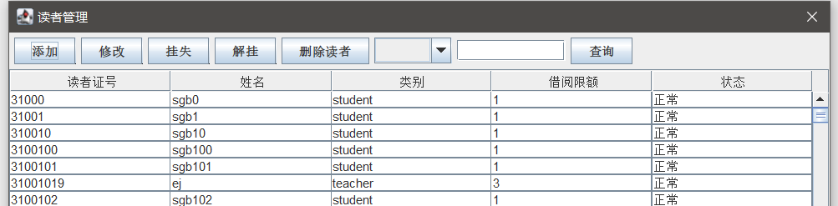
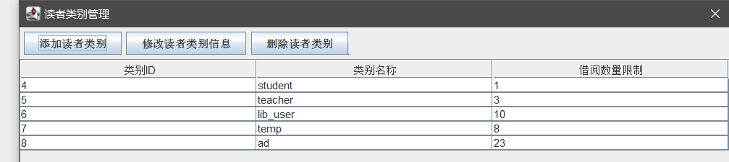
功能均正常

- 设计图书视图view_book，并修改BookManager类中相关代码。
第一步：建立图书视图，要求视图中包含出版社名称；
第二步：改造BookManager类，将其中的连接查询用视图代替。
第三步：运行图书管理系统，进行各个功能的测试
【实验结果与分析】
写出视图创建代码。
USE booklib;

CREATE VIEW view_book AS SELECT
barcode,
bookname,
beanbook.pubid,
price,
state,
storageTime,
beanpublisher.publisherName
FROM
beanbook,
beanpublisher
WHERE
beanbook.pubId = beanpublisher.pubId

- 给出改造后ReaderManager类的各个方法的代码。
Emmm，ReaderManager中没有可以修改的了呀。。

- 设计读者借阅情况统计视图view_reader_static，并在BookLendManager类中添加根据读者ID提取其借阅数量的代码。
第一步：建立读者统计视图，要求视图中包含读者ID、读者姓名、借阅数量；
第二步：在BookLendManager中添加方法 public int loadReaderLendCount(String readerid) throws DbException。并编写其代码
第三步：在BookLendManager类中添加main函数，并编写上述方法的测试代码。进行功能的测试
【实验结果与分析】
写出视图创建代码。
CREATE VIEW view_reader_static AS SELECT
BeanReader.readerId,
count(*) BorrowCnt,
readerName
FROM
beanbooklendrecord,
BeanReader
WHERE
beanbooklendrecord.readerId = BeanReader.readerId
GROUP BY
readerId

给出改造后BookLendManager类的各个方法的代码。
public int loadReaderLendCount(String readerid) throws DbException {
Connection connection = null;
PreparedStatement preparedStatement = null;
ResultSet resultSet = null;
try {
connection = DBUtil.getConnection();
String sql = "SELECT * from view_reader_static where readerId= ? ";
preparedStatement = connection.prepareStatement(sql);
preparedStatement.setString(1, readerid);
resultSet = preparedStatement.executeQuery();

if (resultSet.next()) {

int borrowCnt = resultSet.getInt(2);

return borrowCnt;
} else {
return -1;
}
} catch (SQLException e) {
// TODO: handle exception
e.printStackTrace();
} finally {
DBUtil.release(resultSet, preparedStatement, connection);
}
return -1;

}

- 索引实验：
第一步：完成IndexTest_initData类中的代码，并测试。
第二步：完成IndexTest类中的代码，并测试，记录执行结果
第三步：通过查询分析器，在BeanBookLendRecord表的readerid上建立索引
第四步：再次执行IndexTest类，记录执行结果
给出两个类的代码和索引建立的代码

package cn.edu.zucc.booklib.Index;

import java.sql.Connection;
import java.sql.PreparedStatement;
import java.sql.SQLException;

import cn.edu.zucc.booklib.util.DBUtil;
import cn.edu.zucc.booklib.util.DbException;

public class IndexTest_initData {
public static void main(String[] args) throws DbException {
Connection conn=null;
PreparedStatement pst = null;
try {
conn=DBUtil.getConnection();
for(int i=1;i<=1000;i++)
{
String sql="insert into BeanReader(readerid,readerName,readerTypeId,"+
"lendBookLimitted,createDate,creatorUserId) values(?,?,?,?,?,?)";
pst=conn.prepareStatement(sql);
pst.setString(1, "r"+i);
pst.setString(2, "读者"+i);
pst.setInt(3, 1);
pst.setInt(4, 1000);
pst.setTimestamp(5,new java.sql.Timestamp(System.currentTimeMillis()));
pst.setString(6, "admin");

pst.execute();
pst.close();
}

for(int i=1;i<=1000;i++)
{
String sql="insert into BeanBook(barcode,bookname,pubid,price,state) values(?,?,?,?,'在库')";
pst=conn.prepareStatement(sql);
pst.setString(1, "bbok"+i);
pst.setString(2, "bbokName"+i);
pst.setString(3, "5");
pst.setDouble(4, 111);

pst.execute();
pst.close();
}

for(int i=1;i<=1000;i++)
{
for(int j=1;j<=1000;j++)
{
String sql="insert into BeanBooklendrecord(id,readerid,bookbarcode,"+
"lenddate,returndate,lendOperUserid,returnOperUserid,penalsum) values(?,?,?,?,?,?,?,?)";
pst=conn.prepareStatement(sql);
pst.setInt(1, 1000*i+j);
pst.setString(2,"r"+i );
pst.setString(3, "bbok"+j);
pst.setTimestamp(4, new java.sql.Timestamp(System.currentTimeMillis()));
pst.setTimestamp(5, new java.sql.Timestamp(System.currentTimeMillis()));
pst.setString(6, "admin");
pst.setString(7, "admin");
pst.setDouble(8, 111);

pst.execute();
pst.close();
}

}

System.out.println("每个人借每本书 结束");

} catch (SQLException e) {
e.printStackTrace();
throw new DbException(e);
}
finally{
if(conn!=null)
try {
conn.close();
} catch (SQLException e) {
// TODO Auto-generated catch block
e.printStackTrace();
}

}

}

}

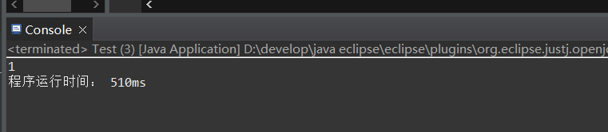
没有建立索引的运行结果
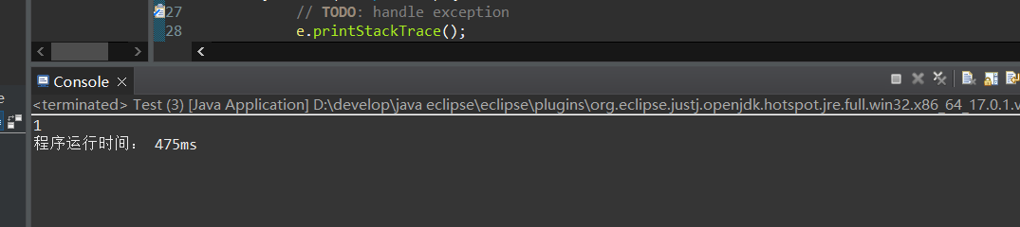
加了索引后的运行时间 不晓得为什么时间降不下来。

  - 比较IndexTest类两次执行的结果，并说明索引的作用。并思考：如果我们需要经常查询某用户近期借阅的n本图书，请问，应该如何建立索引？【提示：多列索引】

- 数据统计实验：
A、在ReaderManager中，添加函数Map<String,Integer> staticTypeReaderCount()...
要求通过读者类别名称及其读者数量，请给出代码：
Map<String,Integer> staticTypeReaderCount() throws BaseException{

Connection conn=null;
PreparedStatement pst = null;
ResultSet rs = null;
Map<String, Integer>res=new HashMap<>();
try {
conn=DBUtil.getConnection();
String sql="SELECT readerTypeId, count(readerTypeId)" +
" from beanreader " +

"GROUP BY readerTypeId";

pst=conn.prepareStatement(sql);

rs=pst.executeQuery();

while(rs.next()){
res.put(rs.getString(1), rs.getInt(2));

}
return res;
} catch (SQLException e) {
e.printStackTrace();
throw new DbException(e);
}
finally{
DBUtil.release(rs, pst, conn);
}

}

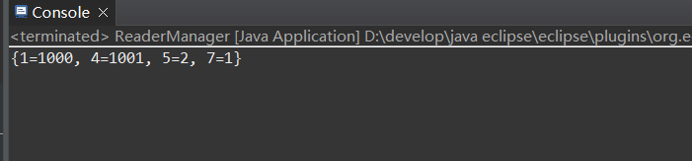

B、在BookManager中，添加函数Map<String,Double> staticPublisherBookAvgPrice()... 。要求统计各出版社名称及其图书的平均价格，请给出代码：
Map<String,Double> staticPublisherBookAvgPrice() throws BaseException{

Connection conn = null;
PreparedStatement pst =null;
ResultSet rs = null;
Map<String, Double>result=new HashMap<>();
try {
conn = DBUtil.getConnection();
String sqlString="SELECT pubid , avg(price) " +
"from beanbook " +
"GROUP BY pubid " ;
// pubid
pst = conn.prepareStatement(sqlString);
rs = pst.executeQuery();
while (rs.next()) {
String putPubidString=rs.getString(1);
Double avgPriceDouble=rs.getDouble(2);

result.put(putPubidString, avgPriceDouble);

}

return result;

} catch (SQLException e) {
e.printStackTrace();
throw new DbException(e);
} finally {
DBUtil.release(rs, pst, conn);
}

}

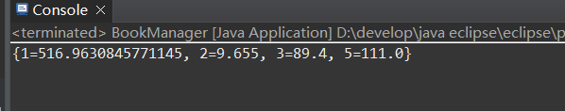

在BookLendManager中，添加函数Map<String,Integer> staticReaderBookCount()... 。要求统计读者为归还的图书数量，返回结果的key为读者ID。请给出代码：

Map<String,Integer> staticReaderBookCount(){
Connection connection=null;
PreparedStatement preparedStatement = null;
ResultSet resultSet = null;

Map<String,Integer> res=new HashMap<>();
try {
connection=DBUtil.getConnection();
String sql="SELECT readerid,COUNT(*) from beanbooklendrecord " +
"where returnDate is NULL " +
"GROUP BY readerid ";
preparedStatement=connection.prepareStatement(sql);
resultSet=preparedStatement.executeQuery();
while (resultSet.next()) {
String readerId= resultSet.getString(1);
int notRetCnt= resultSet.getInt(2);
res.put(readerId, notRetCnt);

}
} catch (SQLException e) {
// TODO: handle exception
e.printStackTrace();
}finally {
DBUtil.release(resultSet, preparedStatement, connection);

}

return res;

}

- 集合对象的遍历实验：
- 编写批量借阅读书函数： public void lendbooks(String readerId,Collection<String> barcodes) .... 。其中第二个参数为图书条码集合。
public void lendbooks(String readerId,Collection<String> barcodes) throws BaseException {
for (String barcode:barcodes) {
lend(barcode, readerId);
}
}

B、编写批量设置罚金函数：public void setPenalSum(String readerId,Map<String,Double> penalSums) .... 。其中第二个参数的key为barcode，value为改读者尚未归还图书的罚金（注意，不要设置已经归还图书的罚金）。
public void setPenalSum(String readerId,Map<String,Double> penalSums) throws SQLException {
Connection connection=null;
PreparedStatement preparedStatement = null;

String sql = "update beanbooklendrecord " +
"set penalSum=? " +
"where returnDate is null and bookBarcode =? ";

try {
connection=DBUtil.getConnection();
preparedStatement=connection.prepareStatement(sql);
for (String barcode:penalSums.keySet()) {
Double penalSum=penalSums.get(barcode);
preparedStatement.setDouble(1, penalSum);
preparedStatement.setString(2, barcode);
preparedStatement.execute();

}
} catch (SQLException e) {
// TODO: handle exception
e.printStackTrace();
}
finally {
DBUtil.release(preparedStatement, connection);
}

System.out.println("set end");

}

