实验4 JDBC进阶

一、相关知识点
1、JDBC基本概念
2、主从关系，分页查询，连接池

二、实验目的：
理解分页查询的概念和处理方法

三、实验内容：
- 数据准备：编写程序，自动生成1000个读者和图书；
生成图书代码如下
BookManager bManager = new BookManager();
for(int i =0;i<1000;i++) {
BeanBook b = new BeanBook();
b.setBarcode("2000"+i);
b.setBookname("hezhiqian"+i);
b.setPrice(20.00+i);
b.setPubid("1");
b.setPubName("scx");
b.setState("在库");
bManager.createBook(b);
}
生成读者代码如下
ReaderManager rM = new ReaderManager();
for(int i =0;i<1000;i++) {
BeanReader r = new BeanReader();
// r.setCreateDate(new java.sql.Timestamp(System.currentTimeMillis()));
r.setCreatorUserId("admin");
// r.setLendBookLimitted(1);
r.setReaderid("3100"+i);
r.setReaderName("sgb"+i);
r.setReaderTypeId(4);
rM.createReader(r);
System.out.println("Yes");

同时需要注意在createReader中删去

生成结果如下
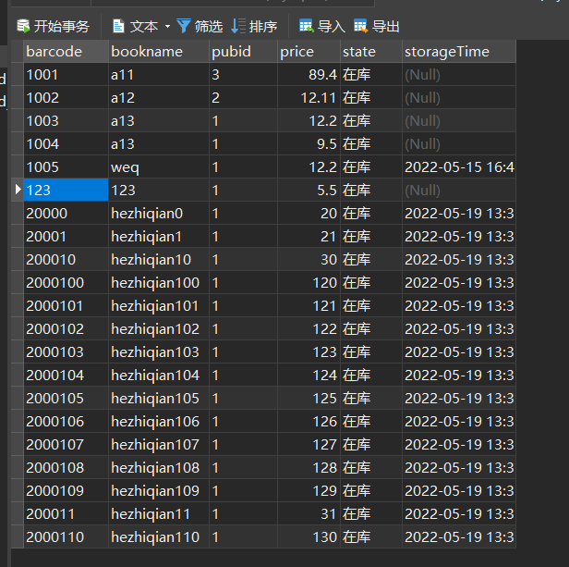
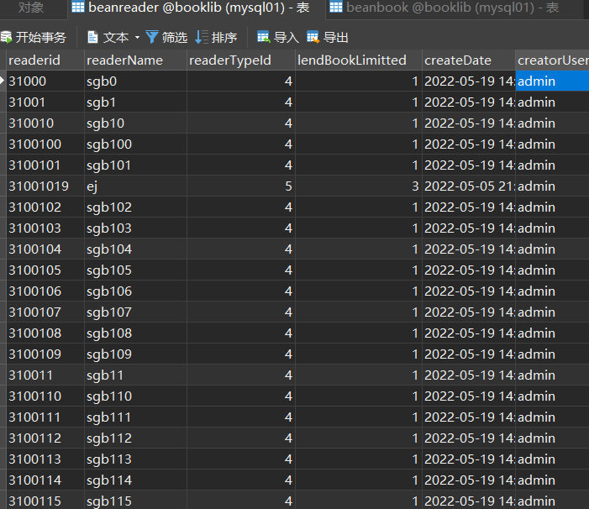

- 改造读者模块，在提取读者的同时，提取其未归还的图书信息
第一步：通过程序增加一些借阅纪录
第二步：改造读者javabean，使之包括借阅的图书信息
第三步：改造ReaderManager中的读者提取方法（public BeanReader loadReader(String readerid) throws DbException ），同时提取未归还图书；
第四步：ReaderManager的main函数中调用该方法进行测试，要求输出指定读者的基本信息及其未归还的图书名称。
【实验结果与分析】
javabean类代码。
package cn.edu.zucc.booklib.model;

import java.util.Date;
import java.util.List;

public class BeanReader {
private String readerid;
private String readerName;
private int readerTypeId;
private int lendBookLimitted;
private Date createDate; //注册时间
private String creatorUserId; //注册操作执行人
private Date removeDate; //注销时间
private String removerUserId; //注销操作执行人
private Date stopDate; //挂失时间
private String stopUserId; //挂失操作执行人

private String readerTypeName;//读者类别，存储在ReaderType表中，读者表中只存储readerTypeId，程序应根据readerTypeId获取该值

private List<String> bookInfos;
public BeanReader() {

}

public BeanReader(String readerid,String readerName,int readerTypeId,int lendBookLimitted,Date createDate) {
super();
this.readerid=readerid;
this.readerName=readerName;
this.readerTypeId=readerTypeId;
this.lendBookLimitted=lendBookLimitted;
this.createDate=createDate;
}

public BeanReader(String readerid, String readerName, int readerTypeId) {
super();
this.readerid = readerid;
this.readerName = readerName;
this.readerTypeId = readerTypeId;

}

public List<String> getBookInfos() {
return bookInfos;
}

public void setBookInfos(List<String> bookInfos) {
this.bookInfos = bookInfos;
}

public String getReaderid() {
return readerid;
}

public void setReaderid(String readerid) {
this.readerid = readerid;
}

public String getReaderName() {
return readerName;
}

public void setReaderName(String readerName) {
this.readerName = readerName;
}

public int getReaderTypeId() {
return readerTypeId;
}

public void setReaderTypeId(int readerTypeId) {
this.readerTypeId = readerTypeId;
}

public int getLendBookLimitted() {
return lendBookLimitted;
}

public void setLendBookLimitted(int lendBookLimitted) {
this.lendBookLimitted = lendBookLimitted;
}

public Date getCreateDate() {
return createDate;
}

public void setCreateDate(Date createDate) {
this.createDate = createDate;
}

public String getCreatorUserId() {
return creatorUserId;
}

public void setCreatorUserId(String creatorUserId) {
this.creatorUserId = creatorUserId;
}

public Date getRemoveDate() {
return removeDate;
}

public void setRemoveDate(Date removeDate) {
this.removeDate = removeDate;
}

public String getRemoverUserId() {
return removerUserId;
}

public void setRemoverUserId(String removerUserId) {
this.removerUserId = removerUserId;
}

public Date getStopDate() {
return stopDate;
}

public void setStopDate(Date stopDate) {
this.stopDate = stopDate;
}

public String getStopUserId() {
return stopUserId;
}

public void setStopUserId(String stopUserId) {
this.stopUserId = stopUserId;
}

public String getReaderTypeName() {
return readerTypeName;
}

public void setReaderTypeName(String readerTypeName) {
this.readerTypeName = readerTypeName;
}

}

给出改造后ReaderManager类的方法代码。
public void createReaders() {
SystemUserManager.currentUser=new BeanSystemUser();
SystemUserManager.currentUser.setUserid("admin");
for(int i=0+100;i<1000+100;i++) {
BeanReader reader=new BeanReader(""+i,"name"+i,4);
try {
createReader(reader);
} catch (BaseException e) {
// TODO Auto-generated catch block
e.printStackTrace();
}
}

}

public BeanReader loadReader(String readerid) throws DbException {
List<String> resultBookNotRetrun=new ArrayList<String>();

Connection conn=null;
try {
conn=DBUtil.getConnection();
String sql="select readerid,readerName,r.readerTypeId,r.lendBookLimitted,createDate,creatorUserId,stopDate,stopUserId,rt.readerTypeName,r.removeDate" +
" from BeanReader r,BeanReaderType rt where r.readerTypeId=rt.readerTypeId" +
" and r.readerid=?";
sql+=" order by readerid";

java.sql.PreparedStatement pst=conn.prepareStatement(sql);
pst.setString(1, readerid);
java.sql.ResultSet rs=pst.executeQuery();

if(rs.next()){
BeanReader r=new BeanReader();
r.setReaderid(rs.getString(1));
r.setReaderName(rs.getString(2));
r.setReaderTypeId(rs.getInt(3));
r.setLendBookLimitted(rs.getInt(4));
r.setCreateDate(rs.getDate(5));
r.setCreatorUserId(rs.getString(6));
r.setStopDate(rs.getDate(7));
r.setStopUserId(rs.getString(8));
r.setReaderTypeName(rs.getString(9));
r.setRemoveDate(rs.getDate(10));
// 读者的 借书信息
String sqlBookNotRetrun="select bookname from BeanReader r,Beanbooklendrecord rt ,"+
"beanbook b where r.readerid=rt.readerid" +
" and r.readerid= ? and rt.returndate is null and"+
" b.barcode=rt.bookbarcode";
sqlBookNotRetrun+=" order by r.readerid";
java.sql.PreparedStatement pstBookNotRetrun=conn.prepareStatement(sqlBookNotRetrun);
pstBookNotRetrun.setString(1, readerid);
java.sql.ResultSet rsBookNotRetrun=pstBookNotRetrun.executeQuery();

while(rsBookNotRetrun.next()){
String s=rsBookNotRetrun.getString(1);
resultBookNotRetrun.add(s);
}

r.setBookInfos(resultBookNotRetrun);

rs.close();
rsBookNotRetrun.close();
pst.close();
pstBookNotRetrun.close();

return r;
}
} catch (SQLException e) {
e.printStackTrace();
throw new DbException(e);
}
finally{
if(conn!=null)
try {
conn.close();
} catch (SQLException e) {
// TODO Auto-generated catch block
e.printStackTrace();
}
}
return null;
}

- 改造读者管理模块，将读者列表页面改造成分页查询方式。
第一步：自行设计PageData类，用于存放分页数据
第二步：改造ReaderManager类，将其中的查询读者方法改造成分页查询。
第三步（选做）：修改ui类，增加上一页、下一页按钮，实现读者的分页查询，要求每页20人
【实验结果与分析】
PageData类代码。
package cn.edu.zucc.booklib.model;

import java.util.ArrayList;
import java.util.List;

public class PageDate {
private int totalRecordCount;
private int pageCount;
private int pagesize;
private int pageIndex;
private List<Object> data=new ArrayList<>();
public final int getTotalRecordCount() {
return totalRecordCount;
}
public final void setTotalRecordCount(int totalRecordCount) {
this.totalRecordCount = totalRecordCount;
}
public final int getPageCount() {
return pageCount;
}
public final void setPageCount(int pageCount) {
this.pageCount = pageCount;
}
public final int getPagesize() {
return pagesize;
}
public final void setPagesize(int pagesize) {
this.pagesize = pagesize;
}

public final int getPageIndex() {
return pageIndex;
}
public final void setPageIndex(int pageIndex) {
this.pageIndex = pageIndex;
}
public final List<Object> getData() {
return data;
}
public final void setData(List<Object> data) {
this.data = data;
}

}

给出改造后ReaderManager类的方法代码。
public PageDate loadAllReader(int page ,int pagesize) throws DbException{
PageDate dp=new PageDate();

Connection conn=null;
try {
conn=DBUtil.getConnection();
java.sql.Statement st=conn.createStatement();
String sql="select count(*) from beanreader";
java.sql.ResultSet rs=st.executeQuery(sql);
if(rs.next()) {
dp.setTotalRecordCount(rs.getInt(1));
dp.setPageCount(dp.getTotalRecordCount()/pagesize);

if(dp.getTotalRecordCount() % pagesize>0)
dp.setPageCount(dp.getPageCount()+1);
}else {
dp.setTotalRecordCount(0);
dp.setPageCount(0);
}

dp.setPageIndex(page);
dp.setPagesize(pagesize);
rs.close();

int start=(page-1)*pagesize;
if(start>=dp.getTotalRecordCount()){
return dp;
}
sql="select readerid,readerName,r.readerTypeId,r.lendBookLimitted,createDate,creatorUserId,stopDate,stopUserId,rt.readerTypeName" +
" from BeanReader r,BeanReaderType rt where r.readerTypeId=rt.readerTypeId" ;
sql+=" limit "+start+","+pagesize;
java.sql.PreparedStatement pst=conn.prepareStatement(sql);

rs=pst.executeQuery();
while(rs.next()){

BeanReader r=new BeanReader();
r.setReaderid(rs.getString(1));
r.setReaderName(rs.getString(2));
r.setReaderTypeId(rs.getInt(3));
r.setLendBookLimitted(rs.getInt(4));
r.setCreateDate(rs.getDate(5));
r.setCreatorUserId(rs.getString(6));
r.setStopDate(rs.getDate(7));
r.setStopUserId(rs.getString(8));
r.setReaderTypeName(rs.getString(9));
dp.getData().add(r);
}

rs.close();
pst.close();

} catch (SQLException e) {
e.printStackTrace();
throw new DbException(e);
}
finally{
if(conn!=null)
try {
conn.close();
} catch (SQLException e) {
// TODO Auto-generated catch block
e.printStackTrace();
}
}
return dp;
}

- 给出ui类中的修改部分（注：生成表格的方法需做微调）

- 用C3P0连接池改造booklib应用
第一步：将mchange-commons-java-0.2.3.4、c3p0-0.9.2.1.jar引入工程
第二步：在cn.edu.zucc.booklib.util包下增加类DBUtil2，并模仿DBPool类实现DBUtil类中定义的功能
第三步：改造BookManager类，将其各方法中获取数据库的连接的方法改成用DBUtil2；
第四步：BookManager中编写main函数，利用循环待用添加图书方法的形式增加1000本图书，并记录整体运行时间；分别测试利用DBUtil和DBUtil2获取数据库连接的耗时。
【实验结果与分析】
- DBUtil2类代码。

- 给出改造后BookManager类的main函数代码。

- 给出用DBUtil和DBUtil2获取数据库连接时，main函数的执行耗时

