浙大城市学院实验报告
课程名称 物联网技术与应用 实验项目 实验五 HTTP Client和WebServer
专业班级 计算2002 学号 32001019 姓名 司晨旭
指导老师（签名 ） 蔡建平 日期 2022/10/19 实验成绩

一、实验目的：
掌握HTTP协议的相关理论与实践；掌握ESP8266的ESP8266WiFi.h、WiFiClient.h、ESP8266WebServer.h等库的基本方法及使用；熟悉网络应用中WebClient、Web Server的角色。
二、实验内容：
1. 将ESP8266作为HTTP Client；访问心知天气API，获取天气信息；
2. 将ESP8266作为Web Server，PC浏览器可以基于IP地址访问WebServer；
3. 实现ESP8266带登录认证的Web Server；
4. 对以上实验抓包分析。
三、实验步骤：
1. 访问心知天气的API，获取JSON并提取所需的字段，申请个人的心知天气的ID（https://www.seniverse.com/），通过TCP client包装HTTP请求协议去调用天气接口获取天气信息。

心知天气的host：
api.seniverse.com

本人心知天气的APIKEY：
ShcPA41WMBb3k3JVp

完整代码：
#include <ESP8266WiFi.h>
#include <ArduinoJson.h>
//以下三个定义为调试定义
#define DebugBegin(baud_rate) Serial.begin(baud_rate)
#define DebugPrintln(message) Serial.println(message)
#define DebugPrint(message) Serial.print(message)
// const char* ssid = "GreenIoT"; // XXXXXX -- 使用时请修改为当前你的 wifi ssid
// const char* password = " **** "; // XXXXXX -- 使用时请修改为当前你的 wifi 密码

const char *ssid = "scxwifi";
const char *password = "cxcx629326";

const char *host = "api.seniverse.com";

const char *APIKEY = "ShcPA41WMBb3k3JVp"; //API KEY

// const char *city = "guangzhou";
const char *city = "hangzhou";
const char *language = "zh-Hans"; //zh-Hans 简体中文 会显示乱码

const unsigned long BAUD_RATE = 115200; // serial connection speed
const unsigned long HTTP_TIMEOUT = 5000; // max respone time from server
const size_t MAX_CONTENT_SIZE = 1000; // max size of the HTTP response
// 从此网页中提取的数据的类型
struct WeatherData
{
char city[16]; //城市名称
char weather[32]; //天气介绍（多云...）
char temp[16]; //温度
char udate[32]; //更新时间
};

#include "SSD1306Wire.h"

#include <Wire.h>

SSD1306Wire display(0x3c, 2, 14);

WiFiClient client;
char response[MAX_CONTENT_SIZE];
char endOfHeaders[] = "\r\n\r\n";
void setup()
{
// put your setup code here, to run once:
WiFi.mode(WIFI_STA); //设置 esp8266 工作模式
DebugBegin(BAUD_RATE);
DebugPrint("Connecting to "); //提示
DebugPrintln(ssid);
WiFi.begin(ssid, password); //连接 wifi
WiFi.setAutoConnect(true);
while (WiFi.status() != WL_CONNECTED)
{
//这个函数是 wifi 连接状态，返回 wifi 链接状态
delay(500);
DebugPrint(".");
}
DebugPrintln("");
DebugPrintln("WiFi connected");
delay(500);
DebugPrintln("IP address: ");
DebugPrintln(WiFi.localIP()); //WiFi.localIP()返回 8266 获得的 ip 地址
client.setTimeout(HTTP_TIMEOUT);
}
void loop()
{
// put your main code here, to run repeatedly:
//判断 tcp client 是否处于连接状态，不是就建立连接
while (!client.connected())
{
if (!client.connect(host, 80))
{
DebugPrintln("connection....");
delay(500);
}
}
//发送 http 请求 并且跳过响应头 直接获取响应 body
if (sendRequest(host, city, APIKEY) && skipResponseHeaders())
{
//清除缓冲
clrEsp8266ResponseBuffer();
readReponseContent(response, sizeof(response));
WeatherData weatherData;
if (parseUserData(response, &weatherData))
{
printUserData(&weatherData);

displayWeatherData(&weatherData);

}
}

delay(5000); //每 5s 调用一次
}
// &
void displayWeatherData(struct WeatherData *weatherData)
{
display.init();
display.clear();

String strWeather = parseWeather(String(weatherData->weather));

display.drawString(0,0,"hangzhou");

display.drawString(0, 20, "weather: " + strWeather);

display.drawString(0, 40, "temperature: " + String(weatherData->temp));

// display.drawString(0, 0, "weather: " + strWeather);

// display.drawString(0, 20, "temperature: " + String(weatherData->temp));

display.display();
}

String parseWeather(String weatherGeted){
if(weatherGeted == "晴天"){
return "sunny";
}
else if(weatherGeted == "多云"){
return "cloudy";
}
else if(weatherGeted =="雨"){
return "rainy";
}
}

bool sendRequest(const char *host, const char *cityid, const char *apiKey)
{
// We now create a URI for the request
//心知天气 发送 http 请求
String GetUrl = "/v3/weather/now.json?key=";
GetUrl += apiKey;
GetUrl += "&location=";
GetUrl += city;
GetUrl += "&language=";
GetUrl += language;
// This will send the request to the server
client.print(String("GET ") + GetUrl + " HTTP/1.1\r\n" +
"Host: " + host + "\r\n" +
"Connection: close\r\n\r\n");
DebugPrintln("create a request:");
DebugPrintln(String("GET ") + GetUrl + " HTTP/1.1\r\n" +
"Host: " + host + "\r\n" +
"Connection: close\r\n");
delay(1000);
return true;
}

/**
* @Desc 跳过 HTTP 头，使我们在响应正文的开头
*/
bool skipResponseHeaders()
{
// HTTP headers end with an empty line
bool ok = client.find(endOfHeaders);
if (!ok)
{
DebugPrintln("No response or invalid response!");
}
return ok;
}

/**
* @Desc 从 HTTP 服务器响应中读取正文
*/
void readReponseContent(char *content, size_t maxSize)
{
size_t length = client.readBytes(content, maxSize);
delay(100);
DebugPrintln("Get the data from Internet!");
content[length] = 0;
DebugPrintln(content);
DebugPrintln("Read data Over!");
client.flush(); //清除一下缓冲
}

bool parseUserData(char *content, struct WeatherData *weatherData)
{
// -- 根据我们需要解析的数据来计算 JSON 缓冲区最佳大小
// 如果你使用 StaticJsonBuffer 时才需要
// const size_t BUFFER_SIZE = 1024;
// 在堆栈上分配一个临时内存池
// StaticJsonBuffer<BUFFER_SIZE> jsonBuffer;
// -- 如果堆栈的内存池太大，使用 DynamicJsonBuffer jsonBuffer 代替
DynamicJsonBuffer jsonBuffer;
// DynamicJsonBuffer is a class from ArduinoJson 5. Please see https://arduinojson.org/upgrade to learn how to upgrade your program to ArduinoJson version 6

JsonObject &root = jsonBuffer.parseObject(content);

if (!root.success())
{
DebugPrintln("JSON parsing failed!");
return false;
}

//复制感兴趣的字符串
strcpy(weatherData->city, root["results"][0]["location"]["name"]);
strcpy(weatherData->weather, root["results"][0]["now"]["text"]);
strcpy(weatherData->temp, root["results"][0]["now"]["temperature"]);

//获取温度、最近更新时间
// -- 这不是强制复制，你可以使用指针，因为他们是指向“内容”缓冲区内，所以你需要确保
// 当你读取字符串时它仍在内存中
return true;
}

// 打印从 JSON 中提取的数据
void printUserData(const struct WeatherData *weatherData)
{
DebugPrintln("Print parsed data :");
DebugPrint("City : ");
DebugPrintln(weatherData->city);
//打印天气、气温、最近更新时间
DebugPrint("weather : ");
DebugPrintln(weatherData->weather);
DebugPrint("temperature : ");
DebugPrintln(weatherData->temp);
}

// 关闭与 HTTP 服务器连接
void stopConnect()
{
DebugPrintln("Disconnect");
client.stop();
}

void clrEsp8266ResponseBuffer(void)
{
memset(response, 0, MAX_CONTENT_SIZE); //清空
}

截图：

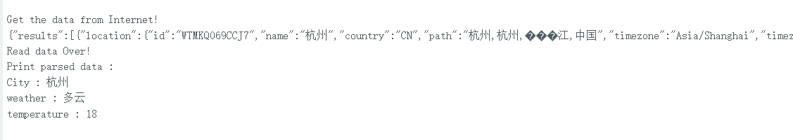

在OLED屏上显示天气信息
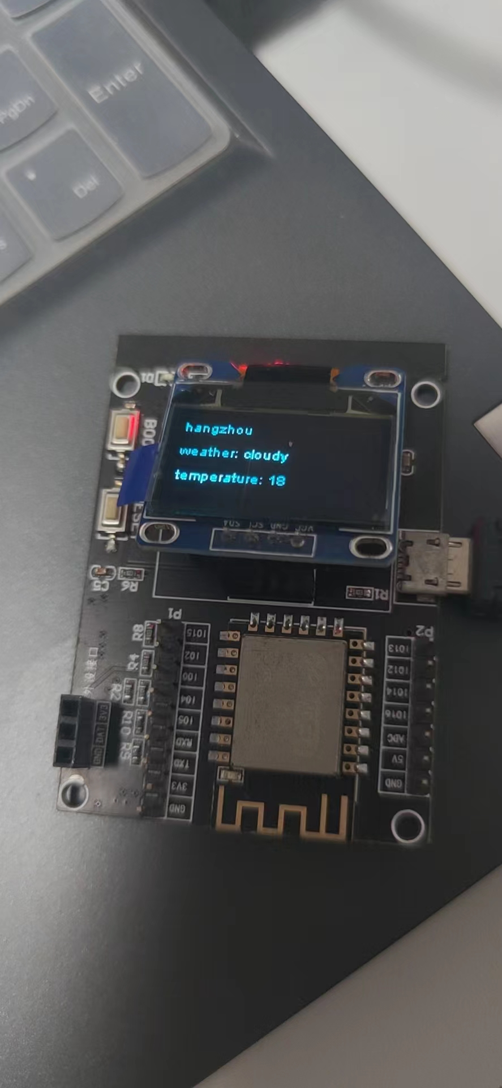

2. 实现ESP8266带高级登录认证（AdvancedAuth）的Web Server，认证的用户名为本人姓名缩写；从PC端浏览器访问ESP8266的WebServer，登录后可以分别访问GPIO口的端口0和端口1，获取各端口的状态 (注意：务必请在浏览器页面上显示本人姓名和学号信息)。
完整代码：
#include <ESP8266WiFi.h>
#include <WiFiClient.h>

#include <ESP8266WebServer.h>
#ifndef STASSID
#define STASSID "scxwifi"
#define STAPSK "cxcx629326"
#define DebugPrintln(message) Serial.println(message)
#define DebugPrint(message) Serial.print(message)
#endif
#include "SSD1306Wire.h"

#include <Wire.h>

SSD1306Wire display(0x3c, 2, 14);
const char *ssid = STASSID;
const char *password = STAPSK;
ESP8266WebServer server(80);
//Check if header is present and correct
bool is_authenticated()
{
Serial.println("Enter is_authenticated");
if (server.hasHeader("Cookie"))
{
Serial.print("Found cookie: ");
String cookie = server.header("Cookie");
Serial.println(cookie);
if (cookie.indexOf("ESPSESSIONID=1") != -1)
{
Serial.println("Authentication Successful");
return true;
}
}
Serial.println("Authentication Failed");
return false;
}
//login page, also called for disconnect
void handleLogin()
{
String msg;
if (server.hasHeader("Cookie"))
{
Serial.print("Found cookie: ");
String cookie = server.header("Cookie");
Serial.println(cookie);
}
if (server.hasArg("DISCONNECT"))
{
Serial.println("Disconnection");
server.sendHeader("Location", "/login");
server.sendHeader("Cache-Control", "no-cache");
server.sendHeader("Set-Cookie", "ESPSESSIONID=0");
server.send(301);
return;
}

if (server.hasArg("USERNAME") && server.hasArg("PASSWORD"))
{
if (server.arg("USERNAME") == "scx" && server.arg("PASSWORD") == "scx")
{
server.sendHeader("Location", "/");
server.sendHeader("Cache-Control", "no-cache");
server.sendHeader("Set-Cookie", "ESPSESSIONID=1");
server.send(301);
Serial.println("Log in Successful");
return;
}
msg = "Wrong username/password! try again.";
Serial.println("Log in Failed");
}
String content = "<html><body><form action='/login' method='POST'>To log in, please use : scx/scx<br>";
content += "User:<input type='text' name='USERNAME' placeholder='user name'><br>"; content += "Password:<input type='password' name='PASSWORD' placeholder = 'password' > <br> ";
content += "<input type='submit' name='SUBMIT' value='Submit'></form>" + msg +"<br>";
content += "You also can go <a href='/inline'>here</a></body></html>";
server.send(200, "text/html", content);
}
//root page can be accessed only if authentication is ok
void handleRoot()
{
Serial.println("Enter handleRoot");
String header;
if (!is_authenticated())
{
server.sendHeader("Location", "/login");
server.sendHeader("Cache-Control", "no-cache");
server.send(301);
return;
}
String content = "<html><body><H2>hello, scx successfully connected to esp8266 !</ H2><br> ";
if (server.hasHeader("User-Agent"))
{
content += "the user agent used is : " + server.header("User-Agent") + "<br><br>";
}
content += "You can access this page until you <a href =\"/login?DISCONNECT=YES\">disconnect</a></body></html>";
server.send(200, "text/html", content);
}

//no need authentication
void handleNotFound()
{
String message = "File Not Found\n\n";
message += "URI: ";
message += server.uri();
message += "\nMethod: ";
message += (server.method() == HTTP_GET) ? "GET" : "POST";
message += "\nArguments: ";
message += server.args();
message += "\n";
for (uint8_t i = 0; i < server.args(); i++)
{
message += " " + server.argName(i) + ": " + server.arg(i) + "\n";
}
server.send(404, "text/plain", message);
}
void gpio_0(){

String header;
if (!is_authenticated())
{
server.sendHeader("Location", "/login");
server.sendHeader("Cache-Control", "no-cache");
server.send(301);
return;
}
Serial.println("Enter gipo_0");
String content = "<html><body><H2>The state of gpio 0 is LOW !</ H2><br> ";
server.send(200, "text/html", content);

}
void gpio_1(){

String header;
if (!is_authenticated())
{
server.sendHeader("Location", "/login");
server.sendHeader("Cache-Control", "no-cache");
server.send(301);
return;
}
Serial.println("Enter gipo_1");
String content = "<html><body><H2>The state of gpio 1 is HIGH !</ H2><br> ";
server.send(200, "text/html", content);
}
void setup(void)
{
Serial.begin(115200);
WiFi.mode(WIFI_STA);
WiFi.begin(ssid, password);
Serial.println("");
// Wait for connection
while (WiFi.status() != WL_CONNECTED)
{
delay(500);
Serial.print(".");
}
Serial.println("");
Serial.print("Connected to ");
Serial.println(ssid);
Serial.print("IP address: ");
Serial.println(WiFi.localIP());
server.on("/", handleRoot);
server.on("/login", handleLogin);
server.on("/gpio/0",gpio_0);
server.on("/gpio/1",gpio_1);
server.on("/inline", []() {
server.send(200, "text/plain", "this works without need of authentication");
});
server.onNotFound(handleNotFound);
//here the list of headers to be recorded
const char *headerkeys[] = {"User-Agent", "Cookie"};
size_t headerkeyssize = sizeof(headerkeys) / sizeof(char *);

//ask server to track these headers
server.collectHeaders(headerkeys, headerkeyssize);
server.begin();
Serial.println("HTTP server started");

display.init();
display.clear();

// String s = String(WiFi.localIP());

display.drawString(0, 20, WiFi.localIP().toString());

display.display();
}
void loop(void)
{
server.handleClient();

}

浏览器访问截图：
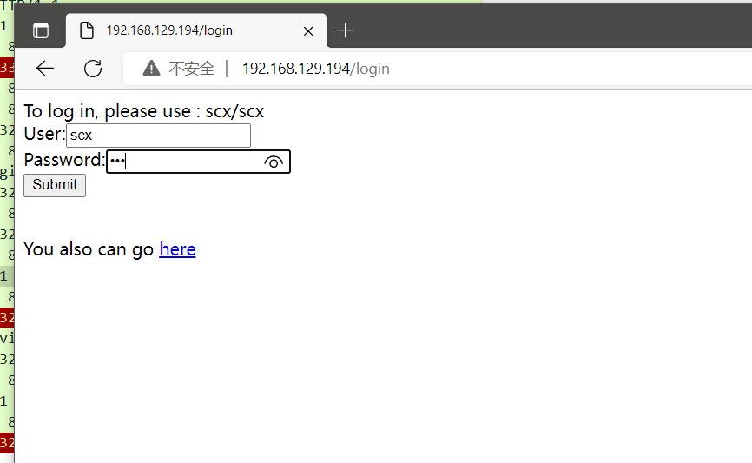

串口监视器截图：
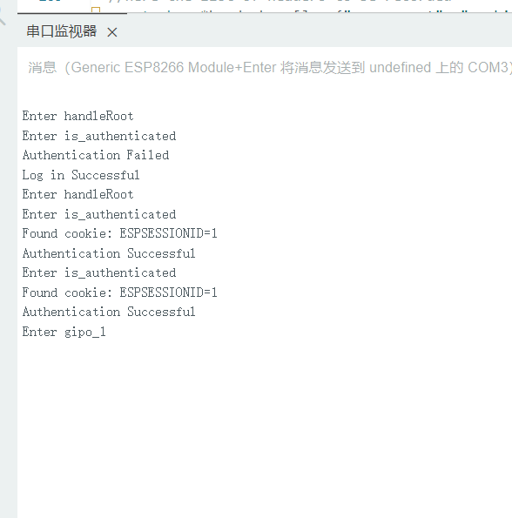

抓包查看访问登录的请求和响应
请求：
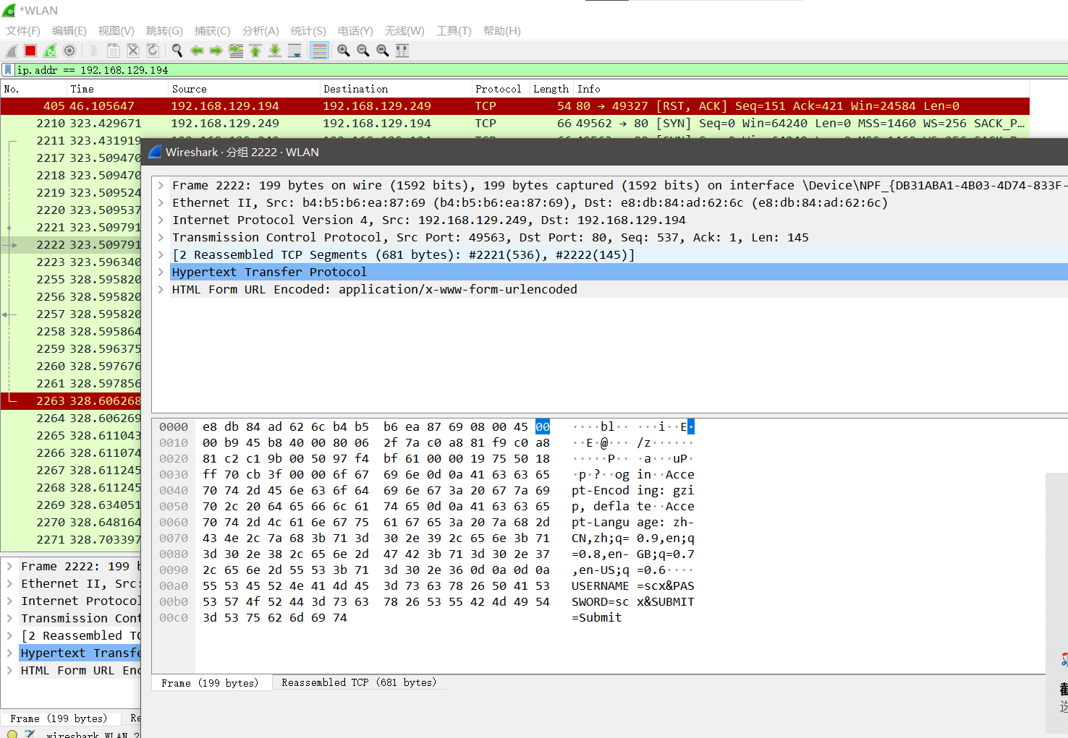

响应：
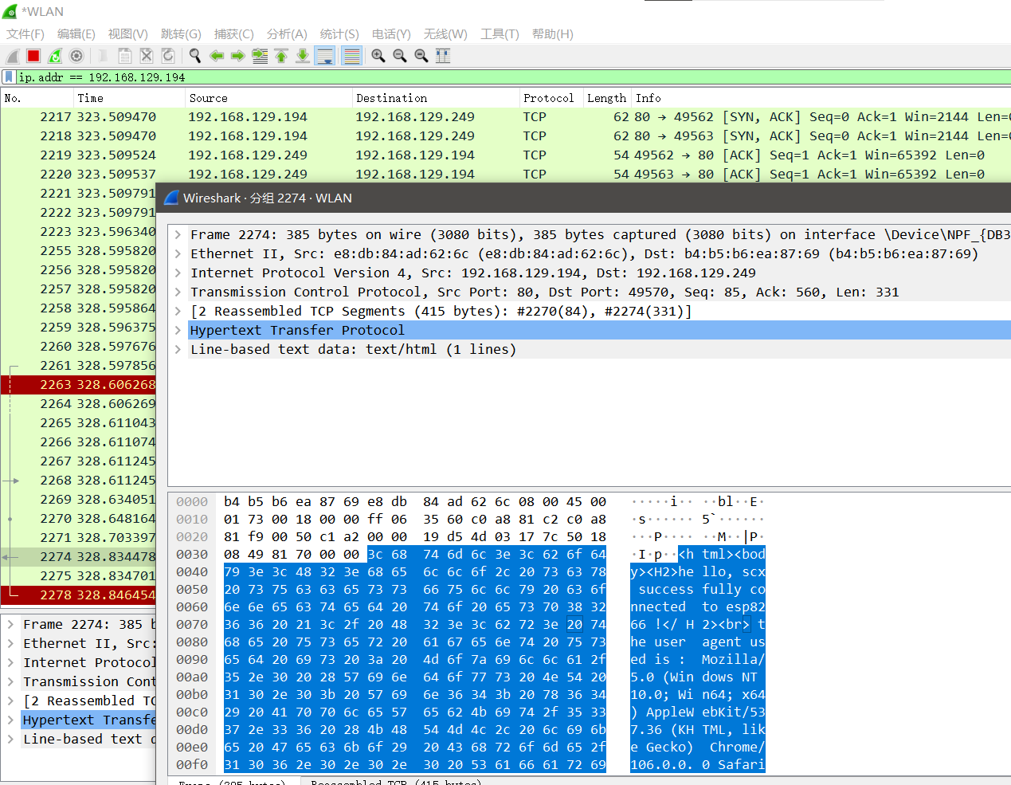

抓包查看访问访问端口1的请求和响应
请求：
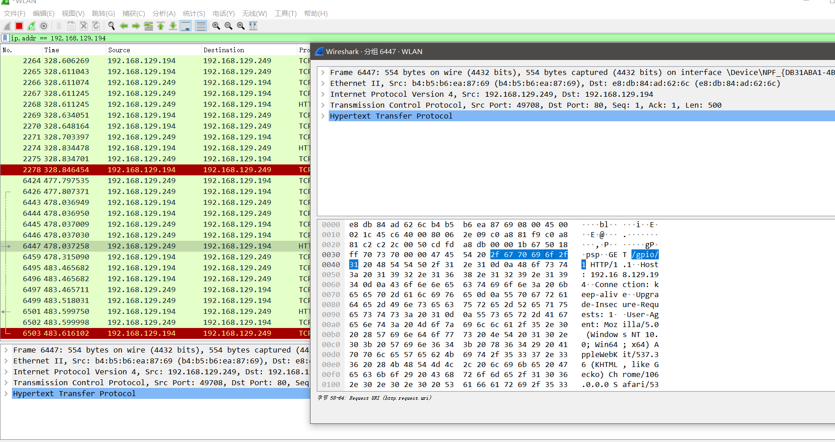

响应：
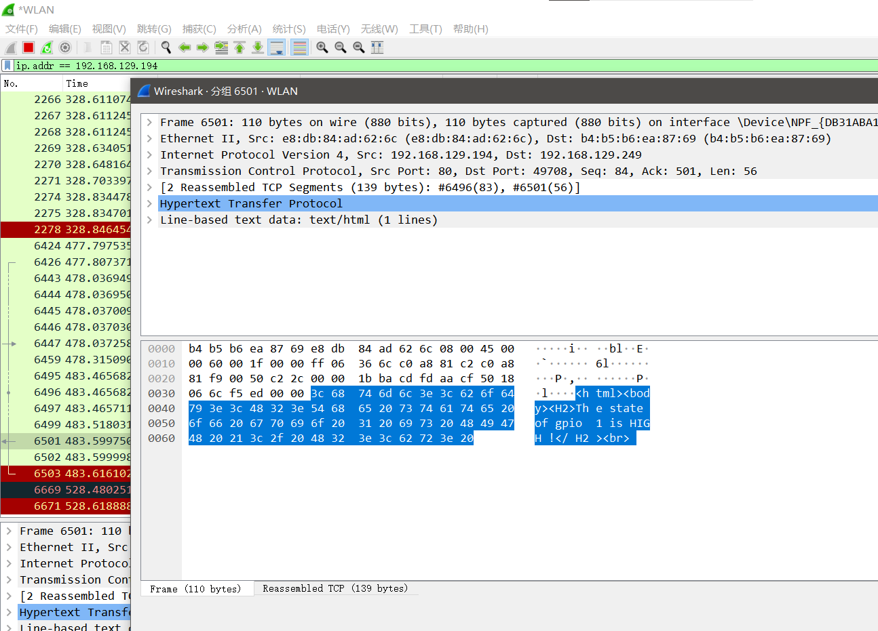

在OLED屏上显示登录的主机的IP地址
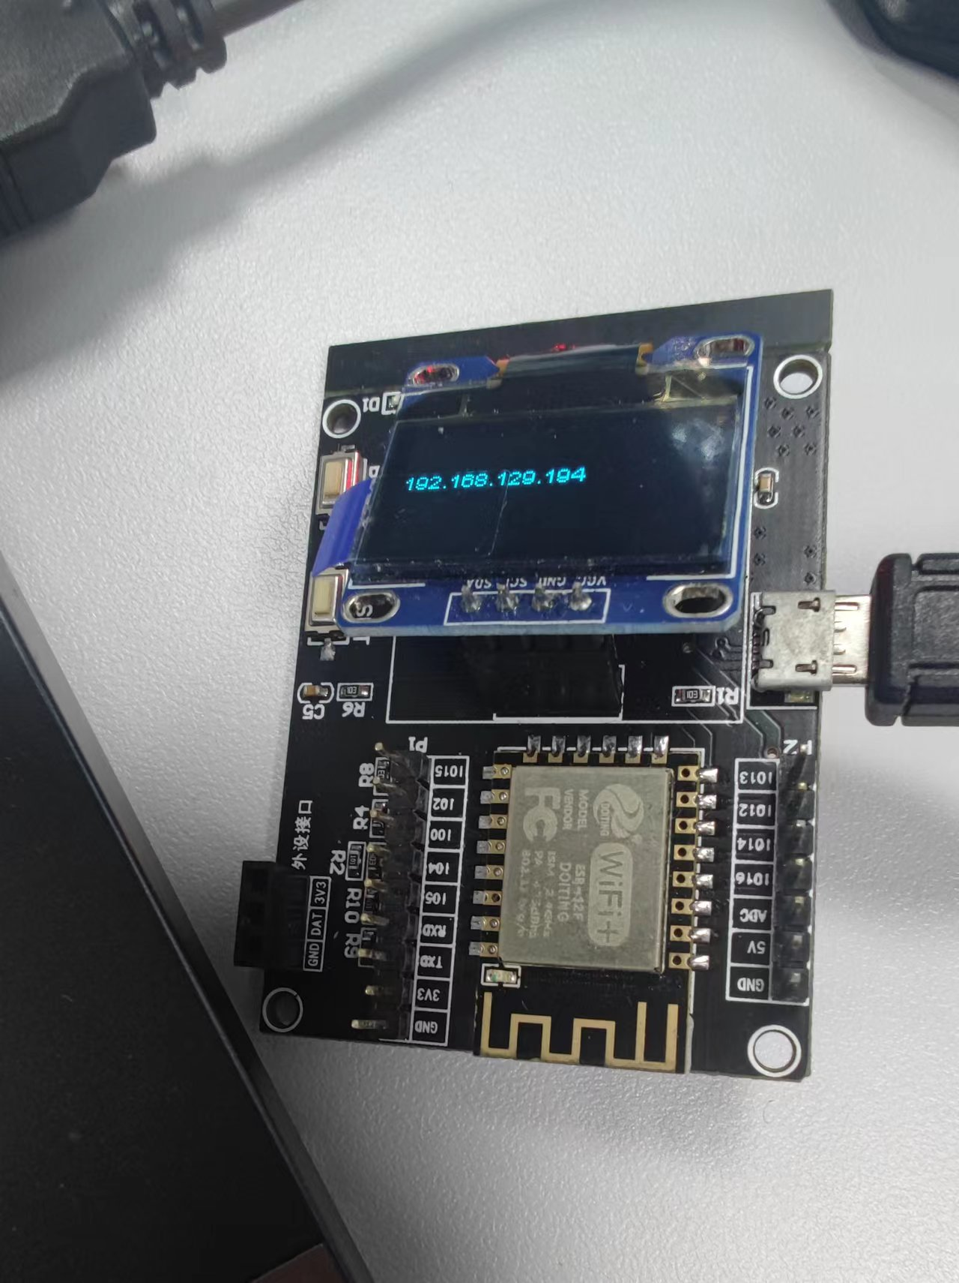

四、实验心得与体会：
发现我个人使用wireshark进行抓包的能力有点弱，每次都需要在网上搜一下显示指示规则。

