浙大城市学院实验报告
课程名称 物联网技术与应用 实验项目 实验九 MQTT客户端设计
专业班级 计算2002 学号 32001019 姓名 司晨旭
指导老师（签名 ） 蔡建平 日期 2022/11/9 实验成绩

一、实验目的：
学习MQTT的Java资源，掌握MQTT客户端设计，连接并完成数据库读写操作。
二、实验内容：
1. 读取订阅的topic消息，显示在控制台;
2. 读取订阅的topic消息，将topic、QoS和payload字段，时间戳分别写入数据表中;
3. 订阅并解析来自WebSocket客户端的JSON格式的消息，并将内容写入数据表中;
三、实验步骤：
1. 编写Java客户端程序，读取订阅的topic消息，显示在控制台（或设计UI界面，将订阅的消息显示在界面中）;
接收消息主题 : toCJP/1248 | 将主题改为姓名缩写/学号后4位
接收消息Qos : 1
接收消息内容 : close
客户端掉线！
接收消息内容 : {"msg": "Hello, CJP20221106!" } | 在Payload载荷部分有姓名缩写和日期信息

JAVA客户端代码：
package web.one;

import org.eclipse.paho.client.mqttv3.MqttClient;
import org.eclipse.paho.client.mqttv3.MqttConnectOptions;
import org.eclipse.paho.client.mqttv3.MqttTopic;
import org.eclipse.paho.client.mqttv3.persist.MemoryPersistence;

public class Client {
public static final String HOST = "ws://121.5.180.148:8083/mqtt";
public static final String TOPIC = "toSCX/1019";
private static final String clientid = "SCX1019";
private MqttClient client;
private MqttConnectOptions options;
private String userName = "";
private String passWord = "";
public void start() {
try {
client = new MqttClient(HOST, clientid, new MemoryPersistence());
options = new MqttConnectOptions();
options.setCleanSession(true);
options.setUserName(userName);
options.setPassword(passWord.toCharArray());
options.setConnectionTimeout(10);
options.setKeepAliveInterval(20);

client.setCallback(new PushCallback());
MqttTopic topic = client.getTopic(TOPIC);
options.setWill(topic, "close".getBytes(), 2, true);
client.connect(options);

int[] Qos = {1};
String[] topic1 = {TOPIC};
client.subscribe(topic1,Qos);

} catch (Exception e) {
// TODO: handle exception
e.printStackTrace();
}
}
public static void main(String[] args) {
Client client = new Client();
client.start();
}
}

回调函数代码：
package web.one;

import org.eclipse.paho.client.mqttv3.IMqttDeliveryToken;
import org.eclipse.paho.client.mqttv3.MqttCallback;
import org.eclipse.paho.client.mqttv3.MqttMessage;

public class PushCallback implements MqttCallback {

@Override
public void connectionLost(Throwable cause) {
// TODO Auto-generated method stub
System.out.println("连接断开，可以做重连");
}

@Override
public void deliveryComplete(IMqttDeliveryToken token) {
// TODO Auto-generated method stub
System.out.println("deliveryComplete--------"+token.isComplete());
}

@Override
public void messageArrived(String topic, MqttMessage message) throws Exception {
// TODO Auto-generated method stub
System.out.println("接收消息主题"+topic);
System.out.println("接收消息Qos"+message.getQos());
System.out.println("接受消息内容："+new String(message.getPayload()));
String str = new String(message.getPayload());
if(str.equals("close")) {
System.out.println("客户端掉线！");
}
else {
SaveMysql save = new SaveMysql();
save.savedate(topic,message.getQos(),str);
}

}

}

数据接收截图：
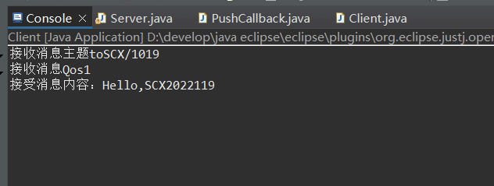

2. 读取订阅的topic消息，将topic、QoS和payload字段、时间戳分别写入数据表中;

写入数据库的程序代码：
package web.one;

import java.sql.Connection;
import java.sql.DriverManager;
import java.sql.ResultSet;
import java.sql.Statement;

public class SaveMysql {
private static String driver = "com.mysql.cj.jdbc.Driver";
private static String url = "jdbc:mysql://localhost:3306/mqtt?serverTimezone=UTC&useSSl=false";
private static String user = "root";
private static String password = "123456";
Connection conn = null;
Statement stmt = null;
ResultSet rs = null;
public void savedate(String topic,int Qos,String payload) {
String sql = "insert into mytest(TOPIC,Qos,Payload)"+"values('"+topic+"','"+Qos+"','"+payload+"');";
try {
Class.forName(driver);
conn = DriverManager.getConnection(url,user,password);
stmt = conn.createStatement();
stmt.executeUpdate(sql);
} catch (Exception e) {
// TODO: handle exception
e.printStackTrace();
}
finally {
try {
if(stmt!=null) stmt.close();
if(conn!=null) conn.close();
}
catch(Exception e) {
e.printStackTrace();
}

}
}

}

截图：
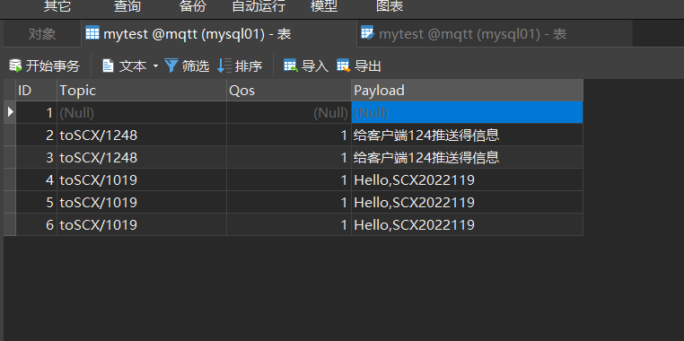

3. 采集ESP8266的温度、湿度、时间等数据，构建JSON格式的消息，并写入到MySQL数据库中。
参考字段：
序号 | 学号 | 姓名缩写 | 湿度 | 湿度

根据上表，在ESP8266的Arduino程序中构建学号、姓名缩写、温度、温度等信息的JSON格式Payload，关发布名为cjpSensor（按个人姓名缩写）的topic，Arduino程序代码：
#include <ESP8266WiFi.h>
#include <PubSubClient.h>
#include <ArduinoJson.h>
#include "DHT.h"

// WiFi
const char *ssid = "scxwifi"; // Enter your WiFi name
const char *password = "cxcx629326"; // Enter WiFi password

// MQTT Broker
const char *mqtt_broker = "121.5.180.148";
const char *topic = "toSCX/1019";
const char *mqtt_username = "emqx";
const char *mqtt_password = "public";
const int mqtt_port = 1883;

// DHT11
#define DHTPIN 5
#define DHTTYPE DHT11 // DHT 11
unsigned long previousMillis = 0;

WiFiClient espClient;
PubSubClient client(espClient);
DHT dht(DHTPIN, DHTTYPE);

void callback(char* topic, byte* payload, unsigned int length) {
Serial.print("Message arrived [");
Serial.print(topic);
Serial.print("] ");
for (int i = 0; i < length; i++) {
Serial.print((char)payload[i]);
}
Serial.println();

// Switch on the LED if an 1 was received as first character
if ((char)payload[0] == '1') {
digitalWrite(BUILTIN_LED, LOW); // Turn the LED on (Note that LOW is the voltage level
// but actually the LED is on; this is because
// it is acive low on the ESP-01)
} else {
digitalWrite(BUILTIN_LED, HIGH); // Turn the LED off by making the voltage HIGH
}

}

void setup() {
// Set software serial baud to 115200;
Serial.begin(115200);
// connecting to a WiFi network
WiFi.begin(ssid, password);
while (WiFi.status() != WL_CONNECTED) {
delay(500);
Serial.println("Connecting to WiFi..");
}
Serial.println("Connected to the WiFi network");
//connecting to a mqtt broker
client.setServer(mqtt_broker, mqtt_port);
client.setCallback(callback);
//connecting to a mqtt broker
while (!client.connected()) {
String client_id = "esp8266-client-";
client_id += String(WiFi.macAddress());
Serial.println("Connecting to public emqx mqtt broker.....");
if (client.connect("ESP8266Client")) {
Serial.println("Public emqx mqtt broker connected");
} else {
Serial.print("failed with state ");
Serial.print(client.state());
delay(2000);
}
}
// dht11 begin
dht.begin();
}

void loop() {
client.loop();
unsigned long currentMillis = millis();
// temperature and humidity data are publish every five second
if (currentMillis - previousMillis >= 5000) {
previousMillis = currentMillis;
float temp = dht.readTemperature();
float hum = dht.readHumidity();
// json serialize
DynamicJsonDocument data(256);

data["xuehao"] = "32001019";
data["name"] = "SCX";
data["temp"] = temp;
data["hum"] = hum;
// publish temperature and humidity
char json_string[256];
serializeJson(data, json_string);
// {"temp":23.5,"hum":55}
Serial.println(json_string);
client.publish(topic, json_string, false);
}
}

JAVA客户端订阅主题，并进行数据解析后写入数据库，程序代码：
package web.one;

import org.eclipse.paho.client.mqttv3.MqttClient;
import org.eclipse.paho.client.mqttv3.MqttConnectOptions;
import org.eclipse.paho.client.mqttv3.MqttTopic;
import org.eclipse.paho.client.mqttv3.persist.MemoryPersistence;

public class Client {
public static final String HOST = "ws://121.5.180.148:8083/mqtt";
public static final String TOPIC = "toSCX/1019";
private static final String clientid = "SCX1019";
private MqttClient client;
private MqttConnectOptions options;
private String userName = "";
private String passWord = "";
public void start() {
try {
client = new MqttClient(HOST, clientid, new MemoryPersistence());
options = new MqttConnectOptions();
options.setCleanSession(true);
options.setUserName(userName);
options.setPassword(passWord.toCharArray());
options.setConnectionTimeout(10);
options.setKeepAliveInterval(20);

client.setCallback(new PushCallback());
MqttTopic topic = client.getTopic(TOPIC);
options.setWill(topic, "close".getBytes(), 2, true);
client.connect(options);

int[] Qos = {1};
String[] topic1 = {TOPIC};
client.subscribe(topic1,Qos);

} catch (Exception e) {
// TODO: handle exception
e.printStackTrace();
}
}
public static void main(String[] args) {
Client client = new Client();
client.start();
}
}

截图：
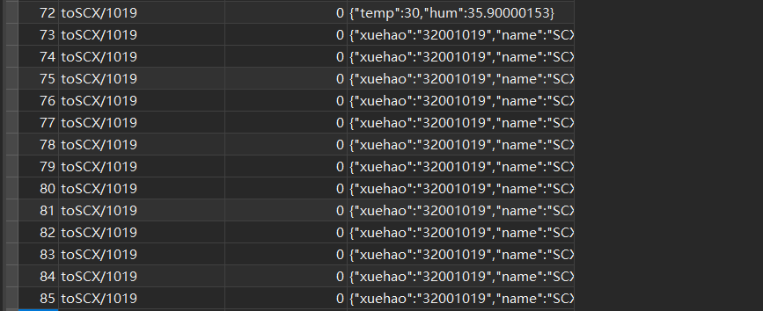

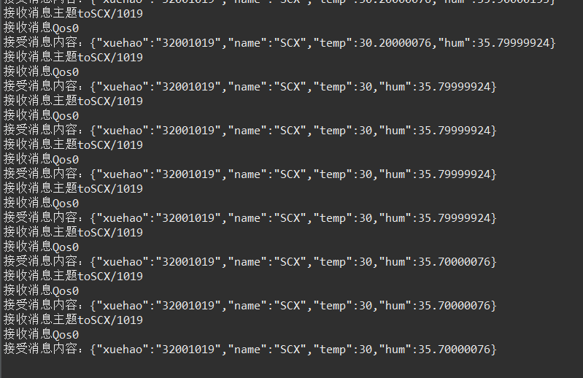

四、本次实验感受：
写入esp8266时 使用的json库版本出了问题，找了蛮久的bug。然后是 client 的连接部分还是有一些不懂的地方
代码会使用，但是代码里面的底层逻辑我并没有很好的掌握，知识都是一知半解的。

