浙大城市学院实验报告
课程名称 物联网技术与应用 实验项目 实验2 OLED显示控制实验
专业班级 计算2002 学号 32001019 姓名 司晨旭
指导老师（签名 ） 蔡建平 日期 2022/9/26 实验成绩
一、实验目的：
熟悉OLED显示模块SSD1306的使用，熟悉128*64点阵分辨率的OLED的显示控制，掌握显示各类对象的函数及参数的用法，掌握屏幕显示坐标计算。
二、实验内容：
1. 用10号，12号，16号字号显示三行字符“Hello, XYZ!” (将XYZ替换为自己姓名缩写)
2. 在屏幕中心位置，依次显示圆形、三角形，正方形
3. 采集DHT11的温湿度值并显示在OLED屏上
4. 自行查找资料，实现中文显示，显示自己的姓名和学号等
三、实验步骤：
1. 用10号，16号，24号字号显示三行字符“Hello, ***!” (将***替换为自己的姓名缩写)。
示例： display->setFont(ArialMT_Plain_16);
#include "SSD1306Wire.h"
SSD1306Wire display(0x3c, 2, 14);
void setup()
{
display.init();
display.clear();

display.setFont(ArialMT_Plain_10);
display.drawString(0,0,"hello,scx");
display.setFont(ArialMT_Plain_16);
display.drawString(0,20,"hello,scx");
display.setFont(ArialMT_Plain_24);
display.drawString(0,40,"hello,scx");
display.display();
}

void loop()
{

}

显示照片：
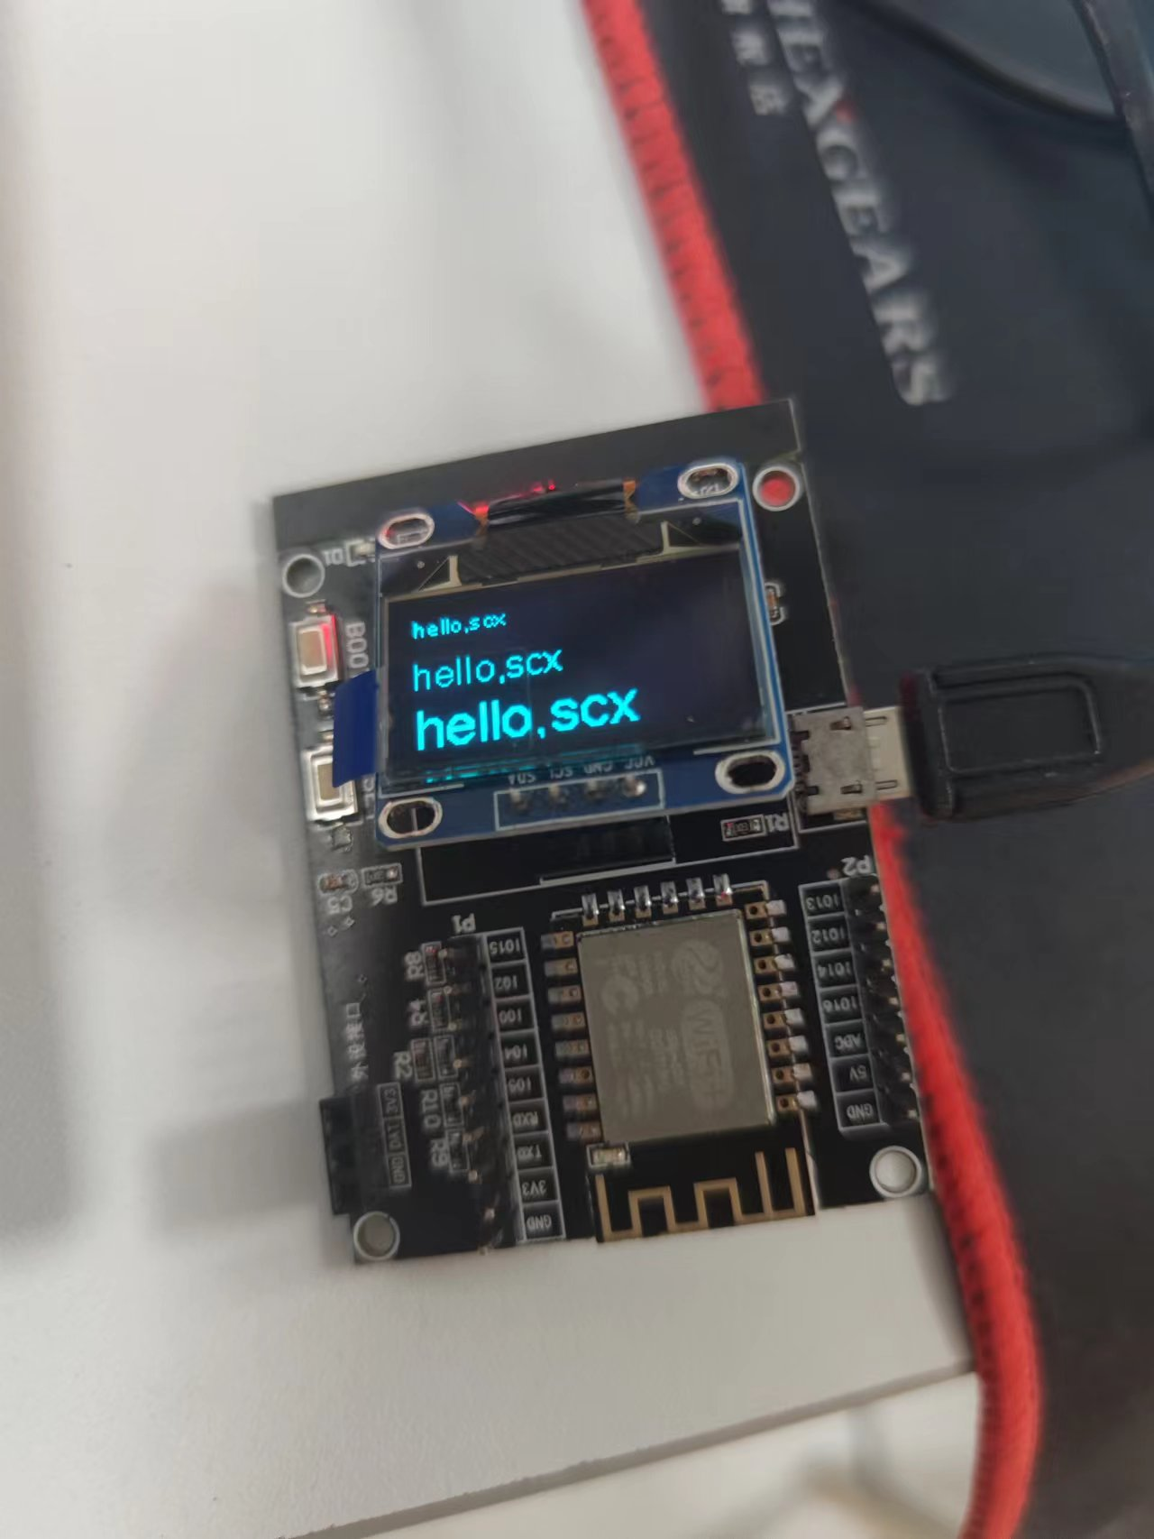

2. 在屏幕中心位置，依次循环显示画斜线、画圆形、画矩形。
代码：
#include "SSD1306Wire.h"
SSD1306Wire display(0x3c, 2, 14);
// 64,0
//32,64 96.64
//32,16,64,32
void setup()
{
display.init();

}

void loop()
{
display.clear();
display.drawCircle(64,32,32);
display.display();
delay(2000);
display.clear();
display.drawLine(64,0,32,63);
display.drawLine(32,63,96,63);
display.drawLine(96,63,63,0);
display.display();
delay(2000);
display.clear();
display.drawRect(32,16,64,32);
display.display();
delay(2000);

}

显示照片：
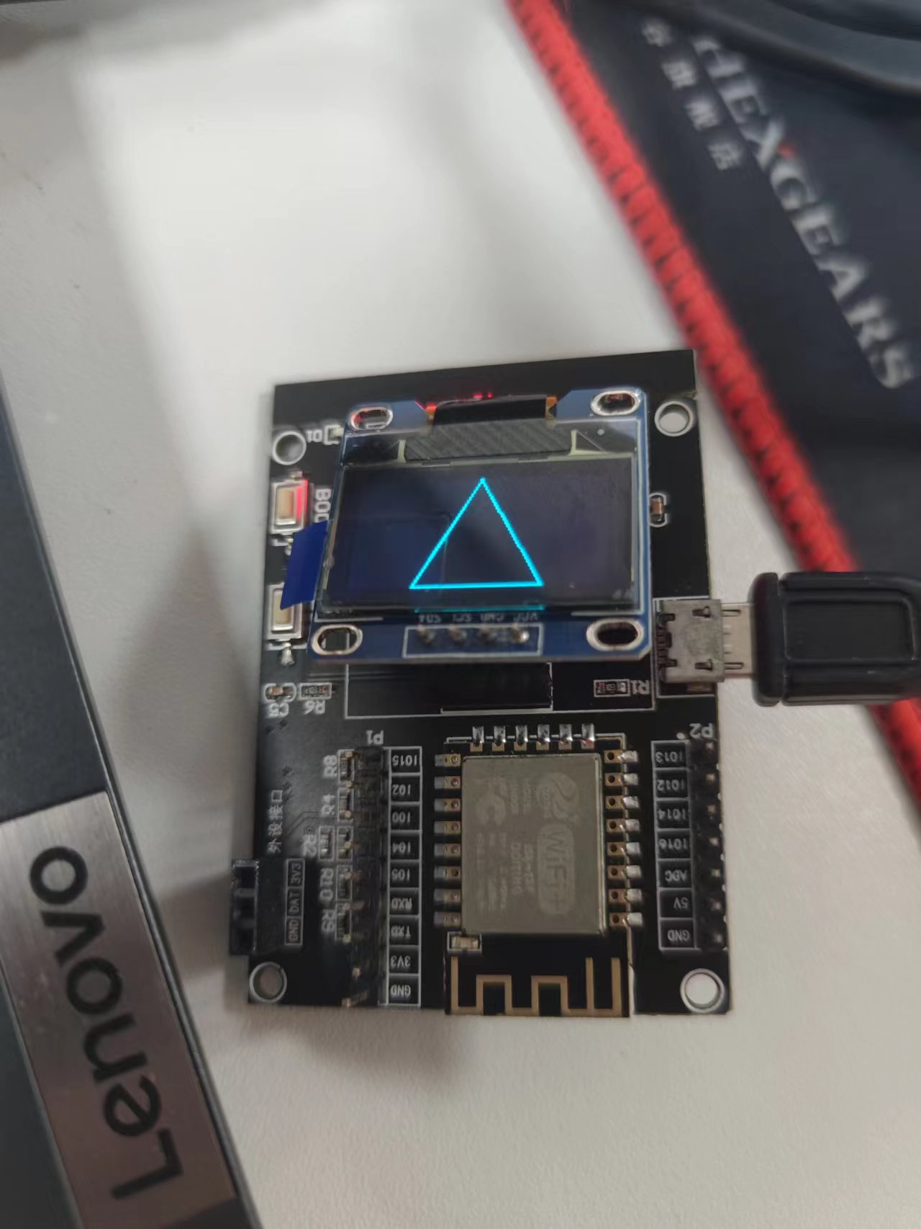
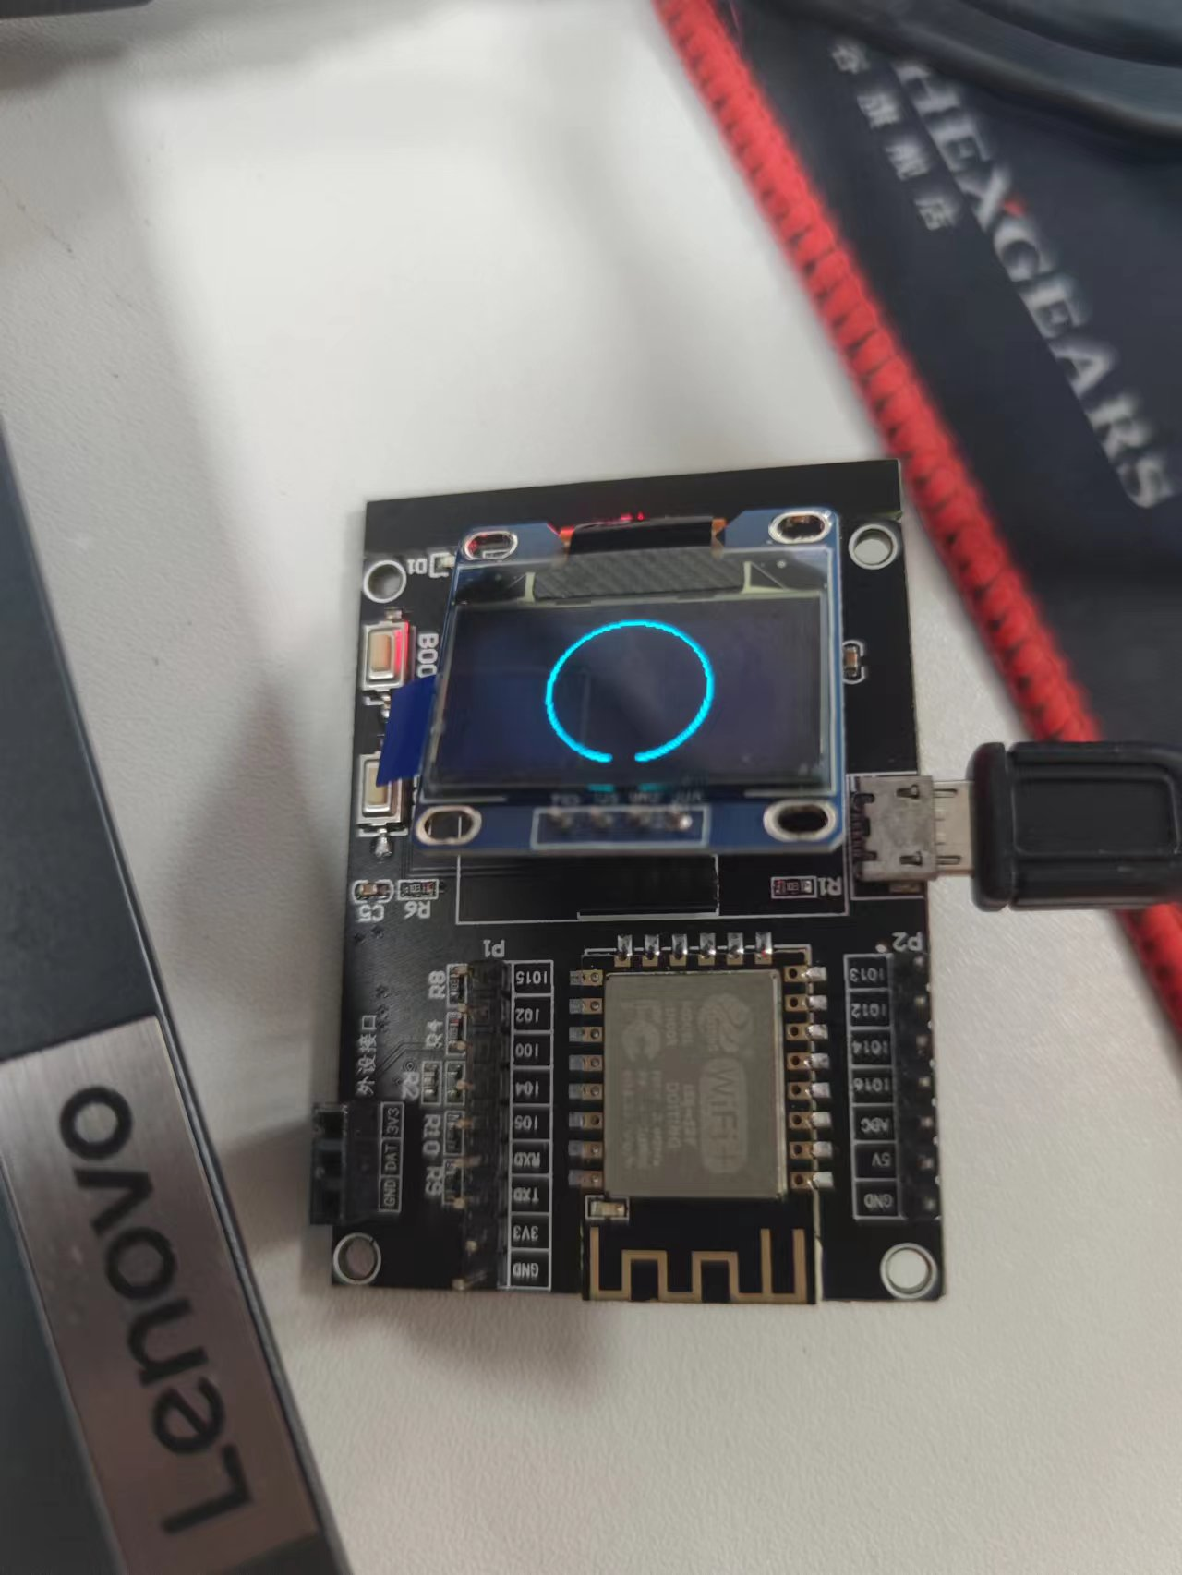
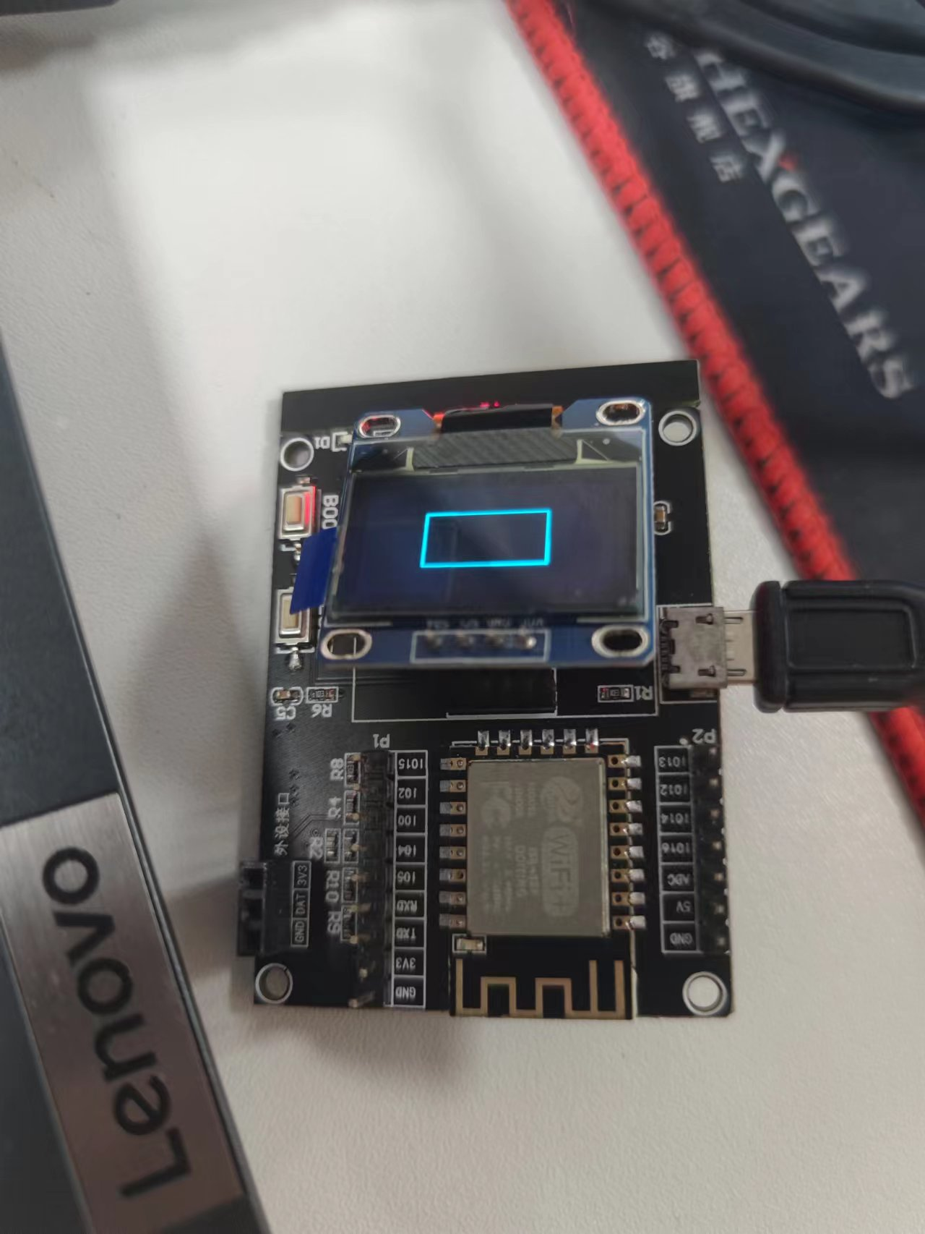

3. 自行查找资料，实现中文显示，显示自己的姓名和学号。
代码：
#include "SSD1306Wire.h"

SSD1306Wire display(0x3c, 2, 14);
const uint8_t si[] = {0x00,0x00,0xFC,0x1F,0x00,0x10,0x00,0x10,0xFE,0x17,0x00,0x10,0x00,0x10,0xF8,0x11,0x08,0x11,0x08,0x11,0x08,0x11,0x08,0x11,0xF8,0x11,0x08,0x11,0x00,0x14,0x00,0x08};
const uint8_t chen[] ={0xF8,0x0F,0x08,0x08,0xF8,0x0F,0x08,0x08,0xF8,0x0F,0x00,0x00,0xFC,0x3F,0x04,0x00,0xF4,0x1F,0x04,0x00,0xFC,0x7F,0x94,0x10,0x14,0x09,0x12,0x06,0x52,0x18,0x31,0x60};
const uint8_t xu[] ={0x04,0x00,0x04,0x1F,0x04,0x11,0x04,0x11,0x3F,0x11,0x24,0x1F,0x24,0x11,0x24,0x11,0x24,0x11,0x24,0x11,0x24,0x1F,0x24,0x51,0x24,0x40,0x22,0x40,0xC2,0x7F,0x01,0x00};
void setup()
{

display.init();

}

void loop()
{
display.clear();
display.drawIco16x16(0,0,si,0);
display.drawIco16x16(20,0,chen,0);
display.drawIco16x16(40,0,xu,0);
display.drawString(0,20,"32001019");
display.display();
}

显示照片：
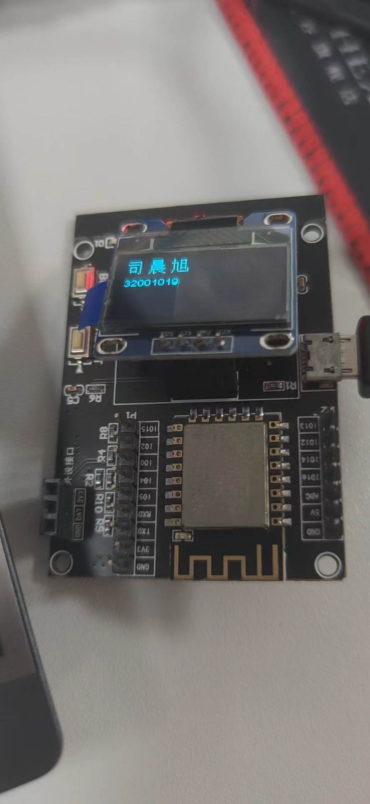

4. 根据DHT11的示例程序，连接DHT11温湿度传感器，通过串口打印输出温湿度值。在OLED屏上显示温湿度值，并设计自己个性化的数字温湿度计，要求有数值显示，有图形元素，或有中文字符显示。
代码：
#include "SSD1306Wire.h"
#include <DHT.h>
DHT dht(5,DHT11);
SSD1306Wire display(0x3c, 2, 14);
const uint8_t si[] ={0x00,0x00,0xFC,0x1F,0x00,0x10,0x00,0x10,0xFE,0x17,0x00,0x10,0x00,0x10,0xF8,0x11,0x08,0x11,0x08,0x11,0x08,0x11,0x08,0x11,0xF8,0x11,0x08,0x11,0x00,0x14,0x00,0x08};
const uint8_t chen[] ={0xF8,0x0F,0x08,0x08,0xF8,0x0F,0x08,0x08,0xF8,0x0F,0x00,0x00,0xFC,0x3F,0x04,0x00,0xF4,0x1F,0x04,0x00,0xFC,0x7F,0x94,0x10,0x14,0x09,0x12,0x06,0x52,0x18,0x31,0x60};
const uint8_t xu[] ={0x04,0x00,0x04,0x1F,0x04,0x11,0x04,0x11,0x3F,0x11,0x24,0x1F,0x24,0x11,0x24,0x11,0x24,0x11,0x24,0x11,0x24,0x1F,0x24,0x51,0x24,0x40,0x22,0x40,0xC2,0x7F,0x01,0x00};
void setup()
{
Serial.begin(9600);
display.init();
dht.begin();

}

void loop()
{
delay(1500);
float temp = dht.readTemperature();
float humi = dht.readHumidity();
display.clear();
display.setFont(ArialMT_Plain_16);
display.drawString(0,0,"Temp:");
display.drawString(52,0,String(temp));
display.drawString(0,20,"humi:");
display.drawString(52,20,String(humi));
display.drawIco16x16(0,40,si,0);
display.drawIco16x16(20,40,chen,0);
display.drawIco16x16(40,40,xu,0);
display.drawProgressBar(60, 40, 50, 16, (uint8_t) temp);
Serial.print("temp : ");
Serial.println(temp);
Serial.print("humi : ");
Serial.println(humi);
display.display();
}

显示照片：
