浙大城市学院实验报告
课程名称 物联网技术与应用 实验项目 实验四 ESP8266WIFI基础实验
专业班级 学号 姓名
指导老师（签名 ） 蔡建平 日期 实验成绩

一、实验目的：
熟悉ESP8266的Wi-Fi库，熟悉基于ESP8266模块Wi-Fi的数据传输。
抓包验证通讯过程。
二、实验内容：
1. IoT Client to PC server；
2. PC Client to IoT Server，OLED屏显示收到的内容；
3. IoT Client to PC Server，将ADXL345数据发往PC Server。
三、实验步骤：
1. 将ESP8266设为IoT Client，通过PC端工具（PC server）接收来自ESP8266的消息。
1)完整代码：
/*
This sketch establishes a TCP connection to a "quote of the day" service.
It sends a "hello" message, and then prints received data.
*/
#include <ESP8266WiFi.h>
#ifndef STASSID
// #define STASSID "NETGEAR"
// #define STAPSK "*******"

#define STASSID "gerogerori"
#define STAPSK "*****"

#endif
const char* ssid = STASSID;
const char* password = STAPSK;

const char* host = "192.168.43.122";

const uint16_t port = 6800;
// Use WiFiClient class to create TCP connections
WiFiClient client;
void setup() {
Serial.begin(115200);
// We start by connecting to a WiFi network
Serial.println();
Serial.println();
Serial.print("Connecting to ");
Serial.println(ssid);
WiFi.mode(WIFI_STA);
WiFi.begin(ssid, password);
while (WiFi.status() != WL_CONNECTED) {
delay(500);
Serial.print(".");
}
Serial.println("");
Serial.println("WiFi connected");
Serial.println("IP address: ");
Serial.println(WiFi.localIP());
}
void loop() {
Serial.print("connecting to ");
Serial.print(host);
Serial.print(':');
Serial.println(port);
if (!client.connect(host, port)) {
Serial.println("connection failed");
delay(5000);
return;
}
Serial.println("sending data to server");
if (client.connected()) {
client.println( "Hello from ESP8266 , Hello from mqp ");

}
delay(6000);
Serial.println("receiving from remote server");
while (client.available()) {
char ch = static_cast<char>(client.read());
Serial.print(ch);
}
Serial.println();
Serial.println("closing connection");
client.stop();
delay(3000);
}

2)截图：
（消息中要包含个人姓名缩写，比如消息格式：Hello from ESP8266，Hello from ABC）
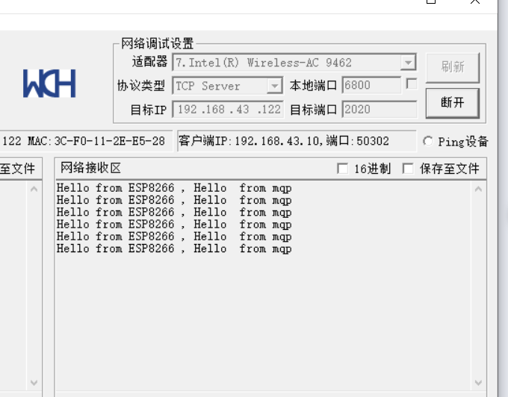
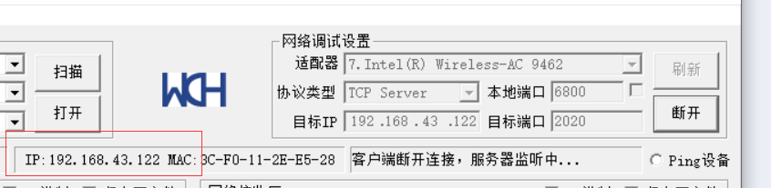
要根据这个ip，这个ip是服务器ip

3)用Wireshark抓取从ESP8266发往PC Server的数据包，截图如下：
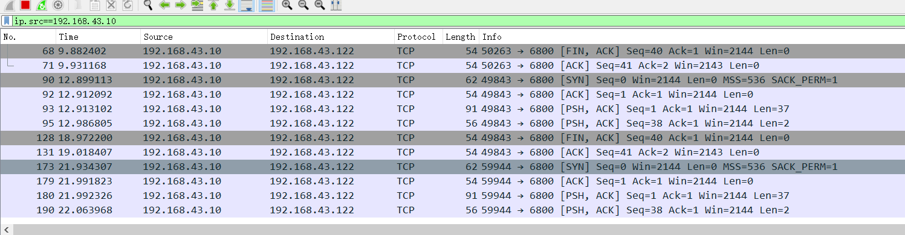

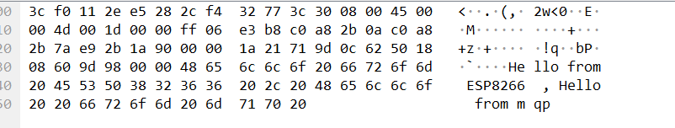

2. PC Client to IoT Server，将ESP8266设为Server, 从PC端TCP Server工具向ESP8266发送数据，在OLED屏上显示所接收到数据并支持内容持续刷新。
1)完整代码：
/**
* 演示 TCPServer 功能
* 打开 TCP 调试助手 模拟 TCP client 请求
*/

#include "SSD1306Wire.h"
SSD1306Wire display(0x3c, 2, 14);

#include <ESP8266WiFi.h>
//定义最多多少个 client 可以连接本 server(一般不要超过 4 个)
#define MAX_SRV_CLIENTS 1
//以下三个定义为调试定义
#define DebugBegin(baud_rate) Serial.begin(baud_rate)
#define DebugPrintln(message) Serial.println(message)
#define DebugPrint(message) Serial.print(message)

const char *ssid = "gerogerori";
const char *password = "*****";

//创建 server 端口号是 2020
// TCPServer server(2020);
WiFiServer server(2020);
//管理 clients
WiFiClient serverClients[MAX_SRV_CLIENTS];
void setup()
{
DebugBegin(115200);
WiFi.mode(WIFI_STA);
WiFi.begin(ssid, password);
DebugPrint("\nConnecting to ");
DebugPrintln(ssid);
uint8_t i = 0;
while (WiFi.status() != WL_CONNECTED && i++ < 20)
{
delay(500);
}
if (i == 21)
{
DebugPrint("Could not connect to");
DebugPrintln(ssid);
while (1)
{
delay(500);
}
}

server.begin();
server.setNoDelay(true);
DebugPrint("Ready! Use 'telnet ");
DebugPrint(WiFi.localIP());
DebugPrintln(" 2020' to connect");

display.init();
}

void loop()
{

display.clear();

uint8_t i;

if (server.hasClient())
{
for (i = 0; i < MAX_SRV_CLIENTS; i++)
{

if (!serverClients[i] || !serverClients[i].connected())
{
if (serverClients[i])
{
serverClients[i].stop();
}

serverClients[i] = server.available();
DebugPrint("New client: ");
DebugPrint(i);

break;
}
}

if (i == MAX_SRV_CLIENTS)
{
WiFiClient serverClient = server.available();
serverClient.stop();
DebugPrintln("Connection rejected ");
}
}
for (i = 0; i < MAX_SRV_CLIENTS; i++)
{
if (serverClients[i] && serverClients[i].connected())
{
if (serverClients[i].available())
{
String str = "";

while (serverClients[i].available())
{
char ch = (char)serverClients[i].read();
str += ch;

Serial.write(ch);

}

display.drawString(0, 0, str);
display.display();
}
}
}
if (Serial.available())
{
//把串口调试器发过来的数据 发送给 client
size_t len = Serial.available();
uint8_t sbuf[len];
Serial.readBytes(sbuf, len);
//push UART data to all connected telnet clients
for (i = 0; i < MAX_SRV_CLIENTS; i++)
{
if (serverClients[i] && serverClients[i].connected())
{
serverClients[i].write(sbuf, len);
delay(1);
}
}
}
}

2)截图：
（消息中要包含个人姓名缩写，比如消息格式：Hello from PC Client，Hello from ABC）
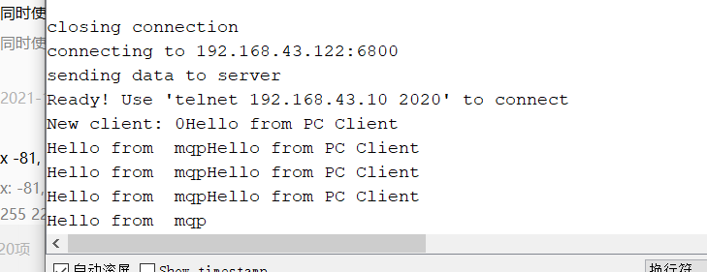
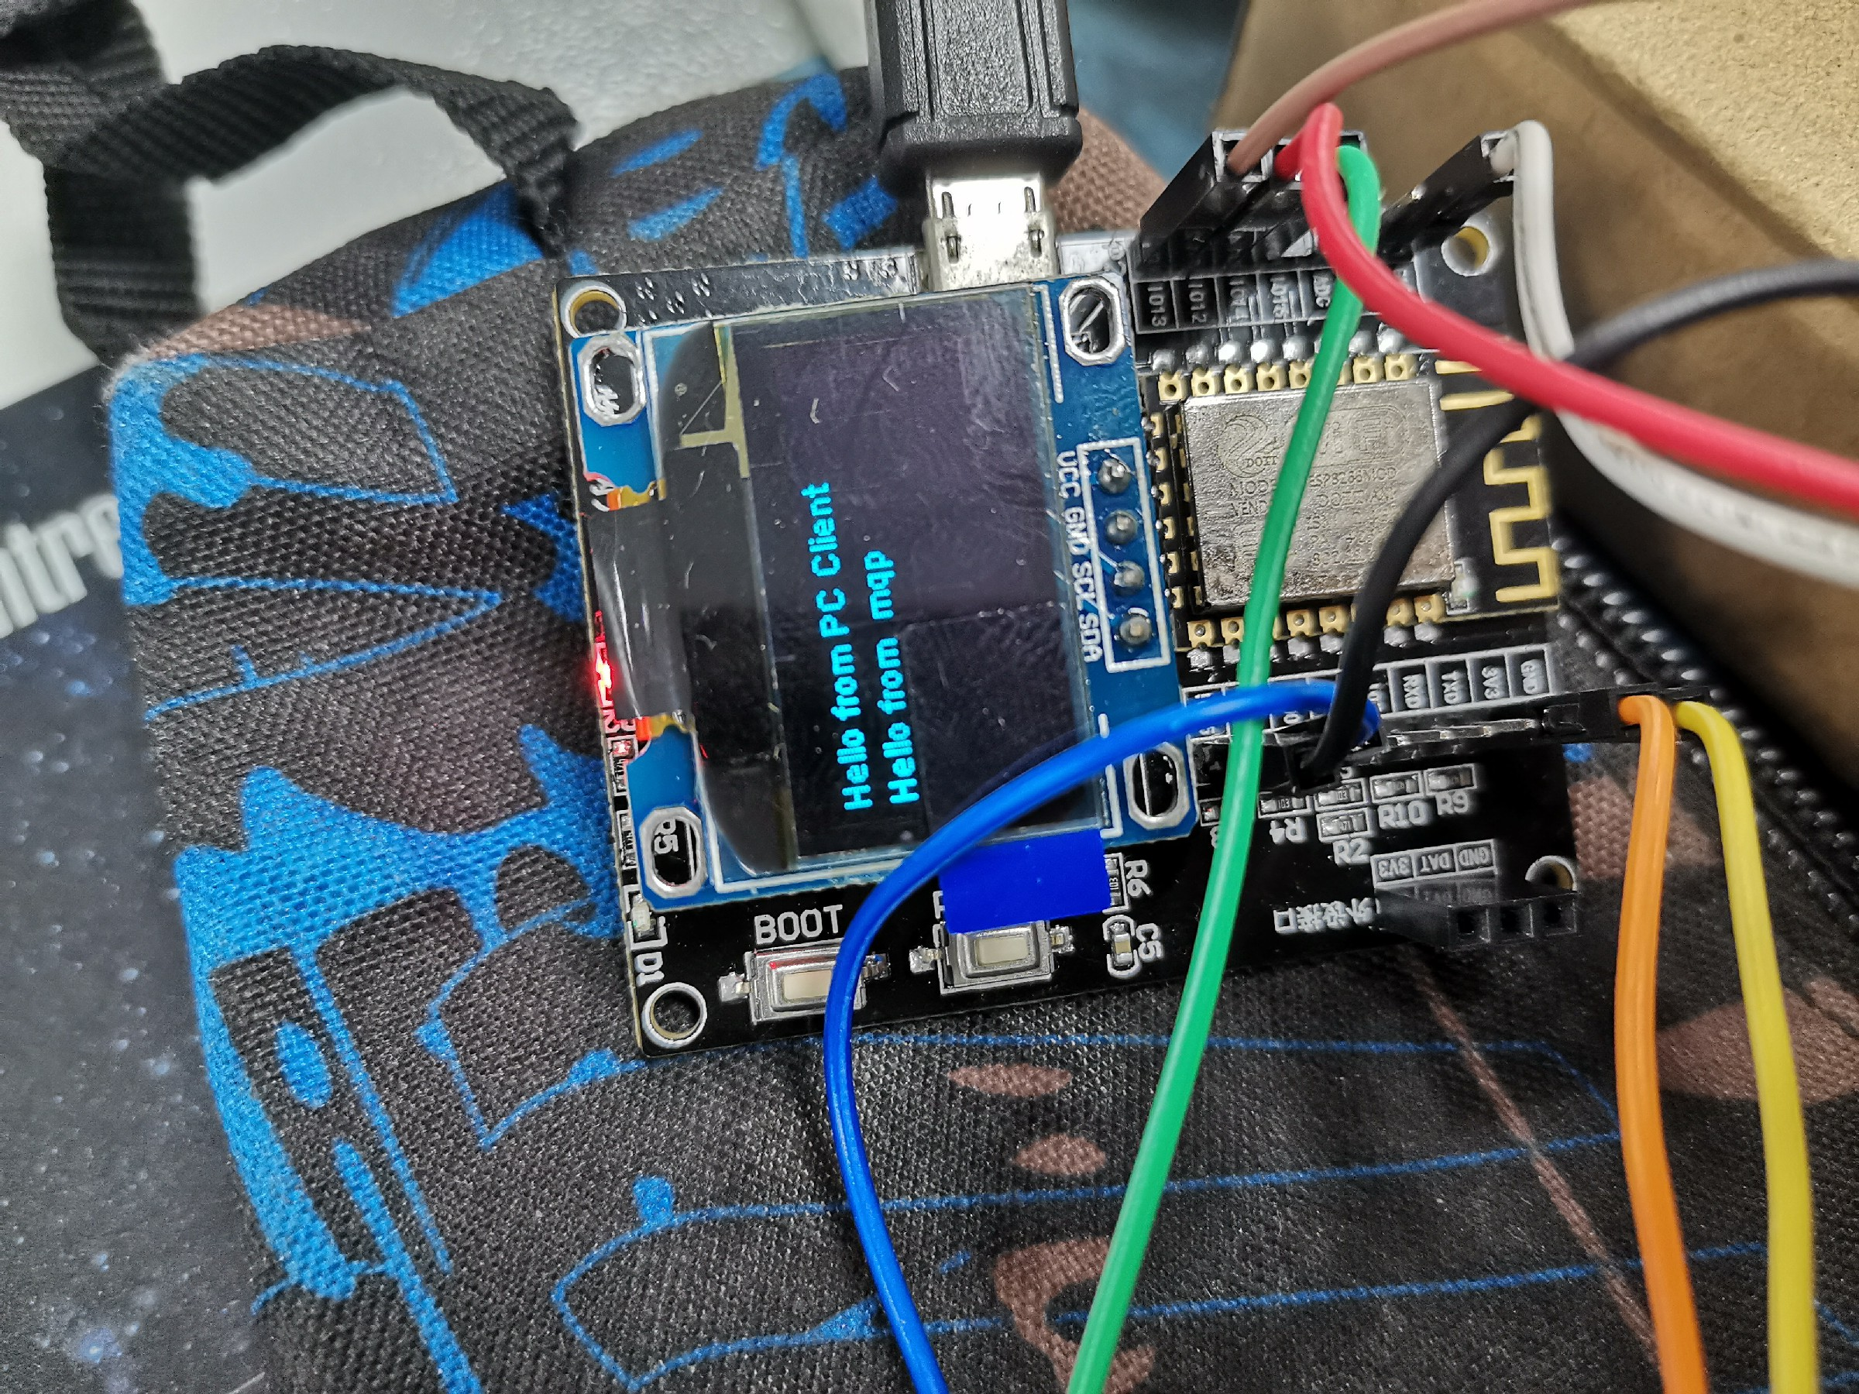

3)用Wireshark抓取从PC Client发往ESP8266的数据包，截图如下：
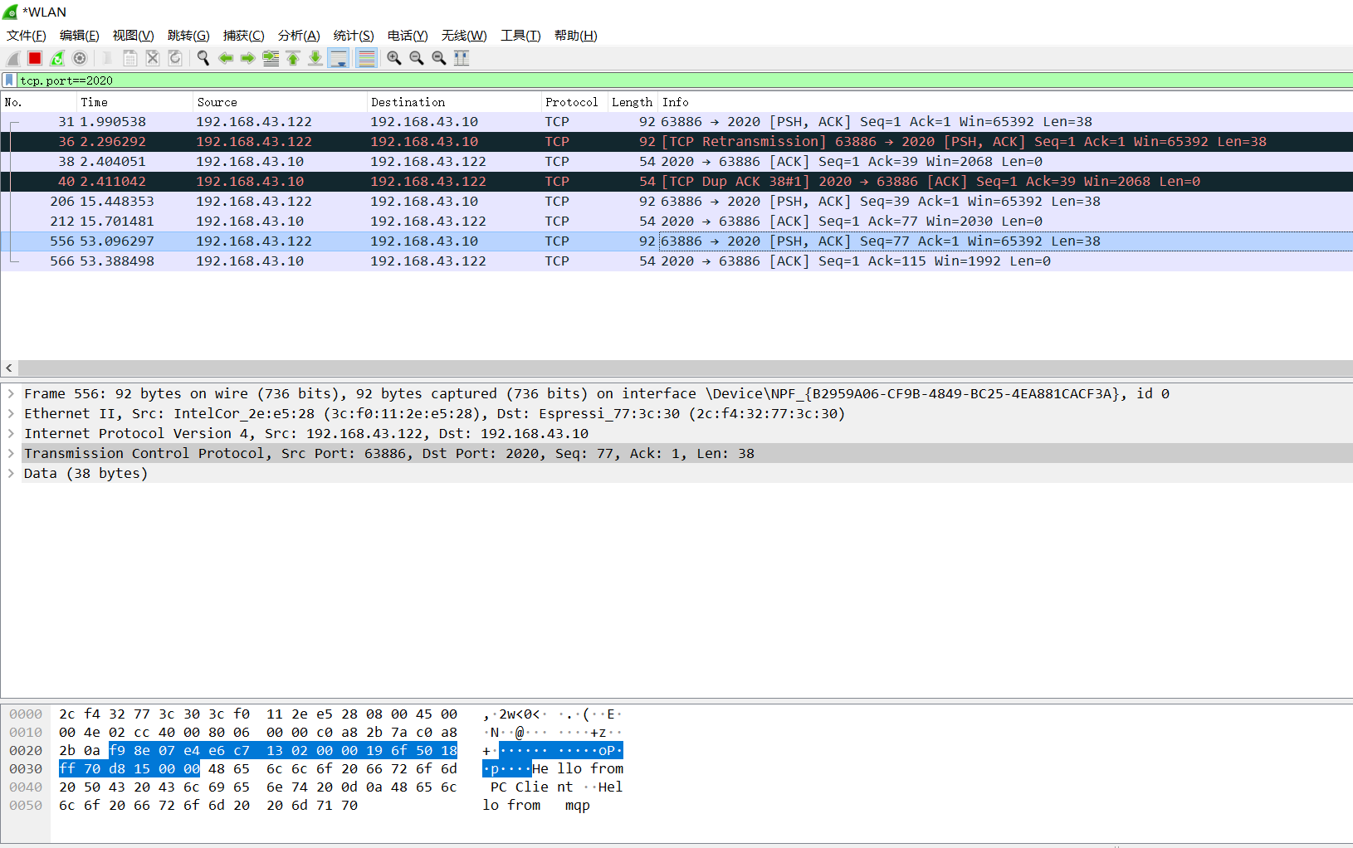

3. IoT Client to PC Server，将ADXL345数据发往PC Server
完整代码：
/*
This sketch establishes a TCP connection to a "quote of the day" service.
It sends a "hello" message, and then prints received data.
*/
#include <ESP8266WiFi.h>
#ifndef STASSID
// #define STASSID "NETGEAR"
// #define STAPSK "*******"

#define STASSID "gerogerori"
#define STAPSK "******"

#endif
const char* ssid = STASSID;
const char* password = STAPSK;
const char* host = "192.168.43.122";

const uint16_t port = 6800;
// Use WiFiClient class to create TCP connections
WiFiClient client;

#include<Wire.h>
#define Addr 0x53
const uint8_t scl=2;
const uint8_t sda=14;

#include<vector>

std::vector<int> readAccl(){

unsigned int data[6];

Wire.beginTransmission(Addr);
Wire.begin(sda,scl);
Wire.write(0x2C);
Wire.write(0x0A);
Wire.endTransmission();

Wire.beginTransmission(Addr);
Wire.write(0x2D);
Wire.write(0x08);
Wire.endTransmission();

Wire.beginTransmission(Addr);

Wire.write(0x31);
Wire.write(0x08);
Wire.endTransmission();
delay(300);
// 少了 delay 就有问题 好像
for(int i=0;i<6;i++){
Wire.beginTransmission(Addr);
Wire.write((50+i));
Wire.endTransmission();
Wire.requestFrom(Addr,1);
if(Wire.available()==1){
data[i]=Wire.read();
}
}

int xAccl=(((data[1]&0x03)*256)+data[0]);
if(xAccl>551){
xAccl-=1024;
}

int yAccl=(((data[3]&0x03)*256)+data[2]);
if(yAccl>551){
yAccl-=1024;
}

int zAccl=(((data[5]&0x03)*256)+data[4]);
if(zAccl>551){
zAccl-=1024;
}

std:: vector<int>v;

v.push_back(xAccl);
v.push_back(yAccl);
v.push_back(zAccl);
return v;

}

void setup() {
Serial.begin(115200);
// We start by connecting to a WiFi network
Serial.println();
Serial.println();
Serial.print("Connecting to ");
Serial.println(ssid);
/* Explicitly set the ESP8266 to be a WiFi-client, otherwise, it by default,
would try to act as both a client and an access-point and could cause
network-issues with your other WiFi-devices on your WiFi-network. */
WiFi.mode(WIFI_STA);
WiFi.begin(ssid, password);
while (WiFi.status() != WL_CONNECTED) {
delay(500);
Serial.print(".");
}
Serial.println("");
Serial.println("WiFi connected");
Serial.println("IP address: ");
Serial.println(WiFi.localIP());
}
void loop() {
Serial.print("connecting to ");
Serial.print(host);
Serial.print(':');
Serial.println(port);
if (!client.connect(host, port)) {
Serial.println("connection failed");
delay(5000);
return;
}
Serial.println("sending data to server");
std:: vector<int> accls= readAccl();
int xAccl=accls[0];
int yAccl=accls[1];
int zAccl=accls[2];
if (client.connected()) {
client.printf("x: %d, y: %d, z: %d\n",xAccl,yAccl,zAccl);

}
delay(6000);
Serial.println("receiving from remote server");
// not testing 'client.connected()' since we do not need to send data here
while (client.available()) {
char ch = static_cast<char>(client.read());
Serial.print(ch);
}
// Close the connection
Serial.println();
Serial.println("closing connection");
client.stop();
delay(3000); // execute once every 5 minutes, don't flood remote service
}

截图：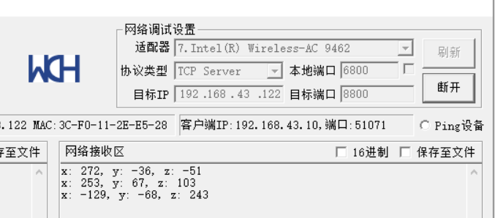

用Wireshark抓取来自ESP8266的数据包，截图如下：

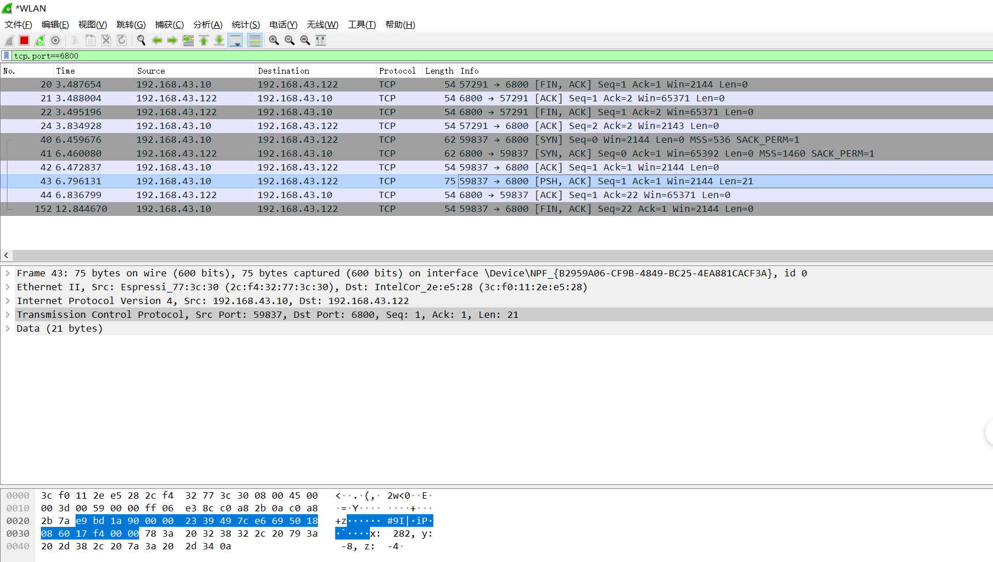

4. 访问API，获取JSON并提取所需的字段，申请个人的心知天气的ID（https://www.seniverse.com/），通过TCP client包装HTTP请求协议去调用天气接口获取天气信息。

心知天气的host：
api.seniverse.com

本人心知天气的APIKEY：
wcmquevztdy1jpca

完整代码：
// #include<ESP8266WiFi.h>
// #ifndef STASSID
// #define STASSID "NETGEAR"
#include <ESP8266WiFi.h>
#include <ArduinoJson.h>
//以下三个定义为调试定义
#define DebugBegin(baud_rate) Serial.begin(baud_rate)
#define DebugPrintln(message) Serial.println(message)
#define DebugPrint(message) Serial.print(message)

const char *ssid = "gerogerori";
const char *password = "*******";

const char *host = "api.seniverse.com";
const char *APIKEY = "wcmquevztdy1jpca"; //API KEY
const char *city = "hangzhou";
const char *language = "zh-Hans"; //zh-Hans 简体中文 会显示乱码

const unsigned long BAUD_RATE = 115200; // serial connection speed
const unsigned long HTTP_TIMEOUT = 5000; // max respone time from server
const size_t MAX_CONTENT_SIZE = 1000; // max size of the HTTP response
// 从此网页中提取的数据的类型
struct WeatherData
{
char city[16]; //城市名称
char weather[32]; //天气介绍（多云...）
char temp[16]; //温度
char udate[32]; //更新时间
};

WiFiClient client;
char response[MAX_CONTENT_SIZE];
char endOfHeaders[] = "\r\n\r\n";
void setup()
{
// put your setup code here, to run once:
WiFi.mode(WIFI_STA); //设置 esp8266 工作模式
DebugBegin(BAUD_RATE);
DebugPrint("Connecting to "); //提示
DebugPrintln(ssid);
WiFi.begin(ssid, password); //连接 wifi
WiFi.setAutoConnect(true);
while (WiFi.status() != WL_CONNECTED)
{
//这个函数是 wifi 连接状态，返回 wifi 链接状态
delay(500);
DebugPrint(".");
}
DebugPrintln("");
DebugPrintln("WiFi connected");
delay(500);
DebugPrintln("IP address: ");
DebugPrintln(WiFi.localIP()); //WiFi.localIP()返回 8266 获得的 ip 地址
client.setTimeout(HTTP_TIMEOUT);
}
void loop()
{
// put your main code here, to run repeatedly:
//判断 tcp client 是否处于连接状态，不是就建立连接
while (!client.connected())
{
if (!client.connect(host, 80))
{
DebugPrintln("connection....");
delay(500);
}
}
//发送 http 请求 并且跳过响应头 直接获取响应 body
if (sendRequest(host, city, APIKEY) && skipResponseHeaders())
{
//清除缓冲
clrEsp8266ResponseBuffer();
//读取响应数据
readReponseContent(response, sizeof(response));
WeatherData weatherData;
if (parseUserData(response, &weatherData))
{
printUserData(&weatherData);
}
}
delay(5000); //每 5s 调用一次
}
bool sendRequest(const char *host, const char *cityid, const char *apiKey)
{

String GetUrl = "/v3/weather/now.json?key=";
GetUrl += apiKey;
GetUrl += "&location=";
GetUrl += city;
GetUrl += "&language=";
GetUrl += language;
// This will send the request to the server
client.print(String("GET ") + GetUrl + " HTTP/1.1\r\n" +
"Host: " + host + "\r\n" +
"Connection: close\r\n\r\n");
DebugPrintln("create a request:");
DebugPrintln(String("GET ") + GetUrl + " HTTP/1.1\r\n" +
"Host: " + host + "\r\n" +
"Connection: close\r\n");
delay(1000);
return true;
}

/**
* @Desc 跳过 HTTP 头，使我们在响应正文的开头
*/
bool skipResponseHeaders()
{
// HTTP headers end with an empty line
bool ok = client.find(endOfHeaders);
if (!ok)
{
DebugPrintln("No response or invalid response!");
}
return ok;
}

/**
* @Desc 从 HTTP 服务器响应中读取正文
*/
void readReponseContent(char *content, size_t maxSize)
{
size_t length = client.readBytes(content, maxSize);
delay(100);
DebugPrintln("Get the data from Internet!");
content[length] = 0;
DebugPrintln(content);
DebugPrintln("Read data Over!");
client.flush(); //清除一下缓冲
}

/**
* @Desc 解析数据 Json 解析
* 数据格式如下：
* {
物联网技术与应用
16
* "results": [
* {
* "location": {
* "id": "WX4FBXXFKE4F",
* "name": "北京",
* "country": "CN",
* "path": "北京,北京,中国",
* "timezone": "Asia/Shanghai",
* "timezone_offset": "+08:00"
* },
* "now": {
* "text": "多云",
* "code": "4",
* "temperature": "23"
* },
* "last_update": "2017-09-13T09:51:00+08:00"
* }
* ]
*}
*/
bool parseUserData(char *content, struct WeatherData *weatherData)
{
// -- 根据我们需要解析的数据来计算 JSON 缓冲区最佳大小
// 如果你使用 StaticJsonBuffer 时才需要
// const size_t BUFFER_SIZE = 1024;
// 在堆栈上分配一个临时内存池
// StaticJsonBuffer<BUFFER_SIZE> jsonBuffer;
// -- 如果堆栈的内存池太大，使用 DynamicJsonBuffer jsonBuffer 代替
DynamicJsonBuffer jsonBuffer;
// DynamicJsonBuffer is a class from ArduinoJson 5. Please see https://arduinojson.org/upgrade to learn how to upgrade your program to ArduinoJson version 6

JsonObject &root = jsonBuffer.parseObject(content);

if (!root.success())
{
DebugPrintln("JSON parsing failed!");
return false;
}

//复制感兴趣的字符串
strcpy(weatherData->city, root["results"][0]["location"]["name"]);
strcpy(weatherData->weather, root["results"][0]["now"]["text"]);
//获取温度、最近更新时间
// -- 这不是强制复制，你可以使用指针，因为他们是指向“内容”缓冲区内，所以你需要确保
// 当你读取字符串时它仍在内存中
return true;
}

// 打印从 JSON 中提取的数据
void printUserData(const struct WeatherData *weatherData)
{
DebugPrintln("Print parsed data :");
DebugPrint("City : ");
DebugPrint(weatherData->city);
//打印天气、气温、最近更新时间
DebugPrint("weather : ");
DebugPrint(weatherData->weather);
}

// 关闭与 HTTP 服务器连接
void stopConnect()
{
DebugPrintln("Disconnect");
client.stop();
}

void clrEsp8266ResponseBuffer(void)
{
memset(response, 0, MAX_CONTENT_SIZE); //清空
}

截图：
