**浙大城市学院实验报告**

课程名称 计算机网络实验

实验项目名称 实验15 DNS原理实验

学生姓名 司晨旭 专业班级 计算2002 学号 32001019

指导老师 蔡建平 实验日期 2022/5/18

一、实验目的

1. 掌握DNS的工作原理；

2.掌握DNS的两种解析方法;

3.掌握DNS服务器的配置

二、实验设备

Packet Tracer模拟器软件；

Cisco 2911路由器若干台，交换机若干台，PC机若干台，服务器若干台。

三、实验内容

1. DNS基本配置实验

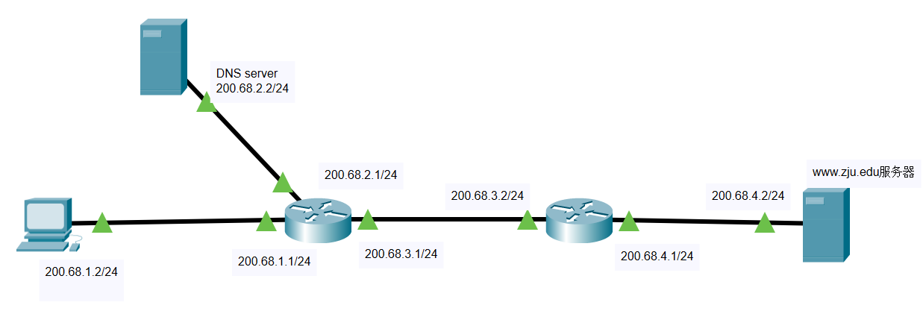

1）配置路由器的各个接口的IP地址，子网掩码

|  |
| --- |
| Router>en  Router#config t  Enter configuration commands, one per line. End with CNTL/Z.  Router(config)#hostname SCXR1  SCXR1(config)#interface g0/0  SCXR1(config-if)#ip address 200.68.3.2 255.255.255.0  SCXR1(config-if)#no shutdown  SCXR1(config-if)#  %LINK-5-CHANGED: Interface GigabitEthernet0/0, changed state to up  %LINEPROTO-5-UPDOWN: Line protocol on Interface GigabitEthernet0/0, changed state to up  SCXR1(config-if)#interface g0/1  SCXR1(config-if)#ip address 200.68.4.1 255.255.255.0  SCXR1(config-if)#no shutdown  SCXR1(config-if)#  %LINK-5-CHANGED: Interface GigabitEthernet0/1, changed state to up  %LINEPROTO-5-UPDOWN: Line protocol on Interface GigabitEthernet0/1, changed state to up |

|  |
| --- |
| Router>en  Router#config  Configuring from terminal, memory, or network [terminal]? t  Enter configuration commands, one per line. End with CNTL/Z.  Router(config)#hostname SCXR0  SCXR0(config)#interface ga0/0  ^  % Invalid input detected at '^' marker.  SCXR0(config)#interface g0/0  SCXR0(config-if)#ip address 200.68.1.1 255.255.255.0  SCXR0(config-if)#no shutdown  SCXR0(config-if)#  %LINK-5-CHANGED: Interface GigabitEthernet0/0, changed state to up  %LINEPROTO-5-UPDOWN: Line protocol on Interface GigabitEthernet0/0, changed state to up  SCXR0(config-if)#interface g0/1  SCXR0(config-if)#ip address 200.68.2.1 255.255.255.0  SCXR0(config-if)#no shutdown  SCXR0(config-if)#  %LINK-5-CHANGED: Interface GigabitEthernet0/1, changed state to up  %LINEPROTO-5-UPDOWN: Line protocol on Interface GigabitEthernet0/1, changed state to up  SCXR0(config-if)#interface g0/2  SCXR0(config-if)#ip address 200.68.3.1 255.255.255.0  SCXR0(config-if)#no shutdown  SCXR0(config-if)#  %LINK-5-CHANGED: Interface GigabitEthernet0/2, changed state to up  SCXR0(config-if)#  %LINEPROTO-5-UPDOWN: Line protocol on Interface GigabitEthernet0/2, changed state to up |

2）配置路由器的路由协议（可以用RIP或者OSPF）

|  |
| --- |
| SCXR0(config-if)#exit  SCXR0(config)#router rip  SCXR0(config-router)#network 200.68.1.0  SCXR0(config-router)#network 200.68.2.0  SCXR0(config-router)#network 200.68.3.0 |

|  |
| --- |
| SCXR1(config-if)#exit  SCXR1(config)#router rip  SCXR1(config-router)#network 200.68.3.0  SCXR1(config-router)#network 200.68.4.0  SCXR1(config-router)# |

3）配置主机和服务器的IP地址、子网掩码、网关，配置[www.zju.edu](http://www.zju.edu)服务器的HTTP服务;

（在[www.zju.edu](http://www.zju.edu)服务页面上显示自己的名字）

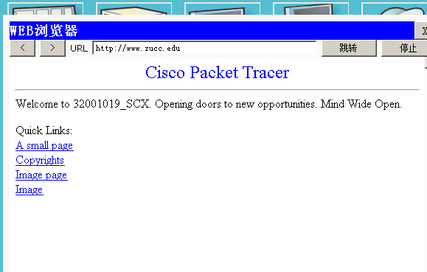

4）测试全网连通性

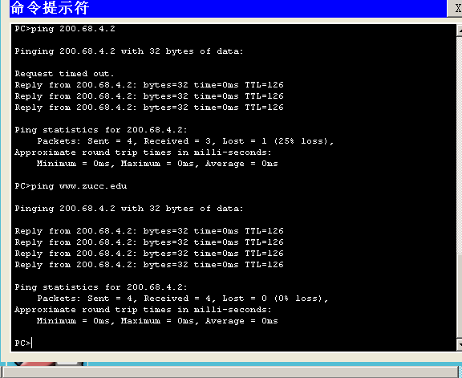

这是最终的连通性。如果没有配置DNS的话是无法ping [www.zucc.edu](http://www.zucc.edu) 的 但是可以ping 200.68.4.2

5）配置DNS服务器的DNS 服务器，添加资源记录表

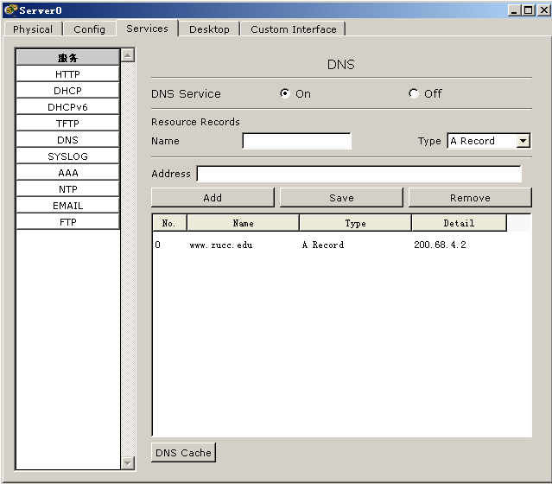

6）配置主机的DNS server

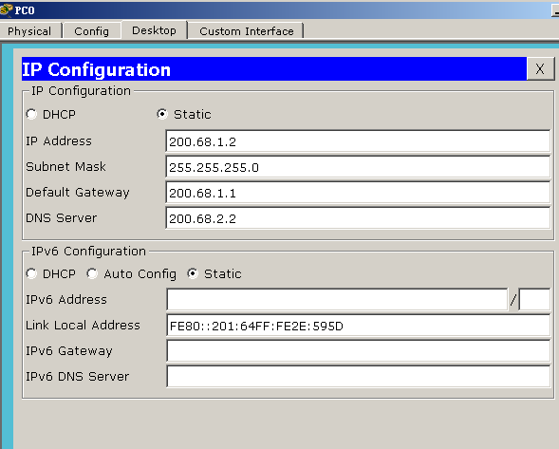

7) 测试域名解析效果以及查看DNS请求和响应过程。





2. DNS原理实验

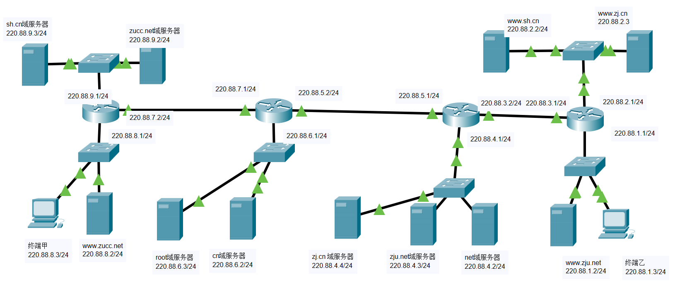

步骤：

1）配置终端甲、终端乙的IP地址、子网掩码、网关;

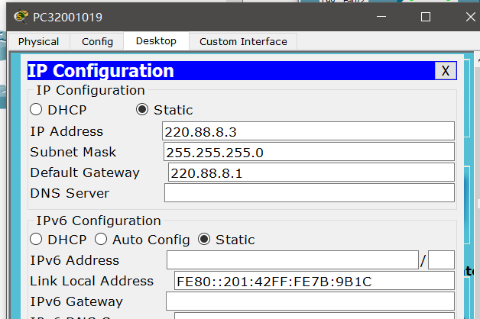

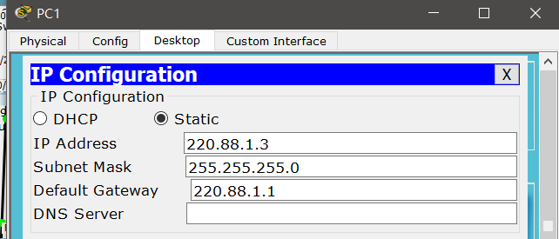

（请将终端甲的显示名字改为自己的学号）

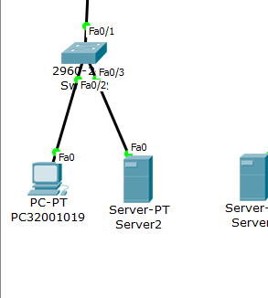

已修改

2）配置路由器各个接口的IP地址和子网掩码;

|  |
| --- |
| Router>en  Router#conf t  Enter configuration commands, one per line. End with CNTL/Z.  Router(config)#hostname SCXR0  SCXR0(config)#interface g0/1  SCXR0(config-if)#ip address 220.88.9.1 255.255.255.0  SCXR0(config-if)#no shutdown  SCXR0(config-if)#  %LINK-5-CHANGED: Interface GigabitEthernet0/1, changed state to up  %LINEPROTO-5-UPDOWN: Line protocol on Interface GigabitEthernet0/1, changed state to up  SCXR0(config-if)#interface g0/0  SCXR0(config-if)#ip address 220.88.7.2 255.255.255.0  SCXR0(config-if)#no shutdown  SCXR0(config-if)#  %LINK-5-CHANGED: Interface GigabitEthernet0/0, changed state to up  SCXR0(config-if)#interface g0/2  SCXR0(config-if)#ip address 220.88.8.1 255.255.255.0  SCXR0(config-if)#no shutddown  ^  % Invalid input detected at '^' marker.  SCXR0(config-if)#no shutdown  SCXR0(config-if)#  %LINK-5-CHANGED: Interface GigabitEthernet0/2, changed state to up  %LINEPROTO-5-UPDOWN: Line protocol on Interface GigabitEthernet0/2, changed state to up  SCXR0(config-if)#  %LINEPROTO-5-UPDOWN: Line protocol on Interface GigabitEthernet0/0, changed state to up |

|  |
| --- |
| Router>en  Router#conf t  Enter configuration commands, one per line. End with CNTL/Z.  Router(config)#hostname SCXR1  SCXR1(config)#interface g0/1  SCXR1(config-if)#ip address 220.88.7.1 255.255.255.0  SCXR1(config-if)#no shutdown  SCXR1(config-if)#  %LINK-5-CHANGED: Interface GigabitEthernet0/1, changed state to up  %LINEPROTO-5-UPDOWN: Line protocol on Interface GigabitEthernet0/1, changed state to up  SCXR1(config-if)#interface g0/2  SCXR1(config-if)#ip address 220.88.6.1 255.255.255.0  SCXR1(config-if)#no shutdown  SCXR1(config-if)#  %LINK-5-CHANGED: Interface GigabitEthernet0/2, changed state to up  %LINEPROTO-5-UPDOWN: Line protocol on Interface GigabitEthernet0/2, changed state to up  SCXR1(config-if)#interface g0/0  SCXR1(config-if)#ip address 220.88.5.2 255.255.255.0  SCXR1(config-if)#no shutdown  SCXR1(config-if)#  %LINK-5-CHANGED: Interface GigabitEthernet0/0, changed state to up  SCXR1(config-if)#  %LINEPROTO-5-UPDOWN: Line protocol on Interface GigabitEthernet0/0, changed state to up |

|  |
| --- |
| Router>en  Router#conf t  Enter configuration commands, one per line. End with CNTL/Z.  Router(config)#hostname SCXR2  SCXR2(config)#interface g0/1  SCXR2(config-if)#ip address 220.88.5.1 255.255.255.0  SCXR2(config-if)#no shutdown  SCXR2(config-if)#  %LINK-5-CHANGED: Interface GigabitEthernet0/1, changed state to up  %LINEPROTO-5-UPDOWN: Line protocol on Interface GigabitEthernet0/1, changed state to up  SCXR2(config-if)#interface g0/2  SCXR2(config-if)#ip address 220.88.4.1 255.255.255.0  SCXR2(config-if)#no shutdown  SCXR2(config-if)#  %LINK-5-CHANGED: Interface GigabitEthernet0/2, changed state to up  %LINEPROTO-5-UPDOWN: Line protocol on Interface GigabitEthernet0/2, changed state to up  SCXR2(config-if)#interface g0/0  SCXR2(config-if)#ip address 220.88.3.2 255.255.255.0  SCXR2(config-if)#no shutdown  SCXR2(config-if)#  %LINK-5-CHANGED: Interface GigabitEthernet0/0, changed state to up  SCXR2(config-if)#  %LINEPROTO-5-UPDOWN: Line protocol on Interface GigabitEthernet0/0, changed state to up |

|  |
| --- |
| Router>en  Router#conf t  Enter configuration commands, one per line. End with CNTL/Z.  Router(config)#hostname SCXR3  SCXR3(config)#interface g0/1  SCXR3(config-if)#ip address 220.88.3.1 255.255.255.0  SCXR3(config-if)#no shutdown  SCXR3(config-if)#  %LINK-5-CHANGED: Interface GigabitEthernet0/1, changed state to up  %LINEPROTO-5-UPDOWN: Line protocol on Interface GigabitEthernet0/1, changed state to up  SCXR3(config-if)#interface g0/2  SCXR3(config-if)#ip address 220.88.2.1 255.255.255.0  SCXR3(config-if)#no shutdown  SCXR3(config-if)#  %LINK-5-CHANGED: Interface GigabitEthernet0/2, changed state to up  %LINEPROTO-5-UPDOWN: Line protocol on Interface GigabitEthernet0/2, changed state to up  SCXR3(config-if)#interface g0/0  SCXR3(config-if)#ip address 220.88.1.1 255.255.255.0  SCXR3(config-if)#no shutdown  SCXR3(config-if)#  %LINK-5-CHANGED: Interface GigabitEthernet0/0, changed state to up  %LINEPROTO-5-UPDOWN: Line protocol on Interface GigabitEthernet0/0, changed state to up |

3）配置root域服务器、cn域服务器、net域服务器、zj.cn域服务器、sh.cn域服务器、zucc.net域服务器、zju.net域务器的IP地址、子网掩码、网关;

（请将root域服务器显示名字改为自己的姓名）

|  |
| --- |
| sh.cn    Zucc.net    Root    Cn    Zj.cn    Zju.net    Net |

4）配置www.sh.cn, www.zj.cn, www.zucc.net, www.zju.net四个服务器的的IP地址、子网掩码、网关， 并配置它们的HTTP服务;

（请在每个HTTP服务页面放置一幅自己喜欢的图片，四个HTTP页面不重复）

没有配置图片，将页面里面添加了姓名

5）配置路由器的路由协议，可以采用RIP或者OSPF;

|  |
| --- |
| SCXR0>en  SCXR0#conf t  Enter configuration commands, one per line. End with CNTL/Z.  SCXR0(config)#router rip  SCXR0(config-router)#network 220.88.9.0  SCXR0(config-router)#network 220.88.7.0  SCXR0(config-router)#network 220.88.8.0  SCXR0(config-router)#  SCXR1>en  SCXR1#conf t  Enter configuration commands, one per line. End with CNTL/Z.  SCXR1(config)#router rip  SCXR1(config-router)#network 220.88.7.0  SCXR1(config-router)#network 220.88.6.0  SCXR1(config-router)#network 220.88.5.0  SCXR1(config-router)#  SCXR2#config t  Enter configuration commands, one per line. End with CNTL/Z.  SCXR2(config)#router rip  SCXR2(config-router)#network 220.88.5.0  SCXR2(config-router)#network 220.88.4.0  SCXR2(config-router)#network 220.88.3.0  SCXR2(config-router)#  SCXR3>en  SCXR3#conf t  Enter configuration commands, one per line. End with CNTL/Z.  SCXR3(config)#router rip  SCXR3(config-router)#network 220.88.2.0  SCXR3(config-router)#network 220.88.3.0  SCXR3(config-router)#network 220.88.1.0  SCXR3(config-router)# |

6）测试网络连通性，在各个节点尝试ping命令测试全网可达性

|  |
| --- |
| 均可到达 |

7） 设计配置root域服务器、cn域服务器、net域服务器、zj.cn域服务器、sh.cn域服务器、zucc.net域服务器、zju.net域务器的DNS资源记录表，并配置DNS服务。

|  |
| --- |
| 按顺序分别为 |

8）测试域名解析效果。

|  |
| --- |
|  |

四、收获感想：

记录实验感受、操作过程中遇到的困难及解决办法、遗留的问题、意见和建议等。

Dns表仍然有些不懂的地方