|  |  |  |  |
| --- | --- | --- | --- |
| Assignment | | | |
| Project name | SA0 | | |
| Document ref |  | | |
| Version |  | | |
| Release date |  | | |
| Author | Wu Fei | | |
| Classification |  | | |
| Distribution List |  | | |
| Approved by | Name | Signature | Date |
|  |  |  |  |



**Ming Hsieh Department of Electrical Engineering**

**University of Southern California, Los Angeles, CA 90089**

**Fall 2022**

**EE 557**

# Simulation Assignment0

Compile inscount0.cpp with test file and generate inscount0.so automatically.

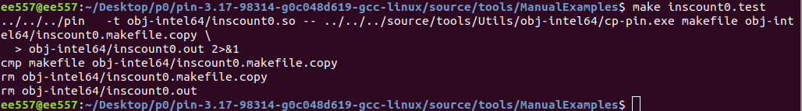



Use Pin tool for counting and generate the .out file

