|  |  |  |  |
| --- | --- | --- | --- |
| Assignment | | | |
| Project name | SA1 | | |
| Document ref |  | | |
| Version |  | | |
| Release date |  | | |
| Author | Wu Fei | | |
| Classification |  | | |
| Distribution List |  | | |
| Approved by | Name | Signature | Date |
|  |  |  |  |



**Ming Hsieh Department of Electrical Engineering**

**University of Southern California, Los Angeles, CA 90089**

**Fall 2022**

**EE 557**

# Simulation assignment 1

Submit this report and the coding files as following:

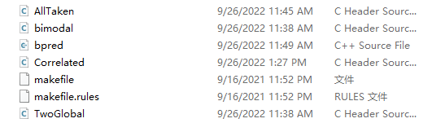

## Ways for prediction

To access the requirement, I add some .H files to implement the other three ways of prediction.

The main changes are about the buffer size change as the requirement, pointer renaming, Instruction function change base on the prediction methods, HistAddress function to change the return of the array of the history addresses and condbranch function to claim the SBP implementation and the conditions to take the prediction.

In the .cpp file, I call all the four methods and generate the results like the format provided.

Some of them show blow while some show in the submitted coding.

### Always taken

**CondBranch function**

|  |
| --- |
| inline VOID ALLTAKEN::CondBranch(ALLTAKEN *at, INT8 * branchHistory,  VOID * ip, BOOL taken)  {      INT8 history;      at->_references++;        history = *branchHistory & 0x3;      //at->_predicts += (taken && history >= 2);      //at->_predicts += (!taken && history <= 1);      at->_predicts += (taken); // insteading of the above conditional counting, always taken takes all the predictions        INT8 delta = 0;      if (taken && history < 3)      {          delta = 1;      }      if (!taken && history > 0)      {          delta = -1;      }        *branchHistory += delta;  } |

### 2-bit Global

**CondBranch function**

inline VOID TWOGLOBAL::CondBranch(TWOGLOBAL *tg, INT8 * branchHistory,

VOID * ip, BOOL taken)

{

    INT8 history;

    tg->_references++;

//2bit saturating branch predictor

    history = *branchHistory & 0x3;//taking the last two significant bits

    tg->_predicts += (taken && history >= 2); // 10 11

    tg->_predicts += (!taken && history <= 1);// 00 01

    INT8 delta = 0;

    if (taken && history < 3)

    {

        delta = 1;

    }

    if (!taken && history > 0)

    {

        delta = -1;

    }

    *branchHistory += delta;

}

### 2-bit Bimodal

Using the same SBP as the 2-bit global predictor while change the value of the buffer size as:

    enum

    {

        //TABLESIZE = 4096,

        TABLESIZE = 1, // do not consider pridicted history as the index of the branch history buffer

        BUNDLESIZE = 32, //For bimodal predictor, we use the last 5 bits of branch PC to index the branch prediction buffer (BPB).

        MAXTHREADS = 100

    };

**CondBranch function**

inline VOID BIMODAL::CondBranch(BIMODAL *bm, INT8 * branchHistory,

VOID * ip, BOOL taken)

{

    INT8 history;

    bm->_references++;

   //2bit saturating branch predictor

    history = *branchHistory & 0x3;//taking the last two significant bits

    bm->_predicts += (taken && history >= 2);

    bm->_predicts += (!taken && history <= 1);

    INT8 delta = 0;

    if (taken && history < 3)

    {

        delta = 1;

    }

    if (!taken && history > 0)

    {

        delta = -1;

    }

    *branchHistory += delta;

}

### 2-bit Correlated

Implement the required buffer size for the Correlated predictor:

  private:

    enum

    {

//TABLESIZE = 4096,

        TABLESIZE = 16, //is concatenated to the right side of the global branch history register (4 bits) to form total 8 bits and then index the BPB

        BUNDLESIZE = 16, //For correlated predictor, the least significant 4 bits of branch PC

        MAXTHREADS = 100

    };

inline INT8 * CORRELATED::HistAddress(INS ins, CORRELATED *cp)

{

    ADDRINT ip = INS_Address(ins);

    //return &(_branchHistory[(ip / BUNDLESIZE) % TABLESIZE][ip % BUNDLESIZE]);

    return &(_branchHistory[cp->_GlobalBranchHistory & 0xf]/*using as the last four recording of previous branch prediction*/[ip % BUNDLESIZE]);

}

**CondBranch function**

inline VOID CORRELATED::CondBranch(CORRELATED *cp, INT8 * branchHistory,

VOID * ip, BOOL taken)

{

    INT8 history;

    cp->_references++;

  // For correlated predictor, the least significant 4 bits of branch PC

    if(taken){

        cp->_GlobalBranchHistory = (((cp->_GlobalBranchHistory) & 0xf) * 2) + 1;

    }

    else{

         cp->_GlobalBranchHistory = (((cp->_GlobalBranchHistory) & 0xf) * 2);

    }

//the same SBP as the 2bit global prediction

    history = *branchHistory & 0x3;

    cp->_predicts += (taken && history >= 2);

    cp->_predicts += (!taken && history <= 1);

    INT8 delta = 0;

    if (taken && history < 3)

    {

        delta = 1;

    }

    if (!taken && history > 0)

    {

        delta = -1;

    }

    *branchHistory += delta;

}

## Result

### Execution

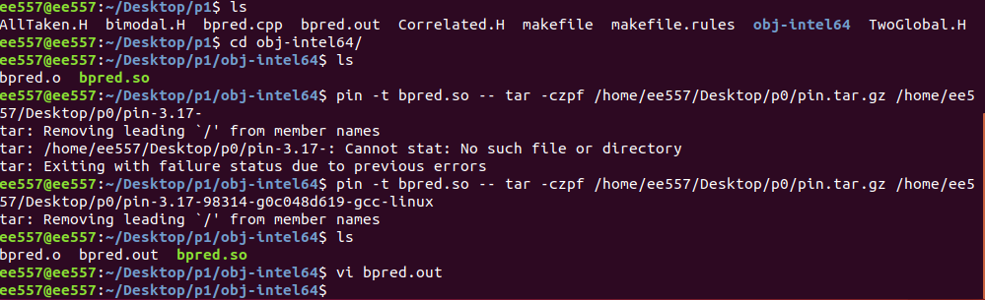

### Bpred.out

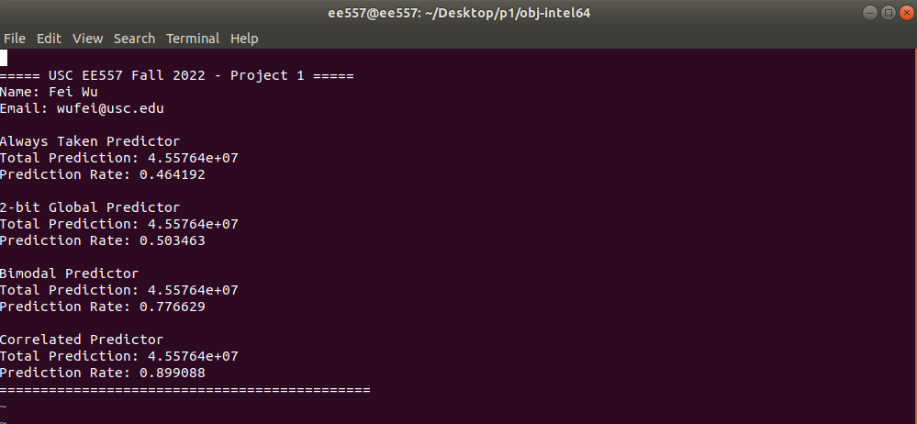

Showing as the result, it can say that the prediction rate growing up as we using more complicate and delicate methods and more memory to store and manage the prediction history.