Epidemic Data Analysis and Modelling

# Introduction

Measles is a highly infectious viral disease caused by *Morbillivirus hominis*, primarily spread via respiratory droplets. Despite the presence of an effective universal vaccination programme in England, measles outbreaks have persisted. This report analyses the 2023–2024 measles outbreak using national surveillance data, estimates epidemic parameters such as the growth rate and reproduction number, and develops a mathematical SEIR model to evaluate the impact of increased vaccination coverage.

# Background

Measles is a highly infectious disease caused by the measles virus, Morbillivirus hominis. Measles is transmitted by respiratory droplets between close contacts. Symptoms include a generalised rash, fever and cold-like symptoms.

The incubation period (from exposure to the first symptoms) is typically 11–12 days. A rash follows the initial symptoms 2–4 days later and usually lasts 5–6 days. Measles is infectious 4 days before and 4 days after rash onset. The Basic Reproduction Number for measles is estimated to be between 12 and 18.

Measles vaccines are highly protective against infection. In the UK, children receive their first measles vaccination at 12-13 months, and then a pre-school booster vaccine is given at 3 years and 4 months. It is estimated that 84.5% of children received two doses of the Measles, Mumps, Rubella (MMR) combined vaccine in England in 2022/2023.

# Epidemic Data Analysis

## i. Surveillance Data Biases

National surveillance data may be subject to underreporting, especially in mild or asymptomatic cases that go untested. Reporting delays and misclassification errors can also occur, along with regional disparities in healthcare access and health-seeking behavior. These biases may lead to an underestimation of the actual burden of disease.

## ii. Explore and Discuss the Dataset

The following figure shows the temporal trend of measles cases:

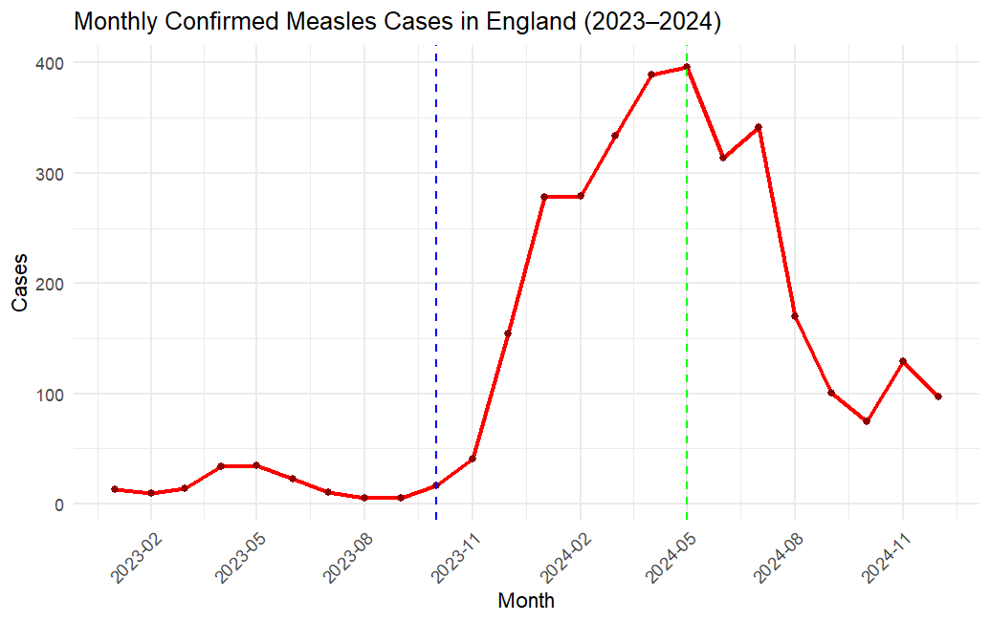

**Figure 1: Monthly Confirmed Measles Cases in England (2023–2024)**

The epidemic is divided into three stages:

Low-level period (2023.01-10) : The average monthly cases were 16.7.

The period of exponential growth (2023.11-2024.05) : The number of cases increased from 41 to 396.

Decline period (2024.06-12) : The average monthly decrease was approximately 50 cases.

## iii. Persistence Despite Vaccination

Despite high vaccine coverage, outbreaks occur due to:

1. Two dose coverage does not meet the herd immunity threshold.  
   Waning immunity in certain populations.
2. Two doses of MMR vaccine were approximately 97% effective, with 3% breakthrough infections present (Rota et al., 2016).
3. Imported cases: continued introduction of the virus due to international travel.

## iv. Basic Reproduction Number

The basic reproduction number (R₀) is the average number of secondary infections produced by one infected individual in a fully susceptible population. For measles, R₀ typically ranges from 12 to 18, indicating high transmissibility. Outbreaks can spread when R₀ > 1. The larger the R₀, the more rapidly it spreads.

## v. Exponential Growth Rate

Exponential growth was identified from November 2023 to May 2024. The growth rate was estimated using a log-linear regression:

Estimated exponential growth rate: r ≈ 0.316 per day

## vi. Approximate Reproduction Number

Generation interval (D): The average time between successive infections in a chain of transmission. For measles, this can be derived from its infectious period and incubation period:

Infectious period: 4 days before rash onset + 4 days after = 8 days total.

Incubation period: 11–12 days (time from exposure to symptoms), but the generation time typically includes both the incubation period and the time to infect others. A commonly used estimate for measles’ generation time is 10–14 days. For simplicity, we use D=12days.

Using R ≈ 1 + rD, with D = 12 days, we find R ≈ 4.79

## vii. Reasons for Difference from Literature

1. Population immunity level: In the actual population, there exists immunity generated by vaccination or previous infections, which reduces the probability of effective transmission.
2. Monitoring bias: Underestimating the actual number of cases leads to a low estimate.
3. Intervention measures: If there are local prevention and control measures (such as isolation) during this period, the transmission may be suppressed.

## viii. Limitations

1. Suppose there is no intervention during the exponential growth stage, but there may actually be unrecorded prevention and control measures.
2. The precise values of the generation interval D and the incubation period affect the calculation.
3. Ignores age structure, mobility, and local clustering.

## ix. Estimate Vaccination Protection

p = 1 – 1 / R ≈ 0.791, or 79.1%

This implies that 79.1% of the population must be immune to halt sustained transmission.

Given that around 84.5% of the population received two doses, and assuming 97% vaccine efficacy for two doses (Centers for Disease Control and Prevention, n.d.), the estimated effective immune coverage is:

0.845 × 0.97 ≈ 0.819, or 81.9%.

This is still slightly above the herd immunity threshold 79.1%, but the narrow difference explains why outbreaks can occur due to spatial/temporal heterogeneity in immunity. While vaccination coverage is high, it does not guarantee herd immunity due to heterogeneous immunity distribution, breakthrough infections, and imported cases. This aligns with the observed outbreak dynamics.

# Methods

## x. Schematic Model Flow Diagram and Justification

S → E → I → R

S (Susceptible): Individuals who are susceptible to infection.

E (Exposed): Individuals who have been exposed to the virus but are not yet infectious (latent phase).

I (Infectious): Individuals who are infected and can transmit the virus to others.

R (Recovered): Individuals who have recovered from infection or were vaccinated and are now immune.

**Justification of the SEIR model:**

* Measles has a non-negligible incubation period, during which individuals are infected but not yet infectious. This justifies including the E compartment.
* Once infected, individuals pass through an infectious stage before recovering or becoming immune, which supports the use of the I and R compartments.
* The model assumes no births or deaths during the time horizon of the outbreak.
* It also assumes homogenous mixing and no re-infections.

## xi. Model Equations and Basic Reproduction Number

We can use the growth rate estimated by the exponential growth period 𝑟≈0.316 (per day) to infer 𝛽.

r = [ - (σ + γ) + sqrt((σ + γ)^2 + 4σβ) ] / 2

The population was assumed to be closed and homogeneous. Differential equations:

dS/dt = -β⋅S⋅I/N

dE/dt = β⋅S⋅I/N − σE

dI/dt = σE − γI

dR/dt = γI

Where:

* β = 1.9855: transmission rate
* σ = 1/12: incubation rate
* γ = 1/8: recovery rate
* R₀ = β / γ = 15.884

This value aligns with known literature values for measles (typically between 12 and 18).

## xii. Programme the Model

* N = 56e6: total population (UK Government, 2025)
* I₀ = 13
* E₀ = 10
* R₀ = 0.845 * N
* S₀ = N - I₀ - E₀ - R₀

## xiii. Plot Infection States and Total Population Size

**Figure 2: SEIR Simulation of Measles in England (2023–2024)**

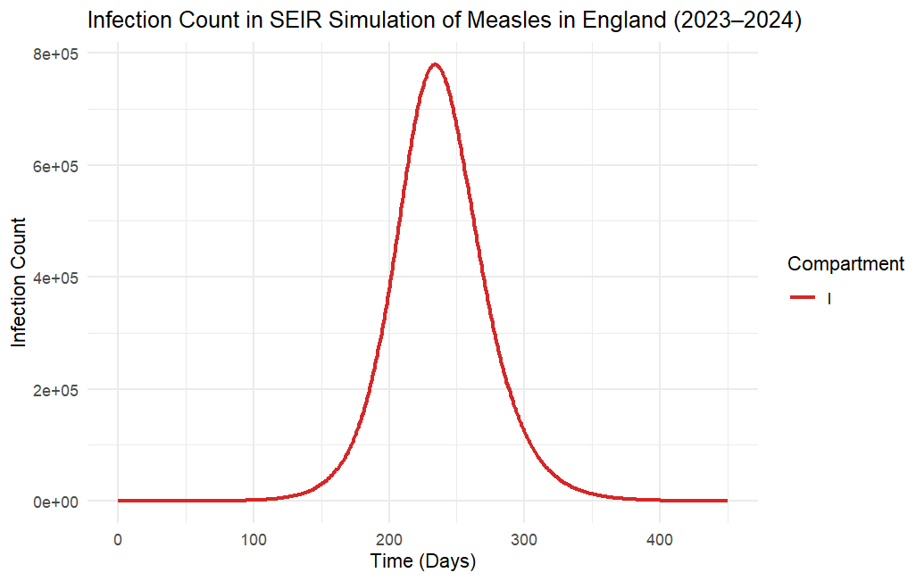

**Figure 3: Infection Count in SEIR Simulation of Measles in England (2023–2024)**

## xiv. Launch a Catch-up Vaccination Programme

To explore the impact of increased vaccination coverage, we extended our SEIR model to include a catch-up vaccination programme initiated after second outbreak month (December 2023). This intervention was modelled by introducing a daily vaccination rate of 0.5% of the susceptible population (v=0.005) into the system of differential equations.

The model was simulated over a two-year period (730 days), under two scenarios:

* Baseline: Vaccination coverage remains constant at 81.9%.
* Intervention: Daily vaccination of 0.5% of the remaining susceptible population begins on day30.

Results:

* Without catch-up vaccination: ~944,000 cumulative cases
* With catch-up vaccination (starting Dec 2023): ~91,000 cumulative cases
* Estimated cases prevented: ~852,000

Interpretation:

The catch-up vaccination programme prevented approximately 852,000 measles infections over the 2023–2024 period. This substantial reduction highlights the critical impact of increasing vaccination coverage during an outbreak. The vaccination effort also flattened the epidemic curve, reducing both the peak and duration of infectious cases.

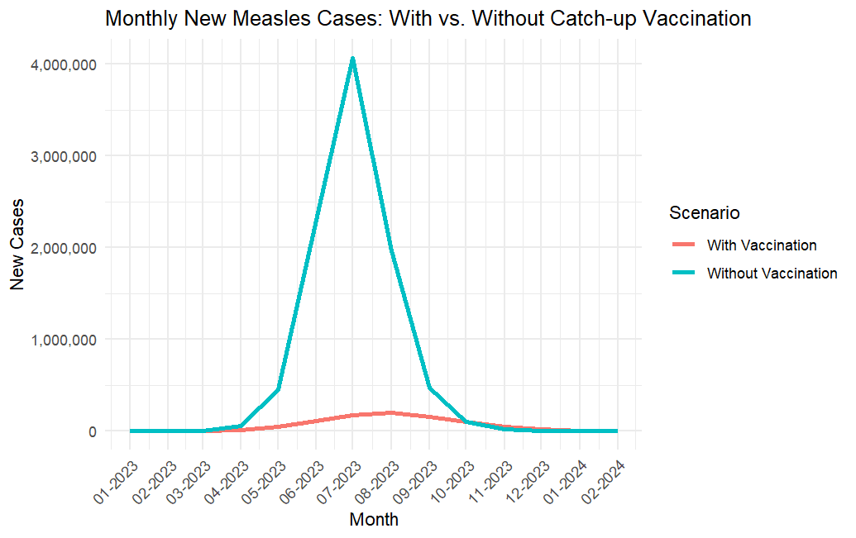

**Figure 4: Monthly New Measles Cases: With vs. Without Catch-up Vaccination**

## xv. Summaries

This report examined the 2023–2024 measles outbreak in England using national surveillance data and a mathematical SEIR model. Despite high baseline vaccination coverage, an epidemic occurred, highlighting the impact of suboptimal herd immunity, waning protection, and imported cases. Key epidemic parameters were estimated, including an exponential growth rate of 0.316/day and an approximate reproduction number (R ≈ 4.79). A modified SEIRV model assessed the effect of a catch-up vaccination campaign initiated in December 2023. The intervention reduced the cumulative number of infections from ~944,000 to ~91,000, preventing approximately 852,000 cases. These findings underscore the importance of timely, enhanced vaccination strategies to mitigate outbreak impact.

# References

1. Centers for Disease Control and Prevention. (n.d.). Measles vaccines. Retrieved April 23, 2025, from <https://www.cdc.gov/measles/vaccines/index.html>
2. Rota, P., Moss, W., Takeda, M. et al. (2016). Measles. Nat Rev Dis Primers, 2, 16049, from  <https://doi.org/10.1038/nrdp.2016.49>
3. UK Government. (2025). Population estimates for the UK, England, Wales, Scotland, and Northern Ireland: mid-2023, from <https://assets.publishing.service.gov.uk/media/67d875029dc953ac3bfe937b/1_Population_18_03_2025.pdf>