**Q1. Find the roots of the following equation and plot the graph.**

$$x^{2} – 5x + 6 = 0$$

**Script Code:**

1. clc, clear
2. %Finding Roots of the Equation
3. %Q1# x^2 - 5x + 6 = 0
4. f = [1 -5 6];
5. root_f = roots(f)
6. %%
7. x = 0:0.2:5;
8. y = x.^2 - 5*x + 6;
9. %Plotting of the Function
10. plot(x,y, 'r--');
11. hold on; %Used for scatter function
12. title('Kamil Siddiqui - Root Finding Lab2 Q1')
13. xlabel('X - Axis')
14. ylabel('Y - Axis')
15. xlim([0 5]), ylim([-1 3]);
16. line([0 5], [0 0])
17. line([0 0], [-1 3])
18. %Pointing the roots on graph
19. scatter(root_f, [0 0], 'ks');

**Results:**

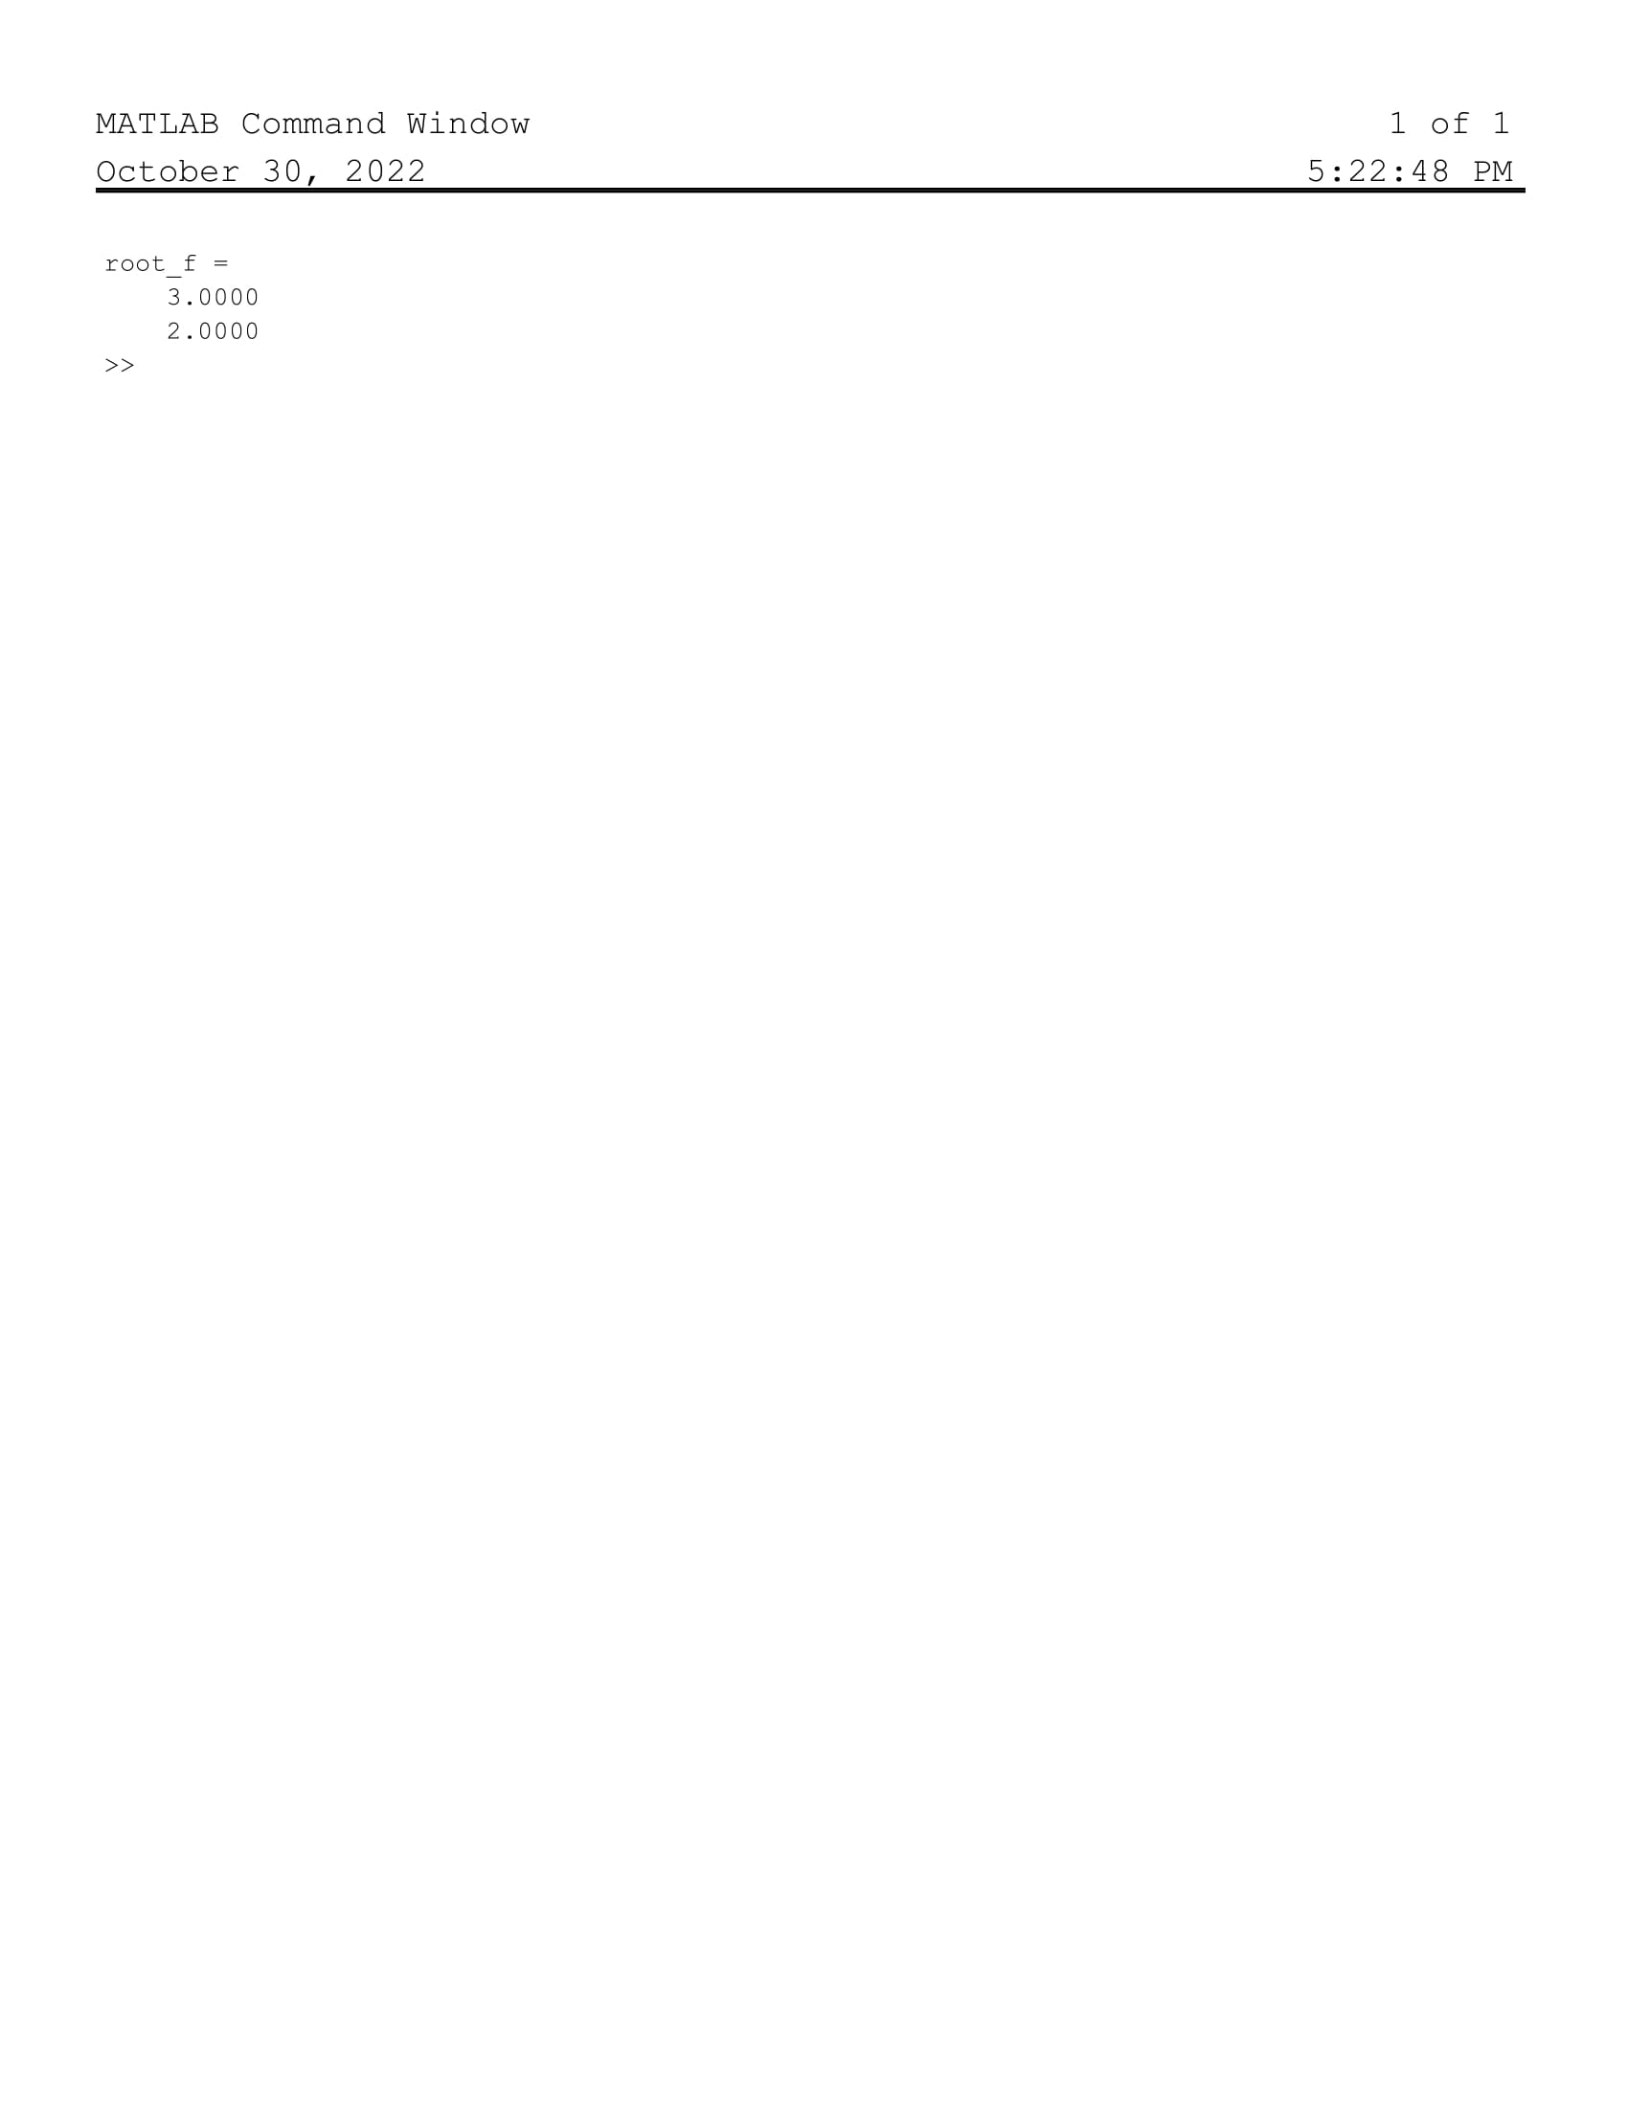

**Graph:**

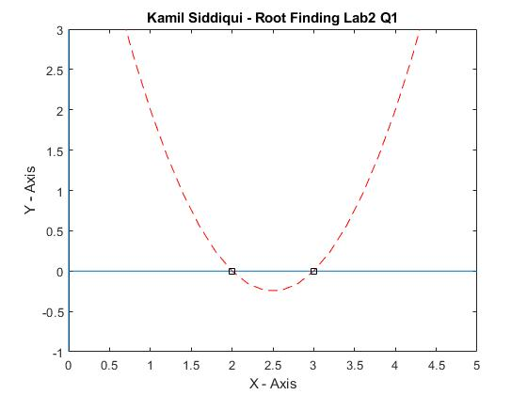

**Q2. Find the roots of the following equation and plot the graph.**

$$x^{2} – 9x + 8 = 0$$

**Script Code:**

1. clc, clear
2. %Finding Roots of the Equation
3. %Q2# x^2 - 9x + 8 = 0
4. f = [1 -9 8];
5. root_f = roots(f)
6. %%
7. x = -1:0.2:10;
8. y = x.^2 - 9*x + 8;
9. %Plotting of the Function
10. plot(x,y, 'r--');
11. hold on; %Used for scatter function
12. title('Kamil Siddiqui - Root Finding Lab2 Q2')
13. xlabel('X - Axis')
14. ylabel('Y - Axis')
15. xlim([-1 10]), ylim([-15 15]);
16. line([-1 10], [0 0])
17. line([0 0], [15 -15])
18. %Pointing the roots on graph
19. scatter(root_f, [0 0], 'ks');

**Results:**

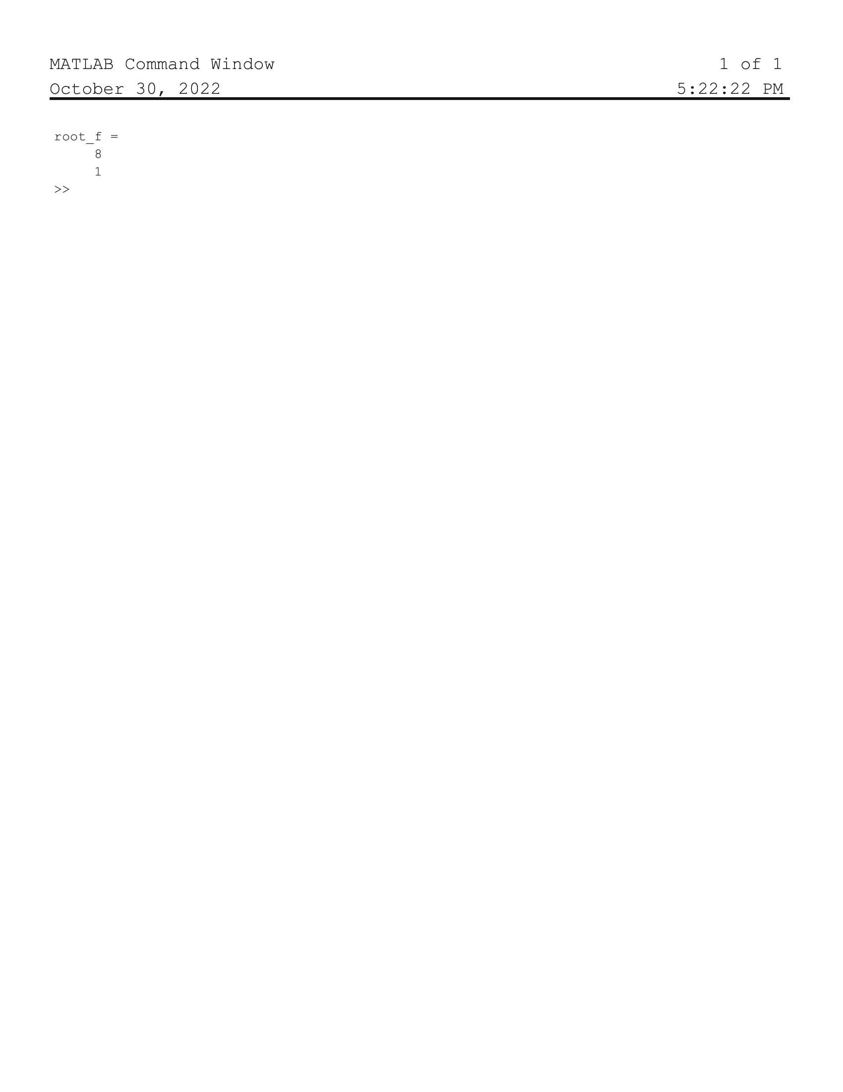

**Graph:**

