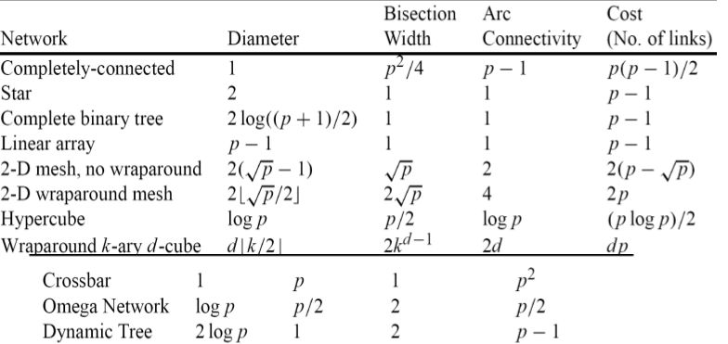
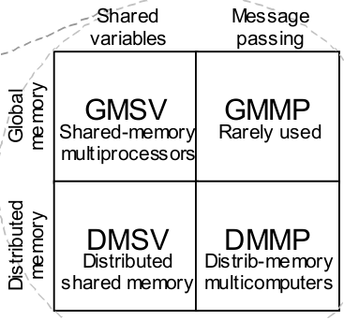
Amdahl's law Gustafson-Barris
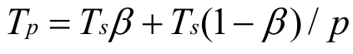
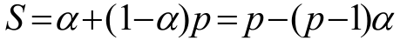
Ts, Tp, Total Time = pTp, Overhead (T0) = pTp – Ts, S = Tp/Ts, E=S/P
Cost optimal, E=1, pTp = Ts
Isoefficiency: Ts >= CT0

obtaining:
implicit (instruction level), explicit
gpgpu, cluseter, cloud, grid, parallel vs distributed
topologies: static, dynamuc
message routing
cache coherence
IC networks
diameter, arc connectivity, bisection width, cost
machine independant issues, parallel computing platforms

partitioning, communication, agglomeration, mapping
first 2 are machine independant
others machine dependant: (map tasks to processes, map processes to processors)
reduction, matrix multiplication, sorting

speedup depends on: input size, num processors, speedup and efficiency
serial/parallel runtime, total time overhead, speedup and efficiency

amdahl's law, Gustafson-Barsis law <- fixed (problem size, num processors respectively)
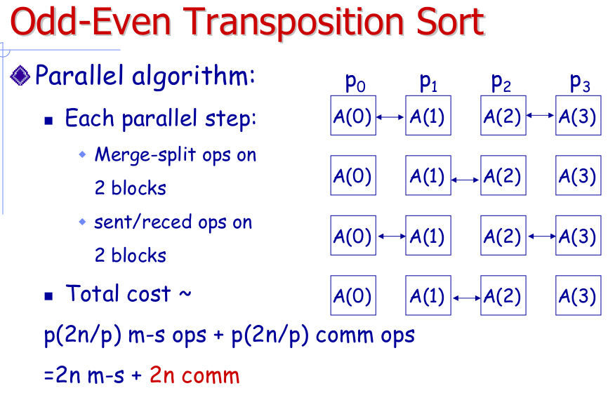
isoefficiency, scaled speedup <- variable everything?
pthread_attr_init(&attr);
pthread_attr_setdetachstate(&attr, PTHREAD_CREATE_JOINABLE);
pthread_mutex_init(&finlock, NULL);
for(t=0; t<N; t++){
pthread_cond_init (&moveSyncs[t], NULL);
pthread_mutex_init(&redLocks[t], NULL);
pthread_mutex_init(&blueLocks[t], NULL);
}

/* create threads, lock locks initially */
/* The logic is: the only reason a lock should be unlocked is if that thread is waiting at a sync point */
for(t=0; t<N; t++){
pthread_mutex_lock(&redLocks[t]);
pthread_mutex_lock(&blueLocks[t]);
pthread_create(&moveThreads[t], &attr, movement, (void *)t);
}

/* Join all threads for termination */
for(t=0; t<N; t++){
pthread_join(moveThreads[t], NULL);
}

/* cleaning */
for(t=0; t<N; t++){
pthread_mutex_destroy(&redLocks[t]);
pthread_mutex_destroy(&blueLocks[t]);
pthread_cond_destroy(&moveSyncs[t]);
}
pthread_mutex_destroy(&finlock);
pthread_attr_destroy(&attr);

void advance(int num, pthread_mutex_t* lcks, pthread_cond_t* syncs){
int i;
for(i=0; i<num; i++){
pthread_mutex_unlock(&lcks[i]);
pthread_cond_signal(&syncs[i]);
}
}

pthread_cond_wait(&moveSyncs[id], &redLocks[id]);

