2. aws; google appengien; …

3.



Core feature: visualization char?

5.



6.

7.

8.

9. rapid, low-cost, flexible, interoperable, and evolvable applications and systems

12.

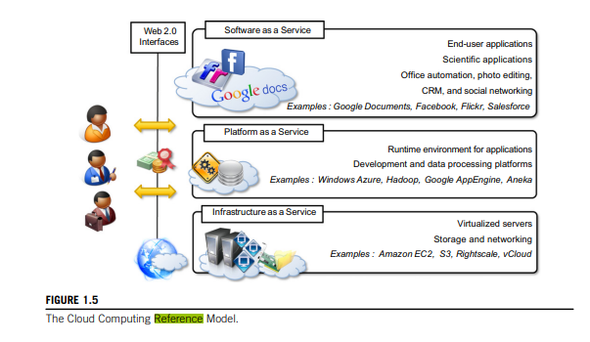

13.

integrating additional capacity or new features into existing systems

The most evident benefit from the use of cloud computing systems and technologies is the increased economical return due to the reduced maintenance costs and operational costs related to IT software and infrastructure.

Increased agility in defining and structuring software systems is another significant benefit of cloud computing.

End users can benefit from cloud computing by having their data and the capability of operating on it always available, from anywhere, at any time, and through multiple devices.

service orientation and on-demand access create new opportunities for composing systems and applications with a flexibility not possible before cloud computing.

14.

IT practitioners, managers, governments, and regulators

15.

Part 2: LAB

Set up and launch an EC2 instance

EC2 auto scaling

Creating an application load balancer

Creating a VPC instance

