**COMP 3069 -- Computer Graphics**

**Project**

**Release Date:** *5* ***November 2020***

**(Weightage to final grade is 70%.)**

## Description

The project requires you to create a 3D scene by yourself. You may decide the content of the scene you create, which could be a scene from real world, or a virtual scene created by your imagination. The purpose of this proposed project is for you to demonstrate your knowledge of computer graphics techniques taught in the lectures and labs. ***We note that you are required use C or C++ programming with OpenGL library to do the programming.*** In the project, we also give credits for your creative ideas being contributed in your project. Some example 3D scene are given for your reference as follows:

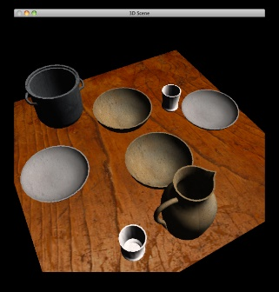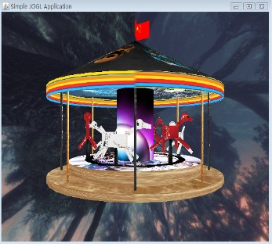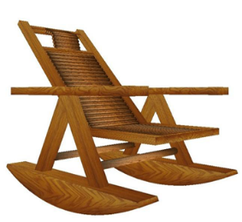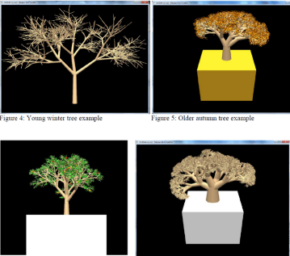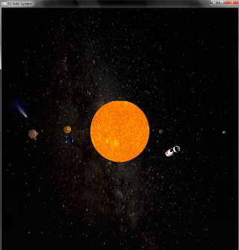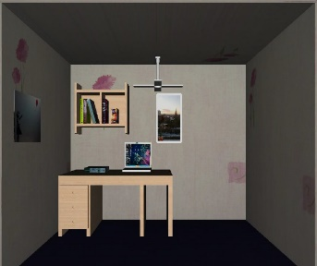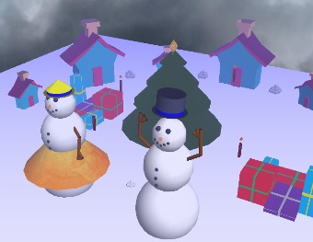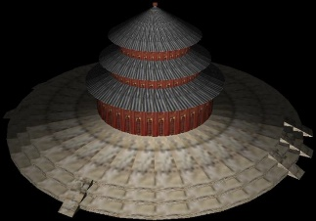

You are required to create a 3D scene with the following items: (**65% in total**)

* + Several 3D models, which may contain some imported objects, and some own-created ones, (**15%**)
  + Transformation of models (scaling, translating, rotating), (**5%**)
  + Different viewpoint to the scene environment, (**5%**)
  + Animations for some objects in the scene, (**10%**)
  + Texturing –you need to employ texture to make some models look more realistic, (**10%**)
  + Lighting – you should apply lighting effect in your scene, (**5%**)
  + Some your own interesting creative ideas. (**15%**)

Here we remark that the marks you obtained for each item of the above depend on ***how impressive*** it is for the scene you create, the ***quality and aesthetic*** of objects or ***required components*** you produced in your scene, and the ***originality and complexity*** of the ideas you used in the project.

## Proposal

In the first one and a half weeks, you need to submit **2-page** draft proposal of what you want to do for creating the 3D scene (although you could deviate a bit when you are progressing in doing your project). We expect that ***each student creates a different scene.***  **(3% marks)**

**Due date: 23:59 (midnight), 17 November 2020, Tuesday**

**File name: CG_2020_ StudentIDNUMBER_PROPOSAL.pdf**

## Interim Report

Then after a couple of weeks, you need to submit a **6-page** progress report telling us the progress of your program, what tasks are remained to be done. The purpose of this interim report is to remind you *NOT* to do the whole project until the very last minute. So please try to do *MORE* programming up to this stage.

**(7% marks)**

**Due date: 4:00pm, 29 November 2020, Sunday**

**File name: CG_2020_ StudentIDNUMBER_INTERIM.pdf**

## Full Program and Report

And then after another couple of weeks, you need to submit a zip file including: full report, and source code.

* + Full report: (**around 10 pages**)

Describing how to use your program, how you meet the requirements of the project, and your creative ideas contributed in creating the scene. Note that in your report, you *MUST* include a screenshot picture of your full scene you produced in your program.

**(15% marks)**

* + Source Code:

Apart from the requirements described in the Description section, some credits are given for accounting for the readability, good structure, good style and good comments of the source code you write.  **(65% marks)**

**Due date: 4:00pm, 20 December 2020, Sunday**

**File name:**

**Zip file: CG_2019_ IDNUMBER_PROJECT.zip,** which contains the following files**:**

**1. Full report: CG_2020_IDNUMBER_REPORT.pdf**

**2. Source Code: Note: Free to name the files(“.cpp”, “.h”, etc)**

## In-class Demo of Your Program

Each of you is required to do an in-class demo of around 5 to 6 minutes to present what the program you wrote can display. You would be assigned to either group 1 or group 2. And the presentation order of the students for each group is listed as follows.

**Group 1: Time: 8:00 am – 12:00 noon, 18 December 2020, Friday, Venue: TBA**

**Group 2: Time: 1:00 pm – 5:30 pm, 18 December 2020, Friday, Venue: TBA**

**(10% marks)**

**Due date: 8:00 am, 20 December 2019, Friday**

**File name: CG_2019_ StudentIDNUMBER_Presentation.ppt**