Main Screen (Rooms) Page
- Sign Out (Allows to log off and will go to log in screen)
- Room List I can click to go to that room, we can see a pill that tells you if you are admin or guest
- Plus button allows you to create new room
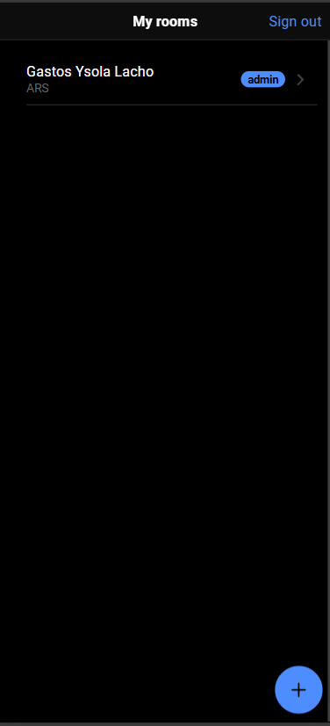

New room Page
- Room name for the name of the room
- Currency is a list of currencies for that room
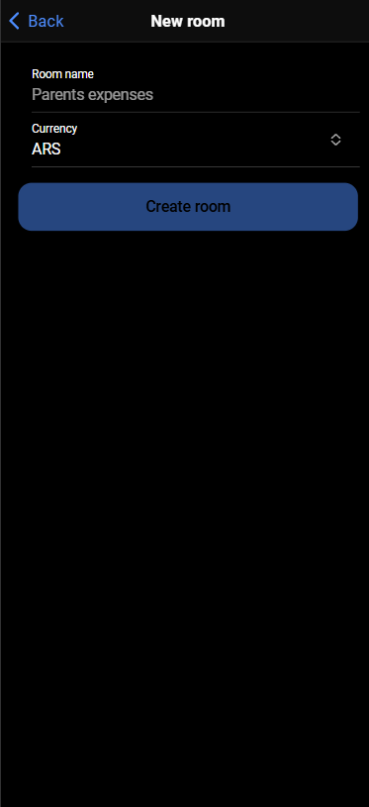

Room Page
- Gear button is to configure the room
- In the main screen I can see buttons to change to different pages, Summary page, Collections Page, Categories page, Dashboard page
- The latest expenses list are the expenses for that month, I can click each of them to update that expense
- Plus button is to add a new expense
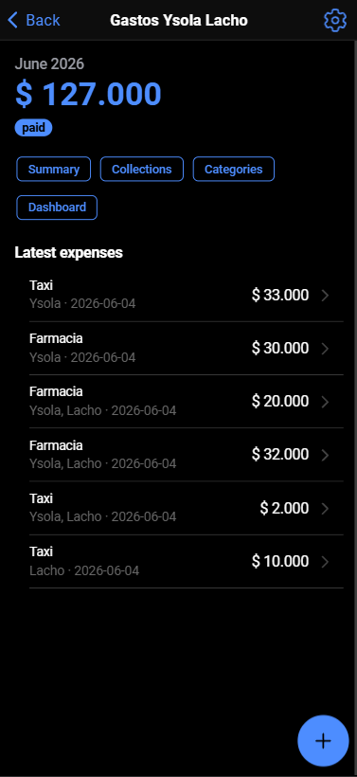

New expense / Update expense Page
- Categories pills is to quickly click to select category
- + Create new category button is to create new category (It just display a new input to type the category and an “Add” button that automatically save and select that category
- Amount is the expense
- Applies to is for each configured Beneficiary
- The update expense is the same page with the data filled
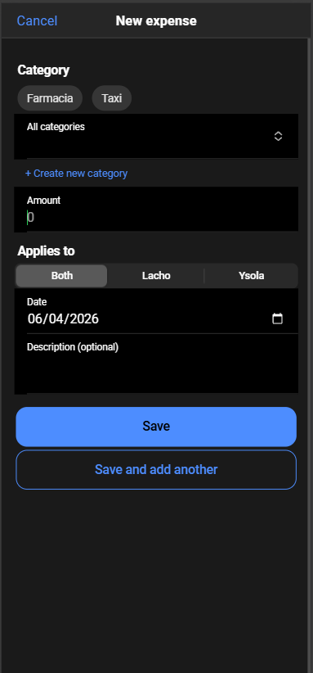

Room settings Page
- Room name
- Currency
- Include detail in collection message (bool, it is to include the detailed category expenses in the message)
- Beneficiaries goes to the beneficiaries page
- Payers goes to the payers page
- Members & invitations goes to the members & invitations page
- Archive room is to archive it
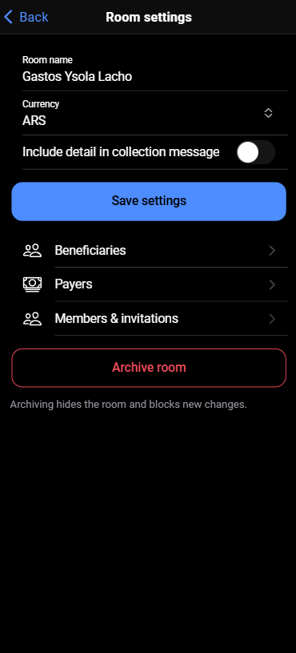

Beneficiaries page
Allows to add, deactivate or remove beneficiaries
- Plus buttons pops up a modal with only a input to put the beneficiary name
- Clicking the Deactivate link will Deactivate that beneficiary and it will say “Activate” which you can click to Activate
- The trash can allows to delete the beneficiary, it pops a confirmation modal
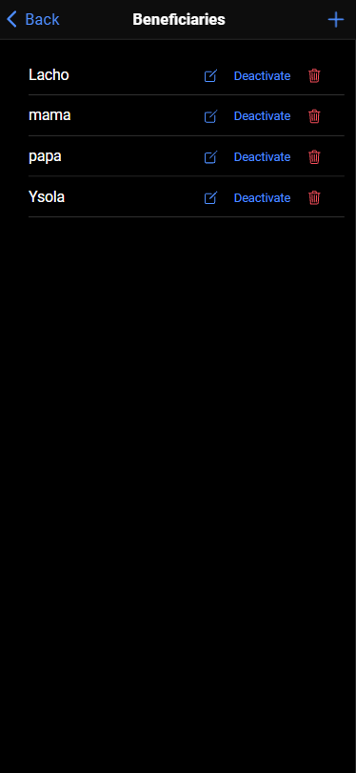

Payers Page
Similar to the beneficiaries page
Allows to add, deactivate or remove payers
- Plus buttons pops up a modal with only a input to put the payer name
- Clicking the Deactivate link will Deactivate that payer and it will say “Activate” which you can click to Activate
- The trash can allows to delete the payer, it pops a confirmation modal



Members and invitation page
- Email input is to put the email
- Guest/Admin pills is to select the role
- Generate invite link is a button that give you a link that you can copy or share, then that user have to create an account if it doesn’t have it, then go to the link and will allow to be part of that room
- The Current members list it only allows to delete a member when you click the trash bin

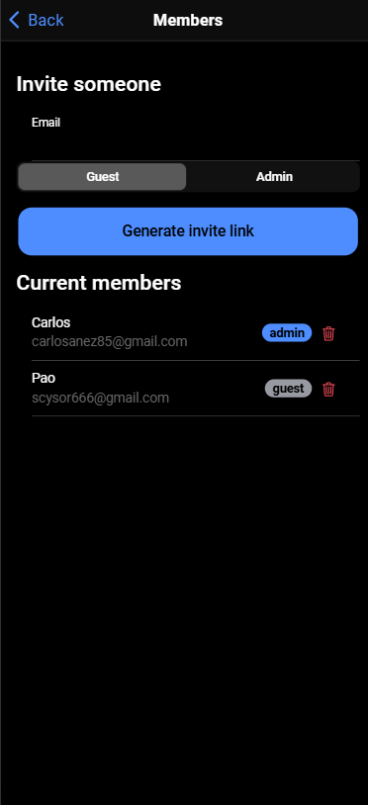

Summary page
- Close month button allows to close that month, then navigates to the Message page an then it will change to 3 buttons (Reopen month, Message, Collections)
- Reopen month button is to reopen that month
- Message will go to the message page
- Collections will go to the collections page
- The chevron left and right allows you to change month
- The By category and by beneficiary list are just a grouped expense
- The Expenses list shows all the expenses and when you click one it will navigate to the New expense / Update expense Page
- The trash bin is for delete that expense
- All of the actions regarding expenses are available only for open months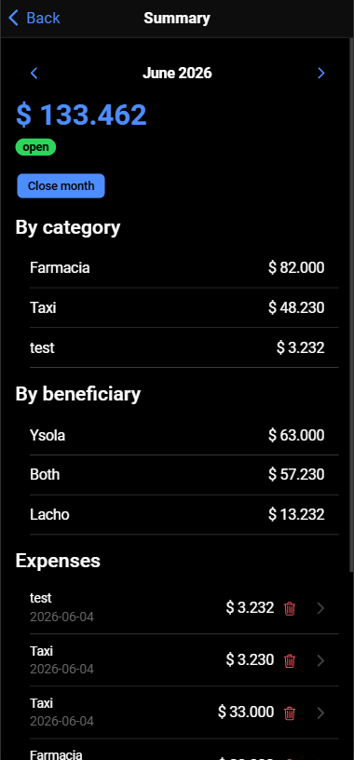
Collections page

- Display the month
- List of Payers with the status pill, if you click the payer it will change the status to Paid, if you click again it will change it to Pending

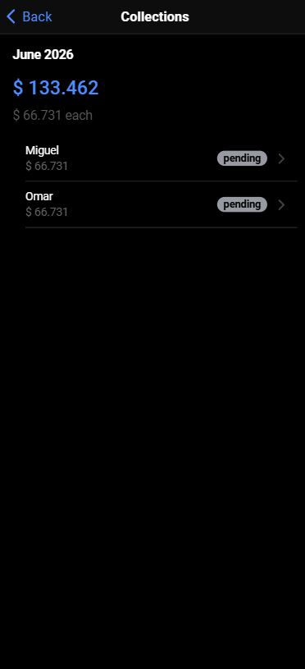

Categories page
Similar to the beneficiaries page
Allows to add, deactivate or remove categories
- Plus buttons pops up a modal with only a input to put the category name
- Clicking the Deactivate link will Deactivate that category and it will say “Activate” which you can click to Activate
- The trash can allows to delete the category, it pops a confirmation modal

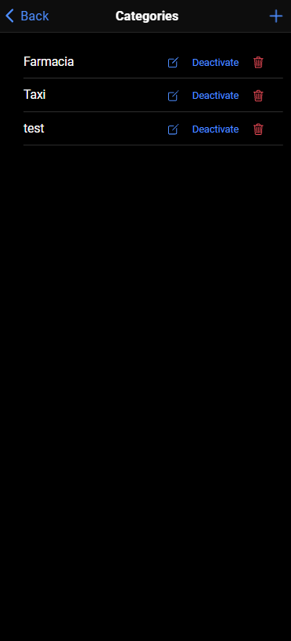

Dashboard page
Display the pending collections which are closed or partially paid, also displays a list of recent months
